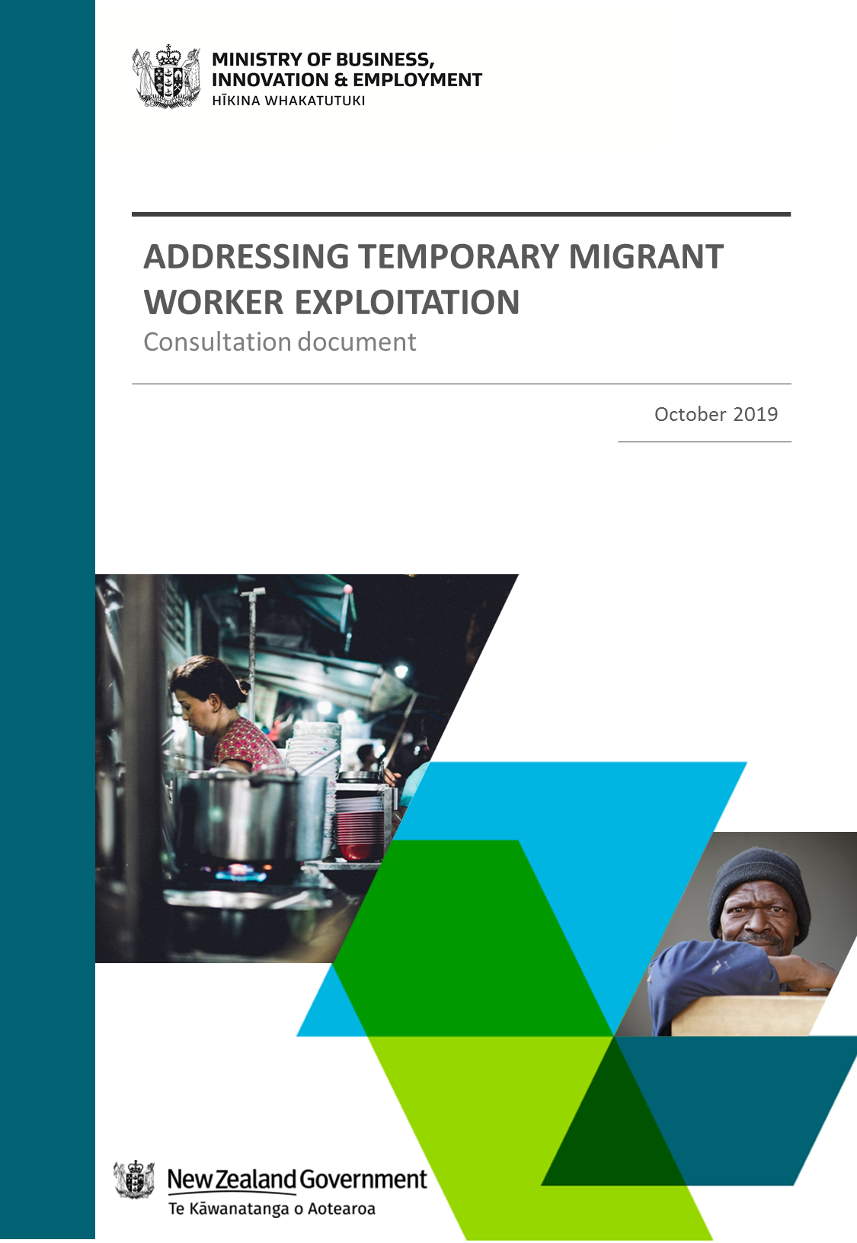

Ministry of Business, Innovation and Employment (MBIE)
Hīkina Whakatutuki - Lifting to make successful

MBIE develops and delivers policy, services, advice and regulation to support economic growth and the prosperity and wellbeing of New Zealanders.

More information
mbie.govt.nz
0800 20 90 20

Information, examples and answers to your questions about the topics covered here can be found on mbie.govt.nz or by calling us free on 0800 20 90 20.

Disclaimer
This document is a guide only. It should not be used as a substitute for legislation or legal advice. The Ministry of Business, Innovation and Employment is not responsible for the results of any actions taken on the basis of information in this document, or for any errors or omissions.

ISBN: 978-1-99-000431-5 (online)
ISBN: 978-1-99-000432-2 (print)

©Crown Copyright 2019
The material contained in this report is subject to Crown copyright protection unless otherwise indicated. The Crown copyright protected material may be reproduced free of charge in any format or media without requiring specific permission. This is subject to the material being reproduced accurately and not being used in a derogatory manner or in a misleading context. Where the material is being published or issued to others, the source and copyright status should be acknowledged. The permission to reproduce Crown copyright protected material does not extend to any material in this report that is identified as being the copyright of a third party. Authorisation to reproduce such material should be obtained from the copyright holders.

Important
To report migrant exploitation, contact the MBIE Service Centre on
0800 20 90 20
To report anonymously, call Crimestoppers on 0800 555 111 or fill out a form on crimestoppers-nz.org
To report people trafficking, call New Zealand Police 105 or 111 (if it is an emergency)

How to have your say
Making a written submission
The Ministry of Business, Innovation and Employment (MBIE) opened this consultation on Thursday 17 October 2019. It seeks submissions by 5pm on Wednesday 27 November 2019.
You can make submissions anonymously.
You do not have to tell us your name. However, if you feel comfortable you can provide your name. You can also provide the name of the organisation (if applicable) you represent in your submission. If you wish to provide these details, please fill out the questionnaire at the back of this document.
We will accept submissions in any form.
You can provide us with feedback in any way you are comfortable. If you use our submission forms, this will help us to collate submissions.
Your submission may respond to any or all of the issues we ask about.
You do not have to answer all of the questions we ask. You may also want to tell us about other things that you think will help reduce exploitation.
You can make your submission by one of these means:
- By online survey OR by filling in the answer fields in the online document – both the links to the survey and the document can be found at mbie.govt.nz/ExploitationReview.
- By printing off this document at the link above and emailing your submission to MigrantExploitationReview@mbie.govt.nz OR mailing it to:
International Labour Policy
Labour and Immigration Policy
Ministry of Business, Innovation & Employment
PO Box 1473
WELLINGTON 6140
Please send any questions to MigrantExploitationReview@mbie.govt.nz

What do we want to know?
We want to know how to address the exploitation of temporary migrant workers and make them less vulnerable to exploitation.
We also want to know about the impact of the proposals and options that we present in this document. We want to hear about the impacts for migrant workers (including international students), other workers, businesses, employers and others. We want to know what you think the benefits might be, as well as their costs. We also want your ideas about how some proposals could be designed and implemented effectively. In some areas, we are testing ideas at this stage, rather than specific proposals.
Your feedback will help inform the Review.
We invite submissions from victims, migrant communities and other community representatives, unions, international education providers, employers, businesses, the legal profession and licensed immigration advisers, and members of the public.

How will we use your submissions?
The information provided in submissions will be used to inform MBIE’s work on the Review.
If you, as a submitter (that is, a person who makes a submission) provide your contact details, we may contact you if we require clarification of any matters in submissions or would like further information. If you wish to provide these details, please fill out the questionnaire at the back of this document. You may however make an anonymous submission.
We will prepare a summary of the submissions we receive and publish this on MBIE’s website, but we will not publish individual submissions or personal information. If your submission contains any sensitive information that you do not want to be in our summary of submissions, please indicate this in your submission by using square brackets around your comments [like this]. The summary will not contain sensitive information that submitters advise us they do not want to be released.
The Privacy Act 1993 applies to all submissions. Any personal information you supply to MBIE in the course of making a submission will only be known by the team working on the Review. Personal information will be withheld from the summary of submissions.
Submissions may be requested under the Official Information Act 1982. Submissions provided in confidence can usually be withheld. MBIE will consult with submitters when responding to requests under the Official Information Act 1982.
Background materials
As part of the consultation process, the Minister for Workplace Relations and Safety, and Immigration, will proactively release papers that put forward the proposals and options in this paper. In addition, the independent research that MBIE commissioned (that informed the proposals and options) will also be released.
These documents will be found at mbie.govt.nz/about/open-government-and-official-information/release-of-information/.

Foreword
We are working hard to build a modern economy fit for the 21st Century, one that prioritises our wellbeing, is inclusive and sustainable. Our aim is to create an economy that contributes to lifting everyone’s wellbeing and treats people fairly as they contribute to it.
Most of us have good working conditions, in workplaces where our rights are respected and upheld. Unfortunately however, this is not the reality for everyone working in New Zealand.
Temporary migrant workers, including international students, are particularly vulnerable to exploitation in the workplace. Some of the exploitation we see includes people not being paid their full wages or working without breaks, and even being prevented from seeking alternative employment when they try to leave.
Exploitation of any kind, against any worker, is simply unacceptable in New Zealand. We need to be a country that supports people to do well, treats each other fairly and upholds the law. Businesses also need to be confident that they can compete on a level playing field, and are not undercut by employers that get ahead through illegal and exploitative practices.
That’s why the Government has committed to taking serious action on temporary migrant exploitation, including of international students.
Our recent reforms to Employer-Assisted Temporary work visas announced in September 2019, has contributed to improving protections for migrant workers by requiring employers to be accredited in order to support a migrant’s application. There is a focus on preventing non-compliant employers from employing migrants in the first instance.
While this work was underway, the Ministry of Business, Innovation and Employment (MBIE) has undertaken a review into temporary migrant worker exploitation in New Zealand. The review is a multi-year project. This first stage has included consultation with migrant, union and business representatives; and independent research to better understand the nature, drivers and consequences of exploitation from both migrant and employer perspectives.
We now want to know what you think of this work and provide a summary of the findings of the Review to date here, along with an initial set of proposals and options designed to reduce the exploitation of temporary migrant workers in New Zealand. These proposals and options aim to:
• Prevent the occurrence of workplace (and other) conditions that might enable temporary migrant worker exploitation.
• Protect temporary migrant workers in New Zealand and enable them to leave exploitative employment.
• Enforce immigration and employment law to deter employer non-compliance through a fit-for-purpose offence and penalty regime.
This consultation seeks your views on how the proposals could be put in place, and whether some options should be looked into further.
I am also open to hearing other ideas that would reduce exploitation, for example those that will enable us to continue to support international education as an export industry and to ensure employers look first to New Zealanders to fill job vacancies.
In the 21st century, there is no place for worker exploitation of any kind. The proposals and options in this consultation are ambitious, and necessarily so. The issue of migrant exploitation is unacceptable and has been let to continue for far too long.
To tackle exploitation effectively, we must hear the voices of victims, migrant communities and other community representatives, unions, international education providers, employers, businesses, and everyday New Zealanders. I look forward to hearing your views.
Consultation closes on Wednesday 27 November 2019. Make sure that you have your say and thank you for taking the time to contribute to this vital work.

Hon Iain Lees-Galloway
Minister for Workplace Relations and Safety
Minister of Immigration

Table of Contents

How to have your say 3
What do we want to know? 4
How will we use your submissions? 4
Foreword 5
Table of Contents 7
Table of Figures 8
What might be of interest to you? 9
Background information 10
Why does this Review matter? 13
What are the goals and the objectives of the Review? 14
How the proposals and options were developed 15
The regulatory systems covered by the Review 15
Section A: Proposals One to Four - Prevent migrant worker exploitation 16
Proposal One: Introduce liability for parties with significant control or influence over an employer that breaches employment standards 18
Proposal Two: Require certain subcontractors and franchisees to meet additional criteria under the employer-assisted visa gateway system 20
Proposal Three: Introduce a labour hire licensing scheme providing certain protections for workers 22
Proposal Four: Prohibit persons convicted of exploitation under the Immigration Act 2009 from managing or directing a company 24
Section B: Proposals Five and Six - Protect temporary migrant workers 26
Proposal Five: Establish an MBIE dedicated migrant exploitation 0800 phone line and online reporting AND establish an MBIE specialised migrant worker exploitation-focused reporting and triaging function 27
Proposal Six: Develop a bridging-type visa for exploited migrant workers OR Improve the current Immigration New Zealand visa status consideration process 30
Section C: Proposals Seven to Ten - Enforce immigration and employment law 35
Proposal Seven: Establish new immigration offences for employer behaviour that contributes to exploitation and vulnerability 37
Proposal Eight: Allow the Labour Inspectorate to issue an infringement notice to employers who do not provide documents requested within a reasonable timeframe 39
Proposal Nine: Expand the stand-down list to include existing immigration offences and, in future, immigration infringement offences for employer non-compliance 40
Proposal Ten: Notify employees on employer-assisted visas who work for an employer who is stood-down 41
Recap of submission details 43
Glossary and acronyms 44
Annex A: Other work underway in government that will help to reduce exploitation 52
Annex B: Current exploitation reporting and referral process 54
Annex C: A summary of other countries’ issues with exploitation and how they deal with it 55
Annex D: Case Study for Proposals One, Two and Four 57
Submitter Questionnaire - Tell Us About Yourself 60

Table of Figures
Figure 1: Summary of proposals/options; where to find them; and who they might interest. 9
Figure 2: Spectrum of minimum employment standard breaches 10
Figure 3: Objectives for the Review and what success will look like 14
Figure 4: Regulatory systems within scope of the Review 15
Figure 5: Toolkit used by Labour Inspectorate to penalise non-compliance 36
Figure 6: Toolkit used by Immigration New Zealand to penalise non-compliance 36
Figure 7: Overview of the proposed response to non-compliance 37
Figure 8: Current exploitation reporting and referral process 54
Figure 9: Summary of key initiatives to address exploitation 56

What might be of interest to you?
To help you read through our proposals and options, and answer questions, we have identified the different areas of interest to some key groups. You can use the table below to help you go to proposals and options that might be of particular interest to you. You are however welcome to read any part of the paper and respond to any questions you like.
Figure 1: Summary of proposals/options; where to find them; and who they might interest.
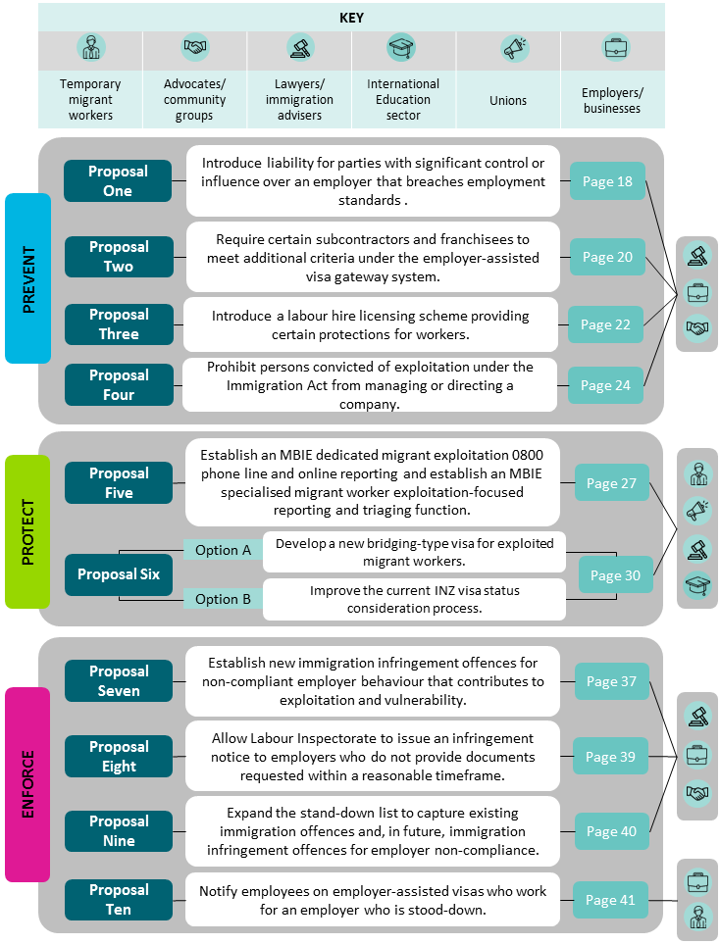

Background information
Who is a temporary migrant worker?
Temporary migrant workers are migrants who are working in New Zealand on a temporary basis. Temporary migrant workers may hold:
- temporary work visas
- student visas that allow them to work (i.e. international students who have work rights), or
- Working Holiday Scheme visas.

What is temporary migrant worker exploitation?
There are a many views of what ‘temporary migrant worker exploitation’ means. Generally exploitation is understood to mean the breach of minimum employment standards. Breaches of minimum employment standards vary, as shown in the picture below.
Figure 2: Spectrum of minimum employment standard breaches
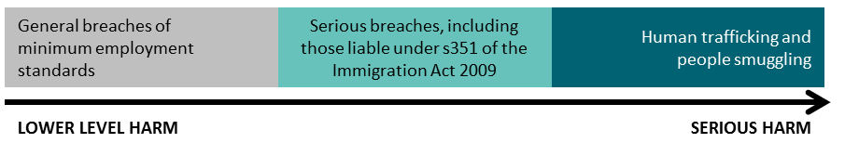
Human trafficking and people smuggling are very serious forms of exploitation. There are offences for these activities in the Crimes Act 1961 and the Government is working to prevent and to address these crimes. For this reason, human trafficking and people smuggling are not within the scope of this consultation.
What are ‘minimum employment standards’?
Minimum employment standards are the standard requirements for workers in employment law, such as the Holidays Act 2003, the Minimum Wage Act 1983 and the Wages Protection Act 1983. They include the minimum wage and minimum annual leave entitlements.
Minimum employment standards prevent employers from underpaying wages, or not paying wages; unlawfully deducting wages; and charging premiums to work.

What are serious breaches under Section 351 of the Immigration Act?
Section 351 of the Immigration Act 2009 defines exploitation of a temporary worker as serious breaches of the Holidays Act 2003, the Minimum Wage Act 1983, and the Wages Protection Act 1983.
A serious breach also happens where an employer seeks to coerce and control a migrant. Coercion and control includes taking or retaining possession or control of a person’s passport. It can also include preventing or hindering a person from:
• having access to a telephone, or
• leaving premises, including leaving them unaccompanied.
Why are temporary migrant workers particularly vulnerable to exploitation?
Temporary migrant workers, including international students, are particularly vulnerable to exploitation, as they may:
- be less aware of their employment rights than New Zealanders
- be from countries that have lower minimum employments standards
- be from countries that do not enforce minimum employments standards
- have limited English, and
- be unaware of how to report exploitation or leave exploitative employers.

Temporary migrant workers often work in industries or sectors where employers have had higher rates of non-compliance with minimum employment standards. Some of these sectors include retail, hospitality and horticulture.
It is hard to say how many temporary migrant workers are being exploited. A main reason for this is that temporary migrant workers fear losing their job or being deported if they report exploitation – and so they do not report.
Immigration New Zealand (INZ) received around 320 complaints of migrant exploitation between 2011 and 2018. However, the number of temporary migrant workers, including international students, exploited in New Zealand is greater than the number of reports made to government agencies. Agencies are receiving increasingly complex cases of exploitation to investigate and address.

What drives temporary migrant worker exploitation?
An employer’s willingness to exploit a temporary migrant worker (including an international student) can be driven by their desire to make a financial gain. An employer might be able to keep their labour costs low if they exploit their migrant workers.
In some cases, organised networks of individuals or businesses (both in New Zealand and offshore) are involved in organising temporary migrant exploitation. These networks might look for migrants that want to move to New Zealand and use that to coerce those migrants into accepting exploitation, or trick them into exploitation.
Migrant exploitation can also happen because there is a power imbalance between a temporary migrant worker and their employer. Their employer might threaten them (e.g. to have the migrant deported). A temporary migrant worker might be prepared to accept exploitative practices in order to remain in New Zealand.
A temporary migrant worker might not know what exploitation is in New Zealand. This might be because employment standards in their home country might be lower, or might not be enforced to the same degree. They may not be fluent in English and may not understand the information given to them about employment standards in New Zealand, or know how to report exploitation.
Migrant workers might not trust agencies that investigate exploitation in New Zealand. They may be worried about what will happen if they make a report. They might worry about their visa status, finding another job to support themselves, or if they might have to stop studying.
A migrant worker that has been caught up in a criminal network organising migrant exploitation might owe that organisation money. Or they may owe money to a recruitment or education agent, or their employer, and be worried about how this will be paid. They might be threatened, or their families in New Zealand and overseas might be.
Case study: the impact of exploitation
This case study is based on a real example. Further case studies are attached in Annex D.
A company operated two stores in isolated towns in New Zealand. Three employees came to New Zealand on student visas to study business management, and were employed as shop assistants in the stores.
In an attempt to ensure the success of their future visa applications to stay in New Zealand, the student’s job titles were exaggerated. They were recorded as being Store Managers.
The employees were required to work up to seven days a week. They were made to work public holidays without receiving annual leave or days off. Their employer required them to work for free around their home and for their family, and did work like cleaning, gardening, cooking and driving. In return, the employer provided free accommodation and food from the stores where the employees worked.
Because of conditions under which the employees were required to work, including excessive hours, they all ended up being paid less than minimum wage, which is illegal.
The employees were not provided with their entitlements to holidays and holiday pay, also illegal. In addition, adequate time and wages records were not kept.
Investigations into the employees’ working conditions also found evidence that their employment agreements were created after they started their work and signed copies of those agreements were not kept. This was another breach of employment law.
The employees’ case was taken to Court. The Court found that the employer had breached the law by:
- failing to provide the employees with employment agreements
- creating the employment agreements at a later date, after the employees started work
- failing to keep accurate wage, time, holiday and leave records, and
- failing to pay minimum wages, holiday pay, public holiday pay and alternative pay.

The company had to pay damages of over $100,000. The Court also considered a shareholder and director of the company, and another majority shareholder, to be persons involved in the breaches of minimum employment standards, under section 142W of the Employment Relations Act 2000. Both of those people were fined amounts between $10,000 and $20,000.
The company and its directors had previously received information from the Labour Inspectorate of their obligations to provide minimum wages, holidays and holiday pay following a complaint by a former employee.
This case also highlights that although the migrants were in New Zealand on student visas, they could not study, or be expected to study, when they were working six and sometimes seven days per week.

Why does this Review matter?
Exploitation has serious, negative outcomes
Independent research commissioned by the Ministry of Business, Innovation and Employment (MBIE) identified that temporary migrant workers who are exploited suffer both physical and psychological harm. Their families can also be harmed. This harm adds to the financial losses the migrant and their family might suffer.
Migrants participating in the research reported that their experiences of exploitative working conditions had damaged their view of work in New Zealand. The research also found that knowledge of exploitation, and concerns about it, extends beyond the temporary migrant worker community and damages other people’s views of working in New Zealand. For example, it can reduce New Zealanders’ confidence that employment will be better than being on a benefit. Exploitation impacts all workers.
Exploitation in the New Zealand workplace damages our international reputation as a great place to live and work. It is also known that exploitative work practices have an impact on our businesses and the economy. Compliant employers who want fair and productive employment relationships are undercut and disadvantaged by exploitative employers using illegal practices to get ahead.
Action must be taken to address exploitation
Action must be taken to reduce the exploitation of temporary migrant workers (including international students) and to make them less vulnerable to exploitation. All workers in New Zealand have the right to enjoy a safe and fulfilling workplace, free from exploitation.
Businesses and employers must understand their responsibilities to their workers. They must fulfil those responsibilities by meeting minimum employment standards. They must also understand and abide by their immigration obligations.
Businesses and employers must be able to operate without being undercut by those that use exploitative practices to get ahead. In addition, New Zealand job seekers should not be deprived of jobs because employers prefer to hire migrant workers who are cheaper to employ if they will accept less than the minimum standards for employment in New Zealand.
Exploitation may also be linked to other serious crime, such as money laundering. Taking action to reduce exploitation may also reduce these other crimes and help New Zealand to maintain its reputation as a safe, secure and non-corrupt country.
It will take a collaborative effort to prevent and deter the exploitation of temporary migrant workers and protect those who have been exploited – it is not only government’s role. We want to hear from a range of people how we can best tackle this issue. We invite submissions from victims, migrant communities and other community representatives, unions, international education providers, employers, businesses, the legal profession and licensed immigration advisers, and members of the public.

What are the goals and the objectives of the Review?
The goal of the Temporary Migrant Exploitation Review (the Review) is to reduce the exploitation of temporary migrant workers, including international students.

The Review wants to address the negative outcomes that arise from exploitation for temporary migrant workers, including international students, but also for other workers, and for businesses and the economy.
We want workers to be in safe and fulfilling work, and for businesses to be able to operate with confidence and on a level playing field.
The proposals and options in this paper are grouped into three areas of focus that collectively aim to prevent the exploitation of temporary migrant workers in the New Zealand workplace; protect temporary migrant workers from being exploited; and enforce immigration and employment law to deter employer non-compliance. The objectives are connected. Achieving one of them will help achieve the others.
Figure 3: Objectives for the Review and what success will look like
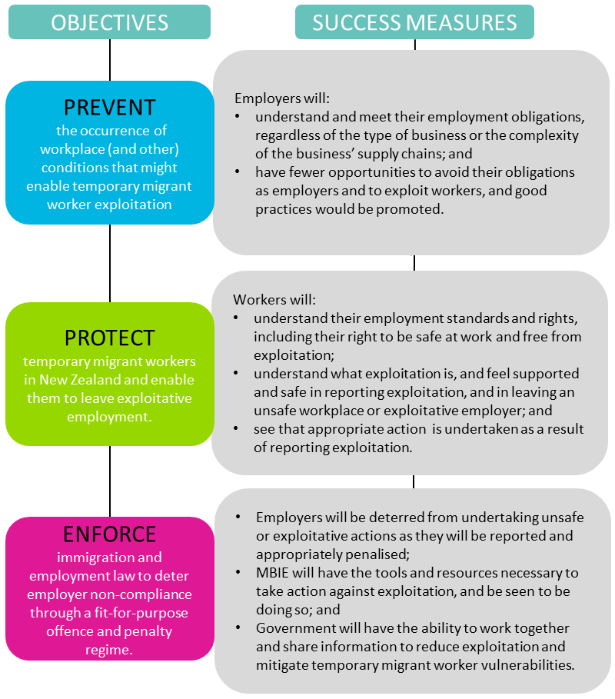

How the proposals and options were developed
In developing the proposals and options, MBIE has:
- undertaken policy analysis to identify gaps and opportunities to reduce exploitation and temporary migrant worker’s vulnerability to exploitation (including international students).
- commissioned wide-ranging independent research on the nature of temporary migrant worker exploitation (including of international students), and the gaps and opportunities to address it. The research will be available on the MBIE website at the following link: mbie.govt.nz/about/open-government-and-official-information/release-of-information/.
- established a consultation group representing migrants, business groups, unions, international students and the legal profession to provide their perspective.

The regulatory systems covered by the Review
The Review covers four of the government’s regulatory systems - employment relations and standards, immigration, health and safety at work, and international education. The proposals and options we are consulting you on are focussed on the employment relations and standards, and immigration systems (although all the systems are connected).
Figure 4: Regulatory systems within scope of the Review
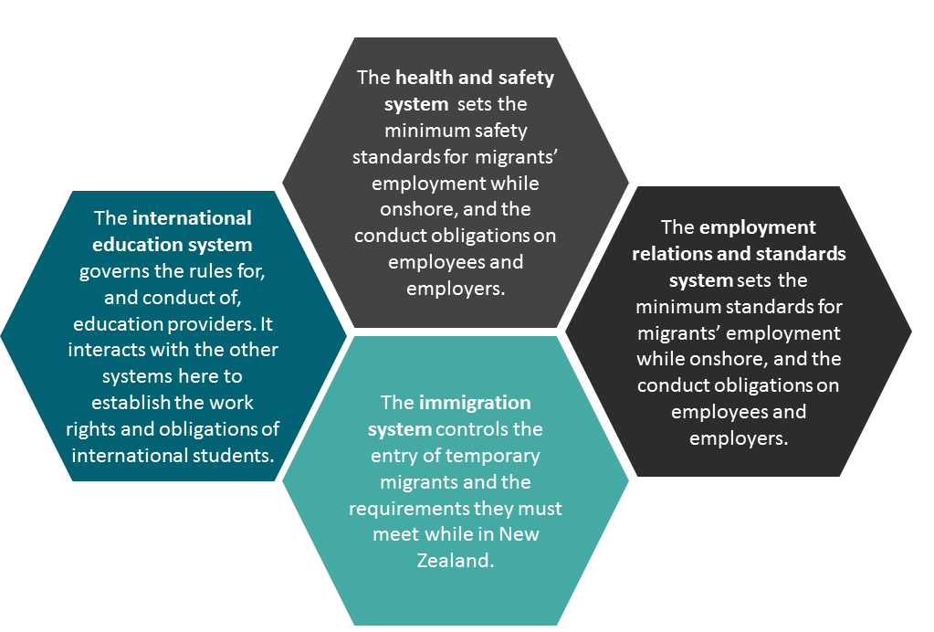
Future phases of the Review might include work to:
- review health and safety policies to better enforce immigration and employment law to deter employer non-compliance.
- better regulate international education to prevent exploitation.
- review how visa settings can help to reduce vulnerability to exploitation and protect temporary migrant workers.

Section A: Proposals One to Four - Prevent migrant worker exploitation
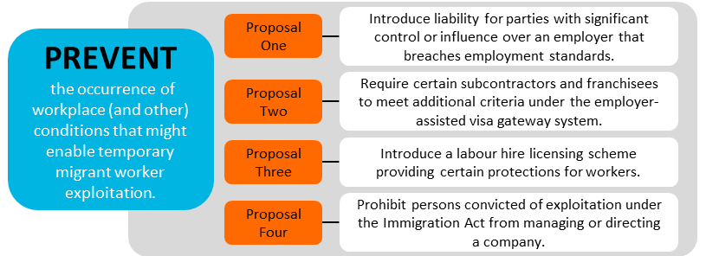
As part of the Review, we are considering the risks of exploitation that can occur within certain business models. In particular, we are focussing on three business models - subcontracting, franchising and labour hire – because we have heard concerns about how they might be allowing exploitation to occur, and we want to find out if there are ways to prevent this from happening.
We also recognise, however, that each of these business models plays an important role in the New Zealand economy and labour market. The models are used by many employers who comply with minimum standards in good faith. We need all employers to obey the law, so that there is an even playing field in the business and labour markets.
We want to promote good business practices that encourage compliance with minimum employment standards across all businesses, while not adding costs to businesses with good employment practices. We want to provide a level playing field and fair competition for businesses, and help to build productive, sustainable and inclusive economic growth.
We have some high-level options that we are keen to test before we do more analysis on them.
What are the business models we are looking at?
We are focussing on three business models - subcontracting, franchising and labour hire. At this stage, we have defined those models in general terms, rather than too technically. Our working definitions are shown in the table below:
Subcontracting | Where a person is contracted to undertake part of a broader contract that has been awarded to a principal or contractor.
Franchising | A business arrangement where a person (the franchisee) trades and operates a business using the systems, conditions and intellectual property of another person (the franchisor).
Labour hire | Where a business’s activity involves arranging for the supply of labour (workers) to another person.

Each business model is used in particular contexts:
- Subcontracting is a popular and effective model often used to access specialist skills and additional labour, and to reduce costs.
- Franchising is a common business model that can offer lower risk to both franchisors and franchisees. Over 124,000 people in New Zealand are employed in franchises.
- Labour hire firms support other businesses by providing a supply of labour to meet temporary demand, while also providing workers access to employment opportunities they may otherwise not have.
When can these business models create risks of exploitation?
The three business models we are considering are not necessarily problematic in themselves; rather, the ways in which they are designed or used can directly or indirectly help exploitation to happen. We give some examples of these features, and describe them in more detail under each of the options in the next section.
We would particularly like to invite submissions from stakeholders that operate, or work with operators of these business models. We want to hear of your experiences as they relate to temporary migrant worker exploitation.
Exploitation can result if businesses must reduce costs to be competitive (e.g. in a labour hire arrangement), or to meet the terms of a contract imposed by a more powerful company (i.e. in a sub-contracting arrangement). Businesses with strong market positions may leverage their positions to exert these kinds of pressures that drive prices down. Exploitation is also often observed in owner-employer businesses that broadly operate independently (such as small retail stores or restaurants).
In this way, exploitation is a particular risk where labour costs must be reduced in order to make the business commercially viable and sustainable, especially where wages make up most of a business’ costs. The three business models we are studying are susceptible to these pressures.
What options are we exploring?
We are exploring four options:
- Making people with significant control or influence over an employer legally responsible when that employer breaks the law
- Requiring certain subcontractors and franchisees to meet additional criteria under the Employer-Assisted visa gateway system
- Creating a labour hire licensing system, and
- Banning people who have been convicted of exploitation offences under the Immigration Act 2009 from directing or managing a company.
These ideas are not final proposals yet – we still have work to do on them. We want your opinion on whether these ideas would be viable, practical and effective. A case study in Annex D illustrates how three of these ideas could work in practice.

Proposal One: Introduce liability for parties with significant control or influence over an employer that breaches employment standards
Employment obligations are generally the sole responsibility of the direct employer who is the party to an employment agreement with an employee. However, in some cases this may not reflect the real nature of the relationship between an employer and an employee, because other people might have control or influence over the employer’s activities, and this can affect employment outcomes. However because the law generally puts responsibility on the employer, those other people can avoid liability.
There is a question about whether liability should apply to more situations in which people could affect employment outcomes. Accessory liability provisions introduced to the Employment Relations Act 2000 in 2016 enable persons “involved in a breach” of certain minimum employment standards to be held liable for the breach, in addition to the employer. To date, these provisions have been used to hold to account individuals (primarily company directors) involved in exploitation.
The liability provisions require that the person was involved in a breach and so do not reflect circumstances where a party pressures the employer more broadly to adopt practices reliant on, or otherwise resulting in, exploitation. That party may profit from exploitation, whether directly or indirectly. However, that party has no legal obligation to address the issue (once it knows about it) and there is therefore no disincentive (other than reputational harm) to taking no action. These settings can encourage aggressive business practices that come at the expense of workers, particularly migrant workers.
What do other countries do?
Australia passed a law (the Fair Work Amendment (Protecting Vulnerable Workers) Act 2017) which allows franchisors and holding companies to be held legally responsible for breaches of employment standards by their franchisees and subsidiaries respectively. This law applies where the franchisor has significant control or influence over the franchisee that has breached the standard, and also requires that the franchisor or holding company knew, or could be expected to have known, that the breach was likely to occur.
Under the Australian approach, it is a defence if the person took reasonable steps to prevent a breach of the same or similar character. In determining this, a court may have regard to all relevant matters, including: the size and resources of the business; the extent to which the person had the ability to influence or control the employer’s conduct; any action taken to ensure the employer was aware of their obligations; the person’s arrangements for assessing the employer’s compliance; the person’s arrangements for receiving and addressing possible complaints; and the extent to which the person’s arrangements require the employer to comply with employment standards.
Australia’s 2019 Migrant Workers’ Taskforce recommended extending these requirements to include all situations where businesses contract out services to persons.

We are seeking views on the idea of making people who have significant control or influence over an employer, to be legally responsible (in some cases) when that employer exploits a worker. In other words, we would broaden the range of parties who are captured by liability provisions, in that it would create liability for persons that have a significant level of control or influence over an employer that breaches employment standards. We propose an approach modelled on the Australian law.
We think that to determine whether a person would be legally responsible for an employer’s breach of employment standards would require several tests, including:
- Did the person have significant control or influence over the employer’s affairs?
- Did the person or a company officer know that the breach of employment standards would occur, or could reasonably have been expected to have known?
- Did the person take reasonable steps to prevent a breach of employment standards occurring?
Our development of these tests will be informed by this public consultation.
This proposal would make little or no difference to businesses and similar entities that already apply good practices, but would likely require many to review their operating practices. Businesses that have significant control or influence over employers, but take no steps to ensure they are complying with minimum employment standards, would need to take some form of action. A downside of using such tests is they are often not clear cut, and there can always be some uncertainty as to what they require, and their thresholds.
There would be some additional monitoring and other costs for businesses and similar entities with significant control or influence over employers. These costs could be passed on to those employers and consumers. However, the overall cost to business would depend on (a) requirements that are yet to be determined, as well as (b) the level of control or influence third party businesses have over employers. Businesses that already have good practices would likely experience no additional costs.
Annex D provides supplementary material on how this approach could work in practice.
1A. Question: Do you agree that people with significant control or influence over an employer should be responsible for that employer’s breaches of minimum employment standards?
☐Yes
☐No
☐Unsure
1Ai. Supplementary question, if you answered YES: If people other than employers were responsible, how should we formulate the tests for this responsibility?
For example:
- How should a threshold of “significant control or influence” be defined?
- What evidence should be considered in determining whether the person knew or should have known that a breach of employment standards occurred?
- What evidence or factors should be considered in determining whether the person took reasonable steps to prevent a breach?
Click here to enter text.

1Aii. Supplementary question, if you answered YES: Should this approach apply to all types of relationships or should it be limited (as is the case in Australia)? Please explain your response.
Click here to enter text.

1B. Question: What would be the advantages of making people with significant control or influence over an employer, responsible for that employer’s breaches of minimum employment standards? Please give your views below.
Click here to enter text.

1C. Question: What would be the disadvantages of making people with significant control or influence over an employer, responsible for that employer’s breaches of minimum employment standards? Please give your views below.
Click here to enter text.

1D. Question: What would be the costs of making people with significant control or influence over an employer, responsible for that employer’s breaches of minimum employment standards? Please give your views below.
Click here to enter text.

1E. Question: If you run a business, what steps does your business take to identify and mitigate the risk of exploitation occurring in your supply chain? (If you are not a business, please write ‘not applicable’).
Click here to enter text.

1F. Question: Do you have any other comments, suggestions or information on this issue?
Click here to enter text.

Proposal Two: Require certain subcontractors and franchisees to meet additional criteria under the employer-assisted visa gateway system
There can be multiple layers of companies (including subcontractors) in supply chains. The complexity and number of these layers can facilitate or hide exploitation. This risk can increase with a higher number of layers of subcontracting, or depending on the nature of the relationship between the franchisor and the franchisee. If we increase the requirements for employers operating with these business models, it might help to mitigate the risk that temporary migrant workers are exploited.
From 2021, employers will need to be accredited in order to participate in the employer-assisted temporary work visa system. Additional criteria for some employers form part of the new employer-assisted visa gateway system, where employers will need to be accredited in order to participate in the employer-assisted temporary work visa system. The employer gateway includes the following three accreditation groups:
- Standard accreditation – setting minimum standards for all employers
- High-volume accreditation – setting higher standards for employers that recruit six or more employer-assisted workers over a 12 month period
- Labour hire accreditation – setting higher standards for labour hire companies.
We are considering whether there are circumstances that are unique to subcontractors or franchisees that increase the risk of exploitation, and if so whether there are additional standards or criteria that could help to mitigate this risk. We would like your views on what sort of additional standards might be effective, and practical ways subcontractors or franchisees might demonstrate that they meet these.
We are particularly concerned with the risk of exploitation occurring in longer subcontracting chains. We therefore consider there could be grounds for limiting additional accreditation criteria to subcontractors at the third or subsequent layer of contracting.
We do not hold comprehensive data on subcontracting and the extent of exploitation in businesses that subcontract, because of challenges in sourcing this information. This option also does not address the issue of cost and other pressures directly; instead it attempts to mitigate risk of those pressures transferring to temporary migrant workers through accrediting employers.
This may add compliance costs to subcontractor, franchisee or other businesses that are reliant on sponsored visa holders, if they need to make changes to meet new standards. In a subcontracting context, if changes are needed, the flow-on effect might be delays and/or cost increases in recruiting and employing migrants for projects (though there would be no restriction or cost for businesses which do not rely on sponsored visa holders, or that meet the new criteria). There will also be additional administrative costs for government from having additional criteria to assess.
We would like your views on this idea, and what accreditation standards should apply. We are particularly keen to hear from principals, contractors and subcontractors involved in any kind of subcontracting arrangement, as well as franchisors and franchisees. We would like to know what you think are the pros and cons of this approach, and the costs on businesses, employers and migrant workers.
2A. Question: Do you think subcontractors and franchisees should be required to meet additional criteria under the new employer-assisted visa gateway system?
☐Yes
☐No
☐Unsure
2Ai. Supplementary question, if you answered YES: What additional criteria should they have to meet?
Click here to enter text.

2Aii. Supplementary question, if you answered YES: If subcontractors were required to meet certain criteria, who do you think they should apply to? Please choose one answer.
☐all subcontractors
☐only to subcontractors that contract beyond a particular tier of a subcontracting chain – please specify which layers you think it should apply to: Click here to enter text.

2B. Question: What would be the advantages of requiring subcontractors and franchisees to meet additional criteria under the new employer-assisted visa gateway system? Please give your views below.
Click here to enter text.

2C. Question: What would be the disadvantages of requiring subcontractors and franchisees to meet additional criteria under the new employer-assisted visa gateway system? Please give your views below.
Click here to enter text.

2D. Question: What would be the costs of requiring subcontractors and franchisees to meet additional criteria under the new employer-assisted visa gateway system? Please give your views below.
Click here to enter text.

2E. Question: Do you have any other comments, suggestions or information on this issue?
Click here to enter text.

Proposal Three: Introduce a labour hire licensing scheme providing certain protections for workers
Exploitation has also been observed in labour hire companies in New Zealand, although data on the extent of exploitation is limited.
Labour hire arrangements can be confusing for workers, and particularly migrant workers. This can present difficulties when those workers seek redress for breaches of employment standards. A licensing scheme could address some risks associated with the labour hire model, and prevent exploitation.
A licensing scheme would extend the accreditation principles proposed under the temporary worker visa reforms (which apply only to labour hire companies intending to sponsor temporary migrant workers) to all labour hire companies. This approach would in turn introduce criteria that are applicable to all labour hire workers, including migrant workers who are not on Employer-Assisted temporary work visas. The licensing requirements and employer accreditation would need to be aligned so that any employers, who are sourcing migrant workers through both schemes, do not have to duplicate their efforts and incur costs.
What do other countries do?
Some states in Australia have introduced laws requiring agencies offering ‘on-hire workers’ (that is, labour hire providers) to be licensed. The Australian Government has also agreed in principle to establish a mandatory National Labour Hire Registration Scheme, which aims to drive out unscrupulous labour hire operators.
In 2010 the United Kingdom passed the Agency Workers Regulation to implement the European Union Agency Workers Directive. The UK also regulates labour hire agencies that provide workers in the agricultural, horticultural, shellfish collecting, and food processing industries through the Gangmasters (Licensing) Act 2004.
In Canada, legislation introduced in 2009 in Ontario regulates temporary agency work (similar to New Zealand’s labour hire arrangements) in a number of ways, including requiring agencies to provide information to workers on wage rates and who they will be working for, not allowing fees to be charged for registration or placement into a job, and protections from reprisals.
If a labour hire licensing scheme was introduced in New Zealand, it could include criteria such as: a fit and proper person test; the provision of information to workers; regulations on the timeliness and/or amount of pay; and the provision of formal mechanisms to facilitate disputes.
The employer-assisted labour hire accreditation requirements will have an impact on labour hire companies that employ temporary migrant workers. However, it is unknown how many labour hire companies employ migrants on open work visas, and how many of those also sponsor employer-assisted visas (and will therefore need to meet accreditation criteria). A licensing scheme could be effective in managing risks across the labour hire model more broadly. It would also extend protections to a wider range of workers, including migrant workers who are not on employer-assisted temporary visas (such as working holiday visa holders and partners of temporary work visa holders).
There might be expensive to administer the scheme, and costs would likely need to be borne by government, or business (through e.g. fees), or both. To provide an indication, the Australian State of Victoria currently sets an application fee of between $1,600 and $7,900 and an annual fee of between $1,100 and $5,450 (varying based on annual turnover); and Queensland sets an annual licensing fee of between $1,000 and $5,100 (varying based on total wages paid). Costs for a New Zealand labour hire licensing scheme would depend on a range of design features.
We are seeking your views on whether you think a licensing scheme should be introduced (and with what criteria), and the benefits and the costs.
3A. Question: Do you think we should introduce a licensing scheme in New Zealand for labour hire companies, to provide certain protections to labour hire workers?
☐Yes
☐No
☐Unsure

3Ai. Supplementary question, if you answered YES: What criteria should a licensing scheme include?
Click here to enter text.

3Aii. Supplementary question, if you answered NO or UNSURE: Please explain your answer. You might wish to outline what you see as the costs and disadvantages of a licensing scheme.
Click here to enter text.

3B. Question: What would be the advantages of a licensing scheme? Please explain your answer.
Click here to enter text.

3C. Question: What would be the disadvantages of a licensing scheme? Please explain your answer.
Click here to enter text.

3D. Question: What would be the costs of a licensing scheme (to employers or others)? Please explain your answer.
Click here to enter text.

3E. Question: Do you have any other comments, suggestions or information on this issue?
Click here to enter text.

Proposal Four: Prohibit persons convicted of exploitation under the Immigration Act 2009 from managing or directing a company
‘Limited liability’ and separate ‘legal personality’ are features of companies, under New Zealand law. These features protect the shareholders and officers of a company from being personally responsible for a company’s obligations. They are important features of the corporate governance system (both within New Zealand and internationally). They encourage people to open new businesses, and they encourage innovation.
However, individuals who exploit migrant workers can also avoid any liability and penalties (such as being put on a stand-down list) by liquidating a business but then reopening a very similar one.
Changes to the Employment Relations Act in 2016 enable persons other than the employer to be held responsible for breaches of minimum employment standards if they have been involved in the breach (these other people can include company directors, senior managers and legal or business advisors). These changes limit the risk of directors liquidating their business to avoid liability, because they allow those directors to be held personally responsible. The Labour Inspectorate is increasingly using these new changes.
However, these changes might not go far enough to prevent or deter some directors from liquidating a company to avoid legal responsibility and penalties where their company has been caught exploiting workers. We are seeking views on whether you think people who have been convicted of exploitation under section 351 of the Immigration Act 2009 should be prevented from managing or directing a company, and for what reasons or under what circumstances.
Consistent with the definition of “director” in the Companies Act 1993, this change would not just apply to individuals who are formally appointed as directors of a company; it would also apply to certain other individuals including “a person in accordance with whose directions or instructions the board of the company may be required or is accustomed to act” – sometimes referred to as shadow directors.
If we could prevent an offender from directing a company, this would mitigate the risk of them re-engaging in exploitation, as it would prohibit them using the limited liability structure under which exploitation can be carried out. We consider this sort of prohibition would also likely have a deterrent effect on potential offenders.
A management prohibition would prevent someone from managing or directing a company, regardless of whether they employ or intend to employ another person. This could potentially have an economic impact. However, this would also likely apply to a very small number of people and they could still either operate as sole traders (under which they would be personally liable for any debts incurred) or work for another employer as an employee.
4A. Question: Do you agree with the idea of not allowing persons to manage or direct a company if they have been convicted of exploitation under the Immigration Act 2009?
☐Yes – please provide reasons Click here to enter text.
☐No – please provide reasons Click here to enter text.
☐Unsure
4B. Question: Would you suggest any other reasons that people should be not allowed to manage or direct a company; or are there alternative options you would suggest? You might wish to consider:
- whether other serious employment-related offences should be included, and
- whether this should only apply in a more limited set of circumstances, such as where a person breaches a banning order?
Click here to enter text.

Other options you might suggest
We are interested to hear if you have any other ideas on how to prevent the risks of exploitation that these business models and practices can have, without hindering legitimate business operations. Your ideas do not necessarily need to focus on what government can do. You might want to consider what others, such as industry or unions, can do.
Section A, Final Question:
Do you have any other thoughts on how the risk of exploitation could be reduced through business models and practices, and who might be best to do this?
Click here to enter text.

Section B: Proposals Five and Six - Protect temporary migrant workers
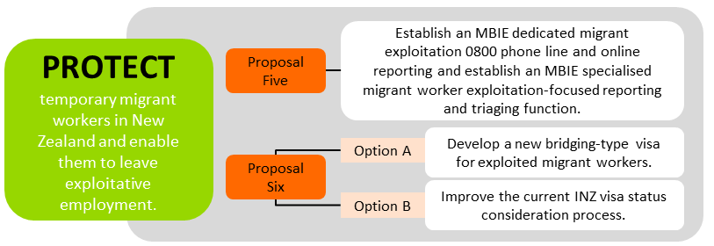
We can make it easier for temporary migrant workers, including international students, to find and report exploitation in the workplace. We also consider that once government agencies receive reports of exploitation, the Ministry of Business, Innovation and Employment (MBIE) can do better at handling these reports and taking action. MBIE’s agencies include those that investigate and take action against exploitation – the Labour Inspectorate and Immigration New Zealand (INZ).
We want to overcome the barriers to reporting exploitation for temporary migrant workers. We are also interested in knowing if international students, women or other groups face any additional barriers to reporting exploitation.
We would like feedback on our ideas to better protect temporary migrant workers. We want your ideas on how best to design new ways for people to report exploitation, which will improve referrals and the handling of reported cases of exploitation. We would also like your views on barriers to reporting, and some options to reduce these. We also are interested in gathering views on how to deal with situations where migrant workers accept being exploited to some degree.
How do temporary migrant workers report exploitation now?
There is a range of ways that temporary migrant workers can report exploitation. The two main points of contact for reporting exploitation are the MBIE Service Centre and the Immigration New Zealand (INZ) Contact Centre. Other agencies (including WorkSafe) can refer temporary migrant workers to either or both of these two contact centres. Other places that migrants report exploitation to are:
MBIE received over 200 complaints of migrant exploitation in the year 2018/19, of which approximately 60 per cent were received by LI, and the remainder by INZ.
- Citizens Advice Bureau
- Police
- Community Law Centres
- Crimestoppers
Annex B provides a diagram of the current process.

What are the problems with the current ways of reporting?
There are already many ways migrant workers can report exploitation, but none of them are specifically focused on temporary migrant worker exploitation. Evidence suggests some temporary migrant workers do not report exploitation because:
- they might not know what their employment rights are, about employment standards in New Zealand, or what exploitation is.
- they might not know how or where to report exploitation, or they cannot contact or access those who could help them.
- they don’t always understand the processes that will follow on from their report, and whether they will be helped.
In addition, the multiple points of contact for receiving and handling reports of exploitation can result in inconsistencies and delays in handling individual complaints. These factors can deter people from reporting in the first place. They might not believe their report will be dealt with properly, fear that it might get lost in the system, or think that it will take too long to get a result. As a result, the worker can miss out on the protection that reporting would give them, and the exploitation might continue.
What do other countries do?
There are various reporting functions relating to migrant worker exploitation used in other countries, though none that operate as the sole portal for migrant worker exploitation.
The United Kingdom has a number of first responders for human trafficking and modern slavery. These include Migrant Help, a helpline for victims of trafficking and slavery, and for refugees seeking assistance with settlement. The Salvation Army’s Modern Slavery Helpline also receives reports of modern slavery which are then referred through a centralised process for appropriate agency action.
In Australia, the Fair Work Ombudsman handles reports of workplace exploitation of migrants, but does not have a dedicated reporting line for migrant exploitation.
In Canada, Employment and Social Development Canada does not have a dedicated reporting line for migrant worker exploitation, but they do have an online tool for reporting breaches of the temporary foreign worker program.

What do we propose to do?

Proposal Five: Establish an MBIE dedicated migrant exploitation 0800 phone line and online reporting AND establish an MBIE specialised migrant worker exploitation-focused reporting and triaging function
We want to make it easy for temporary migrant workers to report exploitation, by making sure the way to report is easy to find, understand and access.
For migrant workers to come forward and report exploitation, they will need to know the way to do so. They will need to be aware of the phone line and online reporting tool, and both need to be easy to use.
A decision has been made to put in place a dedicated migrant exploitation 0800 phone line and online reporting tool that will make reports to MBIE. While there will be costs to Government associated with setting up and running these reporting lines, our analysis indicated that a dedicated 0800 line through to MBIE will offer an efficient and effective approach, bringing these complaints directly through to the regulator that can deal with the allegations.
We want to ensure the design of the phone line and reporting tool makes it easy to use and access. Our questions for you focus on different options for how we design the phone line and reporting tool, and when and how we make people aware of it.
5A. Question: How can MBIE make sure temporary migrant workers know about the 0800 phone line and the online reporting tool?
Click here to enter text.
5B. Question: When should migrant workers be told about the 0800 number and online reporting? Please choose from the following options: (you can select more than one)
☐In visa application information
☐On their visa application form
☐When their visa is granted
☐When they start their job
☐As part of information they receive about study and working while studying
☐When they reapply for a visa
5C. Question: How do you think online reporting could be made easy to use and access? We are considering these options; please tick as many of those you think we should use.
☐Text message
☐Online form
☐App
☐Social media platform (e.g. Facebook, Instagram, Twitter, etc.)

5D. Question: What do you think are the advantages of these options?
Click here to enter text.

5E. Question: What do you think are the disadvantages of these options?
Click here to enter text.

5F. Question: Can you suggest other means of reporting exploitation that would also be easy to use and access?
Click here to enter text.

International students are often the most vulnerable of temporary migrant workers, even though there are ways to provide them with information about their employment rights and employment standards in New Zealand. We also believe women could be particularly vulnerable.
We are interested to hear about particular barriers faced by international students and women in reporting exploitation, and to hear suggestions for what is needed to address these barriers.
5G. Question: Do you think there are particular barriers that international students face to reporting exploitation in the workplace?
☐Yes
☐No
☐Unsure
5Gi. Supplementary question only if answered YES: What do you think those barriers are, and how can they be overcome, to encourage international students to report exploitation?
Click here to enter text.
5H. Question: Do you think there are the particular barriers that women face to reporting exploitation in the workplace?
☐Yes
☐No
☐Unsure
5Hi. Supplementary question only if answered YES: What do you think those barriers are, and how can they be overcome, to encourage women to report exploitation?
Click here to enter text.

5I. Question: Do you think there are other groups of migrant workers who face barriers to reporting exploitation in the workplace and, if so, who are those groups?
☐Yes (please specify: Click here to enter text.)
☐No
5Ii. Supplementary question only if answered YES: What do you think those barriers are, and how can they be overcome, to encourage the group(s) you identified to report exploitation?
Click here to enter text.

Currently migrant workers can report exploitation to government agencies in different ways, meaning their reports can be received and handled by different teams. None of the teams are specifically focused on migrant exploitation in the workplace.
We propose to establish a specialised team in MBIE which would receive migrant worker reports of exploitation (including through the proposed 0800 phone line and online reporting tool). This team would take reports from a temporary migrant worker (or people ringing on behalf of one); triage them, and refer them to the appropriate agency (such as the Labour Inspectorate or INZ). This process would provide a more timely process to take a complaint and deal with it, including investigation.
We are interested to know how migrant workers can feel protected and supported in coming forward to report exploitation.
5J. Question: What types of information could a specialised team provide to someone reporting exploitation?
Click here to enter text.

5K. Question: How could a specialised team work with the migrant worker, throughout the process (from the time they first make a report, through to when their report is dealt with)?
Click here to enter text.

5L. Question: What do you think is a reasonable response time for a decision on a report to be made?
Click here to enter text.

5M. Question: What other functions should a specialised team perform?
Click here to enter text.

5N. Question: How do you think a specialised team should deal with reports of exploitation that are investigated but are inaccurate or false?
Click here to enter text.

5O. Question: Is further support needed to encourage migrant workers to report exploitation? If so, what do you think this could be?
Click here to enter text.

Proposal Six: Develop a bridging-type visa for exploited migrant workers OR Improve the current Immigration New Zealand visa status consideration process
What are barriers to reporting and leaving exploitative jobs?
Temporary migrant workers, including international students, can face barriers which make reporting exploitation hard. These barriers can stop people from reporting, and/or leaving an exploitative employer. Migrants often fear the consequences of reporting, such as potentially having to:
The Review’s independent research indicated almost all migrants who are exploited have accepted, to some degree, their situation.
- leave New Zealand if they are unable to obtain a work visa for a new employer,
- face retaliation from their employer or agent, including through physical violence or psychological bullying against them or their family, or
- face deportation or prosecution for breaching employment or immigration laws.
In particular, migrant workers can be concerned if they have accepted an exploitative situation (for whatever reason) or gave false or misleading information to Immigration New Zealand (INZ) for their visa application. They might have colluded with the employer in their exploitation, or been coerced into staying silent. Their acceptance can reflect many factors, including a power imbalance between the employer and employee. Examples may include:
- a person applying for a visa who pays for a fake or exaggerated job offer from a business that they know exploits workers, to show they have a job on their visa application, or
- a worker forced to falsify and undercount the hours they have been working, as their employer threatens otherwise to report them to INZ so they will be deported, or
- a worker accepting exploitation as they have no other way to pay off a debt to an offshore agent who is threatening otherwise to take the family home as payment, or
- an international student enrolling in a work-place training course they know is a front for illegal and exploitative work – but a student visa will let them enter New Zealand.
How are barriers are dealt with now?
There is an existing INZ process for migrant workers claiming exploitation but it is not widely known about or used - a migrant worker may apply for another visa (of the same type as the visa they currently hold) of initially up to six months duration if they are:
- lawfully in New Zealand, and
- make a claim of exploitation which is accepted for investigation.
An application of this type is assessed on a case-by-case basis.
What do other countries do?
Canada and Australia have recent initiatives providing some assurance for exploited migrant workers to help them to come forward to report exploitation.
Canada has recently allowed migrant workers on employer-specific work permits either experiencing or at risk of abuse in their employment to apply for an open work permit. This provides them with a way to leave their employer.
In Australia, the Australian Assurance Protocol (AAP) (established in 2017) provides assurance to migrants in breach of their work-related visa conditions through exploitation that their current visa will not be cancelled.

We have two options for the situation when a temporary migrant worker claims exploitation and needs to apply for a new visa to leave their exploitative employer. We consider either of the two options could help reduce the barriers to reporting exploitation, especially a migrant’s concerns about their immigration status. These options would either revise or replace the current process of applying for a new visa. We are seeking your view on both which option you prefer, and also the design of your preferred option.
The options are to EITHER:
- Proposal Six (A) - develop a bridging-type visa specifically for temporary migrant workers who have reported exploitation. This visa would allow the migrant worker to leave an exploitative employer, and give them some assurance about their immigration status while their report of exploitation is assessed by INZ.
OR
- Proposal Six (B) - improve the current Immigration New Zealand visa process for when a temporary migrant worker reports exploitation, to allow Immigration Officers to re-issue a visa of the same type that the migrant worker is already on (note: if the exploited migrant is currently on an Employer-Assisted visa, they would be considered for a new visa with open work rights, and able to leave the exploitative employer).
Either option needs to be able to preserve the integrity of the immigration system from fraud and abuse. It is important to balance this objective with that of protecting temporary migrant workers and encouraging them to report exploitation. Related to this, we are considering how to take into account in a visa application whether the migrant accepted their exploitation to some degree, whether it was by collusion, coercion, control, or for some other reason.
In terms of the options proposed, we are mindful that introducing a bridging visa (Proposal Six (A)) carries the risk that it could encourage people to make false reports of employer exploitation, or to collude in exploitation to stay in New Zealand. We would need to design the visa to address these risks.
The risk of Proposal Six (B) is that it might not go far enough to address the barriers that prevent migrants from reporting their exploitation, such as fears of being penalised if the migrant colluded in their exploitation, and the impact on their future visa applications. Again, we will work to mitigate the barriers, by reviewing the design of the existing process.
Both options are likely to encourage an increase in exploitation claims received by the government. Additional funding would be required to triage and deal with these claims appropriately, including investigation.
6. Question: Which of these options do you prefer? Please select one.
☐Proposal Six (A) - develop a bridging-type visa for exploited migrant workers
OR
☐Proposal Six (B) - improve the current INZ visa status consideration process

6Ai. Supplementary questions if you chose Proposal Six (A): Why do you prefer the option of a bridging-type visa?
Click here to enter text.

6Aii. How long do you think this visa should be for (that is, what should be its duration)?
Click here to enter text.

6Aiii.What conditions or restrictions (if any) do you think should be put on this visa?
Click here to enter text.

6Aiv. What type of evidence do you think migrant workers who report exploitation should have to provide? Please list your ideas. If you think no evidence is necessary, please write “none”.
Click here to enter text.

6Av. Do you think a temporary migrant worker who reports exploitation should be required to cooperate with INZ with the following actions? Please tick those you agree with.
☐Giving their name
☐Cooperating with those investigating their report
☐Providing information when asked
☐Providing any changes to contact information, such as a postal or email address
☐Other requirements (please provide your ideas here)Click here to enter text.

6Avi. How do you think exploited migrants can be made aware that this visa type exists?
Click here to enter text.

6Avii. What grounds (i.e. reasons) do you think might be acceptable for declining a request from a temporary migrant worker for a bridging-type visa?
Click here to enter text.

6Bi. Supplementary questions if you chose Proposal Six (B): Why do you prefer the option of improving INZ’s current process for re-issuing visas to temporary migrant workers who have been exploited?
Click here to enter text.

6Bii. What do you think the problems are (if any) with the current process?
Click here to enter text.

6Biii. What changes to the current process do you think are needed to address these problems?
Click here to enter text.

6Biv. How do you think we can ensure that migrant workers who are exploited are aware of the existing visa process?
Click here to enter text.

6C. Question: Do you think a migrant worker’s acceptance of their exploitation (and the reasons for this acceptance) should be an important factor when INZ considers that exploited migrant’s visa application?
☐Yes – please explain: Click here to enter text.
☐No – please explain: Click here to enter text.
☐Unsure

What other ways to improve reporting and referrals are we considering?
MBIE is bringing together all the information it provides (e.g. through INZ and the Labour Inspectorate) on employment standards and rights, and how to report exploitation. It is also working with other agencies that use and provide similar information, to make sure that their information is clear and consistent with ours. MBIE is also looking at ways to assess whether migrant workers and their employers are aware of the information available to them and whether it helps them.
We are interested to hear your views on how best to provide information and make sure it is useful and effective.
6D. Question: When do you think would be a good time to provide temporary migrant workers with information on what employment standards to expect, what exploitation is, and what to do if they think their employer is exploiting them? Please choose as many as you like from the following:
☐In visa application information
☐On their visa application form
☐When their visa is granted
☐When they start their job
☐As part of information they receive about study and working while studying
☐When they reapply for a visa
6E. Question: How should this information be available? Please choose as many as you like from the following:
☐Online (web-based)
☐Paper-based
☐Other - please explain: Click here to enter text.
6F. Question: How else do you think we can educate temporary migrant workers and employers about employment standards and rights, and also immigration requirements?
Click here to enter text.

Other options you might suggest
We are interested to hear if you have any other ideas on how to improve reporting of exploitation and how to reduce barriers to exploitation. Your ideas do not necessarily need to focus on what government can do. You might want to consider what others, such as community groups, can do.
Section B, Final Question:
Do you have any other thoughts on how to improve reporting of exploitation?
Click here to enter text.

Section C: Proposals Seven to Ten - Enforce immigration and employment law
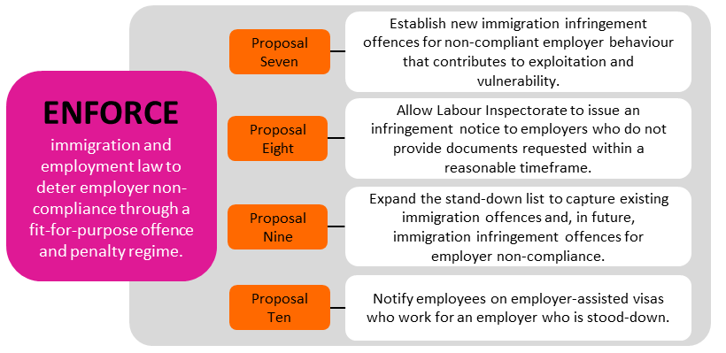
Most employers and businesses in New Zealand obey the law in employing and managing temporary migrant workers. But some do not, and their behaviour can have significant impacts on the migrant’s well-being and their finances. These employers and businesses can also undercut others who do obey the law.
To reduce exploitation, New Zealand needs to enforce employer compliance with minimum employment standards and immigration law through a fit-for-purpose offence and penalty regime. This will help to deter employers who might exploit migrants. When employers do break the law, New Zealand needs to be able to respond in a robust, proportionate and efficient way. Workers and the public also need to have confidence that effective and timely action will be taken against exploitation.
How are employers who don’t comply with the law penalised currently?
Penalties for employer non-compliance in the migrant exploitation space sit mainly in employment and immigration law.
Minimum employment standards are requirements in employment law, such as the Holidays Act 2003, the Minimum Wage Act 1983 and the Wages Protection Act 1983. The standards include the minimum wage, annual leave entitlements and protections against premiums charged for jobs. The Labour Inspectorate generally enforces minimum employment standards through a civil penalty regime. Cases of exploitation can also be put to the Employment Relations Authority or prosecuted through the courts. Figure 5 below provides a diagram of the current ‘penalty toolkit’ under employment law.
Meanwhile, the Immigration Act 2009 provides sanctions for employers who:
- employ migrants who are not entitled to work
- are responsible for serious failures under the laws listed above, and
- are responsible for coercion or control behaviours, such as preventing employees from leaving the job, or holding their passports.
There are significant penalties for employers who are found guilty. Figure 6 below provides a diagram of the current ‘penalty toolkit’ under immigration law and policy.
Figure 5: Toolkit used by Labour Inspectorate to penalise non-compliance
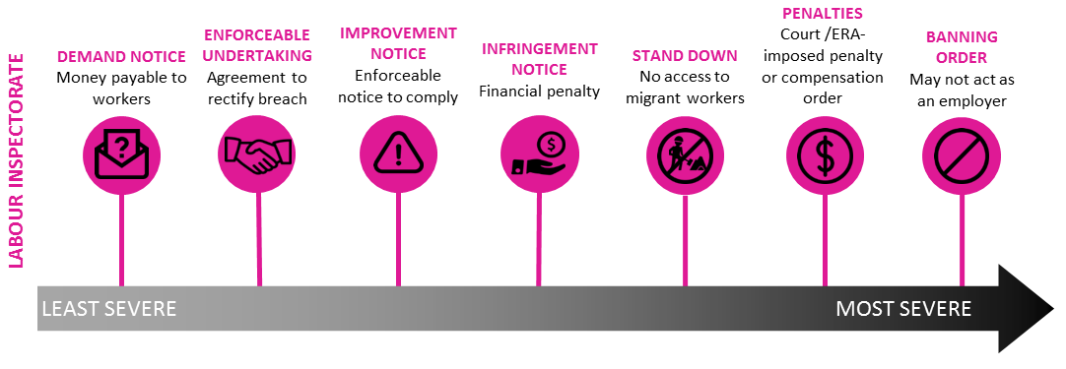
Figure 6: Toolkit used by Immigration New Zealand to penalise non-compliance
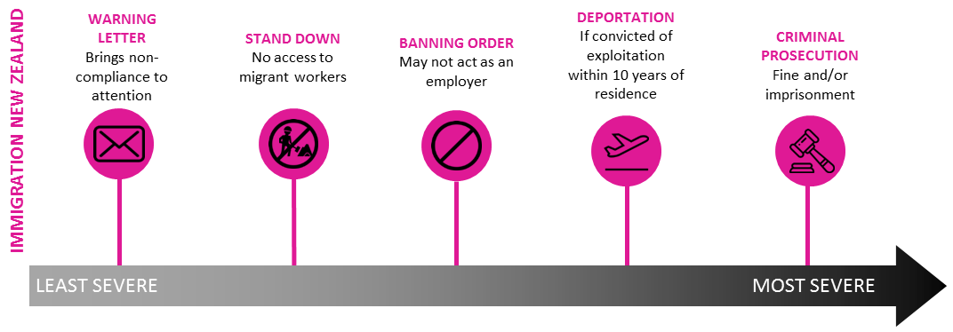
The Labour Inspectorate, between 1 May 2018 - 20 April 2019, took the following actions related to migrant exploitation:
• issued 34 infringement notices
• issued 86 improvement notices
• made 14 enforceable undertakings
• made 20 applications to the Employment Relations Authority
• made 1 application to the Employment Court
• made 1 application to the higher Courts
Immigration New Zealand (INZ) prosecuted 15 cases of exploitation between January 2012 and December 2017.

What is the problem with how current penalties are applied?
At the moment, some employers are not always deterred from non-compliance, or penalised. There are limitations on how government agencies can respond to migrant exploitation. The reasons for this include that there are some gaps in the current employment and immigration toolkit that limit our ability to respond quickly, efficiently and proportionately to less severe breaches of employment law.
The subsections below go into more specific aspects of the problem, and how we propose to address them to better enforce compliance.
What do we propose to do?
We have four proposals which we are seeking your feedback on:
- Establish new immigration infringement offences for wrongful behaviour by employers that contributes to exploitation and vulnerability.
- Allow the Labour Inspectorate to issue an infringement notice to employers who do not provide documents requested within a reasonable timeframe. This is a small change to the existing employment penalty toolkit.
- Expand the stand-down list to capture existing immigration offences and, in future, immigration infringement offences for employer non-compliance.
- Notify those employees on employer-assisted visas who work for an employer who is stood-down.
These proposals will enhance our toolkit to better enforce compliance with minimum employment standards. They will help deter exploitation, and enable wrongful behaviour to be penalised more effectively and in a way that is proportionate to the level of non-compliance.
Figure 7 below gives a summary of what the new approach would look like.
Figure 7: Overview of the proposed response to non-compliance
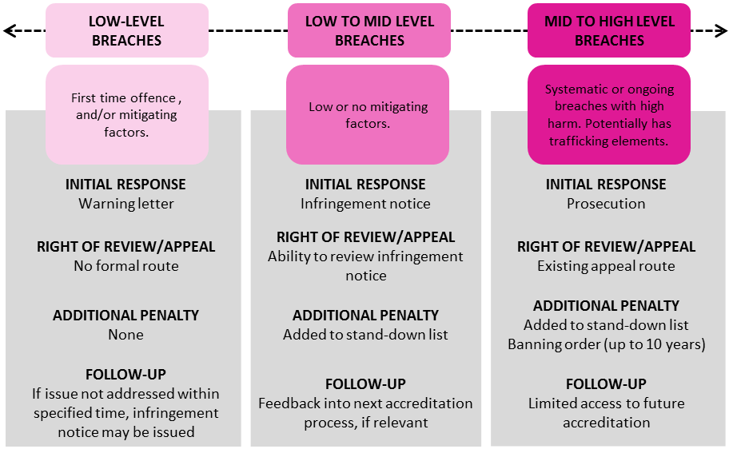

Proposal Seven: Establish new immigration offences for employer behaviour that contributes to exploitation and vulnerability
An infringement regime creates lower level offences for certain aspects of immigration law and policy. We propose to expand the current immigration infringement regime to incorporate non-compliant employer behaviour that is linked to, or increases the risk of, migrant exploitation. We would do this by establishing new immigration offences. The infringement offences would be for lower-level breaches. If an employer committed an offence, INZ would be able to issue an infringement notice to that employer. That notice would require the employer to pay a fee.
The expanded infringement regime would provide an additional tool where enforcement action should be taken against an employer but where the other tools are not proportionate, timely or cost effective.
We are considering what specific behaviours might be included as infringement offences. These might include, for example:
  - failing to provide information or documents when requested by an Immigration Officer (because failing to do this can make it harder to investigate migrant exploitation).
  - employing workers who are not entitled to work in New Zealand, or who are in breach of their visa conditions (because these actions put workers in a vulnerable position).
  - paying less than the salary documented in a visa application (which puts workers in a vulnerable position and may show that the application included false information).
There will be costs relating to the establishment and running of the regime, but it is expected to be an efficient use of investigative resource. The process for users is straightforward, and does not entail complex review processes, or cost of legal representation (unless desired).
The costs of an infringement regime would mostly fall on non-compliant employers, who might also face an additional penalty of being put on the stand-down list (refer Proposal Nine). However, there would also be some administrative cost to INZ in setting up and operating the infringement regime; these costs are currently being scoped.

7A. Question: Do you think INZ should be able to issue infringement notices when an employer does not comply with immigration law and policy?
☐Yes
☐No
☐Unsure
7Ai. Supplementary question if you answered YES: What kind of behaviours do you think should result in an infringement notice?
Click here to enter text.
7Aii. Supplementary question if you answered YES: What do you think are the factors (if any) that INZ should take into account when deciding whether to issue an infringement notice? For example:
- the level of harm done (that is, how bad was the behaviour and its effects)
- whether this is repeat or first time offending by the employer (whether or not they got an infringement notice or any other penalty in the past)
- any previous infringement notices that the employer has received, or if this is the first
Click here to enter text.

7Aiii. Supplementary question if you answered YES: How do you think penalties (the fees) should vary depending on the situation, such as the size of the business, or some other aspect? Please describe what factors should determine how penalties could vary.
Click here to enter text.

7Aiv. Supplementary question if you answered NO: Why do you think INZ should not set up a new infringement regime? You might wish to outline what you see the costs and disadvantages (cons) of an infringement regime.
Click here to enter text.

Proposal Eight: Allow the Labour Inspectorate to issue an infringement notice to employers who do not provide documents requested within a reasonable timeframe
The Labour Inspectorate currently has a ‘toolkit’ of penalties such as enforceable undertakings, improvement notices and various monetary penalties. Generally the toolkit provides the right tools, and remains fit for purpose to deter and penalise wrongful behaviour. However, some employers are slow to provide (or try to delay providing) documents when these are requested by a Labour Inspector (e.g. wage and time records or employment agreements). This can cause delays in finalising the case, and potentially prevents agencies from enforcing the law.
We propose a small change to the existing infringement regime – allowing the Labour Inspectorate to issue an infringement notice to employers who do not provide requested documents within a reasonable time. We believe this would provide a stronger incentive for employers to keep documentation required under existing legislation. There would be some additional cost to the Labour Inspectorate to implement the proposal but this is not considered to be substantive.
8A. Question: Do you think the Labour Inspectorate should be allowed to issue an infringement notice to employers who do not provide requested documents within a reasonable timeframe?
☐Yes
☐No
☐Unsure

8Ai. Supplementary questions, if you answered YES: What do you think would be a reasonable timeframe for providing documents?
Click here to enter text.

8Aii. Supplementary questions, if you answered YES: What should the penalty be for not providing information?
Click here to enter text.

Proposal Nine: Expand the stand-down list to include existing immigration offences and, in future, immigration infringement offences for employer non-compliance
Employers who are penalised for non-compliance with employment law can be put on a stand-down list for between six to 24 months. The stand-down list is a collaboration between the Labour Inspectorate and Immigration New Zealand (INZ), and was established in April 2017. More information can be found at employment.govt.nz/resolving-problems/steps-to-resolve/labour-inspectorate/employers-who-have-breached-minimum-employment-standards/
The criteria for going on the list apply to an employer who has received an infringement notice or penalty, or has been taken to the Employment Relations Authority. Once an infringement notice or penalty has been determined, Employment Services can apply a stand-down period (the length of which relates to the severity of the breach). There is no ability to challenge the stand-down itself, but employers have access to existing review mechanisms for the penalty that resulted in a stand-down period.
The stand-down list has costs for the employer: while they are on the stand-down list, they cannot support a visa application for a migrant worker, or seek accreditation as an employer from INZ, or apply for an Approval in Principle to employ migrant workers. The stand-down list is published on employment.govt.nz, and so the employer’s reputation can also be affected (another type of penalty). The inability to hire temporary migrant workers could have negative impacts on an employer’s business, although significant impacts would raise concerns as to why the employer is not able to attract New Zealand residents and citizens and instead must rely on overseas workers, and how sustainable the business is.
There is anecdotal evidence that the stand-down list is increasing compliance with the law: it encourages employers who rely on a migrant workforce to obey employment law; and few employers have been placed on the list more than once. The government agencies that use or refer to the stand-down list find it is cost-effective, simple for employers to understand and for government agencies to administer.
The stand-down policy provides some protection for migrant workers who may have been employed by poor employers otherwise, by preventing those migrants from working for that employer, and by publicising the employer’s non-compliance.
There are however opportunities to increase the impact of the list, to enforce compliance with the law, by capturing other kinds of wrongful behaviour that would place workers at risk. Employers convicted of Immigration Act 2009 offences, for example, might be put on the stand-down list. In other words, offences against the Immigration Act would form other criteria for the stand-down list.
An example of an employer being placed on the stand-down list (based on a real example)
A restaurant company was put on the stand-down list for 12 months after the Employment Relations Authority found they had breached employment law. The company had neglected to prevent or correct a breach of minimum standards, and had failed to accurately record and pay for all the hours worked by employees. The case that led to the stand-down involved a trainee manager. The manager’s salary was set at such a low level that when she worked overtime, it meant that her salary was equivalent to being paid less than the minimum wage.
The stand-down applied to a large number of stores across New Zealand that were owned by the company. In addition, when the company was put on the stand-down list it had just recruited migrant workers whose visa applications were being processed by INZ. Some of those workers withdrew their applications, and INZ gave the others additional time to find new job offers.

9A. Question: Do you know where to find a copy of the stand-down list?
☐Yes
☐No
☐Unsure

9B. Question: Do you think we should expand the stand-down list’s criteria, so that it includes breaches of the Immigration Act and immigration policies?
☐Yes
☐No

9Bi.Supplementary question, if you answered YES: Are there any particular immigration offences that you think should be part of the stand-down list’s criteria?
☐Yes – which? Click here to enter text.
☐No

9Bii. Supplementary question, if you answered YES: As well as offences under immigration law and policy, are there offences under other laws or policies that you think should also be included in the stand-down list (for example, breaches of health and safety law)?
Click here to enter text.

Proposal Ten: Notify employees on employer-assisted visas who work for an employer who is stood-down
This proposal is related to Proposal Nine. If a migrant worker’s visa expires while their employer is on the stand-down list, that worker will not be granted a further visa linked to that employer. Currently, INZ does not systematically advise employees that their employer has been added to the stand-down list (although the list is published on the Employment New Zealand website). This means, for example, that a migrant worker might not know before their visa expires that they need to seek a job with a different employer when they reapply for a visa.
An opportunity exists to make sure that INZ notifies employees who are on Employer-Assisted visas that their employer is on the stand-down list. For example, a letter would be sent to those migrant workers whose visa expires during the stand-down period. The letter would give advice on what the stand-down means, and what the migrant worker might do next. The advantage of this option is that it would help the migrant worker to understand the process and to have time to consider their options.
The administrative cost of this proposal is likely to be low. It is hoped that the process for writing and sending notices to the employees would be largely automated, and would likely be overseen by an existing team within MBIE.
10A. Question: Do you think we should notify temporary migrant workers whose visas are linked to their employer if their employer is put on the stand-down list?
☐Yes
☐No

10Ai. Supplementary question, if you answered YES: What information should we be providing to migrant workers when their employer is put on the stand-down list?
Click here to enter text.

10Aii. Supplementary question if you answered YES: How else can we best support temporary migrant workers who are working for that employer?
Click here to enter text.

Other options you might suggest
We are interested to hear if you have any other ideas on how to improve the ways we can enforce compliance with the law, including by deterring exploitation and penalising non-compliance. Your ideas do not necessarily need to focus on what government can do. You might want to consider what others, such as industry, can do.
Section C, Final Question:
Do you have any other thoughts on how to improve the ways we can deter and penalise employers’ non-compliance with immigration and employment requirements?
Click here to enter text.

Recap of submission details
The Ministry of Business, Innovation and Employment (MBIE) seeks submissions by 5pm on Wednesday 27 November 2019.
You can make submissions anonymously.
You do not have to tell us your name. However, if you feel comfortable you can provide your name. You can also provide the name of the organisation you represent in your submission.
We will accept submissions in any form.
You can provide us with feedback in any way you are comfortable. If you use our submission forms, this will help us to collate submissions.
Your submission may respond to any or all of the issues we ask about.
You do not have to answer all of the questions we ask. You may also want to tell us about other things that you think will help reduce migrant worker exploitation.
You can make your submission:
- By online survey OR by filling in the answer fields in the online document at mbie.govt.nz/ExploitationReview.
- By printing off this document at the link above and emailing your submission to MigrantExploitationReview@mbie.govt.nz OR
- By mailing your submission to:
International Labour Policy
Labour and Immigration Policy
Ministry of Business, Innovation & Employment
PO Box 1473
WELLINGTON 6140
Please send any questions to MigrantExploitationReview@mbie.govt.nz

Glossary and acronyms
Note that there are also definitions of terms given on these agencies’ websites:
- Employment Services: employment.govt.nz/about/glossary-of-terms/
- Immigration New Zealand: immigration.govt.nz/about-us/site-information/glossary
Acronym | In full
the Inspectorate/LI | MBIE’s Labour Inspectorate
INZ | Immigration New Zealand
MBIE | Ministry of Business, Innovation and Employment
the Review | Temporary Migrant Worker Exploitation Review

Word(s) | What it means
Accredited employer | An employer approved by Immigration New Zealand to employ workers under the Talent (Accredited Employers) Work Immigration Instructions.
accredited labour hire company | An accredited labour hire company is one that has Immigration New Zealand’s approval to employ people from overseas to supply labour to third-parties.  Labour hire companies providing labour to the construction sector in Christchurch must be accredited for work visas to be approved.
annual leave entitlement | Employees are entitled to annual holidays, public holidays, sick leave, bereavement leave, parental leave and other types of leave as long as they meet certain conditions. The minimum entitlement for annual leave is four weeks of paid annual holidays after each 12 months of continuous employment for their employer.
Approval in Principle (also known as AiP) | By obtaining Approval in Principle, employers can hire as many migrant workers as needed without repeating the labour market test for each worker.
asset recovery | The ability under the Criminal Proceeds (Recovery) Act 2009 for the New Zealand Police to take action for the restraint and forfeiture of assets that were acquired or derived from the proceeds of crime. Only the civil standard of proof is required to authorise asset recovery (i.e. on the balance of probabilities), as opposed to the criminal threshold of ‘beyond reasonable doubt’.
banning order | An order that prohibits a person from entering into employment agreements as an employer, or being an officer of an employer (e.g. a director or a general partner), or being involved in the hiring of employees. These are usually ordered by the Employment Court at the request of a Labour Inspector or Immigration Officer. A breach of a banning order is a criminal offence subject to a penalty of a fine of up to $200,000 or up to 3 months imprisonment, or both.
body corporate | A body corporate is the legal entity (such as an association or company) which exists separately from its members.
breach | Where someone has not met the standards set in law.
bridging-type visa | A visa intended to be of transitional nature (as opposed to New Zealand residence or a visa that provides a solid pathway to residence).
Budget | The Budget is the annual process in which Government makes most of its spending decisions.
coercion | The use of force or intimidation to obtain compliance. Section 351 of the Immigration Act 2009 identifies coercive behaviours, such as an employer preventing their employees from leaving their employment, leaving New Zealand, finding out or seeking their entitlements under New Zealand law, or telling someone about the circumstances of their employment.
collusion | Knowingly and secretly helping someone to break the law, whether this help is given directly (for example, by paying for a job) or indirectly (for example, by agreeing to not report exploitation).
compliant/ compliance | Compliance is the attitude or act of meeting the requirements set out in law. A compliant employer meets standards of employment required in New Zealand workplaces, or obligations for employers who employ migrant workers.
conditions (of a visa) | Basic conditions include: the visa expiry, the number of times someone can enter New Zealand, and by what date they need to enter. Other conditions depend on the nature of the visa (that is, work, visit, or study) but could relate to the ability to work, the specific employer or job that may be undertaken, the location of a specific job, or any ability to study while in the country. Visa conditions are explained in an e-visa, on the label in a passport, or in the approval letter sent by INZ.
corporate governance system | This system provides the legal framework for the operation of businesses, not-for-profit entities and civil society organisations. The system's objective is to promote accountable, transparent, and high-performing businesses and similar entities by setting rules and incentives for how businesses and similar entities must be structured, governed and dissolved.
deduction | Amounts taken out of a worker's pay by an employer. Deductions can only be made if they are required by law (e.g. Pay As You Earn PAYE tax), or are reasonable and agreed to in writing by the employee. Sometimes deductions can be made where there have been overpayments.
demand side | An economics term referring to the demand by employers and businesses for employees. It includes the key people that might represent the employers' and businesses' interests, including business representative organisations, industry representative organisations, recruitment agents, and immigration advisers.
deportation | The removal, by New Zealand agencies, of a non-New Zealand citizen from New Zealand.
deterrence | The result of discouraging someone from taking a specific behaviour or action. For the proposals in this paper, deterrence is about making sure our settings discourage poor behaviour by employers.
education agent/ agencies | These agents and agencies provide advice, counsel, and placement assistance to prospective students. They are paid for their services by the educational institutions they represent, the students they assist, or both. They may operate from New Zealand (onshore), or from the student’s home country (offshore).
education provider | The organisation that a student is enrolled to study at. It has to be approved by the Tertiary Education Commission to run their courses and could be a university, Private Training Establishment (PTE), or Institute of Technology or Polytechnics (ITP), or English Language school.
employer-assisted visa | This is a work visa where the migrant is required to work for a specific employer.
employment agreement | ‘Employment agreement’ has a broad meaning. It includes all documents and other agreements that form the contractual agreement between the employee and employer.  Includes all documents and agreements forming part of the contractual agreement between the employee and employer.
employment rights | This term means certain entitlements such as being paid at least the minimum wage; being provided annual leave and holiday pay; and being paid wages that have not had illegal deductions.
employment standards | The set of minimum standards that employers must comply with under various employment laws. These standards set out certain rights for employees and obligations that employers must meet.
enforceable undertakings | An agreement in writing between a labour inspector and an employer that the employer will, by a specified date, rectify the breach of any provision of employment legislation, pay money owed to an employee, or take any other action that the labour inspector determines is appropriate. A failure to meet the terms of the agreement can result in a penalty, and any money owing can be enforced through civil debt proceedings.
enforcement | This has a broad meaning, but here it means investigations where it is suspected a breach of the law or policy has occurred; and also means the resulting action taken, such as penalising the person or business who committed the breach.
entitlement | The ability to do something legally, such as the ability to legally work in New Zealand, according to the conditions set out on the person’s visa. Sometimes an entitlement is referred to as a ‘right’.  A core subset of employment standards are called ‘minimum entitlement provisions, and include:  - minimum entitlements under the Minimum Wage Act 1983  - provisions of the Wages Protection Act 1983  - minimum entitlements and payments under the Holidays Act 2003
exploitative | The attitude or action of exploiting a worker.
franchising | A business arrangement where a person (the franchisee) trades and operates a business using the systems, conditions and intellectual property of another person (the franchisor). Note this has been used as a working definition only in our proposals.
holding company | Generally this means a body corporate with control over another company. See section 5 of the Companies Act 1993 for more detail.
human trafficking | The act of recruiting, transporting, transferring, harbouring and receiving a person through the use of force, coercion, deception or other means for various illegal purposes (also known as “people trafficking”). Further detail is set out in section 98D of the Crimes Act 1961.
immigration obligations | These are obligations on either employers or on migrants. For employers, these could include obligations such as checking whether a migrant is entitled to work for them before hiring the migrant. For a migrant, these could include meeting the conditions of their visa.
immigration status | A person’s ability to remain in New Zealand lawfully. For example, whether they hold a valid visa or not. The same concept is also sometimes referred to as ‘visa status’.
improvement notice | A Labour Inspector can issue an improvement notice requiring an employer to take steps to correct a breach of employment standards. The Employment Relations Authority enforces the notices.
‘in good faith' | A legal term that broadly means “acting fairly and honestly”.
infraction | A breach of requirements in law or policy; wrongful behaviour.
infringement notice | A legal document that requires the person to pay a fee for committed an infringement offence. For example, Labour Inspectors can issue an infringement notice for a $1,000 fee where an employer has failed to keep required wage, time and holiday records or they have failed to retain a copy of individual employment agreements.
infringement offence | A type of criminal offence that is not serious enough to result in a criminal conviction. Infringement offences are intended to deter behaviours that are of relatively low seriousness but could lead to worse behaviour if not deterred.
infringement system (or regime) | The system that determines when infringement offences have occurred, produces infringement notices, and collects fines.
international student | Students from overseas who are not New Zealand residents or citizens and chose to undertake all or part of their tertiary education in New Zealand. International students must hold a visa with study rights, in order to legally study here.
labour hire | A company that enters into contracts with third-parties to supply labour, and employs people to provide that labour.
Labour Inspector | Warranted officers who have powers under the Employment Relations Act to make sure that workplaces meet at least the minimum standards and requirements of employment law. They work for the Labour Inspectorate, which is part of Employment Services, a branch of MBIE.
legal personality | The capacity to have legal rights and duties.
liability | The state of being legally responsible for an action or obligation.
licensing system | A system in which an authority issues official documents giving license holders permission to own, do, or use something.
licensed immigration adviser | Licensed immigration advisers (LIAs) are licensed by the Immigration Advisers Authority (IAA) to provide specialist immigration advice to the public.
limited liability company | A corporate structure where the company’s shareholders are only liable for the money owing on their shares, and personal guarantees they have given to lenders or creditors, such as banks or suppliers.
liquidate | The act of closing down a company, so that its assets can be sold to pay debts.
minimum wage | This is the least amount someone working in New Zealand can be paid by law. Minimum wage rates are reviewed every year and are available on the Employment New Zealand website.
minimum employment standards | Minimum employment standards are set in the Employment Relations Act 2000; Equal Pay Act 1972; Holidays Act 2003; Minimum Wage Act 1983; Parental Leave and Employment Protection Act 1987; Volunteers Employment Protection Act 1973; Wages Protection Act 1983; and Home and Community Support (Payment for Travel Between Clients) Settlement Act 2016.
modern slavery | An overarching term that covers situations that a person cannot leave due to threats, violence, deception, coercion and/or abuse of power. Modern slavery can include forced labour, debt bondage, forced marriage, other slavery and slavery-like practices (such as servitude or serfdom), and human trafficking.
non-compliance | An action that is in breach of standards or obligations set in law.
officer (in employment law) | Section 142W(2) of the Employment Relations Act 2009 defines an officer of an entity to include:  - a person occupying the position of a director of a company if the entity is a company  - a partner if the entity is a partnership  - a general partner if the entity is a limited partnership  - a person occupying a position comparable with that of a director of a company  - any other person occupying a position in the entity if the person is in a position to exercise significant influence over the management or administration of the entity.
online tool | A way of doing something on the internet, such as an online portal for reporting exploitation; or a website that provides information on employment rights.
open work rights/open work visa | This visa or right allows a migrant worker to work for any employer, in any role.
pastoral care | The responsibility to ensure someone is safe and properly cared for. Under the Education (Pastoral Care of International Students) Code of Practice 2016, education providers are responsible to ensure the pastoral care of international students. The Code can be accessed on the NZQA website.
‘penalty toolkit' | The various legislative and policy tools MBIE might use to penalise employers who do not meet the set standards. Tools might include infringement notices, prosecution, improvement notices or enforceable undertakings.
penalty/penalties | Punishment for non-compliance.
people smuggling | A migrant voluntarily paying a smuggler to facilitate illegal entry into another country, and the smuggler obtaining, directly or indirectly, a financial or other material benefit for obtaining their entry.
phoenix activity | Situations where a company is liquidated to avoid liability (including, for example, wages and taxes are owed to workers) or to avoid penalties, and then the same person creates a new company.  In this document, ‘phoenix activity’ is used in the colloquial sense, and is not the same as the technical meaning provided in the Companies Act 1993.
premium | An amount paid to an employer to increase the chance of or guarantee a job.
‘preserve the integrity' | This means to keep the condition or system of something pure and sound, and to not harm or undermine it.
prosecution | Another term for legal proceedings. An example of prosecution would be charging an employer with an offence against the Immigration Act.
recruitment agent | Recruitment agents provide employment placement assistance to migrant workers. They may operate from New Zealand, or from another country (offshore).
referral | The passing of an exploitation report from one part of the system to another.
regulations | Subordinate legislation made under delegated authority of an Act. Regulations usually deal with matters of detail or implementation, technical matters, or those likely to require frequent updating.
regulatory system | A system designed to regulate the practices and activities of certain businesses or institutions.
reporting line | The place where reports of exploitation are made to and the process for doing this.
sanctions | Another term for penalties or consequences of non-compliance.
shareholder | An owner of shares in a company.
significant control or influence | Where a person has a significant degree of influence or control over the employer’s affairs, including their operational and financial affairs. We are seeking feedback on how this term is used in our proposals.
standard | A term that is often used to mean a ‘right’.
stand-down list | A list of employers who have been found to have breached employment standards by the Employment Relations Authority, Employment Court or Labour Inspectorate action. Employers whose names are on the list are not allowed to support a visa application for a specific period of time (the 'stand-down period'). The stand-down list policy is set out in immigration instructions.
student visa | A visa for a migrant whose primary purpose is to study in New Zealand. Many student visas provide some ability to work.
subcontractor | A person or business that contracts to provide a service that is necessary for the performance of another contract.
subsidiary/ subsidiaries | A company controlled by a holding or parent company.
supply chain | A network of businesses involved in creating and supplying a product or service.
supply side | An economic term for the supply of workers to employers who need to fill jobs. The supply side also includes key people that might represent those workers' interests, including unions, migrant community leaders, community organisations, advocates, and lawyers and immigration advisers.
temporary migrant worker | A migrant who holds a temporary work visa and is in employment.
temporary work visa | A work visa that provides temporary employment for a migrant. The duration and conditions of the visa depends on the type of visa.
triage | A term that means to decide how to deal with a report or complaint of exploitation (including how urgently it needs to be followed up), and who will deal with it (that is, which agency will follow up).
warning letter | A letter given to employers warning them that, if their practices do not change, enforcement action will be taken.
work rights | The entitlement or right to be able to work in New Zealand, as set out on the person’s visa.
worker (in employment law) | Any person working for an employer in New Zealand.
workforce | All the people in New Zealand who are engaged in work.
Working Holiday Scheme | Bilateral arrangements allowing young people to live and work in other countries. New Zealand has 45 such arrangements allowing migrants between 18 and 35 years old (depending on their country) to live and work in New Zealand on open work visas for up to 23 months (the period depends on their country).

Annex A: Other work underway in government that will help to reduce exploitation
The Ministry of Business, Innovation and Employment (MBIE) is consolidating its information on employment standards and rights, and on reporting exploitation. It is also working with other agencies to ensure that information is clear and consistent. MBIE is also looking at ways to assess whether migrant workers and employers are aware of the information available to them and whether it helps them.
MBIE also proposes to make it harder for employers who have exploited migrant workers to start a new business. We think this could be done through asset recovery. Under the Criminal Proceeds (Recovery) Act 2009 (CPRA), the New Zealand Police can seize assets that have been acquired illegally – for example, if an employer did not comply with immigration and employment law, but exploited workers and made money from doing so.
Asset recovery helps prevent employers from using those assets to resume or relocate their business, and then potentially exploit other temporary migrant workers in future. Immigration New Zealand (INZ) and the Labour Inspectorate could prepare and refer more cases to Police for asset recovery. Asset recovery has a lower threshold than that required for prosecution, and would provide another effective and proportionate tool in the penalty toolkit.
In addition, we are considering other ways to support government’s ability to deter and penalise employers who do not obey immigration and employment law. These other ways will fill gaps we have identified, and with the proposals we presented in this paper, will build our enforcement approach. For example, we can strengthen cross-agency working and formalise our policies and procedures for working together. We think there are some opportunities to build on and improve collaboration, get the settings right, and make best use of all the available ‘levers’. Examples of this work could include:
- developing a joint compliance and enforcement strategy across INZ and the Labour Inspectorate on temporary migrant exploitation, and
- improving cross-agency collaboration by completing information-sharing agreements.

Outside of the Review, there is a variety of other work going on across MBIE and the government that will have a positive impact and support the range of proposals to reduce migrant exploitation. This work includes:
- Changes to employer-assisted work visa policy, introducing compulsory employer accreditation and a detailed assessment of employers seeking to hire migrant workers. This should result in a better ability to prevent high-risk employers from accessing migrant workers who may then become vulnerable to exploitation.
- Roll-out of a case management tool for INZ compliance staff, which is already used by the Labour Inspectorate and will strengthen their ability to lawfully and effectively undertake joint investigations into exploitation and provide opportunities to improve data collection and reporting.
- The implementation of initiatives that received Budget 2019 funding of $31 million over four years for additional resources in immigration education, intelligence, compliance and investigation functions, to support a targeted compliance strategy in priority sectors.
- An INZ pilot project to standardise assessment, referral and recording of allegations received (including those related to exploitation).
- Work to strengthen immigration risk and verification functions, particularly after a visa is granted, to ensure that risk mitigation controls are producing the desired effect and to identify any adverse outcomes that may occur.
- The organisational realignment of INZ, including a refocusing of its role as a regulator, and establishment of a Data and Intelligence Branch to guide operations, and a Risk Branch to ensure appropriate identification, management and treatment of risk.
MBIE is also working on:
- Fair Pay Agreements which should benefit all workers, not just work migrant workers, and protecting workers against unfair contract terms
- improving Government procurement practices to prevent the circumstances that might enable exploitation to occur
- protections for dependent contractors, and
- protections against unfair contract terms (within the Small Business and the Commerce and Consumer Affairs portfolios).
In addition, the Ministry of Education is leading the implementation of the International Education Strategy 2018-2030. The Review of temporary migrant worker exploitation is a part of that Strategy.
The Minister for Workplace Relations and Safety recently announced New Zealand will be ratifying the International Labour Organisation’s Forced Labour Protocol and supporting work by the International Labour Organisation to end violence and harassment at work. The Government has also committed to refreshing the Plan of Action on People Trafficking.

Annex B: Current exploitation reporting and referral process
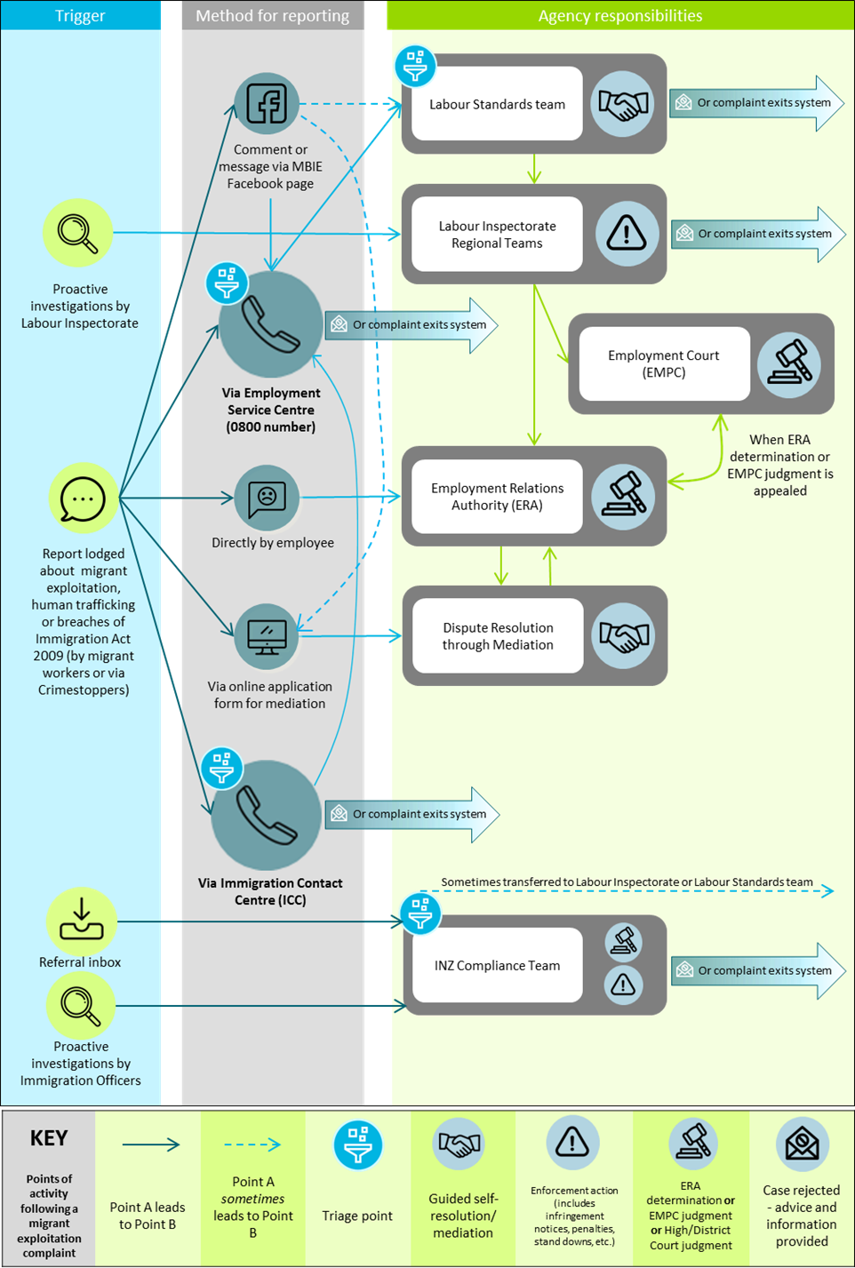
Figure 8: Current exploitation reporting and referral process

Annex C: A summary of other countries’ issues with exploitation and how they deal with it
The following information is a summary of Component 3 of the independent research, which will be available at mbie.govt.nz/about/open-government-and-official-information/release-of-information/.
Do other countries have problems with the exploitation of migrant workers?
The independent research, commissioned by MBIE, studied three countries (Australia, Canada and the United Kingdom) and found there were similarities between the three countries in terms of the types and drivers of exploitation. The types of exploitation experienced by migrants in those countries included:
- wage theft (such as underpayment or non-payment of wages)
- unlawful and significant pay deductions
- the use of recruitment fees and imposition of debt bondage
- exploitative contracting practices (for example, having contractual terms and conditions changed upon arrival in the destination country, or being kept on contracts with flexible working hours), and
- health and safety violations (including working excessive hours in unsafe conditions, and not being provided protective gear).
The drivers of migrant worker exploitation were also similar in the three countries. These include:
- migrant workers’ vulnerability (if they had visas tied to employers, due to the resulting power imbalance)
- a lack of effective enforcement mechanisms
- migrants being afraid to report (due to the risk of job loss, deportation and/or threats), and
- financial strain associated with payments of remittances and debt.

How do these three countries deal with exploitation?
A summary of key initiatives to address exploitation is given below in Figure 9.

Figure 9: Summary of key initiatives to address exploitation
Australia
 | Key initiatives | Main outcomes
Federal legislation | Introduction of the Modern Slavery Act 2018 | Companies are required to release a public statement on the risks of slavery in their supply chains.
 | Fair Work Amendment (Protecting Vulnerable Workers) Act | Increased penalties for non-compliance with minimum wage requirements.
 | Introduction of Temporary Skill Shortage Visa | Applicants must meet higher standards.  Visas tied to employers.
 | Changes to requirements for Working Holiday Makers program | Onus is placed on migrant workers to prove they are paid in compliance with wage laws.
State legislation | Labour hire legislation | Introduces tougher requirements for labour hire companies.
 | Proposed wage theft law (Queensland) | The Queensland Government proposes making wage theft a criminal offence. Recommends that changes must be implemented by the Federal Government.
Canada
 | Key initiatives | Main outcomes
Federal legislation | Amendment to the Immigration and Refugee Protection Regulation | Open work visas will be granted to migrants who can prove they have been exploited by their employer.
 | Proposal for a Modern Slavery Act | Proposal for companies to release a public statement on the risks of slavery in their supply chains.
Provincial legislation | Worker Recruitment and Protection Act (Manitoba) | Employers and recruiters are required to register with the provincial government, recruitment fees are banned and financial penalties introduced.
 | Worker Recruitment and Protection Act (Nova Scotia) | Employers and recruiters are required to be licensed by the provincial government, recruiters pay a bond and recruitment fees are banned.
 | Foreign Worker Recruitment and Immigration Services Act (Saskatchewan) | Contains strong worker-protection and anti-exploitation provisions.
United Kingdom
 | Key initiatives | Main outcomes
Federal legislation | Modern Slavery Act 2015 | Companies are required to release a public statement on the risks of slavery in their supply chains.
 | Modern Slavery (Victim Support) Bill | A private members’ bill awaiting its second reading. Seeks to address weaknesses in the Modern Slavery Act and in particular the status and support offered to victims.
 | Immigration Act 2016 | If a migrant is working illegally there is a restriction on their rights; from being charged for some National Health Service treatments, to being barred from accessing certain types of housing, to being detained and deported from the UK.
Local govt. | Local Government Association | Increased awareness of how local government can help reduce slavery.

Annex D: Case Study for Proposals One, Two and Four
Illustrative case study: exploitation in a franchising context
Note this case study is provided for illustrative purposes only, to support you in your consideration of the ideas we wish to test under Section A ‘Reducing risks around business models and practices’. All references to companies are fictional and any similarities to real events are coincidental.

‘123 Limited’ is a New Zealand franchisee of Number Corporation, and trades using its “Numbers” brand. Number Corporation is a multinational franchise with overseas headquarters, and its New Zealand affairs are managed by an Australasian regional subsidiary.
123 Limited is required to pay the franchisor, Number Corporation, fees and ongoing royalties. The franchisor controls 123 Limited’s store design, opening hours, prices, territory, and advertising. The franchisor also specifies the suppliers from which the franchisee must purchase goods and services from, including its accounting and payroll system providers. The franchisee (123 Limited) is required to participate in training that the franchisor specifies, including full and complete training on the accurate use of accounting software using the franchisor’s accounting methods. 123 Limited is also required to maintain and periodically send detailed accounting records to Number Corporation. 123 Limited must also be available for audits from time to time, which are conducted by Number Corporation.
123 Limited is responsible for employment matters relating to employees of 123 Limited, including recruitment, wages and working hours for those employees. The employment agreements are between the employee and 123 Limited.
123 Limited is alleged to have misrepresented the number of hours worked by its front-line temporary migrant workers to Immigration New Zealand, and to have paid them below the minimum wage. 123 Limited’s director is also alleged to have ordered those temporary migrant workers to withdraw cash from their bank accounts and give this to the director on multiple occasions over several months.
We use the example of the above situation to show how Proposals One, Two and Four in Section A might work in practice.

Proposal One: Introducing liability for parties with significant control or influence over an employer that breaches employment standards
In Section A, we are seeking your views on whether legal responsibility for breaches should be extended to others, and on each of the tests proposed below.
In this case, Number Corporation has control or influence over many of the franchisee’s operations, including its financial and operational affairs. Number Corporation could potentially meet the ‘significant control or influence’ threshold under Proposal One. Whether potential liability would extend to Number Corporation’s headquarters or their Australasian subsidiary would depend on the relationships between each party.
If Number Corporation meets the significant control/influence threshold, the next test is whether or not they knew about the breach or could reasonably be expected to have known that a breach of the same or a similar character was likely to occur. The fact that the employment agreements were between 123 Limited and its employees would not in itself be a defense against Number Corporation’s liability under this proposed option.
In this case, Number Corporation requires that 123 Limited provide detailed accounting records and be available for audits. Even if the purpose of this is for Number Corporation to verify the amount of royalties owed (or for other reasons unrelated to compliance with employment standards), it is likely that the audits would require some investigation into expenses – including employee expenses. It could be reasonable to expect a franchisor to have known that a breach was likely to occur if, for example, the franchisee’s employment expenses and/or wage and time records were materially different from what the franchisor could reasonably expect (given that the franchisor would have oversight and knowledge of the records of all franchisees in the same region or country).
If employees were making cash payments back to the franchisee’s director on a private basis (that is, records would not show this), then it is unlikely that a franchisor would be expected to know that this was occurring.
The final test under Proposal One is to determine whether Number Corporation took reasonable steps to prevent the breach. This could include general steps, such as providing training to franchisees on their employment obligations (which could include, for example, requiring them to complete the online learning modules available at employment.govt.nz/els) and providing a mechanism for workers to raise employment concerns.
There might also be specific steps, according to the circumstances. In the case above, reasonable steps could include making reasonable inquiries into the cause of the deviation (if any) between 123 Limited’s records and what Number Corporation could expect, and then taking steps to ensure any discrepancies are fixed. Reasonable steps in relation to staff being instructed to repay 123 Limited’s director would likely be limited, as a franchisor is generally unlikely to be aware of private transactions between individuals.
What “reasonable steps” means in a particular circumstance could also depend on factors such as the size and resources of the franchisor, and their ability to influence or control the franchisee in relation to the breach.
Proposal Two: Requiring certain franchisees to meet additional criteria under the employer-assisted visa gateway system
In Section A, we are seeking your views on whether franchisees and subcontractors seeking to employ temporary migrant workers should be required to meet additional criteria, and if so then what those criteria should be.
Under the new employer-assisted visa gateway system, all employers will need to be accredited in order to sponsor visas for employer-assisted temporary migrant workers. Requirements will include compliance with regulatory standards, and steps to reduce exploitation risk – including by providing their temporary migrant workers with publicly available information on employment rights and settlement, and committing to pay all recruitment costs and fees.
We want to test whether franchisees (123 Limited in the above example) and subcontractors, or employers operating under other business models, should be required to meet higher standards (criteria) under the new employer-assisted visa gateway system. High-volume and labour hire companies, for example, will additionally be required to demonstrate that they are committed to training and upskilling workers, and that they are committed to increasing pay and conditions over time. We invite all views and suggestions on what additional criteria, if any, should apply.
Proposal Four: Prohibiting persons convicted of exploitation under the Immigration Act from managing or directing a company
In Section A, we are seeking your views on whether an individual should be prohibited from managing or directing a company after they have been convicted of exploitation under the Immigration Act 2009.
Under the Companies Act 1993, people can be prohibited from managing or directing companies for a period of time after they are convicted of certain offences. Those offences include offences in connection with the promotion, formation, or management of a company, and crimes involving dishonesty as defined in the Crimes Act 1961. They do not currently include exploitation offences under the Immigration Act 2009, and we wish to seek your views on whether they should.
A person convicted of exploitation of unlawful employees and temporary workers under the Immigration Act 2009 is liable for up to seven years’ imprisonment, a fine of up to $100,000, or both. This can include serious default under the Minimum Wage Act 1983 and serious contraventions of the Wages Protection Act 1983.
Using the fictional example above, 123 Limited and its director could potentially be charged under both pieces of legislation, depending on the seriousness of the default and contravention respectively. If they were charged and convicted, then under Proposal Four they would also be prohibited from managing or directing a company.

Important
To report migrant exploitation, contact the MBIE Service Centre on
0800 20 90 20
To report anonymously, call Crimestoppers on 0800 555 111 or fill out a form on crimestoppers-nz.org
To report people trafficking, call New Zealand Police 105 or 111 (if it is an emergency)

Submitter Questionnaire - Tell Us About Yourself
In order to make sure that the views of different groups, sectors, and regions are properly shown in any analysis, please provide some preliminary information about your submission.
Questions that are marked * are mandatory. The other questions are optional.

* AA. What sector(s) are relevant to your work or business, or other interest? You can tick more than one.
☐General submission - no specific sector  ☐Aged Care  ☐Construction  ☐Finance  ☐Education  ☐Energy  ☐Forestry  ☐Healthcare (other than aged care)  ☐ICT | ☐Labour hire  ☐Manufacturing  ☐Natural resources  ☐Petroleum and minerals  ☐Retail  ☐Tourism and hospitality  ☐Transport and freight  ☐Viticulture and horticulture  ☐Other (please specify) Choose an item.

* BB. Which region(s) do your responses most closely relate to? You can tick more than one.
☐All regions  ☐Auckland  ☐Bay of Plenty  ☐Canterbury  ☐Gisborne  ☐Hawke’s Bay  ☐Manawatu-Whanganui  ☐Marlborough  ☐Northland | ☐Nelson  ☐Otago (Other than Queenstown lakes)  ☐Queenstown lakes  ☐Southland  ☐Taranaki  ☐Tasman  ☐Waikato  ☐Wellington  ☐West Coast

* CC. Which of the following most closely describes you? Please tick one.
☐Employer - *Please tell us the size of business by total number of employees.
☐1-10 | ☐10-19 | ☐20-49 | ☐50-99 | ☐100-499 | ☐500+
☐Employee - New Zealander citizen or resident
☐Employee - Temporary work visa holder - What type of visa do you hold?
☐Essential skills
☐Post-study work visa
☐Partner of a visa holder
☐Special purpose
☐Talent
☐Other (please specify) Click here to enter text.
☐Employee - Student visa holder
☐Employee - Visitor visa holder
☐Employee – Other (please specify) Click here to enter text.
☐Industry organisation
☐Economic development agency
☐Licenced immigration advisor
☐Union
☐Non-Governmental Organisation (NGO)/Social services provider
☐Local Government
☐Other (please specify) Click here to enter text.

* DD. FOR EMPLOYERS ONLY - Is your business primarily any of the following? (tick as many as apply)
☐Franchisor
☐Franchisee
☐Primary contractor or other contractor that engages subcontractors
☐Subcontractor
☐Labour hire provider
☐If none of the above, please briefly describe your business Click here to enter text.
☐Don’t know or would rather not say.

* EE. FOR EMPLOYERS AND EMPLOYEES ONLY - Are you currently living in New Zealand?
☐Yes
☐No

*FF. FOR EMPLOYERS AND EMPLOYEES ONLY - Did you come to New Zealand as a migrant?
☐Yes
☐No
* GG. FOR EMPLOYERS AND EMPLOYEES ONLY IF ANSWERED YES FOR FF - Where did you come from?
Choose an item.

* II. If you are submitting on behalf of an organisation, what is the name of that organisation?
Click here to enter text.

* JJ Would you prefer your submission, either in part or in full, be withheld from public release? (Personal information such as your name and contact details would not be released).
☐No, the contents of my submission are able to be publicly released in full.
☐Yes, please withhold my entire submission from any public release of submissions.
☐Yes, please withhold private or confidential information as indicated in my submission within square brackets. I do not need to be consulted further regarding public release of submissions.
☐Yes, private or confidential information has been indicated in my submission within square brackets. Please consult me before releasing my submission as part of a public release.

The following questions are optional so you don’t have to answer them. We are asking them to help with analysing the submissions and how different groups in the communities might view the proposals.
KK. If you are making a submission as an individual, what is your gender?
☐Male
☐Female
☐Other – please specify: Click here to enter text.

LL. If you are making a submission as an individual, what is your age group?
☐Under 19 years
☐20–29 Years
☐30–39 Years
☐40–49 Years
☐50–59 Years
☐60–69 Years
☐Over 70 years

The following questions are optional. We are asking them in case we want to contact you to ask for some clarification on your answers, or if your submission is requested under an Official Information Act request.
What is the name of the person completing this submission?
Click here to enter text.

What are your contact details?
Email (preferred) Click here to enter text.
Phone Click here to enter text.
Alternative contact Click here to enter text.

There are some exceptions, when other persons are involved in a breach of employment standards.
See legislation.gov.au/Details/C2017A00101
Refer Proposal Two in text above.

