
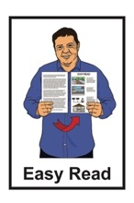

New Zealand Relay Service insights report
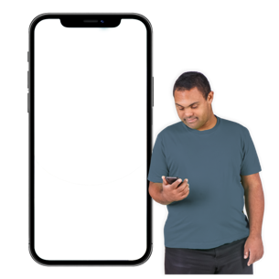
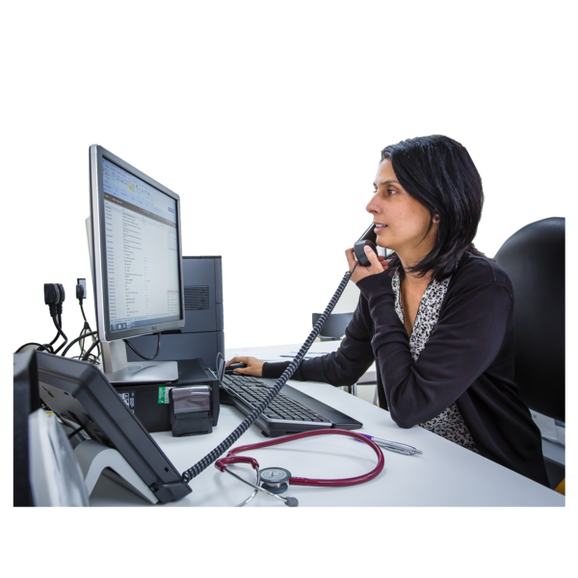


Published: September 2026

Before you start

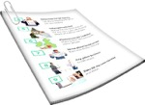
This is a long document.


It can be hard for some people to read a document this long.


Some things you can do to make it easier are:
read it a few pages at a time
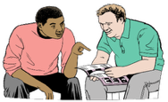
set aside some quiet time to look at it
have someone read it with you to support you to understand it.

What you will find in here

Page number:


About this Easy Read 3
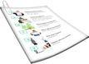

About the insights report 7


Important things to think about 12


Conclusion / wrapping up 32

About this Easy Read

This Easy Read is from the Ministry of Business, Innovation and Employment – Hīkina Whakatutuki.



The Ministry of Business, Innovation and
Employment – Hīkina Whakatutuki is a Government agency that does many things to support the economy of New Zealand.


The economy means all the things we do to:

make money
spend money
save money to use later.

In this Easy Read the Ministry of Business, Innovation and Employment will be called MBIE.


This Easy Read is a summary of the New Zealand Relay Service insights report.


A summary:
is shorter than the main document
tells you the important ideas.

The New Zealand Relay Service is for people who find it hard to use the phone like people who:
are Deaf
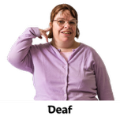
have hearing loss
are deafblind
are speech impaired / find it hard to talk.

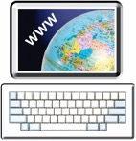
You can find out more about the
New Zealand Relay service at:

www.nzrelay.co.nz


This website is not in Easy Read.



In this Easy Read the New Zealand Relay Service will be called the Service.

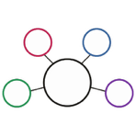
Here an insights report is a report that puts together all the things that were found out during a consultation.

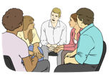
Here a consultation is a
formal / official way of talking to people to:
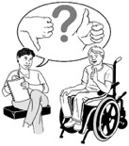
get information
find out what they think about things.

About the insights report


The Service exists to support people to access the phone.


The Service is important for people who:
are Deaf
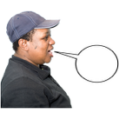

have hearing loss
are speech impaired / find it hard to talk.


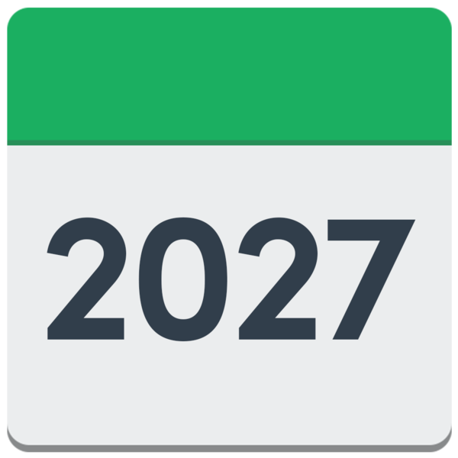
The contract / agreement for who runs the Service ends in May 2027.


A consultation was done to get information about what:
the Service is like now
the changes people would like to see.

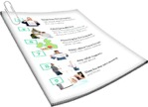
This information is in this insights report.


The insights report supports MBIE to think about what they need from any provider who does the Service later.

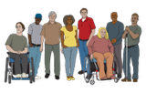
The insights report was written by a team of disabled people.

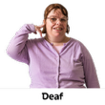
The people who were part of running the consultation included:

Deaf people
tāngata turi / Māori Deaf people.


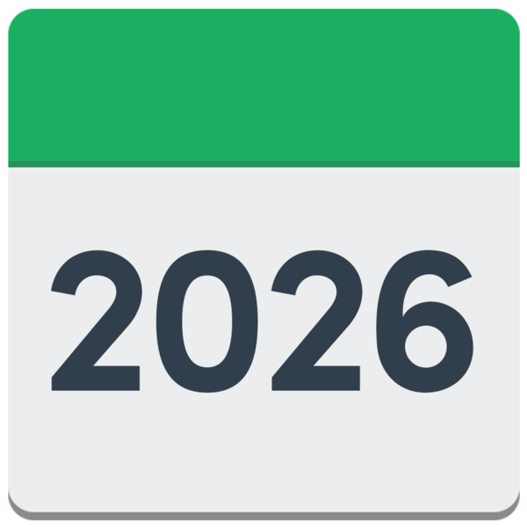
The consultation ran:
from 2 June 2026

to 20 July 2026.

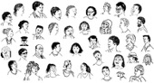
More than 180 people took part in the consultation.

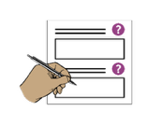
The consultation included:
surveys
submissions in:
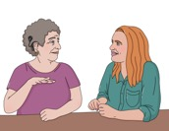
- writing
- New Zealand Sign
Language / NZSL

focus groups
1 on 1 conversations.
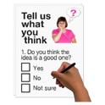

A survey is a list of questions that you can answer.


A submission is when you tell people what you think about things by:

email
video in New Zealand Sign Language / NZSL.


A focus group is a group of people who come together to talk about a topic / issue they have in common.

Important things to think about

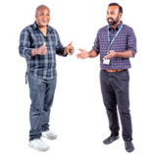
Service and technology

90 percent of people who use the Service would tell other people it is good to use.

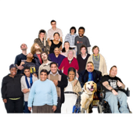
Percent is a number out of every 1 hundred.

For example 10 percent means
10 out of every 1 hundred.


People who use the Service give a good rating of 4.25 out of 5 to the:
relay assistants
interpreters.
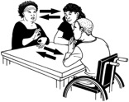
An interpreter is someone who supports people who do not use the same language to understand
each other.


Users say the things they want improved the most are the:
app for their:
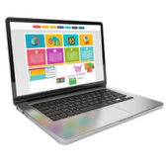
- phone
- tablet
website.


Half of the Service users do not use the app at all.

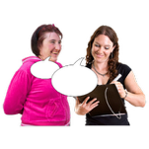
28 percent of people made comments about the technology of the Service.

Convenience
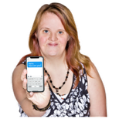
41 percent of users said they use the Service because it is the most accessible option for them to communicate with.

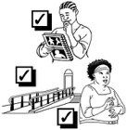
Here accessible means something can be used by everyone including deaf and disabled people.


Here communicate means
talking to other people
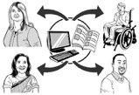
getting information from other people
anything you use to support
your:
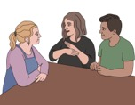
- speech / talking
- writing.

37 percent of users preferred to use New Zealand Sign Language / NZSL to communicate.


7 percent of users said they used the Service because it was:
fast
convenient / easy to use.


There is a need to make all parts of the Service easier to use.

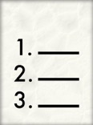
The service needs to improve

Users said they want:
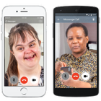
to be able to see a queue / list of where they are in line
2-way communication.
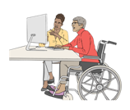
Here 2-way communication means everyone can use the Service to communicate with Deaf and disabled people.

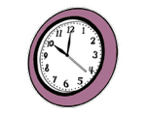
Users also said they want:

the Service to run at night

to know who is interpreting for them
to be able to ask for someone they trust to interpret for them
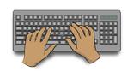
the internet text relay to work better.


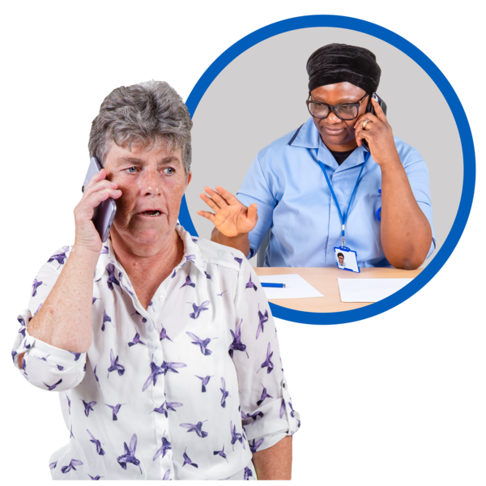
Here text relay is when someone uses the New Zealand Relay website to type in their part of a phone conversation with another person.


Technology that needs to be thought about

The Service is free to use.


To use the Service a person needs things that costs money like:
internet

a phone
an access device / technology that lets a person connect to the Service.


People who use video interpreting services need things to be fairer because they use a lot of mobile data.

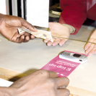
Here mobile data is the amount of internet use you pay for on your phone.

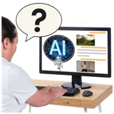
People said Artificial
Intelligence / AI:
might be a part of the Service later on

but
it is not good to use in many parts of the Service.


Artificial intelligence / AI means computer programmes that can do some of the things humans can do like:
learning
solving problems.
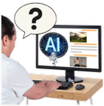
People said AI should not be used for New Zealand Sign Language / NZSL interpretation.

Registration
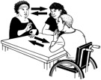

57 percent of users said they support registration for the Service.

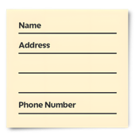
Here registration means giving your personal details to a service.

This supports the Service to be more personalised to / made for you.



Registration supports keeping safe the:
interpreters
relay assistants.
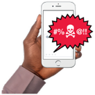
Registration also makes sure people do not use the Service for bad things like prank calls.


50 percent of users were worried about privacy if they register for the Service.


Here privacy means keeping information about you safe.


Users said they want registration to:
happen 1 time only

be done in:
- New Zealand Sign
Language / NZSL
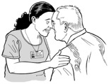
- plain language
be culturally appropriate.
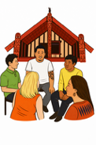
Here culturally appropriate means something fits with the:
culture of a person

values of a person
way a person does things.


Culture is a way of:
thinking that a group shares
doing things as a group.

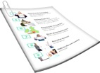
Users also said they want registration to:
not need to show any documents

be done by:
- hearing people
- non-disabled people too.
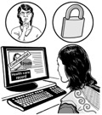
Users also said they want a way to keep calls anonymous even if they register.


Anonymous means no one will be able to find out who you are.



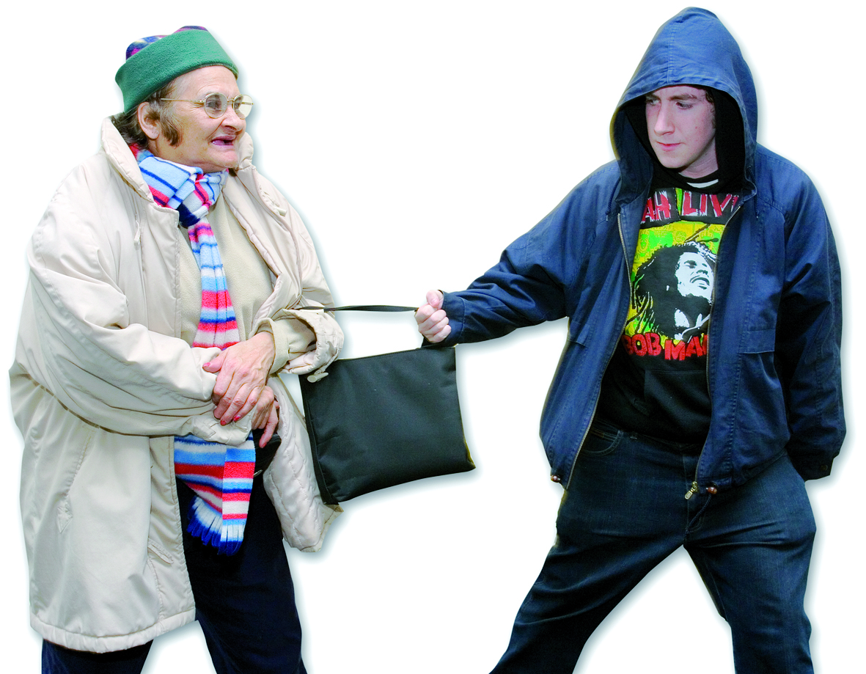
This is so they can make calls that report:
crime
violence.

Phasing out

teletypewriters / TTY

60 percent of people said they were comfortable with phasing out
teletypewriters / TTY.

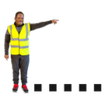
Phasing out means getting rid of something slowly / over a long time.

Teletypewriters / TTY are a type of keyboard that:
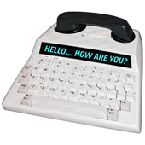
turns the words spoken through a phone into words on a screen
lets a person type words that are read by the keyboard into the phone.
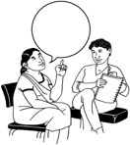
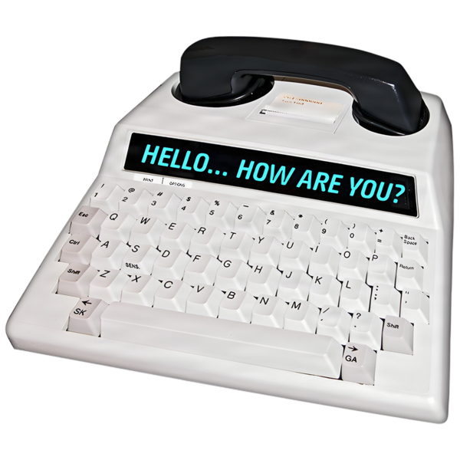

10 percent of people did not want to get rid of teletypewriters / TTY.

People said:
it was important that no one should be left behind because of change
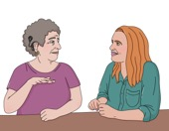
phasing out
teletyperwriters / TTY should:
- not happen suddenly
- be done with the people it affects.

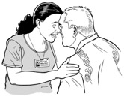
Tāngata turi Māori / Māori Deaf people

It is very important the Service is culturally appropriate for tāngata turi Māori / Māori Deaf people.

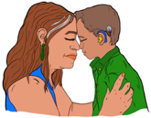
Here culturally appropriate means being a good fit with the culture of a person – in this case Māori Deaf culture.


The Service needs more Māori interpreters.


The caller using the Service must translate te reo Māori / the Māori language.

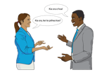
It is important for people to understand that there are different ideas about what sign words in te reo Māori / the Māori language should be used.


Some people feel there should be a standard / set of rules to say how to interpret te reo Māori / the Māori language.

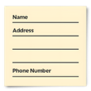
Many tāngata turi Māori / Māori Deaf people said they would be left out if registration needed a:

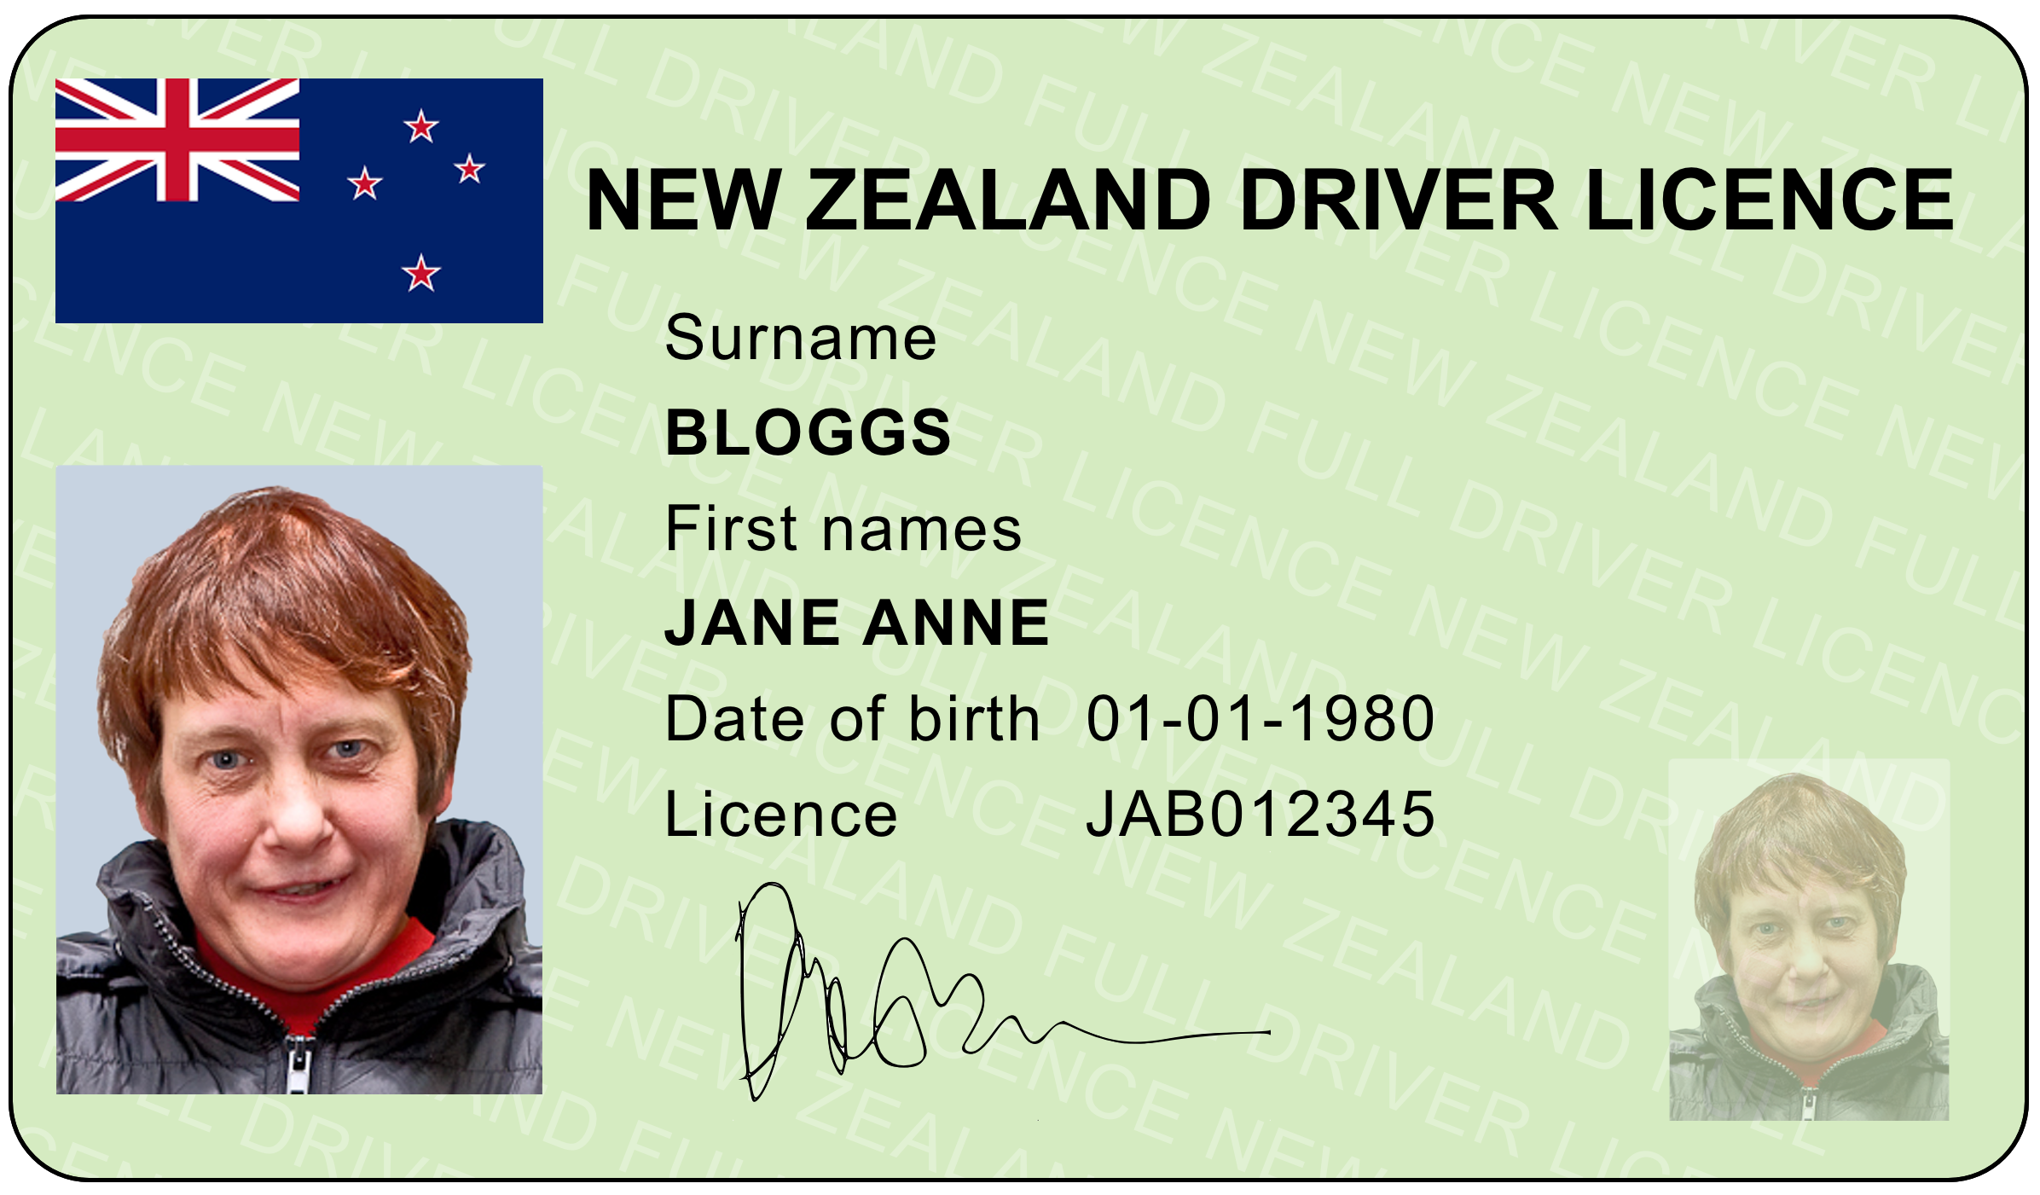
drivers licence
passport.


Funding

The Service needs more
money for the things people are asking for.

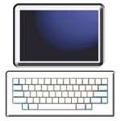
Things the Service need more money for are:
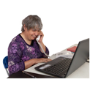
the technology
delivery / how the Service is done.


Tell more people about the Service

People do not:
know about the Service


have enough trust in the Service
have enough confidence the Service works well.

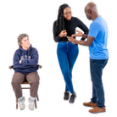
The Service needs to:
connect with the Deaf community in a good way

tell people about what they can do
have enough leaders who are:

- Deaf
- disabled.

MBIE could do more to support the Service.


The Service needs more people who support it.

The Service needs to be better for different people


There are some people who:
want to use the Service
but

have different needs to what the Service does now.

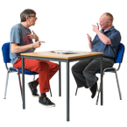
For example there are people who have had strokes who have:
hearing loss
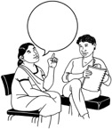
changes to their speech
changes to how they move.

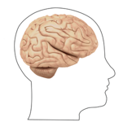
A stroke happens when the brain does not get enough blood.


There are people with learning disability who:
live in a way that means they can take care of themselves
but
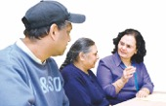
need support with some conversations / things they talk about.


People with learning disability could use the Service.


This would support them to be understood even if they say things in a different way.


The Service would be better if more people could use it to support communication needs.

Conclusion / wrapping up


The Service is very important to the people who use it.


People choose to use it because they need it.


People say it is not always easy to use.

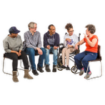
The Deaf and disabled community want the Service to be:
known about by many people

accessible.


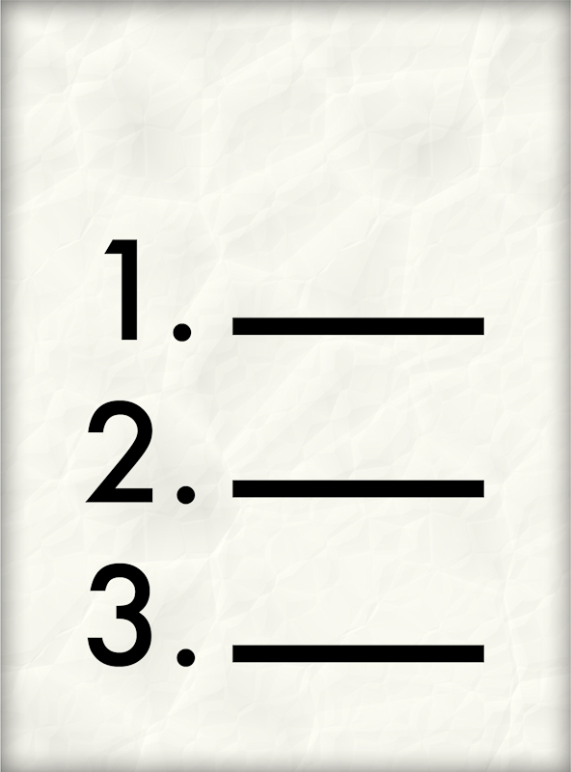
Users want the Service to have:
a queue / list they can watch


hours that are good for their needs
interpreters they:
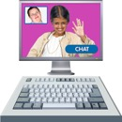
- know
- trust.


Users want the Service to:
have good 2-way communication
be culturally appropriate.


The Service needs to be:

good for many different people
flexible / able to change.

The Service also needs to:
share reports on how it is going

talk to the Deaf and disabled community.


The Service needs leaders who are:
Deaf
disabled.


To run well the Service will need:

good funding / money
people who will support it.


The insights report has given MBIE good information about what to tell providers who apply to run the Service.

This information has been written by the Ministry of Business, Innovation and Employment – Hīkina Whakatutuki.

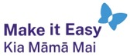
It has been translated into Easy Read by the Make it Easy Kia Māmā Mai service of People First New Zealand Ngā Tāngata Tuatahi.

The ideas in this document are not the ideas of People First New Zealand Ngā Tāngata Tuatahi.

All images used in this Easy Read document are subject to copyright rules and cannot be used without permission.

Make it Easy uses images from:


- Photosymbols

- Change Images


- Huriana Kopeke-Te Aho

- SGC Image Works

- T Wood


- Studio Rebeko

- Inga Kramer.

