

NZ Relay Service Consultation:
Insights Report
August, 2026

Introduction 2
Summary 4
Findings: How the service is experienced 16
Findings: Who the service does not reach 34
Findings: What tāngata turi Māori told us 41
Findings: What the service must not lose 46
Findings: Governance, trust, and the terms of the contract 51
Conclusion 57
Appendix A — Survey results 59

Introduction
The New Zealand Relay Service (NZ Relay) exists to support everyone to have access to telecommunications. It principally serves communities who are Deaf, experiencing hearing loss or living with speech impediments, which make using the telephone and communicating with others more difficult. NZ Relay currently delivers its service through several offerings, including: Video Interpreter Service, text relay, captioned relay, speech-to-speech and teletypewriter services. NZ Relay is funded through the Telecommunications Development Levy, of which it receives a portion, and is administered by the Ministry of Business, Innovation and Employment (MBIE)

MBIE oversees service delivery and contracts its operation to a provider. The current contract expires on 8 May 2027. A consultation was undertaken to inform the tender that will underpin the expectations upon the provider selected to deliver NZ Relay from mid-2027 onwards.

The consultation focused on understanding, first, what services people use within the current offering, what their experiences of those services were, and what services, if any, might be phased out from their perspective. It then asked how people would feel about a registration process, which MBIE is considering as a way of preventing misuse of the service. While these questions were the focus of the consultation, participants in focus groups and interviews were given a broad remit, and this report captures what was heard.

Although NZ Relay users are unified by a shared experience of barriers to telephone communication, the community served is diverse, with specific cultural and linguistic requirements between them. A ‘one-size-fits-all’ approach will inevitably fail segments of this audience. To succeed, service design must appreciate the distinct needs of NZ Relay’s users. This is about being flexible in their ability to respond, while providing a consistent delivery model so users know what to expect. This requires ongoing collaboration with users and a deep appreciation for the nuances of the communities within the ‘disability’ umbrella.

This consultation was also shaped by the fact that at present no demographic information about service users is held by the provider. That was a deliberate decision when the service was established, to make NZ Relay as similar as possible to picking up a traditional phone, and this remains defensible. However, it also means that the service isn’t personalised, and interactions with the Relay Service are more transactional than relational. This shaped the consultation and meant that building trust with the community was critical to engagement.

The findings that follow are organised in five parts:

- How the service is experienced
- Who it does not reach
- What tāngata turi Māori told us
- What the service must not lose
- The governance and contract terms the community wants to see.

In this report, every survey figure is reported as a percentage and a raw count, with the base named (n=) because the bases differ from question to question, and reporting the raw count places the percentage into proportion. Further, survey figures are footnoted to the relevant appendix table. In submissions, where a fact has been asserted, rather than a view (a cost, a population, a comparison with another country), it is footnoted as such.

This report was written by a team who are all themselves disabled. Partnership with the community was key to this consultation, with Deaf and tāngata turi Māori communities working as part of the engagement team. The themes heard were synthesised and then taken back to the community for their validation before any full write-up took place.

We would like to thank all of the MBIE team and community members who contributed to or worked on this consultation.

Summary
This report presents what people shared during a consultation commissioned by MBIE about NZ Relay.

This report outlines the findings from the consultation, and considers what these mean for future contract operations. Specifically, these insights are informing the expectations, requirements and capabilities expected of any provider selected when the contract tender process is underway. These insights should also provide MBIE, as the agency responsible for service delivery, with insights that enable reflection on the service itself, including the quality of NZ Relay, its futureproofing and how the service’s capacity to support New Zealanders can be better maximised.

All is for All led engagement with partners, including a kaupapa Māori agency, AWE, who supported the meaningful engagement of tāngata turi Māori. Community partners were also worked with to engage a diverse group. Over 180 people contributed through a survey, written submissions, focus groups, wānanga and one-on-one conversations. The findings were taken back to a selection of community members in validation sessions, before being written here.

Topline considerations
We heard that ultimately, the service is valued, and the technology is not. Ninety per cent of service users would recommend NZ Relay to someone else (61 of 68 service users), and satisfaction with Relay Assistants and interpreters averages 4.24 out of 5 (68 service users). Contrasting against that, improving the app or website is among the most selected improvements (48%, 32 of 66 service users), half of service users do not use the app at all (34 of 68), and 28% of open comments concern technology when grouped (12 of 43 comments). The role that NZ Relay plays is valued, but its backbone: platform and technology, needs improvement.

People are not using NZ Relay because it is easy. When asked their main reason for choosing the services they use within NZ Relay’s offering, 41% said they chose those services because they were the most accessible option for their communication needs (28 of 68 service users) and 37% said they preferred New Zealand Sign Language (NZSL) (25 of 68). Only 7% said they chose the service for speed or convenience (5 of 68). This tells us that people are choosing NZ Relay for their communication needs, and not for its overall ease. In this sense, NZ Relay is delivering a service that is critical for its users, but this shouldn’t reduce the importance of a holistically effective service; speed and ease should be increased.

The service needs tangible improvements. This looks like a queue you can see, hours that match when people need to make calls, including at night and in crisis. It means knowing who is interpreting for you and being able to ask for someone you trust. It means facilitating two-way communication. And it means web-based text relay that works: the service used to run in real time, letter by letter, but the current system batches whole messages behind a send button, leading to long silences, stunted communication and mutual frustration.

There are nuanced considerations for technology. While the NZ Relay service is free, it relies on an infrastructure that costs. For Video Interpreting Service users, significant mobile data is needed, which manifests as an added financial cost. Moreover, broadband and equipment are also a cost, meaning those who cannot afford it, but may benefit from the NZ Relay offering, are disadvantaged. Alongside these considerations sits the role of future technology, such as artificial intelligence (AI). Participants were clear that AI may have some role, but AI isn’t fit for purpose in many situations, such as where it could be used for NZSL interpretation. Automation must be carefully considered and done with the community’s input.

Registration for NZ Relay is cautiously welcomed. Interpreter safety was the most frequently named advantage of registration (57%, 46 of 81 respondents) — a contrasting result, as personal privacy is simultaneously the largest barrier (50%, 42 of 84). This reflects that registration processes are contingent on trust, which needs to be strengthened. Participants expressed specific conditions for supporting registration, among them: registration being one-time rather than per-device; the process must be made for NZSL and in plain language; culturally appropriate, with a verification route that requires no documents (formal identification being supplied was pushed back on, and there was no alignment on one type of identification) Participants, also sought preservation of an explicit anonymous route for some calls. This was specifically important for reporting crime and violence. Participants also expressed that registration needs to be two-way, not only a burden on the Deaf or disabled person.

Most of those who engaged were comfortable with phasing out teletypewriter (TTY) services, but most were not TTY users themselves. 63% (25 of 40 commenting) were comfortable, against 10% (4 of 40) who were opposed. However, while comfort was broad, the community was clear that no one should be abandoned by a change made; more work is needed to identify TTY users, understand how they would be impacted, and support their transition to alternatives. Some participants shared that because the landline network TTY depends on is itself scheduled for phase-out, there is a natural need to support a transition from TTY, but this needs to be well planned. No phase-out of TTY should be sudden, sharp or done without the participation of those impacted.

Tāngata turi Māori participants expressed a unique context. They described that cultural bridging (where te ao Māori concepts are successfully translated across languages) is unpaid work currently done by the caller when the interpreter isn’t able to. This additional work needs recognition as it impacts user experience. We also heard that there is no agreed te reo Māori sign vocabulary and no certification for interpreting into it. Participants also shared that a registration model built on a driver’s licence or passport requirement would disproportionately exclude tāngata turi Māori; this should directly inform decision-making.

Funding is the pre-condition. The potential of NZ Relay can be greatly maximised. However, in order to improve its technology, service delivery and better realise its potential, the service needs greater investment.

The service needs to be more visible, and it needs a champion. At the moment, the service is not visible in, or connected to, the community it serves. The absence of community connection, visible outreach or Deaf and disabled leadership has a significant impact on the community’s trust and confidence. Moving forward, an emphasis on outreach and visibility, with real pathways for community-level influence, is needed. Moreover, while MBIE delivers the service, the agency is at arm’s length from it. It appears that the service functions largely without anyone ‘in its corner’ and this has impacted quality and impeded trust in the service. Future service delivery would benefit from greater visibility, input and investment from the agency.

Methodology
This report was developed using a mixed-methods approach. A combination of quantitative and qualitative mechanisms was used to engage the community.
Engagement ran from 2 June 2026 to 20 July 2026. The engagement was extended to allow more people to take part. The online survey was live from 23 June 2026, opening after the wider engagement period began and closing shortly after it ended. The consultation was delivered alongside community partners and working closely with NZSL translation experts.

In total, over 180 people contributed across the survey, written submissions, focus groups and one-on-one conversations.

The engagement design was shaped by what was already known, and not known, about the people who use the service. The NZ Relay service collects no demographic information about its users. This was a deliberate choice made when the service was established, so that using it would be no more onerous than using a telephone. It means, however, that there was no existing database of service users to recruit from, nor was there a consistent communications platform service users engaged with, so reaching people required broad and sustained outreach across the community of potential users. Further, the service users were themselves from a broad community, making diverse recruitment and engagement an integral part of the methodology.

Terminology in this report
The communities this service is built for are diverse, and the language people use for themselves differs across them.

- 'Deaf' with a capital ‘D’ is used where people identify with Deaf culture. We recognise that to be Deaf is cultural, and not necessarily considered a disability.
- 'Tāngata turi Māori' is used for Deaf Māori.
- People experiencing hearing loss, or deaf with a lower case ‘d’ is used to express the broader spectrum of hearing loss.
- Deafblind refers to the dual experience of being both blind and deaf, which is a spectrum of experiences.
- ‘Learning disability' rather than 'intellectual disability' is used in alignment with the preference of peak bodies whose members regard the latter as a medical diagnostic term.
- 'Speech impediment' is used for disabilities impacting speech, such as cerebral palsy, people recovering from stroke, those experiencing aphasia, people whose speech has changed through injury, and some non-speaking people.

Not every service user will resonate with this terminology, and we respect that. Throughout this report, Deaf and disabled may be used as umbrella terms to describe service users. This does not diminish the importance of other terminology, or the right of each community to define and express themselves.

Approach to recruitment
Recruitment was targeted because the people who use the NZ Relay service are a specific segment of the wider Deaf and disabled communities. Moreover, this consultation landed when a range of others were live, so a wide net would have risked reinforcing engagement fatigue. A targeted, relationship-based approach, which leveraged wider promotional channels to supplement, was considered most effective in this context, to capture depth and quality of feedback.

On this basis, we worked through intermediary organisations, community networks and trusted relationships, knowing that people are more likely to engage with an invitation that reaches them through someone they already know and trust. More than 80 individual lines of outreach were logged over the engagement period. These spanned national Deaf and disability organisations, regional Deaf clubs and societies, Deafblind organisations, interpreting and speech-language services, disability support and residential providers, advocacy networks, information services funded to reach disabled communities, government agencies and partners, and community leaders, as well as All is for All’s range of individually known contacts and established community relationships. Outreach was also made directly to members of a former advisory group for the service, to those membership bodies who support interpreters and to organisations whose own teams use NZ Relay in their work.

Recruitment was supported through a range of developed alternative formats, and the development of an NZSL flyer - a short video in NZSL that was shared on Facebook pages and groups and easily emailed. This flyer was specifically referenced as being effective. The flyer was promoted on paid social media, alongside a post caption in written English. Two paid (boosted) posts reached more than 38,000 people and generated 408 click-throughs to the MBIE consultation page.

Ultimately, people self-selected to take part. Anyone who came forward through any channel was able to participate in the way that suited them.

Data collection
Four ways to take part were offered, so that people could choose the format that worked for them. The topics explored across all four were the same, and were set out in a published discussion document. Each data collection mechanism played a role. The survey reflected the service's current utility, while the interviews and focus groups revealed the experiences and gaps that must be addressed.

Survey
An online survey gathered structured responses to key questions and was the quickest way to take part. It was designed for people who wanted to contribute without giving extended qualitative answers or who were time-pressured. The survey was built on Accessible Surveys – a tool which is designed for Deaf and disabled respondents. As a result, the survey was natively available in NZSL, Easy Read, audio and read aloud alongside English, and was built to accessible survey standards.

The survey was kept short and answerable through structured questions, without laborious typing. Every question in the survey was optional, and skip logic was guidance, rather than enforced to preserve participant autonomy. This means the number of respondents differs between questions, and the base (n=) is stated each time a survey result is reported in this document. Percentages against small bases should be read in proportion. The survey was open from 23 June to 26 July 2026. In total, 85 people responded.

To preserve the quality and relevance of answers about the service as it stands, those figures are drawn from the 68 people (n=68) who confirmed at Q1 that they had used the service within the last 12 months, rather than from everyone who answered. Questions about attitudes, awareness and demographics use the full base. (n=85)

Written submissions
People could respond to the questions in the discussion document by email or post. An NZSL submission portal was provided, using NZSL Direct, and NZSL submissions were translated into English for analysis. We received 24 written submissions. Seven of these were made in NZSL.

Focus groups and interviews
Online focus groups were held over Zoom, at a range of times including nights and weekends. Focus group sessions ran for up to 2 hours with breaks. All sessions had NZSL interpretation and captioning available, and participants could also contribute through the chat function. Participants were asked about their access needs beforehand to make sure everyone was able to contribute.

Community partners were also engaged to lead focus groups with their community; some of these were in NZSL, recorded and then translated for analysis. This included specific focus groups with tāngata turi Māori.

One-on-one conversations of 60 to 90 minutes were offered to anyone, and were the primary method for Deafblind participants, who at times required specialist communication support, such as tactile sign. Interviews were also an option for people who needed more time as they relied on communication devices, or those who felt whakamā about discussing their experience in a group. Interpreters were present as required, and for interviews, as much as practical, we endeavoured to use participants' preferred interpreters. Interviews were also undertaken with some peak bodies, and membership organisations representing those who use or enable NZ Relay.

Accessibility
The consultation’s discussion document was published bilingually in te reo Māori and English, and was made available in NZSL, Easy Read, Braille and audio. An NZSL flyer was produced for distribution through the community, online and Deaf community spaces. People could register to take part by email or text, and accessibility requirements for one-on-one conversations were arranged individually with each participant.

Cultural approach
Aotearoa New Zealand's obligations under Te Tiriti o Waitangi required this consultation to actively support the participation of Māori. This is particularly significant for this community, because of the dual diminishing of te reo Māori and of sign language as a result of domestic policy — a harm evidenced in the findings of the Royal Commission of Inquiry into Abuse in Care and in the WAI 2575 inquiry.

In response, we partnered with AWE, a kaupapa Māori agency, to work with their community partners and support recruitment and delivery for Māori participants. This was alongside the work being done by the broader team to support diverse recruitment. This approach ensured added intentional focus on our cultural commitments, building community trust and confidence.

Analysis
A thematic analysis was conducted across both the quantitative and qualitative datasets. Insights were themed progressively. One set of early themes was provided to MBIE across the engagement period, so that findings could inform the contract tender drafting process. This report brings that work together and presents the themes across the full dataset. The findings were analysed by a team who are themselves disabled, and who applied a lived experience lens to the material. MBIE was provided with an outline of the key report themes for their input and consideration, prior to any write-up.

Some participants provided case studies and letters as evidence of prior experience. We have not treated these as primary findings, but we have included them and identified where they appear.

Community playback sessions
Once the themes had been drawn together, we took them back to a focused group of community members and led playback sessions, where we refined and validated the core themes. These sessions enabled confirmation of what we had captured, as well as identifying any insights that needed to be strengthened, or key messages that had to be refined, so they are impactful to the reader.

Across the sessions, the key themes were reinforced by the community, and the additions and points of emphasis raised have been incorporated into the findings that follow. This step in our methodology provided a critical layer of community-level assurance and validation.

Limitations
This report reflects the views of those who chose to participate, and because participation was self-selected, the findings should be used to guide future decision-making rather than as a strict mandate. Further, we did not enforce structured demographic questions to respect participant autonomy, meaning our data provides an overview of respondents rather than a complete demographic picture. Ongoing community engagement remains essential for future service design.

Participant information
In this engagement, data was treated as taonga. Engagements were transcribed. Participants could request a copy of their own data, or ask for it to be deleted up until analysis, where they took part through a submission, the survey or a one-on-one conversation. Participants in group settings were told before taking part that they would not be identifiable in session notes. They could not later retrieve or delete their contribution, but they could stop participating at any point during a session.

Identifiable information was held in a two-factor authenticated, password-protected environment, and seen only by the engagement team. Raw data was deleted at the conclusion of the consultation.

Attributions describe the person's relationship to the service, for example, a submitter - rather than identifying them. People who made written submissions were advised that submissions may be published on the MBIE website and are subject to the Official Information Act 1982, and were able to request that their submission, or identifying details within it, be withheld.

We also had a wellbeing escalation process for the duration of the engagement. If a participant raised an immediate safety concern, or a significant service failure, then details were recorded, and the participant was asked whether they wished to be identified so that we could follow up with them, and escalate to MBIE.

Participants were told what their contribution would be used for, that the engagement team were from All is for All and commitments to publishing key insights were made.

Findings: How the service is experienced

The service is valued, but the technology is not fit for purpose
Ninety per cent of service users would recommend NZ Relay to someone else (90%, 61 of 68 service users). Satisfaction with Relay Assistants and interpreters averages 4.24 out of 5 (68 service users). In the survey, seventeen respondents had not used the service in the last 12 months. Among those non-users who answered about satisfaction, 78% would still recommend the service (7 of the 9 non-users) and satisfaction averages 3.83 (n=12).

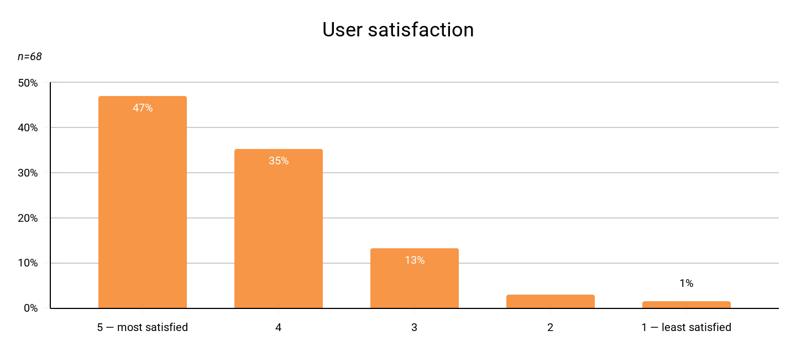

The fact that users would still recommend the service further strengthens the finding that the service is valued and important to the community. However, this does not negate issues and frictions within the service.

Technology and platforms create points of friction for users. This is supported in the survey data. Improving the app or the website is among the most selected improvement, chosen by 48% of service users (32 of 66). Seven of 43 open comments left at the end of the survey name issues with Microsoft Teams directly. 28% of open comments at the end of the survey concern technology issues once three themes are grouped: platform problems, technical reliability and call handling, and an out-of-date service model (12 of 43). The survey also reflects that half of service users do not use the NZ Relay App at all (50%, 34 of 68).

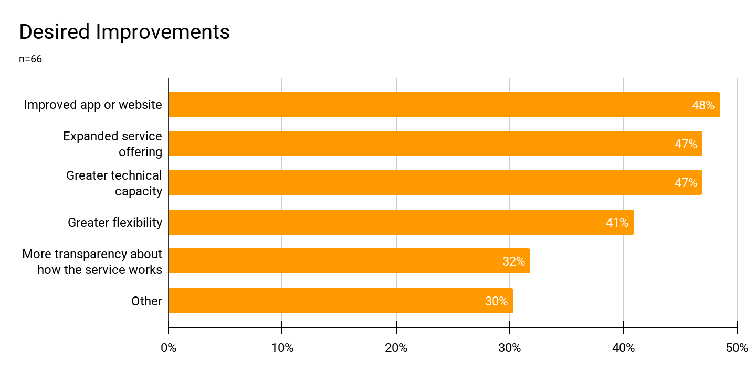

Among everyone who answered, 6 people had stopped using a relay service because they found it too difficult to access, with 5 having moved to other tools instead (of 82 respondents). These figures indicate the presence of friction in service provision and that these issues have, in some cases, directly contributed to people having discontinued their use of the NZ Relay service. Across interviews and focus groups, technological and platform concerns were routinely expressed. Ultimately, while the service is broadly valued, it also frustrates many users.

"There is so much problems using teams as a platform to make calls. It's frustrating and at times have put me off making calls, at least for a few days anyway." — Survey respondent

Future contracts need to look beyond high satisfaction scores, because while satisfaction speaks to broad support for the role the service plays, it risks closing over issues that require dedicated attention. Consultation findings indicate that, below initial satisfaction, technical problems and frustrations with NZ Relay are significant, and that improving the platform the service runs on is imperative to a future-facing service.

People use the service because it serves their communication needs, not because it is convenient
Asked their main reason for choosing the services they use, 41% of service users said those services were the most accessible option for their communication needs (28 of 68), and 37% said they prefer to communicate in NZSL (25 of 68). Only 7% chose on the basis of speed or convenience (5 of 68).

This data highlights why usability is so important. NZ Relay users cannot easily switch between communication channels because NZ Relay is often the only service that meets their specific needs. With few alternatives available, users often accept a compromised level of ease and convenience to access a service that fits their communication requirements.

Within the context of having few viable alternatives, people may accept some level of frustration. Still, poor usability becomes a major barrier that risks totally preventing communication, because communication cannot simply ‘happen elsewhere’.
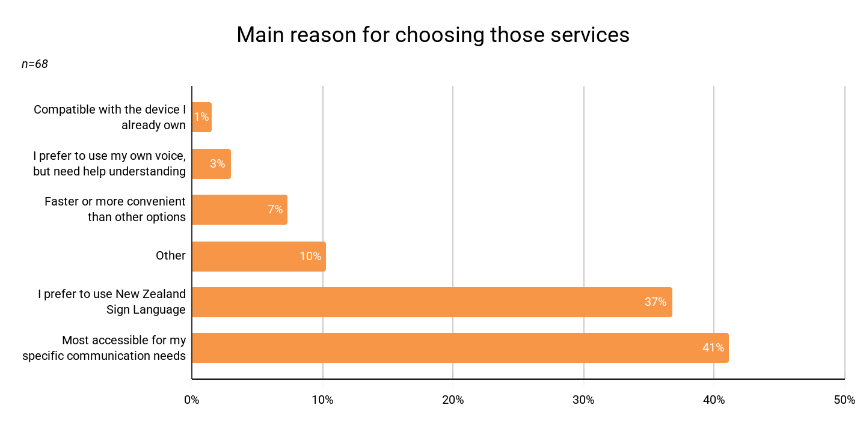
Participants also explained why people choose the Video Interpreting Service over text-based services. They shared that text carries the words, but not the context. Deaf participants who preferred to communicate in NZSL expressed that an interpreter carries tone and provides access to the full picture of conversation. An interpreter, for example, can convey whether the person on the other end is warm, impatient, or annoyed, and that information is key to understanding. To these participants, text-based services and video interpreting are not interchangeable. They play distinct roles. This must be understood, as for many, video interpreting provides greater access to the holistic elements of communication.

Promotion and awareness are critical and currently missing
Across interviews and focus groups, outreach and the need for lived experience-led community connection were described as one of the most critical needs. Outreach, promotion, awareness, and community connection are core to building trust, supporting cultural competency, bridging information, and testing new technologies.

Clear directions for improvement in terms of raising awareness of the NZ Relay emerged from participants’ responses. 75% of survey participants, for example, desired increased advertising for the service on social media (62 of 83 respondents). 75% of participants, likewise, desired that information on NZ Relay be delivered through hospitals and GP clinics (62 of 83). 73% of the group, moreover, desired greater in-person education and relational outreach in the Deaf community (61 of 83). And 69% of participants desired flyers and notices in local community hubs (57 of 83). A desire that the service work more closely with speech therapists and clinicians was, lastly, selected by 41% (34 of 83). Participants most wanted to be reached where they were already, rather than through any specialist pathway.

Survey respondents, when asked about desired outreach, selected 3.53 channels on average, the highest average of any question in the survey. This communicates that no single channel is sufficient. Instead, outreach and connection have to be multichannel, and across all forms—online and offline, with in-person connection critical to trust building for some communities.

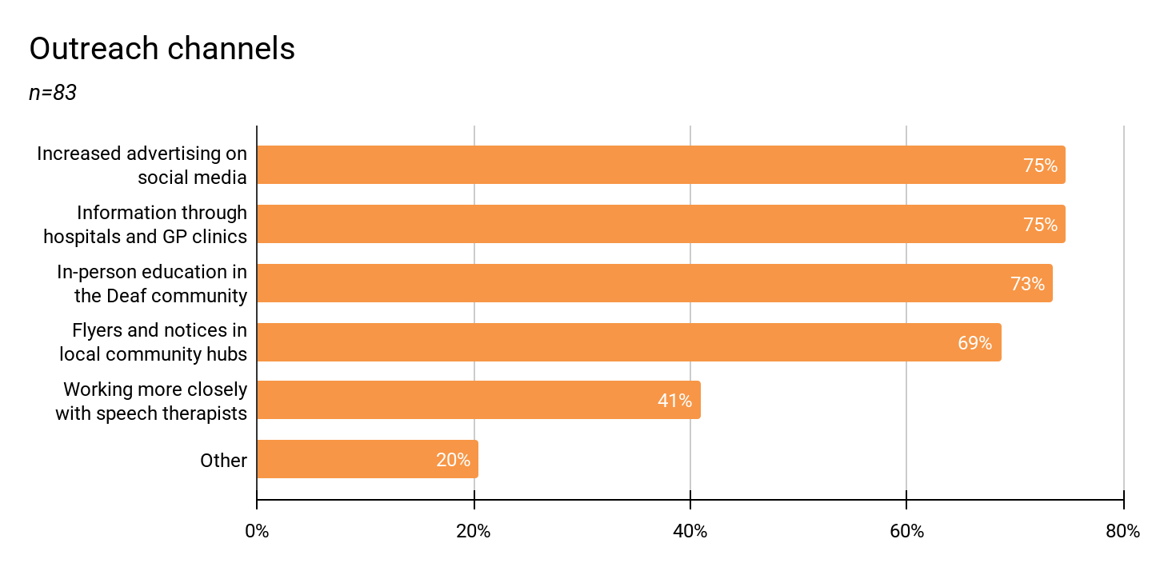

The absence of awareness flows into submissions; one submitting organisation told us it ‘rarely hears’ about the service at all. Another noted that approximately 95% of Deaf children are born to hearing parents, so information about the NZ Relay does not travel through family by default. A third with subject matter knowledge pointed to the digital divide, and the value of NGO channels. The absence of promotion, the significant impact of this, and the need for checks and balances to make sure promotion actually happens, were consistently raised in submissions. Further strengthening this were people's first-hand accounts; for example, one participant told us she found the service herself from a hospital bed.

It’s important to consider the role of awareness for NZ Relay within the context of the wider community. Two participants working in Deaf education described students in mainstream settings who have no exposure to the Deaf community, no Deaf adults in their lives and, therefore, no knowledge that the service exists. This leaves them, therefore, relying on others. The absence of awareness and promotion of the NZ Relay therefore has a tangible impact on individual independence and participation.

"We want to encourage independence for them to be able to advocate for themselves." — Focus group participant.

The community wanted to see outreach teams led by Deaf and disabled people, with such people being actively and consistently in the community for the purposes of raising awareness in multiple ways. This should be considered key to service delivery, not on the periphery of it.

Calls need to result in communication
In order for the system to actually work, it needs to support a successful call. Across the engagement, participants expressed that they’d be hung up on by hearing or non-disabled people who didn’t understand what the NZ Relay is, or does.

"Very disappointed that some businesses choose to hang up part-way through the call, despite the RA explaining that they are calling on behalf of a deaf person." — Survey respondent

"Some businesses need education on phone etiquette, as some hang up on me." — Survey respondent.

Participants said that, at times, they are hung up on and said that a call is, at times, likewise refused or considered a scam.

"One place… not accepting NZ Relay calls at all, shockingly. Even with an explanation of the system, they still refuse." — NZSL submitter.

Building on this, one participant in a wānanga said that the NZ Relay doesn’t always make it clear what is happening, or whether the call is being disconnected or not accepted by the receiver. More transparency was desired. An NZSL submitter reported banks treating Video Interpreting Service (VIS) calls as scam calls, and a peak body requested in their submission that guidance be given to agencies, banks, medical providers, and utilities so that users are not told to 'call back another way.’ Some participants had developed workarounds for this—as, for example, by emailing in advance of the relay call. Such efforts, however, add additional time for the caller, and place more on the shoulders of Deaf or disabled people. Education is needed so relay calls are connected.

We heard, also, that what contributes to this issue is how relay calls are introduced. Often the first voice on the line is not the user's own, and this contributes to the perception that a call isn’t genuine. A participant told us that opting out of this is in fact possible, but this wasn’t widely known. People said plainly that they want the first voice on the line to be theirs, and this may resolve the issue where a call is considered fake. Ultimately, this links to promotion; much more investment is needed so that agencies, core services, businesses, and communities understand the relay experience and know what to expect. Further, the service has to actively promote the ability to adapt its functions, so people can shape their own call, and be the first voice if they wish to be.

A part of delivering a successful, maximised, and effective service is educating the public, and this expectation shouldn’t fall on individual Deaf or disabled people alone; it should be part of the contract’s expectations and supported by those that are responsible for, fund, and monitor the relay service. Those subject to the New Zealand telecommunications levy and MBIE have a responsibility within promotion too.

Text relay lost real-time typing, and gained a double lag
Participants shared that under the previous provider, web-based text relay ran in real time. Both parties saw text appear letter by letter, so the operator could begin voicing while the user was still composing. This was a better experience, as it didn’t create additional lags and did enable some flow. However, the current system batches whole messages behind a send button, so every exchange carries two waits—the user composing, and then the operator voicing. Participants expressed that this is a frustrating experience and results in abandoned calls. Multiple participants described a long pause, an ellipsis that may or may not indicate the other person is still there, then lots of typing: "Are you still there? Are you still there?"—then the call ends.

"In the past, when it was under the old provider, the text relay was in real time, like real-time typing, so you could actually see the operator when they were typing. Whereas now I have to wait for the operator to hit send, and then it comes through to me, and then I have to read that, and then I have to type my response, and then hit send. So there's a time lag for the hearing person, and for the deaf person there's a time lag." — Interview participant.

The same loss runs through the captioned service. Participants shared that, under previous interactions of captioned relay, a person with hearing loss picked up the phone and read the text while the other person was still speaking. Now nothing appears until the operator presses send. This increased the wait times experienced. Participants sought a return to real-time typing, so extended ‘lag times’ could be resolved.

One participant described to us that she asked the provider why there was a switch away from real-time typing for web-based text relay, and the response she received was that it was a government decision. The participant said the usual response to service shortcomings was ‘it's not within the contract’. This reinforces the importance of agency oversight for quality, and including checks and balances in the contract for community feedback to shape services, so they can remain at a quality that facilitates, rather than stalls, communication.

Lastly, another improvement requested was from participants with speech impairments who type using assistive technology. They told us that predictive text within web-based text relay would make the service substantially faster for them. Restoring real-time text should be specified in the next contract as a technical requirement, not only an aspiration, and introducing predictive text should at least be meaningfully explored.

The queue is invisible
The community’s request for a better queue system is simple: they want to know where they stand and when they will be connected, and they want a fair and reasonable wait time instead of having to ‘double queue’.

Participants consistently requested improved queuing, with participants naming visual queue indicators across services as a core technical requirement.

Participants desired proper queuing not only to display current wait times but also to help explain and implement any prioritisation. This would enable urgent calls, such as those to mental health helplines, to take precedence. We heard that a more visible, active queuing system will help users understand and manage wait times. In engagements, we understood that models for this already exist and are already being provided by others offering similar services in New Zealand. Some participants described calls failing or being abandoned because users cannot tell if an interpreter is available. In some cases, this led them to abandon video services and users defaulting to less accessible alternatives.

Participants also identified the frustration of having to ‘double queue’. This describes the fact that after waiting for a Relay Assistant or Interpreter, the user often has to wait again in the call centre queue of the organisation they want to communicate with. One participant described waiting two hours in a second queue with an Interpreter held on the line, after she’d already waited for the Interpreter when she called NZ Relay. She said this was wasting a limited, publicly funded resource and proving to be an additional burden on her time.

To resolve this, participants proposed a ‘fast-pass’ or a system where calls arriving through NZ Relay can move to the front of the receiving organisation's queue, using priority routing. This would enable improved distribution of NZ Relay resources and reduce the personal burden of having to ‘double queue’.

Providing queue visibility and reducing the need to ‘double queue’ would help make wait periods feel more actively managed. This improves user experience and also ultimately contributes to cost-effectiveness—supporting fewer abandoned calls and faster connection between the service user and the person they wish to dial, which enables improved resource allocation.

Users want to know who is interpreting for them

"Lots of low-quality interpreters work on this service. It would also be good to have names of interpreters instead of just VIS01, etc. I want to know their first names." — Survey respondent.

Participants have suggested a suite of changes to the Relay system for non-scheduled calls. These are centred on: building trust, quality assurance, and improving individual confidence. Changes include replacing the current anonymous identifiers for Interpreters (like "VIS01") with Interpreters' first names, and making forward-rostering visible so users know who to expect, and when. Wānanga participants said that because recognition is easier than recall, a visual register would be better than names alone. Furthermore, participants sought a clear, published conduct standard and a transparent route for raising concerns about accuracy or professionalism.

These changes sit within a complex operational context. While the desire for Interpreter visibility was understood, some participants expressed that this changed service delivery, because NZ Relay operates fundamentally—and is designed—as a call centre. This means demand is met by whoever is currently available. Some participants said they felt confusion was introduced when NZ Relay began to support pre-booked calls (where a specific interpreter could be used) and expressed that the nature of NZ Relay as a ‘call centre’ needs to be considered, further refined, and properly expressed to service users.

In the context of Deaf culture, the importance of preferred interpreters where they provide trust and confidence of articulation cannot be understated. However, we also heard that allowing specific preference for calls could concentrate demand on a few skilled individuals while others sit idle, potentially depleting an already small workforce—and we heard that sometimes rotating Interpreters is a safeguarding measure. Adding to this, some participants told us that specific-interpreter requests cannot always be met at the current workforce size.

However, the potential benefit of this additional visibility (i.e. names instead of numbers) is that it enables insight into those Interpreters who are preferred and those who are not—creating space for greater professional development—which, we heard, is important for a workforce that is largely made up of freelancers. Further, participants broadly recognised the importance of a more consistent feedback mechanism, but were clear that this must be developmental rather than punitive.

Ultimately, this is a delicate and complex area, and a middle ground is needed. Considering that the Deaf and NZSL interpreting community is tight-knit already, a layer of increased visibility objectively wouldn’t increase vulnerability for the workforce. It should be meaningfully considered in order to build trust and provide more insight into staff skill level. Beyond this, service design needs to be more actively considered and refined, to determine what the role of preferred Interpreters is. How preferred Interpreters fit within, and are delivered by, the NZ Relay service model would also need to be clearly communicated.

While these are complex considerations, they shouldn’t be issues left unresolved in the short-term as they are core to service and workforce clarity and quality. In considering these issues, the community encouraged reflection on overseas practice. The need to look to international examples to improve practice should be an ongoing process.

Ethical standards are applied inconsistently, and there is no clear route to raise concerns
Some participants raised ethical concerns about interpreting in the service; they spoke about variability in professionalism and impartiality, about Interpreters whose personal reactions to a call were visible on-screen, and about the inconsistency with which Interpreters' ethical expectations are understood and applied. There is a responsibility, on both the chosen provider and the agency responsible for delivery, to ensure ethics are understood by all parties in conversations, that these standards are consistently applied, and that Interpreters are supported to know what quality means. Ensuring all of these things is imperative to the delivery of quality services.

A clearer complaints and feedback pathway is needed and should be prioritised. Participants expressed feeling like they do not have an independent, clear feedback pathway within the service. Participants expressed that at times they feel the ethical obligations of Interpreters are not met, and they do not know who to raise this with. It is crucial to address this by providing a clear feedback and complaints pathway, in a community-friendly format, while making sure such feedback supports skill development rather than being punitive.

Ultimately, a refined service delivery scope, greater visibility, and an improved complaints pathway help reduce call-drop patterns where users end calls to avoid non-preferred Interpreters. These changes also make the service feel more empathetic and personalised.

Where there has been discussion of variable quality and ethical concerns among Interpreters, there have also been some participants who expressed that this gap is something that requires mutual engagement to resolve. Meaning, in other words, that this requires work on behalf of the disabled or Deaf person and the staff member. For example, a Deaf participant felt there was an education gap on both sides, because Deaf education has been systemically lacking, and the pathways into Sign Language may be different for some Deaf people than it is for Interpreters who learn theory consistently. Conversely, Interpreters are not always told how variable NZSL fluency is across a community whose access to its own language was historically restricted. These are systemic realities that need to be understood and factored into the design of the NZ Relay’s feedback pathways.

The chosen provider needs to work with the community and service users to communicate ethical and complaints standards, and support their implementation. There needs to be better monitoring of this implementation as well. This requires mutual collaboration between the workforce and the people it serves, as well as the right settings to appreciate culture and history’s impact on contemporary services.

It is notable that, in our discussions with peak bodies and government agencies who are supporting NZSL and its interpretation, we heard about active work to support Interpreters' professional development and registration, and to develop independent complaints pathways. As the agency responsible for NZ Relay, it is important that MBIE engage in and support these efforts—and that the chosen service provider for NZ Relay actively invests in supporting consistent measures for workforce improvement.

We heard that an independent registration body for interpreters is in development, distinct from the existing membership organisation, and it is intended to hold both a complaints process and a professional development system. Interpreter standards are also being developed, which should inform and guide the future service provider.

The community wants 24/7 access
User demand for expanding the Video Interpreting Service (VIS) is significant. VIS is the most used part of the offering: 66% of service users had used it in the last 12 months (45 of 68).

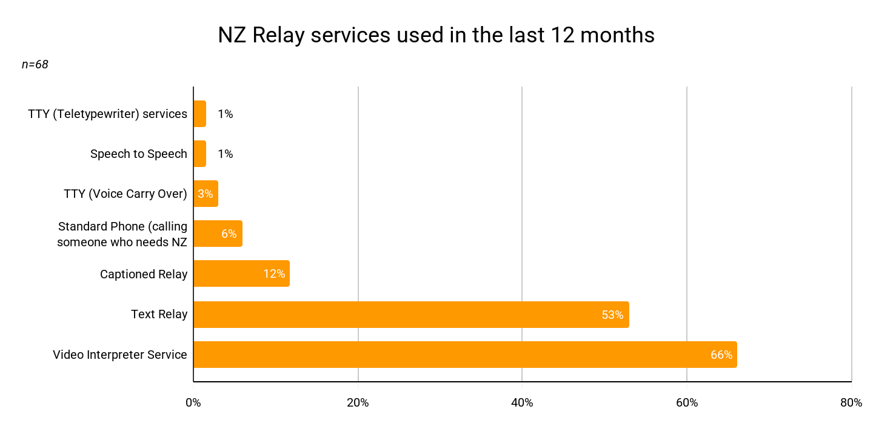

Participants framed the need for 24/7 access as a matter of equity, not only convenience. Participants felt the current lack of overnight coverage creates critical gaps, particularly during significant events like mental health crises where Deaf people have little to no access to helplines. Community members emphasised that expanded hours would enable real-time participation and independence, ensuring the service is available whenever a communication need arises, including in times of need.

While the user community views 24/7 access as a necessity, some operational realities were expressed that need to be considered. For example, implementing overnight shifts would require drawing someone away from the already limited pool of Interpreters. Some participants wanted to ensure there was demand for 24/7 provision before resourcing decisions were made. Submitters also stressed that there has to be an uplift in the service’s technical standards, not just an hours extension. This includes the provision of HD video, to mitigate concentration fatigue and burnout, and more active skill matching of the interpreter to the call subject.

Overall, 24/7 VIS services are called for by the community; some raise solutions like using New Zealanders who communicate in NZSL and are living overseas or in other regions to staff the night shift during their day.

More discovery is needed to determine with service users what this looks like; it is something that has been consistently asked for and should not be put off any longer. Participants suggested a pilot, which is especially relevant considering 24/7 provision is being piloted in Australia. While 24/7 services may take longer to implement, in the short term a technical quality uplift for VIS is critically needed. The future contract should mandate and monitor a clear standard of functional quality like HD video, and standards for set up (like a clear background).

Deaf Interpreters are needed
Sitting differently, but alongside this, is the need for the service to engage, support, and hire more Deaf interpreters, who are a critical bridge that brings both the language and the cultural knowledge into interactions. We heard, for example, of Deaf interpreters being used in situations where the caller was a migrant learning NZSL, and so a Deaf interpreter was needed to help the NZ Relay Interpreter understand the caller and what they needed. From this example, the role of Deaf interpreters and the ability for them to support service delivery is clear.

Privacy is the largest barrier to registration, and the platform is partly responsible
Personal privacy concerns represent the single largest barrier to registration, identified by 50% of respondents (42 of 84). This apprehension is rooted in practical privacy risks encountered within the current service model. For instance, an NZSL submitter described the vulnerability of having to disclose sensitive information, such as driver’s licence and bank account numbers, through a video call because there is no secure way to enter a PIN on an in-app dial pad.

These risks are compounded by platform limitations in Microsoft Teams, where users have reported an inability to have confidence and surety that conversation histories are deleted after a call, leading to fears that subsequent Interpreters or others using the same device could access private transcripts. Overall, this leaves people with feelings of vulnerability, and further entrenches valid feelings of mistrust.

Submitters also noted that personal information is compromised because users are forced to route calls through others rather than choosing to include them. While to some extent this is intrinsically linked to the reality of communication assistance, the current service platforms and design fail to offer users meaningful control over their information, and transparency around how it is treated in the space it is shared within.

Participants also described a related arrangement that sits outside the service altogether. Where the NZ Relay service is unavailable, unreliable, or not accepted by the person being called, people fall back on someone they trust to speak for them: a partner, an adult child, a colleague, or a support worker.
One participant told us she has a designated person for this. Submissions describe the same pattern—a son who makes and takes calls for his father, colleagues who make calls for a deaf accountant, a husband who speaks for his wife and passes on messages. It is a workaround people have built deliberately, and it functions, but it carries costs of its own. The designated person is not always accepted by the organisation on the other end of the line, so their authority to speak has to be argued for. And the arrangement removes any privacy from the conversation permanently, rather than for the duration of one call.
This should inform how the service thinks about privacy, because it changes the comparison being made. The alternative to a relay call that feels insufficiently private is frequently not a private call at all. It is a conversation about health, money, or a relationship conducted through a family member. Improving privacy within the service is therefore not only a matter of platform settings; it is what determines whether a person can hold a private conversation by telephone at all.
To build trust, users require the technical agency to manage the information they share. The service needs to better centre around user-managed 'control' of private information and more clearly articulate how private information is managed and protected. It is noted that this is done against a backdrop where communication assistance requires a third-party, but work can be done to improve the balance between this reality and the right to privacy.

Findings: Who the service does not reach

The service is organised around categories that people do not fall neatly into
The service is organised around distinct user categories. The people who fall between them, participants told us, are not edge cases. The NZ Relay could maximise its audience by better meeting the needs of a broader community.

No demographic information is held about service users, so the size of the communities the service could serve is contested rather than known.
In submissions, peak bodies set out the problem and their suggested fix. Expressing that users have "genuine communication needs, even though they may not fit neatly within the existing categories [of service]". One peak body described situations like: stroke survivors who have hearing loss, changed speech and affected dexterity at once. A submitter expressed that these intersections are not presently accounted for in the service. "The current service compartmentalises people into one of four groups with no apparent recognition of combinations of disabilities."

Other submitters referenced temporary need, such as someone in recovery whose daily communication is affected for a period, and others made the wider point that disabled people not traditionally associated with the service can benefit from it too, such as those with learning disabilities.

A national learning-disability advocacy leader put the question to her team if any of those they support used NZ Relay, and no one did. While the service won’t be fit for purpose for all those with learning disabilities, we heard that for some who live largely independently but need assistance for particular conversations, like in the case of speaking with government agencies, a doctor or a bank, the service would be valuable to prevent them from being dismissed because a request was not phrased in the expected words.

In this sense, the service would help rephrase questions so the person with a learning disability understands what is being asked. In the words of the advocacy leader, without that, people are fobbed off, they do not ask a follow-up question, they go round in circles, and they give up. The NZ Relay service can very much support people with learning disabilities to participate in conversations, but this isn’t something it is considered to be doing at present.

Overall, the definition of who the NZ Relay is for should not be designed based only on diagnostic categories because impairments combine, change, arrive suddenly, and impairment-based boxes result in the service missing an opportunity to help people it could. An eligibility principle that defines the serviced communication needs would be better, we heard.

Building services for a full spectrum
Participants who experience hearing loss and think and speak in English—and do not use NZSL—felt that the current NZ Relay options underserve them, and the feeling was broadly expressed that this community doesn’t ‘fit’ the current service model. Some submissions felt that this group was the ‘largest’ and ‘worst served’.

For example, some participants expressed that if Voice Carry Over is ever removed, they would stop using the phone altogether. One survey respondent describes VCO as "by far the most accessible service" for their needs. A letter from a participant makes this same argument. Voice Carry Over and Hearing Carry Over are critical services for this cohort.

This is also the group most affected by a change that has already been made. The withdrawal of the CapTel captioned telephone at the change of provider recurs across submissions as the moment at which some people stopped using the service altogether. One submission sets out case studies of people with hearing loss. One concerned a man in his eighties who had used CapTel to stay in contact with family and to support his wife’s care; unable to adapt to the small screen of a smartphone and lacking the dexterity to use it, he gave up on the service and, after his wife died, lived in increasing isolation. Another was a man who had used a CapTel phone for reception duties at work; those duties pared back when CapTel was withdrawn.
Submitters identify screen size, fine motor control, and set-up complexity as barriers now that CapTel isn’t present. Several describe needing paid help to configure a device that still did not work well for them. A survey of former CapTel users supplied to the consultation recorded “too complicated” as the most common reason given for not moving to the replacement.
Submitters representing older New Zealanders argued that the NZ Relay should be understood as essential communications infrastructure rather than as a disability support service. They said that hearing loss becomes more common with age, and that improving access to communication should be treated as an investment in healthy ageing, given the recognised association between hearing loss and cognitive decline. The same submission made the intersectional point directly: stroke prevalence rises with age, and stroke survivors frequently experience hearing loss, changed speech, and affected dexterity at the same time.
Ultimately, the service design of NZ Relay can capture a broader base of disabilities and respond better to lived realities where disabilities are combined. It can also better support temporary needs, while serving the full spectrum of needs within a given lived experience. Organising service design around communication needs, rather than a specific diagnosis, may go some way to achieve this.

However, while breadth is important, this has to be achieved without diminishing the central audiences served by NZ Relay or diminishing Deaf culture and the critical role of the service for those who use NZSL. As a submission said, NZSL users’ needs are "materially different from other users of the service, and … risk being lost within a consultation process that treats all 'communications-disabled' users as a single, homogenous group."

Other submissions agree, with this said, that all these needs can be met, in balance. Such balance can be achieved, but community collaboration and communication are needed for this, alongside technical rigour for service design and delivery. Moreover, it is important to recognise that some of these points sit within a broader cultural context of the Deaf and disabled community, and as such, work to better serve a full spectrum of potential users is not a unique request for the NZ Relay.

Deafblind users are at times not served by the current design
For Deafblind users, specific design and service elements need strengthening. For example, submitters said the system must not time out, disconnect, or treat pauses as inactivity. This is because Deafblind users require additional time to read, interpret, and respond. Submitters said Relay Assistants need specialised training in Deafblind communication, including tactile signing. Furthermore, braille access must be a core feature, not an optional addition, as it is the only independent route to remote communication for many. Submitters, for example, referenced the need for Real Time Text delivered to a braille pad at user-controlled speeds. It is notable that some Deafblind participants spoken to, who relied on tactile sign language, attempted, but could not successfully, use the NZ Relay—demonstrating that more work is needed to serve this group.

We also heard that Deafblind people who rely on tactile sign Interpreters often face significant barriers to finding Interpreters, and having their language recognised. This impedes access to daily communication. We heard there needs to be more recognition of tactile sign language and how Deafblind people communicate. For example, participants noted that ‘stacked’ messages can push previous text out of view, forcing a scroll backwards and creating further communication barriers. Making sure services flow and are designed in a way that facilitates the communication of Deafblind people is a crucial consideration for service design in the future, especially because Deafblind people are especially vulnerable to marginalisation.

Submitters set out that an accessible text interface should work with commonly used screen readers and refreshable braille displays, that controls and buttons should be properly labelled, that a person should be able to navigate by keyboard alone without sighted assistance, and that the service should not depend on visual icons, audio alerts, or messages that disappear from view. For low vision users, submitters asked for control over font, text size, foreground and background colour, and for adjustable braille reading speed.
A submitter made the wider point that accessibility “cannot be assessed only by whether an application technically opens. It must be practical, understandable, responsive and usable in real-life situations.”
Finally, a nuanced understanding of the impact of when dual sensory loss is acquired is needed. Participants distinguished between those who lose their sight in adulthood, often bringing established physical confidence and experience, and those who lose it in adolescence. Submitters also pointed to variability in literacy, based on when dual-sense loss occurs. This supports the belief that serving this cohort, and indeed most others in scope for the service, requires the flexibility to provide a tailored—rather than relying on a fixed one-size-fits-all—approach.

Cost barriers can be prohibitive
While the actual NZ Relay service is free, the infrastructure needed for it is not, and we heard that this is at times prohibitive. Some submitters pointed to the need for equipment subsidies, which could fully cover equipment costs for those in hardship who needed to use the NZ Relay. For those audiences who may be more vulnerable, submitters also pointed to a need for funded in-home installation, configuration, training, and follow-up. It was, for example, pointed out that “a service cannot be regarded as fully accessible if the equipment needed to use it is unaffordable."

A submitter with subject matter knowledge noted that a 50%-subsidised CapTel phone at $323 remains out-of-reach for many. Some proposed iPads (bought with the benefit of Government discounts) that could be pre-loaded and dispatched, upon registration, with peripherals on-demand. Locked-down devices with predetermined numbers for people with learning disabilities were also suggested. While these suggestions should not be considered mandates, or solutions without community involvement and engagement, they should prompt consideration of how tech set-up is supported so service engagement is maximised. Other submitting peak bodies also raised affordability as a barrier.

Participants described dropouts on older handsets and unreliable performance on budget mobile networks, among other issues. This points to the suggestion that someone assessing the service on a current phone and with good broadband is having a different experience and easier access than some others. These difficulties don’t just impact a single demographic.

It’s notable that digital connectivity and broadband access are a broader issue than is within MBIE’s remit, and moves beyond the NZ Relay. However, access to the services relies on connectivity; MBIE does have some responsibility to champion these issues within the telecommunications sector and alongside agency partners who also have a role in supporting Deaf and disabled community access.

VIS requires increased data
In this same vein, wānanga participants raised that VIS consumes more mobile data than a hearing person's voice call. Participants outside of home or work wi-fi described rationing video calls, freezing mid-call, and reverting to typing because it uses less data. This latter movement to another service, it was noted, isn’t something they would choose, and it was done only to use less data. One participant framed it that being able to afford a data plan is not universal. Some had practical solutions, such as the idea that telecommunications companies might allow willing Deaf people to use their ‘call’ minutes as data instead, given that they are not making voice calls. Participants also suggested zero-rated access to NZ Relay traffic, on the model of government websites, which are already exempt from data charges.

While some aspects related to data and technology are broader than the NZ Relay, and are not MBIE’s remit alone, it is worthwhile to consider MBIE’s role in championing these issues with telecommunications providers. Investment in connection and technology set-up can also help people avoid isolation, which participants felt was important.

Findings: What tāngata turi Māori told us
These findings need to be understood in context: tāngata turi Māori experienced a dual suppression—of both their identity as Māori and of access to Deaf culture and sign language. It is also important to recognise that these two identities can feel friction with each other, which entrenches feelings of suppression. One participant described having been made to choose between being Deaf and being Māori, rather than being tāngata turi Māori, and described the loss of te reo Māori that flowed from having to make that ‘choice’. Cultural competency is a critical need for the whole expression of identity; it is not a courtesy.

Māori interpreters are a critical bridge
A Māori Interpreter, participants told us, removes a barrier. Māori-specific concepts requiring translation can be unpacked inside the interpreting rather than lost within it, and there is a pre-existing safety in the interaction, rather than trust being built from scratch. One participant, who described always doing that cultural bridging work herself when the interpreter is Pākehā, pointed out that a Māori Interpreter creates one less barrier and enables an easier interaction, with less expectation on the Deaf participant to be the bridge.

Participants described Māori Interpreters as in constant demand, which is why increased in-workforce representation is only part of the solution. Cultural training across the whole workforce was called for, as was the call for more Māori staff within functions across the service.

While the underrepresentation of Māori interpreters is broader than MBIE and NZ Relay’s remit, both do have a role in championing their importance. More specifically, robust cultural training is an important inclusion for the future contract. Workforce representation and support for Māori Interpreters should also be a consideration. While this is a long-term consideration, requiring cross-agency support, work to achieve these outcomes should be considered a priority, which MBIE and the chosen provider need to be part of.

Impact of having no agreed te reo Māori sign vocabulary
We heard there is currently no agreed te reo Māori sign vocabulary in Aotearoa, and interpreters working across all three languages are scarce. This has a tangible impact on access to language. One participant described a Pākehā Interpreter simply stopping at karakia and not interpreting it.

A wānanga participant proposed that a safeguard was needed to protect against this variability and said interpreting into te reo Māori should be certified. This helps support improved calls. Of course, this is a broader cultural need than is within MBIE’s remit. However, it is an important recognition. A contract that specifies cultural competency needs to acknowledge the absence of vocabulary alignment, which impacts services. The service needs to do its part working with the community to understand and consider this issue. This requires the appropriate engagement of tāngata turi Māori working through the appropriate cultural processes for this.

Participants' sense of safety varies, and this should inform outreach
In a wānanga, cultural protocols, understandings, and values are shared and do not need explaining. Outside of this, that changes. One participant described feeling safe in wānanga in a way she does not always feel in general Deaf spaces. This insight should inform the future contract’s outreach strategy.

Participants said Māori Deaf wānanga needed to be held separately from general Deaf community engagement, rather than folded into it, and one asked specifically for women-only wānanga, where whakaaro could be shared away from mixed-gender dynamics.

Participants also told us what makes engagement work in practice. Kai brings people together. Face-to-face visits are important. And one participant proposed whānau outreach teams that come to a household, and teach the hearing family how to ring their Deaf relatives using the service. This was described as opening the door to communication.

Ultimately, this insight needs to inform the future contract’s engagement and outreach requirements. Outreach has to be lived experience-led, with Māori leadership and intentional strategies to ensure all in Aotearoa are reached.

In wānanga, participants described that building institutional trust with tāngata turi Māori was the single most critical factor; engagement and outreach are the foundation for this, but will take considerably longer than a single contract cycle. Engagement and outreach have to be considered a relationship, not sets of events. MBIE has a role in this, helping achieve consistency, noting contract providers may change.

Identification documents create rather than solve problems for this audience
While registration is discussed in full later in this report, tāngata turi Māori were distinctly clear about registration in wānanga. They said mandatory display of identification documents to access the service would be rejected by many they know. One participant shared that her own brother, and others she knows, would reject the service rather than hand over official identification. A submitter said registration information, instructions, and support must be culturally appropriate for Māori Deaf users, with alternative identity verification pathways for people who do not hold standard documents.

In wānanga, participants said that access to documentation and the cost of obtaining photo identification would prove barriers for some tāngata turi Māori. A registration model built on a driver’s licence or a passport would be exclusionary for many in this audience. Wānanga participants proposed alternatives: verification through Deaf community membership, a code to a registered phone, and human verification of a signed video. Ultimately, this points to an openness for the concept of registration, but the form is up for debate and has to be culturally appropriate. That finding flows through to the broader discussion about registration too.

Recognition of the rural reality
The Teletypewriter (TTY) is discussed later in this report. In wānanga, participants told us clearly that it must be maintained precisely because it works over a landline without data, and this remains usable for rural Māori Deaf facing connectivity barriers and marginalised by the cost of internet access. One participant described whānau in the far north who simply cannot connect, and who are therefore not future users of anything other than TTY. This should be considered a key consideration.

AI has no role in carrying language or cultural protocol
The potential role of artificial intelligence (AI) was specifically discussed in wānanga.
Participants were clear that AI has no role in language, saying that a signing avatar cannot hold a karakia, and that AI is not culturally sound, nor is it a substitute for NZSL interpretation.

Who appears in the service’s communications has impact
Awareness and outreach are generally missing for all audiences. However, wānanga participants described the service's social media presence as intermittent, and described seeing the same few people in the service's videos for years. What they asked for was more visible tāngata turi Māori presenters, more variety of faces, and content to promote the service that’s designed to be watched, not endured; short, visual, and entertaining enough to stop one from scrolling past. Participants said they sometimes scroll past most things and cannot tell which posts carry information they actually need.

This reflects that who appears in a service's communications is a signal about whose service it is, and at present the signal tāngata turi Māori are receiving is that it is not especially theirs.

Findings: What the service must not lose

Nothing should be retired until more engagement is done
Across engagement forms, from interviews and focus groups to wānanga, the majority of those who gave a view were comfortable with the retirement of Teletypewriter (TTY) services. Most felt this way because they do not use the technology and regard it as outdated. Survey data shows that 63% of those who commented (25 of 40) were comfortable with retiring TTY, against 10% (4 of 40) who were opposed. Comfort among people who do not use TTY is not, however, a mandate to proceed.

Some stated that retirement of the service is only acceptable if transition support and functional alternatives are established first. Respondents noted that while they are personally unaffected, they remain concerned for those who still rely on TTY. Across every engagement form, participants acknowledged it could be phased out, but also emphasised the need to hear from current users and to support them before any change should proceed. One wānanga concluded that further investigation is essential to ensure older Deaf people, in particular, who may depend on TTY but did not participate in the consultation, are not isolated.

"If TTY services are phased out, I would like to see reliable, accessible replacement services in place before they are removed."

"Tough for our old people. ... They're already pretty isolated, so it depends if you can find them and help them all."

It is notable that while a smaller voice, those who engaged and who do use TTY were unequivocal that this would have an impact. One survey respondent stated they "would likely stop using NZ Relay altogether" if the service ended. In documentation provided to the consultation, some users argued that no one should be forced to adopt new technology simply to maintain the level of access they already possess.

Connectivity also remains a primary barrier. As noted earlier, TTY is essential in rural and remote areas where data is either poor or unaffordable.

Some community members, however, highlighted that TTY is faced with an impending deadline. New Zealand's landline network is itself scheduled for phase-out. While not in the short term, this broader phase-out does mean that TTY will one day be retired. This makes it all the more important to consider how people will be supported, and that this support will need to be delivered by the service provider, funder, and delivering agency. Participants suggested that digital notices or website updates are insufficient to reach this affected group. Instead, remaining users should be traced through equipment distributors and tailored work should be done to ensure they’re properly informed.

Overall, no service should be retired in this contract cycle. Still, strategies to reach and engage TTY users should be made proactively, in consideration of the impending broader phase-out of landline technology. Participants also suggested a cost-benefit analysis be done. Moreover, the design of any alternatives should be done with the impacted community, and alternatives need to be as inclusive as possible. Submitters were also clear that the "NZ Relay services should never be considered through an economic lens, but through the needs of a person."

Emergency access is not equivalent
Submitters and participants raised concerns around emergency access. We recognise that the NZ Relay service is not used to make emergency calls. However, this wasn’t consistently understood, so we have synthesised the inputs from submitters, with a view that these can support broader service improvement.

Provided feedback underscores that the current emergency provisions are not equivalent to voice-based 111 services. Concerns centre on three themes:

- Submitters feel there is a critical need for emergency calls to be automatically prioritised, presented to all available positions, and returned to the front of the queue if held.
- Submitters demand that these interactions be recorded and retained on the same basis as voice emergency calls, utilising international benchmarks like the UK’s 999 BSL service.
- Positioning emergency access behind a registration process doesn’t reach all potential users. Participants shared that this model fails the individual who acquires a disability suddenly, the overseas visitor, or the person forced to use a stranger’s device in a crisis. Submitters felt that emergency access must remain open, rather than behind any process, to ensure that assistance in an emergency is never limited. Users also reported wait times of up to fifteen minutes for text responses and instances where health-alarm activations went unanswered. The absence of an accessible non-emergency route (on the 105 model) further exacerbates this by forcing urgent-but-not-critical calls down the same path.

The service is one-directional, but conversation is not
Participants said the NZ Relay service currently operates as a largely one-directional tool, effectively functioning—as one user put it, on this account—as "half a relay service."
In effect, this means that while Deaf or disabled service users can easily place outbound calls, the system, we heard, is not set up for a hearing or non-disabled person to easily initiate a call back to a NZ Relay user. This doesn’t mirror natural conversation, and it forces people into a relationship that is transactional, with more reliance on a third party.
Participants shared that, as a result of this, inbound calls (from hearing or non-disabled people to service users) are a very small percentage of calls in the service. Submitters said that, in Norway, where every user is assigned a national number and interpreters are bridged into inbound calls automatically, there is a much more balanced use of the service for both inbound and outbound calls.
Submitters expressed that the human impact of this one-way system is a loss of independence and social agency. Some noted that the withdrawal of previous two-way technologies like CapTel left many users unable to receive urgent information or make spontaneous social contact. Other peak bodies felt that while the NZ Relay service nominally allows hearing people to call in, it is difficult to access in practice. This leaves users feeling like ‘second-class citizens’, denied the same access to conversation and relationships.
Participants described receiving calls through the service from an unknown number, with nothing to indicate who was calling or where from, and therefore not answering. Some later received an email saying someone had tried to reach them, also without saying whom. One participant said that had she known who was calling, she would have done more to respond. Ultimately, more is needed to make the service two-way.
"We are continually being made to feel like second-class citizens; not being enabled to use the phone in the same way that hearing people use the phone." — survey respondent.
Submitters desire the implementation of personal, portable national telephone numbers for every user. Such a system would allow for a two-way, direct-dial service where a qualified Interpreter or Relay Assistant is automatically bridged into the call before the hearing party is rung. This would not only resolve the equity argument but also address the 'receiver-refusal' problem; by carrying a recognised identity, calls would no longer appear as unknown or ‘scam’ numbers. Submitters express this as a fundamental requirement for true telephone equality.
The consideration is ultimately that more needs to be done to enable the service to move beyond outbound calls.

Funding is the precondition for everything else
Submissions asked for workforce investment, improved (HD) video quality, and equipment subsidies. Funded in-home support and outreach that is properly resourced rather than aspirational were also suggested. Some wanted other particular changes. All desired improvements and quality uplifts require investment, and if the service is maximised then investment is needed to meet demand. Therefore, ultimately increased funding is needed for this service if quality uplifts are genuinely desired.

This should be considered in this contract cycle.

Two submissions went further and proposed mechanisms. One supported increasing the Telecommunications Development Levy. Another addressed the tender itself, proposing that the bulk of evaluation weighting sit on user requirements.

Findings: Governance, trust, and the terms of the contract
Some peak body submissions highlighted that they would like terms of the contract openly defined. These included the provider's right to "modify, suspend or restrict" the service, as well as a clarification of what is meant by genuine use. Other submissions said that the total absence of published performance metrics contributes to feelings of mistrust. A provider that has no metrics published cannot be held to a standard, and quality cannot be consistently defined. As a remedy to these identified issues, participants sought:

- Clear, publicly visible definitions for key terms and contract boundaries.
- A published dataset covering wait times, abandoned calls, technical failures, and service resilience.
- A complaint route that is outside of the provider.

Submitters also raised resilience as a contract requirement in its own right, arguing that NZ Relay should deliver the system availability the wider public expects of telecommunications.

The advisory group needs to be re-established, with real influence
The current provider no longer has a community advisory group. The calls for a re-established advisory group are strong. Beyond just existing, participants desire the group to have real influence. Moreover, MBIE needs to be involved in and support this advisory group; they cannot leave it to the provider. The government agency needs to help set the expectation that this advisory group is meaningful. It is noted that the diversity of view in the community of users is considered by some to be prohibitive to governance; this is entirely navigable if the design of the group is thoughtfully considered; this will take time.

Employment and governance
The community reinforced the role of lived experience continually, emphasising that hiring Deaf and disabled staff is a necessary first step. Still, it is not the same as empowering Deaf and disabled governance. Submitters framed Deaf people as the guardians of NZSL, advocating for procurement processes that value this expertise.

The need for Deaf expertise, disabled persons' expertise, and lived experience representation isn’t only about working in the service, we heard; it is also about designing the service. A recurring theme in engagement was that the current service, designed by hearing professionals, lacks the nuanced understanding of the community it serves. This creates gaps, and means the service doesn’t meet people's needs as well as it could if lived experience was woven into service design. Ultimately, ensuring that lived experience is not just valued but enabled to shape the service is key.

Microsoft Teams is a barrier in its own right
Microsoft Teams creates barriers for users. One submitter said that for her, creating an account took approximately 90 minutes and, they felt, the process assumed a level of digital competency that some will not have. Beyond this initial setup, participants reported facing ongoing frustrations with Teams—for example, the inability to maintain separate personal and work accounts.

Based on engagement findings, there is broad consensus that Microsoft Teams is a suboptimal software for the service. Some participants expressed that a tailored software would be better. A couple of participants with closer subject matter knowledge felt that the contract process may not be set up to support the development of tailored solutions, because, they said, the intellectual property of these would need to be ‘surrendered’ under current settings. The participants felt that these expectations may discourage bidders from developing bespoke, accessible solutions and said this might influence a shift toward off-the-shelf products. The feeling was that more needed to be done to provide bidders with commercial safety, so that more tailored and fit-for-purpose solutions could be developed.

AI is rejected for language, but could have a role otherwise
As explored earlier, participants told us that AI or avatar signing is one-way and this is not communication as such. Moreover, participants shared that AI cannot participate in cultural protocols. More broadly, participants felt overall that AI is not culturally sound, and cannot be a replacement for NZSL interpretation.

Some participants did say AI could have some uses, such as enabling an after-hours option for simple urgent matters where the alternative is nothing at all. It was suggested that AI, moreover, might support English grammar, and help build a customer relationship through understanding saved contexts,

As in interviews and focus groups, survey respondents also signalled that AI-based solutions aren’t broadly desired. When asked about future transition support the service could offer those moving off TTY, chatbot or AI assistance was the least-wanted substantive form of support, chosen only by 15% of those answering (10 of 65).

While there isn’t broad comfort with AI, some submissions did signal other potential uses for it, such as supporting automatic speech recognition to remove delays in text-based services. The distinction the engagement insights support is between AI as a substitute for an interpreter, which is rejected, and AI as a transcription tool for people who do not use NZSL, which is wanted in some cases. Any future position on AI has to hold both of these realities at once. Ultimately, AI is nuanced, and it shouldn't be discarded, but it also shouldn't impede culture or the expression of NZSL. There may be some ways AI can support service delivery, but much more work is needed to determine these, and the community needs to be involved.

Registration is cautiously welcomed
The community is open to registration, but needs to trust it. While 57% of survey respondents (46 of 81) identify interpreter safety as a key benefit, 50% (42 of 84) are concerned about privacy and the risk of exclusion due to complex processes.

Users support registration where it enables personalisation, such as a saved profile with contact lists and interpreter preferences, but across engagement forms participants were clear they did not want a document-heavy registration process, nor did they want registration to only be expected of the Deaf or disabled person. It has to be expected of all.

Overall, models asking for limited information rather than identification or document submission are preferred. This is considered fairer; users provide enough information to improve their service experience rather than just satisfying external administrative requirements.

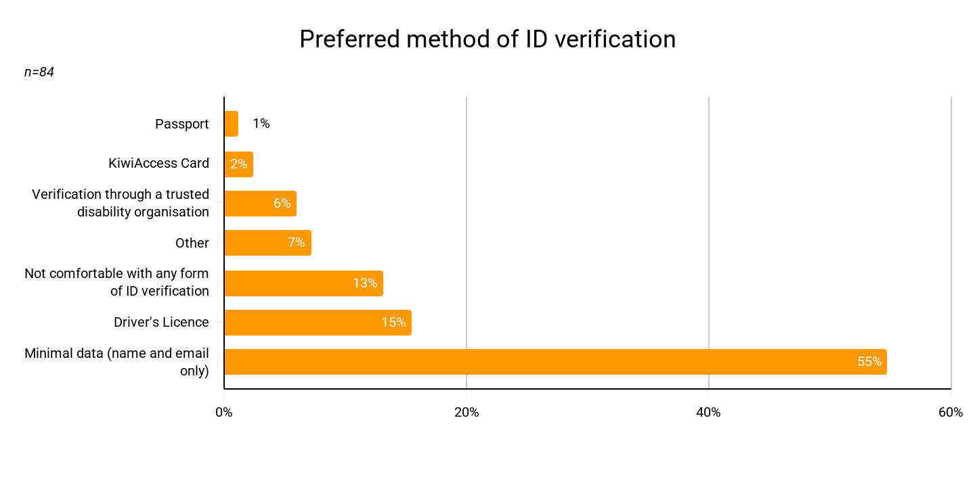

Participants said registration must be one-time, fully accessible in NZSL and plain language, and culturally appropriate for Māori Deaf users. Crucially, an anonymous route for some calls, such as those reporting crime and violence, must be preserved. Ultimately, the registration process needs to be audience-first. Not relying on complex documents needs to be a part of this, and participants on this note suggested that they could submit a video of themselves signing to be verified, for instance. Participants were also clear: the burden of preventing misuse must not fall on legitimate users.

One organisation proposed that government-funded NGOs and community groups should be engaged to support people through registration, on the basis that those most at risk of exclusion are the least likely to complete it unaided.
The same submission felt that responsibility for addressing misuse and harassment doesn’t sit with users. Asking users to solve it through registration alone “unfairly places the burden of solution-focused outcomes on the wrong group.” Therefore, the service provider has a role to play, too, and registration needs to be proportional.
Overall, registration needs to deliver a sense of mutual benefit, and while there’s openness, the exact mechanism for delivery is still open for debate, and perhaps should always be multichannel.

Plainly, any registration also needs to be clear, accessible, and have a publicly published process that provides tangible service benefits. And, moreover, that service users aren’t necessarily against the existence of a registration process.

A path to personalisation
Registration helps make the service more personalised. Currently, the lack of user data in the service means every interaction starts from scratch, without the context of user communication needs, and this also means the provider cannot proactively communicate to its user base. Registration could support personalisation features like saved interpreter preferences, saved contacts, priority routing, and understanding of call context. Participants broadly saw the value in personalisation, which is what registration potentially provides.

We note this needs to be carefully balanced, ensuring that personalisation enhances rather than distracts from the service’s core function as a responsive call centre—if that is indeed the core focus. Ultimately, registration is broadly accepted if it directly yields a better, more personalised service. However, details of the process need to be determined with the community.

The community wants an ongoing dialogue, and the service deserves a champion
Peak bodies and community members emphasised that this consultation should be the start of an ongoing dialogue, not a transactional one-off.

Alongside this, it is clear that the service needs a champion. MBIE, as the responsible agency, must demonstrate a commitment to building trust with the community through community connection, quality monitoring, and the meaningful inclusion of service-user voices. MBIE needs to be more visible to service users and more involved.

Conclusion
The NZ Relay service is vital to its users. However, people choose this service because it meets specific communication needs, not because it is easy to use. The technical frictions that users experience are frustrating, and the overall ease of the service needs to be improved.
The community seeks a service that is visible and accessible. This looks like a queue that can be monitored, hours that can meet real-world needs, the ability to identify and trust interpreters, real-time text capabilities, and the capacity for a two-way service. It is also about delivering a service that is designed to serve a full spectrum of users, without losing sight of cultural elements.
Furthermore, the community envision a registration process built on trust that doesn’t create burdens through documentation, and desires much more visible community outreach.
Underpinning these requested improvements are two critical shifts in approach:
- The current service is structured around rigid user categories. However, impairments combine, change, and emerge suddenly. Future service design should be broader, more inclusive, and flexible.
- A lack of transparency in performance reporting, outreach, and visible Deaf and disabled leadership hampers current community trust and confidence. This has resulted in a service that the community values but doesn’t feel connected to, or understood by. This must be addressed.

Maximising the potential of NZ Relay requires dedicated consideration regarding issues of funding and, at the same time, an agency willing to be visibly in the service’s corner. The community has provided clear, consistent input on what they require.
The upcoming tender is the primary mechanism through which these requirements can be considered. In our view, it is important to provide rationale where the tender diverges from what the community has asked for, so as to build trust and ‘close the loop’.
Moreover, at its core, if the service is designed to be a reactive call centre, then the boundaries of this need to be better communicated to users, so their expectations are properly shaped.

Thank you for the opportunity to support this consultation

Appendix A — Survey results

Main survey results

Table A1 — Use of the service in the last 12 months (Q1; base 85)

Response | n | %
Yes | 68 | 80%
No | 17 | 20%

Table A2 — Would recommend the service (Q2; base 77 all, 68 service users)

Response | n (all) | % (all) | n (service users) | % (service users)
Yes | 68 | 88% | 61 | 90%
No | 9 | 12% | 7 | 10%

Table A3 — Services used (Q4; multiple answer; base 72 all, 68 service users)

Service | n (all) | % (all) | n (service users) | % (service users)
Video Interpreter Service | 46 | 64% | 45 | 66%
Text Relay | 36 | 50% | 36 | 53%
Captioned Relay | 9 | 13% | 8 | 12%
Standard Phone (calling someone who needs NZ Relay) | 6 | 8% | 4 | 6%
Speech to Speech | 2 | 3% | 1 | 1%
TTY (Voice Carry Over) | 2 | 3% | 2 | 3%
TTY (Teletypewriter) services | 1 | 1% | 1 | 1%
Mean options selected | 1.42 |  | 1.43

Table A4 — Main reason for choosing those services (Q5; base 77 all, 68 service users)
Reason | n (all) | % (all) | n (service users) | % (service users)
Most accessible for my specific communication needs | 29 | 38% | 28 | 41%
I prefer to use New Zealand Sign Language | 28 | 36% | 25 | 37%
Faster or more convenient than other options | 6 | 8% | 5 | 7%
I prefer to use my own voice, but need help understanding others | 3 | 4% | 2 | 3%
Compatible with the device I already own | 1 | 1% | 1 | 1%
Other | 10 | 13% | 7 | 10%

Table A5 — Use of the NZ Relay App (Q6; base 84 all, 68 service users)

Response | n (all) | % (all) | n (service users) | % (service users)
No | 48 | 57% | 34 | 50%
Yes | 36 | 43% | 34 | 50%

Table A6 — Whether respondents have stopped using a service (Q7; base 82 all, 68 service users)
Response | n (all) | % (all) | n (service users) | % (service users)
No — still use the same services | 60 | 73% | 56 | 82%
Yes — found the service too difficult to access | 6 | 7% | 4 | 6%
Yes — now use other tools instead | 5 | 6% | 3 | 4%
Other | 11 | 13% | 5 | 7%

Table A7 — Satisfaction with Relay Assistants and interpreters (Q8; base 80 all, 68 service users)

Rating | n (all) | % (all) | n (service users) | % (service users)
5 | 35 | 44% | 32 | 47%
4 | 30 | 38% | 24 | 35%
3 | 11 | 14% | 9 | 13%
2 | 2 | 3% | 2 | 3%
1 | 2 | 3% | 1 | 1%
Mean | 4.18 |  | 4.24
Rated 4 or 5 | 65 | 81% | 56 | 82%

Table A8 — Improvements that would make the service better (Q9; multiple answer; base 82 all, 66 service users)
Improvement | n (all) | % (all) | n (service users) | % (service users)
Improved app or website | 38 | 46% | 32 | 48%
Expanded service offering | 38 | 46% | 31 | 47%
Greater technical capacity | 36 | 44% | 31 | 47%
Greater flexibility | 33 | 40% | 27 | 41%
More transparency about how the service works | 29 | 35% | 21 | 32%
Other | 27 | 33% | 20 | 30%
Mean options selected | 2.45 |  | 2.46

Table A9 — Views on phasing out TTY (Q10; open text, analyst-coded; base 40)

Theme | Comments | %
Comfortable — no longer uses TTY or sees it as outdated | 25 | 63%
Conditional — only with transition support and alternatives | 5 | 13%
No clear view / unclear response | 5 | 13%
Opposed — TTY or VCO still needed | 4 | 10%
Personally unaffected but concerned for remaining users | 1 | 3%

Table A10 — Support wanted if TTY were phased out (Q11; multiple answer; base 65 all, 53 service users)

Support | n (all) | % (all) | n (service users) | % (service users)
Online educational videos about available services | 37 | 57% | 30 | 57%
1-on-1 learning sessions showing alternative services | 25 | 38% | 20 | 38%
A dedicated helpdesk | 22 | 34% | 18 | 34%
Chatbot or AI assistance | 10 | 15% | 7 | 13%
Other | 10 | 15% | 9 | 17%

Table A11 — Whether respondents currently log in (Q12; base 85 all, 68 service users)

Response | n (all) | % (all) | n (service users) | % (service users)
No | 40 | 47% | 31 | 46%
Yes | 25 | 29% | 24 | 35%
I'm not sure | 20 | 24% | 13 | 19%

Table A12 — Perceived advantages of registration (Q13; multiple answer; base 81 all, 66 service users)

Advantage | n (all) | % (all) | n (service users) | % (service users)
Protecting the safety and well-being of interpreters | 46 | 57% | 38 | 58%
Reducing fraudulent calls and scams | 43 | 53% | 34 | 52%
Allowing the provider to understand better and improve the service | 40 | 49% | 34 | 52%
Allowing the service to send targeted updates or outage alerts | 37 | 46% | 32 | 48%
None of the above | 12 | 15% | 11 | 17%
Other | 6 | 7% | 5 | 8%

Table A13 — Perceived barriers to registration (Q14; multiple answer; base 84 all, 68 service users)

Barrier | n (all) | % (all) | n (service users) | % (service users)
Concerns about my personal privacy | 42 | 50% | 35 | 52%
Risk of being excluded if I cannot complete registration | 36 | 43% | 28 | 41%
The process would make the service less convenient | 31 | 37% | 26 | 38%
Difficulty providing identification or verification documents | 29 | 35% | 25 | 37%
I do not have a valid ID | 3 | 4% | 3 | 4%
None of the above | 18 | 21% | 16 | 24%
Other | 10 | 12% | 7 | 10%

Table A14 — Preferred method of ID verification (Q15; base 84 all, 68 service users)
Method | n (all) | % (all) | n (service users) | % (service users)
Minimal data (name and email only) | 46 | 55% | 39 | 57%
Driver's Licence | 13 | 16% | 9 | 13%
Not comfortable with any form of ID verification | 11 | 13% | 10 | 15%
Verification through a trusted disability organisation | 5 | 6% | 4 | 6%
KiwiAccess Card | 2 | 2% | 1 | 1%
Passport | 1 | 1% | 1 | 1%
Other | 6 | 7% | 4 | 6%

Table A15 — How people should hear about the service (Q17; multiple answer; base 83 all, 67 service users)

Channel | n (all) | % (all) | n (service users) | % (service users)
Increased advertising on social media (especially Facebook) | 62 | 75% | 55 | 82%
Providing information through hospitals and GP clinics | 62 | 75% | 50 | 75%
In-person education and relational outreach in the Deaf community | 61 | 73% | 50 | 75%
Flyers and notices in local community hubs | 57 | 69% | 47 | 70%
Working more closely with speech therapists and clinicians | 34 | 41% | 27 | 40%
Other | 17 | 21% | 14 | 21%
Mean channels selected | 3.53 |  | 3.63

Table A16 — Themes in final open comments (Q18; analyst-coded; base 43 comments)

Theme | Comments | %
Value of the service / continued funding | 6 | 14%
Platform (MS Teams) problems | 5 | 12%
No further comment / other | 5 | 12%
Extend service hours / 24-7 access | 4 | 9%
Interpreter quality, availability and information | 4 | 9%
Technical reliability and call handling | 4 | 9%
Awareness, outreach and hearing-side education | 3 | 7%
Governance, Deaf-led service and te reo Māori | 3 | 7%
Service model and out-of-date technology | 3 | 7%
Relay Assistant practice | 2 | 5%
App, website and information accessibility | 1 | 2%
Emergency access | 1 | 2%
Registration and stored user profiles | 1 | 2%
Survey design feedback | 1 | 2%

Table A17 — Demographics

Measure | Response | n | Base | %
Deaf (Q19) | Yes | 65 | 83 | 78%
Tāngata turi Māori (Q20) | Yes | 10 | 82 | 12%
Ethnicity (Q24) | New Zealand European | 74 | 83 | 89%
 | Māori | 13 | 83 | 16%
 | Niuean / Samoan / Tongan | 3 | 83 | 4%
 | Indian | 1 | 83 | 1%
 | Other | 6 | 83 | 7%
Age (Q23) | 45–59 | 36 | 79 | 46%
 | 30–44 | 20 | 79 | 25%
 | 60+ | 16 | 79 | 20%
 | 16–29 | 7 | 79 | 9%
Region (Q25) | Wellington | 22 | 84 | 26%
 | Auckland | 18 | 84 | 21%
 | Canterbury | 17 | 84 | 20%
 | Waikato | 11 | 84 | 13%
 | All other regions combined | 16 | 84 | 19%

Table A18 — Disability and relationship with the disabled community (Q21, Q22; multiple answer)
Response | n | Base | %
Hard of hearing or experiencing hearing loss (Q21) | 33 | 76 | 43%
Does not identify with any listed category (Q21) | 33 | 76 | 43%
Chronic or invisible disabilities (Q21) | 11 | 76 | 14%
Neurodivergent (Q21) | 11 | 76 | 14%
Physical disability (Q21) | 9 | 76 | 12%
Disabled and also caring for a disabled person (Q21) | 5 | 76 | 7%
Experiencing mental distress or mental health conditions (Q21) | 3 | 76 | 4%
Vision impairment, including Deafblind (Q21) | 3 | 76 | —
Learning disabilities (Q21) | 2 | 76 | —
I am disabled (Q22) | 37 | 77 | 48%
Advocate or ally of the disabled community (Q22) | 19 | 77 | 25%
Provider of disability support services (Q22) | 13 | 77 | 17%
Family, whānau member, carer or support worker (Q22) | 8 | 77 | 10%
Tāngata Whaikaha Māori (Q22) | 4 | 77 | 5%

Further open-text results

Table A19 — Reasons given for not using the service (Q3; open text, analyst-coded; base 21)
Theme | Comments | % of comments
Uses other channels (text, email, family) | 5 | 24%
No need to use it | 4 | 19%
Low awareness of the service | 2 | 10%
App or login is a barrier | 1 | 5%
Change in personal circumstances | 1 | 5%
Concerns about interpreter quality | 1 | 5%
Hearing businesses do not understand relay calls | 1 | 5%
Platform (MS Teams) seen as outdated | 1 | 5%
Technology limitations, such as not being able to leave a message | 1 | 5%
Told they are not eligible to use it | 1 | 5%
Too complicated or poor usability | 1 | 5%
Other or situational | 1 | 5%
No comment given | 1 | 5%
Total | 21
Percentages do not sum to 100 because of rounding.

Table A20 — Preferred alternative to ID verification (Q16; open text, analyst-coded; base 10)
Theme | Comments | % of comments
Opposed — equity and freedom concerns | 3 | 30%
Prefers a light-touch alternative (email, phone or address) | 3 | 30%
No clear preference or not applicable | 2 | 20%
Opposed — deal with misuse through enforcement instead | 2 | 20%
Total | 10

One submission describes the service as having 96% outbound calls and this being ‘half’ a relay service.
Q10, analyst-coded open comments (Appendix A, Table A9).
Phase out is indicated here.
Waitangi Tribunal. (2024). Wai 2143 Tāngata Turi: Amended statement of claim. Manatū Hauora – Ministry of Health. https://www.health.govt.nz/system/files/2024-05/wai-2143-tangata-turi-amended-statement-of-claim.pdf Ōtautahi Tāngata Turi. (2022, September). Collective statement of Ōtautahi Tāngata Turi [Collective witness statement]. Royal Commission of Inquiry into Abuse in Care. https://www.abuseincare.org.nz/\_\_data/assets/pdf\_file/0028/24589/collective-statement-of-otautahi-tangata-turi-september-2022-1.pdf
One anomaly in the survey data is recorded for transparency. Eight responses were submitted within 122 seconds on 7 July 2026. The responses are meaningful, however the cause of this burst is not established, the responses have been retained, but the burst is footnoted for completeness.
Q2, service-user base (Appendix A, Table A2).
Q8, service-user base (Appendix A, Table A7).
Relates to survey questions 2 and 8. Of the 17 survey respondents who had not used the service in the last 12 months, 9 answered question two and 7 of them would recommend the service. 12 answered question 8, giving a mean satisfaction score of 3.83. Both figures are worked out by subtracting service users from the totals in Tables B2 and B7.
Q9, service-user base (Appendix A, Table A8).
Q18, analyst-coded open comments (Appendix A, Table A16).
Q6, service-user base (Appendix A, Table A5).
Q7, all-respondent base (Appendix A, Table A6).
Q5, service-user base (Appendix A, Table A4).
Q17, all-respondent base (Appendix A, Table A15).
Figure cited in an individual submission on Deaf education. Not independently verified.
Q4, service-user base (Appendix A, Table A3).
Q14, all-respondent base (Appendix A, Table A13).
Case studies supplied in a submission from a hearing-loss organisation. Presented as submitted; not independently verified.
Assertions made in a submission from a national membership organisation for older people. Not independently verified.
Device price and subsidy level reported by a submitter with subject matter knowledge. Not independently verified.
Asserted by a written submission.
Q11, all-respondent base (Appendix A, Table A10).
Q13, all-respondent base (Appendix A, Table A12).
Q14, all-respondent base (Appendix A, Table A13).

