



Building (Post-Event Assessment) Methodology 2026

CONSULTATION DOCUMENT
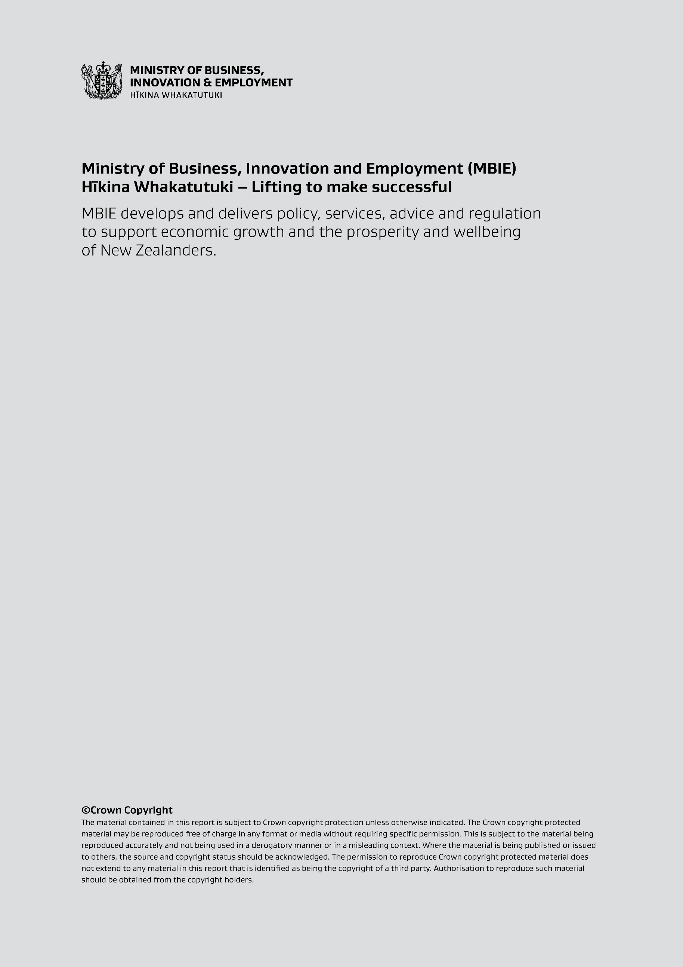

Disclaimer
This document is a guide only. It should not be used as a substitute for legislation or legal advice. To the extent permitted by law, the Ministry of Business, Innovation and Employment (MBIE) is not responsible for the results of any actions or omissions taken on the basis of information in this document, or for any errors or omissions.
ISBN (online) 978-1-991409-59-1
August 2026
More information
Information, examples, and answers to your questions about the topics covered here can be found on our website: www.mbie.govt.nz or by calling us free on 0800 24 22 43.

Building (Rapid building Assessment) Methodology 2026 Consultation

The Ministry of Business, Innovation and Employment (MBIE) would like your feedback on the proposed methodology for conducting rapid building assessments after a hazard event.

About the consultation
Rapid building assessments (specified as post-event assessments in the Building Act) quickly establish the usability of buildings and associated infrastructure where functions may be compromised by an emergency event. If a rapid building assessment operation is required, teams of Rapid Building Assessors (RBAs) will be sent to assess damaged buildings and existing or potential hazards.

Under the Building Act 2004, MBIE has several building emergency management roles and responsibilities, including the Chief Executive’s power to set a rapid building assessment methodology under section 133BQ(2)(a).
What are rapid building assessments?
Rapid building assessment assessments quickly establish the usability of buildings and associated infrastructure where functions may be compromised by an emergency event. The focus of rapid building assessments is on immediate public safety. They are a brief visual assessment that is conducted to ensure the safety of building occupants and the public - they do not provide an engineering assessment service to building owners. When carrying out these assessments, assessors also need to consider actual or potential land instability and geotechnical hazards.
Rapid building assessments primarily assess:
- the threat of overall or partial collapse due to loss of strength, stability or stiffness of the structural system
- the threat of non-structural elements of a building, that are not part of the structural frame, becoming falling hazards (eg loose bricks from a chimney, tiles from a roof)
- the threat posed by damage to adjacent structures or land
- other threats to public safety caused by the event, such as biocontamination through leaked sewage or electrical issues.
The focus of a rapid building assessment is on applying judgment to assess future risk from damage, based on a minimum of specific knowledge about a building. Assessor teams may also make recommendations for work to be done under urgency where there is a need to demolish or secure the structure to keep the public safe or to protect adjacent property.

Why do we need a rapid building assessment methodology?
Issuing a methodology under section 133BQ(2)(a) of the Building Act provides:

- a regulatory document that bridges the gap between prescribed rapid building assessment requirements, such as approved assessment forms and placards, and guidance-based processes, such as guidance material, training and field guides
- minimum health and safety guidelines that must be implemented for rapid building assessment operations to mitigate risks posed in the field; and
- consistency by outlining a basic assessment approach that must be followed by assessors when conducting rapid building assessments under the Building Act.

Scope
The proposed Building (Post-event Assessment) Methodology 2026 sets out how the responsible person must prepare a rapid building assessment under section 133BQ of the Building Act 2004. This includes:
- Level 1 assessments
- Level 2 assessments.
Out of scope:
- assessments conducted under the Civil Defence Emergency Management Act 2002 (CDEM Act)
- detailed evaluations/assessments undertaken after a rapid building assessment
- reassessments undertaken after repair or remediation work
- geotechnical rapid building assessments.

GUIDANCE
While the Building (Post-Event Assessment) Methodology does not cover assessments carried under the CDEM Act, MBIE recommends that all rapid building assessment operations should be carried out the same way for consistency.

Further information on building emergency management guidance is available at: www.building.govt.nz

Definitions
Key term | Definition
Approved assessment form | rapid building assessment form approved by the Chief Executive of MBIE under section 133BQ(2)(b) of the Building Act
Assessor | means the responsible person (including a person authorised by the responsible person to carry out rapid building assessments under section 133BQ of the Building Act)
Level 1 assessment | a rapid building assessment that involves a visual inspection of damage to a building or land
Level 2 assessment | a detailed rapid building assessment that involves both external and internal inspection of a building (if safe to enter) or land
Placard | a sign or notice approved by the Chief Executive of MBIE under 133BT(3)(a) of the Building Act to be placed by the person responsible on or near a building in a designated area prohibiting or restricting the use of the building if—  (a) the responsible person believes that it is reasonably necessary to remove or reduce risks of injury or death; or  (b) an evacuation of the building has been directed under section 133BR of the Act.  Note: white placards are not issued under section 133BR of the Building Act as they do not prohibit or restrict the use of the building.
Rapid building assessment | post-event building assessment undertaken in a designated area by an assessor under section 133BQ of the Building Act
Responsible person | person authorised by section 133BJ or 133BK of the Building Act to exercise powers under Subpart 6B of the Building Act.

Building emergency management
The Building Act provides a system and powers for quickly and effectively managing buildings during and after an emergency event. This system is set out in subpart 6B of Part 2 of the Building Act and allows for the designation of an area for building emergency management following an event.
What this means is if the area has been designated under the Building Act, assessors acting under the direction of the responsible person can conduct rapid building assessments and place placards on buildings to restrict or prohibit access.

GUIDANCE
Any person properly authorised by the responsible person under the Building Act may undertake a rapid building assessment. However, MBIE recommends:
• only trained and registered Rapid Building Assessors should complete rapid building assessments and placard properties and buildings
• any building officials and engineers who are not trained on rapid building assessments but who are supporting the emergency response should form part of a team with a trained assessor.

Who is the responsible person for rapid building assessments?
The Building Act specifies that the responsible person may exercise powers under subpart 6B of part 2 of the Building Act. Once an area has been designated, who the responsible person is may depend on how and who put the designation in place. The following diagram shows who the responsible person is in different situations:
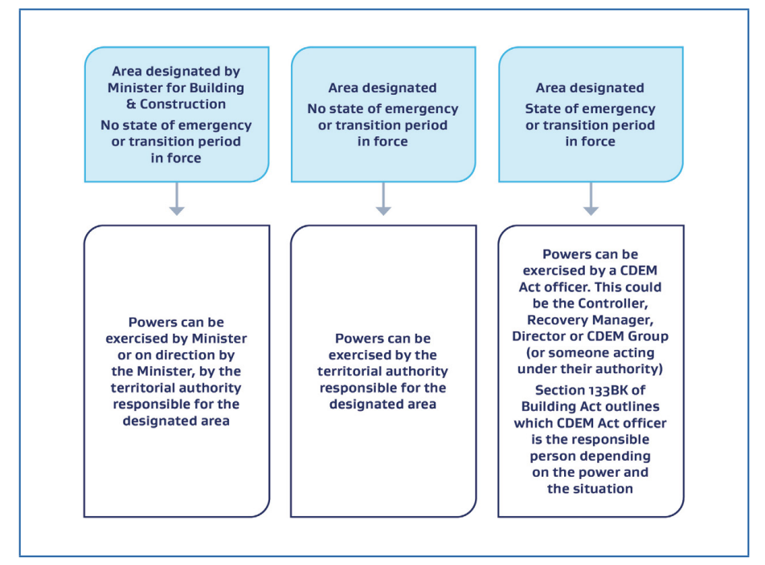
Figure 2: Who can exercise powers under subpart 6B of the Building Act
Note: If a state of emergency or transition period expires or is terminated early and a designation is in force, the responsible person will switch from the CDEM Act officer to the responsible territorial authority.

The next section details the proposed rapid building assessment methodology. The grey guidance boxes provide further information on how to prepare and conduct rapid building assessment operations, but they do not form part of the methodology itself.

The Building (Post-event Assessment) Methodology 2026

Referenced documents
This methodology refers to the following documents:
- 2025 Field Guide: Rapid Building Assessments - All event types
- 2025 Building emergency management - Guidance for territorial authorities and decision-makers

Preparing a rapid building assessment operation
Part 1 of the methodology outlines health and safety requirements that must be implemented as part of a rapid building assessment operation.

Assessor responsibilities

GUIDANCE
Every assessor should be authorised by the responsible person before they can begin assessments. Where practicable, authorisation should be formally documented through a signed authorisation form. A sample authorisation form and guidance can be found in:
- Appendix 5 of the 2025 Building emergency management - Guidance for territorial authorities and decision-makers and
- Appendix 1 of the 2025 Field Guide: Rapid Building Assessments - All event types.

  - Assessors must comply with all health and safety directives outlined in Section 2.2 of the 2025 Field Guide: Rapid Building Assessment – All event types.

GUIDANCE
Section 2.2 of the Field Guide: Rapid Building Assessment – All event types outlines the field safety steps an assessor should take before beginning a rapid building assessment. Rapid building assessments are inherently a dangerous activity, so assessors need to be able to identify and mitigate risk, including conducting a preliminary hazard assessment to identify event-specific risks (eg structural damage to buildings and infrastructure, electrical safety after flooding and land instability).

Rapid building assessment operational responsibilities
  - The person managing a rapid building assessment operation must ensure the health and safety directives outlined in Section 8.4.1 of the 2025 Building emergency management - Guidance for decision-makers and territorial authorities are implemented as part of the rapid building assessment operation.

GUIDANCE
A rapid building assessment operation should be conducted in line with the requirements set out in the 2025 Building emergency management - Guidance for territorial authorities and decision-makers.
Section 8.4.1 of the 2025 Building emergency management - Guidance for territorial authorities and decision-makers. outlines health and safety requirements for operational staff. Before deploying assessors, it is important that all relevant health and safety processes have been considered and incorporated into the operational plan and are implemented before deployment of operational staff begins. This includes:
- ensuring assessors are appropriately briefed and provided with sufficient and appropriate personal protective equipment (PPE) and equipment based on field conditions and event type
- a process has been implemented for assessors to log in and out each day and record the area to which they have been assigned. There must also be a way to contact assessors in the field.
- confirming how assessors can safely get to and from the damaged areas and provide suitable transport if required
- ensuring there are processes implemented to manage the mental wellbeing of assessors both during and after deployment in the field
- ensuring that no assessor is deployed alone (at least two assessors minimum per team)
The following appendices in the building emergency management guidance also provide useful checklists before commencing deployment:
- Appendix 4: Equipment and Resource Checklist
- Appendix 6: Activating a Rapid Building Assessment Operation Checklist
- Appendix 7: Daily Operational Checklist.

Rapid building assessment process
Part 2 of the methodology outlines basic assessment steps that must be taken as part of a rapid building assessment.

GUIDANCE
All rapid building assessments should be conducted in line with the requirements set out in the 2025 Field Guide: Rapid Building Assessment – All event types.
For information on the placarding process including principles, key observations and examples, please see section 3.1 of the Field Guide.
The rapid building assessment process must be conducted in accordance with the framework outlined in Figure 3 below to the extent that is practicable in the circumstances:
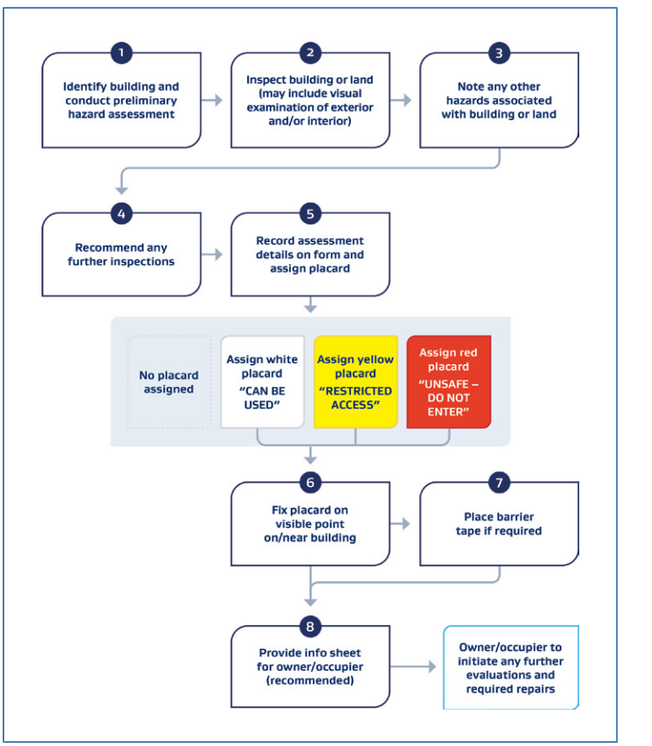
Figure 3: the rapid building assessment process

GUIDANCE
As part of the rapid building assessment, assessors must complete all mandatory fields of the approved assessment form (see section 133BQ((2)(b) of the Building Act).
Where a placard is issued after an assessment, assessors must use the approved placards (see section 133BT(3)(a)), and detail all mandatory information specified in section 133BT(3)(b)(c) of the Act.

Level 1 rapid building assessments
- All Level 1 assessments should be carried out in accordance with the technical requirements outlined in Section 5.2 of the 2025 Field Guide: Rapid Building Assessment – All event types to the extent that is practicable in the circumstances.
- Assessors must identify the building that is to be assessed and record the details on the approved assessment form (if any).
- Each completed assessment form must be submitted to responsible person on the completion of the day’s assessments (to the extent that is practicable in the circumstances).

GUIDANCE
Section 4.0 of the 2025 Field Guide: Rapid Building Assessment – All event types provides more information on the rapid building assessment forms, including both digital and paper-based forms.
Section 5.2 of the Field Guide provides detailed observational criteria that should be applied when conducting a Level 1 rapid building assessment, including observations for structural damage, flooding and severe weather damage and observations.
Section 6.0 and Section 7.0 provide further detail on assessing specific building types (eg timber based structures, unreinforced masonry, steel frame structures).

Level 2 rapid building assessments
- All Level 2 assessments should be carried out in accordance with the technical requirements outlined in section 5.3 of the 2025 Field Guide: Rapid Building Assessment – All event types to the extent that is practicable in the circumstances.
- Assessors must identify the building that is to be assessed and record the details on the approved assessment form (if any).
- Each completed assessment form must be submitted to responsible person/relevant territorial authority on the completion of the day’s assessments (to the extent that is practicable in the circumstances).

GUIDANCE
Level 2 assessments should be conducted on buildings with typical commercial construction (eg unreinforced masonry walls, tilt-up panels) multi-storey buildings with 3 or more residential units and essential facilities.
A Level 2 assessment generally involves entry into the building. Before entering the building, assessors must first assess the exterior of the building for damage and hazards. In addition, assessor also need to ensure that pathways in and out of the building are clear and safe to enter.
Refer to the 2025 Field Guide Section 2.2.2: Entry into damaged buildings.

Questions:
- Does the proposed methodology provide suitable flexibility to be applied for different hazard events?
- Does the format of the proposed guidance document provide users with sufficient information to understand and implement the methodology in rapid building assessments?
- Are there any other factors MBIE should consider before issuing the methodology?



