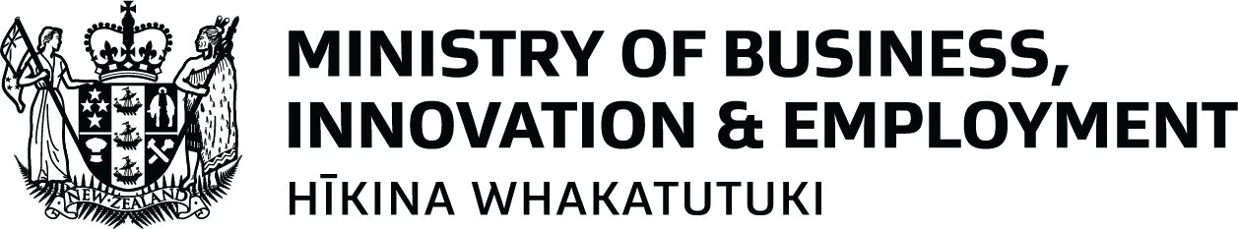

New Zealand’s Fuel Response Plan 2026
Fuel prices have gone up because of conflict in the Middle East. Fuel is important for everyday life. It helps people:
- Get to work, school, or appointments.
- Run hospitals, ambulances, and fire services.
- Deliver food and other essential supplies.
Fuel is petrol, diesel and jet fuel.
The Government has a plan, so New Zealand is ready if fuel becomes harder to get.
This plan has four phases. A group of senior Ministers decides when to move between phases for each type of fuel.
Ministers think about things like:
- How much fuel New Zealand has.
- Whether fuel deliveries to New Zealand are delayed or cancelled.
- What the fuel companies are saying.
- What is happening in other countries.
- Whether some regions are impacted more than others.
Ministers explain their decisions to the public.

The four fuel phases

Phase 1: Watchful

What is happening
- Fuel is available across New Zealand.
- There is enough fuel for everyone.
- Fuel prices are higher because of changes overseas.
- The Government is watching the situation closely and getting ready in case things change.

What the Government will do
- Keep track of how much fuel New Zealand has, what fuel shipments are coming to New Zealand, and what’s happening in other countries.
- Share fuel updates with New Zealanders.
- Work with fuel companies and other countries.
- Get government agencies ready to reduce fuel use if needed.
- Make temporary rule changes where it helps.
- Make plans to build up fuel supplies and be ready if there are problems.
- Ask businesses, and the public for feedback on possible actions, including rule changes.
- Share tips to help people save fuel and money.

What you can do
- Buy fuel as you normally do.
- Check the Ministry of Business, Innovation & Employment (MBIE) website for updates.
- Think about ways to save fuel, if you can.
- Look at advice from the Energy Efficiency and Conservation Authority (EECA) about saving fuel.

Phase 2: Precautionary

What is happening
- Fuel is still available, but there are some problems.
- For example, some fuel deliveries to New Zealand may be delayed.
- The Government will take extra steps to protect fuel supply.
- The Government will ask people to use less fuel where possible.

What the Government will do
- Keep checking fuel supplies, shipments, what’s happening overseas.
- Continue sharing updates with New Zealanders.
- Work closely with fuel companies, importers and big fuel users.
- Work with other countries to keep fuel coming to New Zealand.
- Reduce fuel use in the public sector.
- Make temporary rule changes where it helps.
- Give more advice to New Zealanders on how to use less fuel.

What you can do
- Combine trips where you can. For example:
  - Try to go to the supermarket and pick up medicine on the same trip.
  - Plan appointments close together, if that works for you.
- Use other transport options, like public transport, if you can.
- Follow fuel saving advice from EECA.
- Check the MBIE website for updates.

Phase 3: Managed

What is happening
- There are bigger problems getting fuel, and these may last longer.
- Fuel is still available, but more action is needed to manage supply.
- This phase is unlikely to happen.

What the Government will do
- Continue reducing fuel use in the public sector.
- Change rules to help stop problems from getting worse.
- Use fuel reserves if needed.
- Work with and encourage businesses and big fuel users to make plans to reduce their fuel use.
- If needed, create ways to help people reduce the amount of fuel they use (for example, by increasing public transport).
- Regularly review the situation.
- Go back to Phase 2 as soon as possible.

What you can do
- Fill up your vehicle only as needed.
- Follow any new rules.
- Follow EECA guidance on how to help save fuel.

Phase 4: Protected

What is happening
- There is a serious and long-lasting fuel shortage.
- The focus is on making sure critical services can keep running.
- This phase is very unlikely to happen.

What the Government will do
- Make sure critical services always have fuel (e.g. emergency responders, disability support services, banks, public transport, social services, schools and education providers, animal care, and marae).
- Make businesses, freight companies, and community groups save fuel and use less of it.
- Limit how much fuel people can buy at petrol stations.
- Do spot checks to make sure people are following the rules and apply penalties if they are not.
- Consider stronger rules to help save fuel.
- Go back to Phase 2 or 3 as soon as possible.

What you can do
- Know that food supply and critical services will continue.
- Follow any new rules, such as how much fuel you can buy or use.
- Avoid unnecessary fuel use.
- Use petrol stations according to the rules.

Where to get more information
EECA has advice on how to use less fuel when you drive. This is available in alternate formats. You can find it here: https://www.eeca.govt.nz/fuel/

MBIE publishes information on the current fuel situation for New Zealand here: https://www.mbie.govt.nz/building-and-energy/energy-and-natural-resources/energy-generation-and-markets/liquid-fuel-market/fuel-supply-disruption-response/middle-east-conflict-and-new-zealands-fuel-stocks or https://mbie.govt.nz/fuel. This information is not available in alternate formats.
End of information | New Zealand’s Fuel Response Plan 2026
This Large Print document is adapted by Blind Citizens NZ from the standard document provided by Whaikaha | Ministry of Disabled People, on behalf of the Ministry of Business Innovation and Employment

