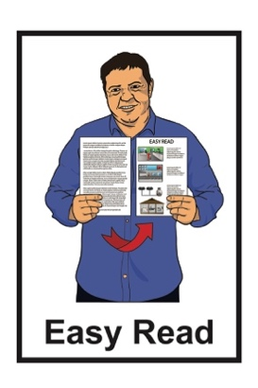
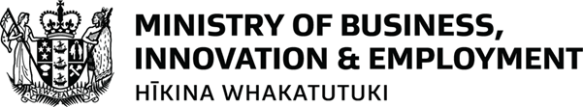

Fuel response plan 2026
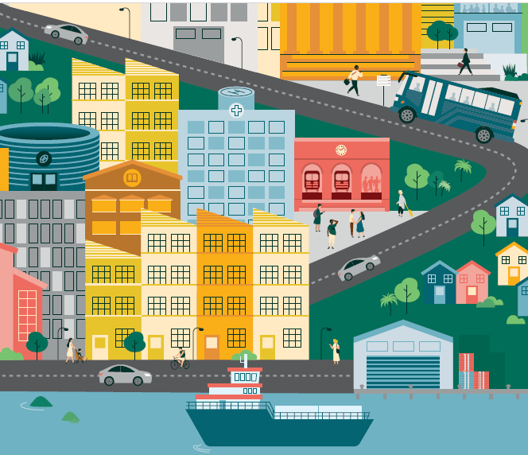

Published: May 2026

What you will find in here

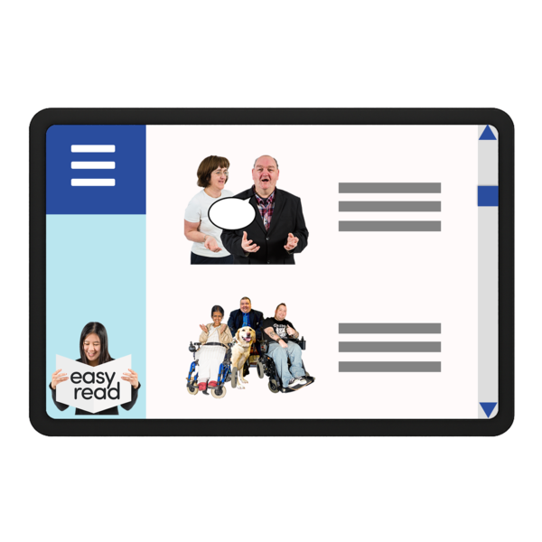
Page number:

About this Easy Read 2
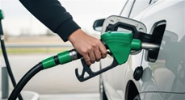

Why has the fuel plan been made? 4


Phase 1: Watchful 9

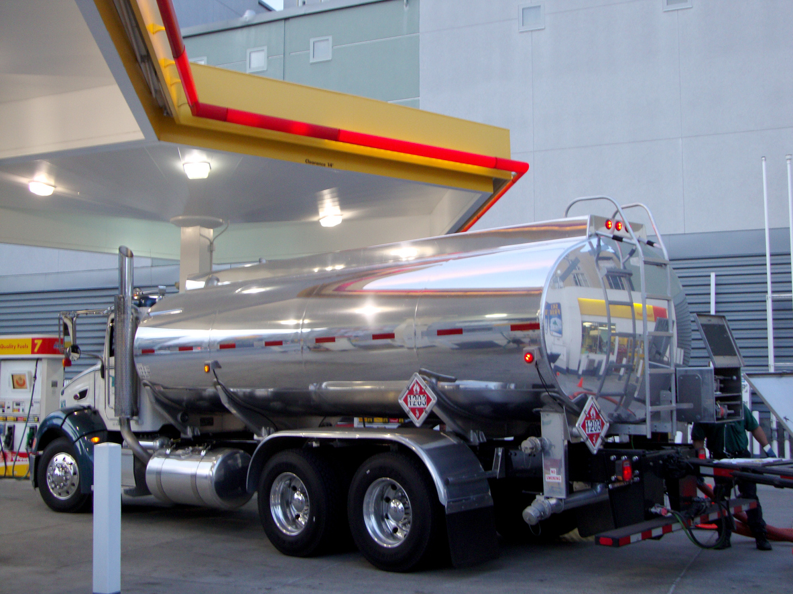
Phase 2: Precautionary 14


Phase 3: Managed 18

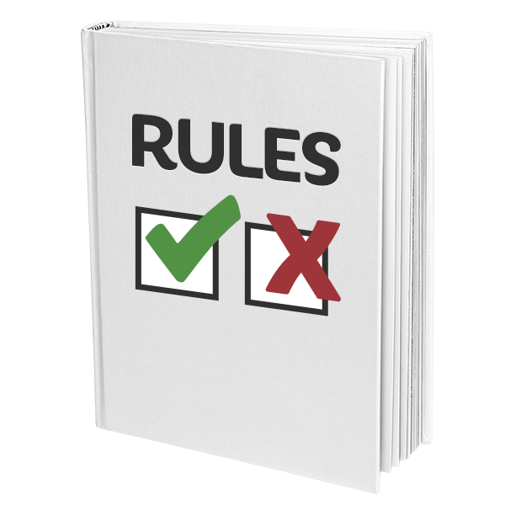
Phase 4: Protected 21

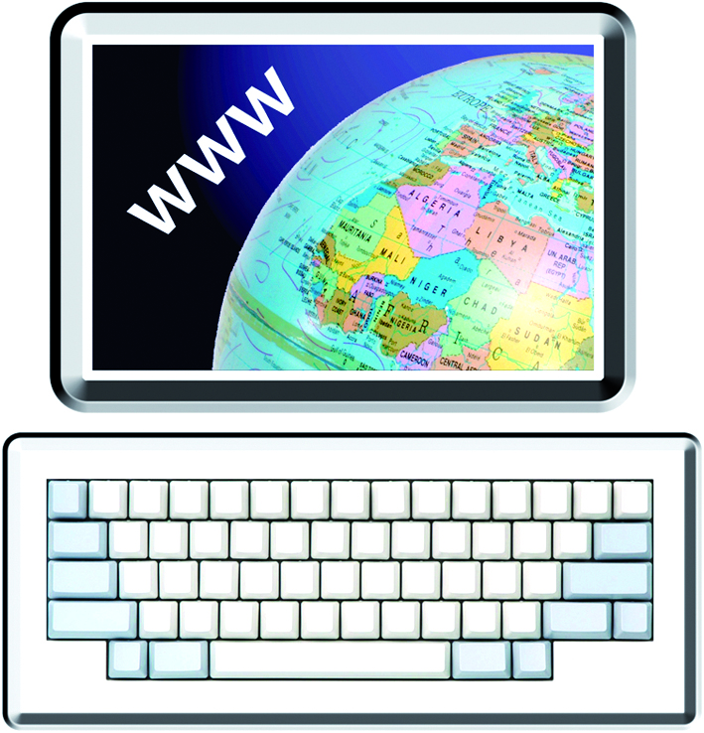
Where to get more information 25

About this Easy Read

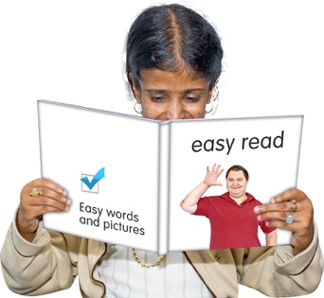
This Easy Read is from the Ministry of Business, Innovation, and Employment.

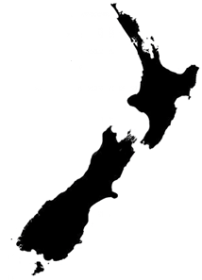
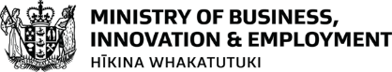
The Ministry of Business, Innovation, and Employment is a government agency that does many things to support the economy of Aotearoa New Zealand.


The economy means all the things we do to:
- make money
- spend money
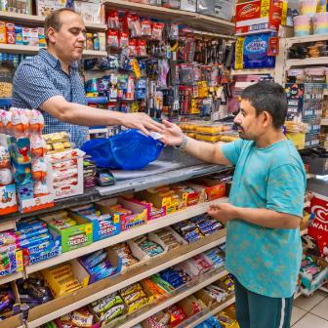
- save money to use later.


In this Easy Read the Ministry of Business, Innovation, and Employment will be called MBIE.

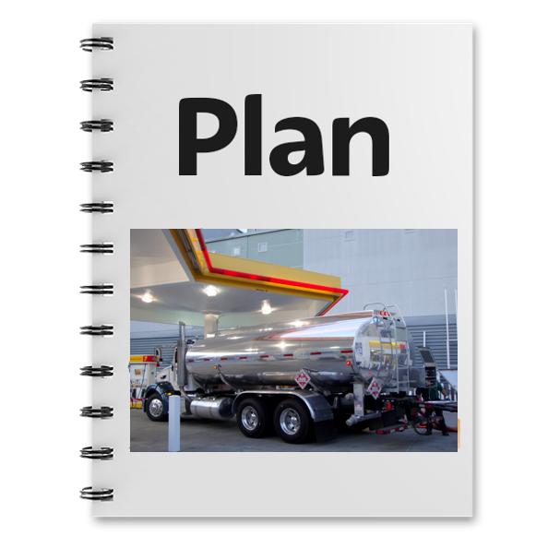
This Easy Read is about the Government plan if fuel becomes harder to get.

Why has the fuel plan been made?
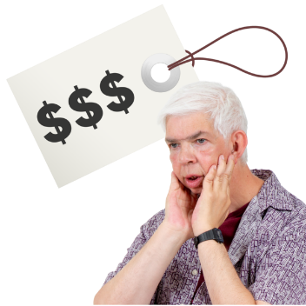

The price of fuel has gone up.

Fuel means things we use for energy like:
petrol
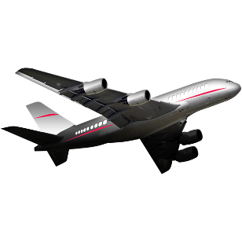
diesel
jet fuel that runs aeroplanes.
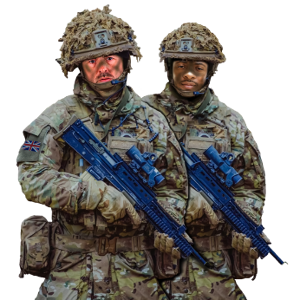

This is because of the war / fighting in the Middle East.

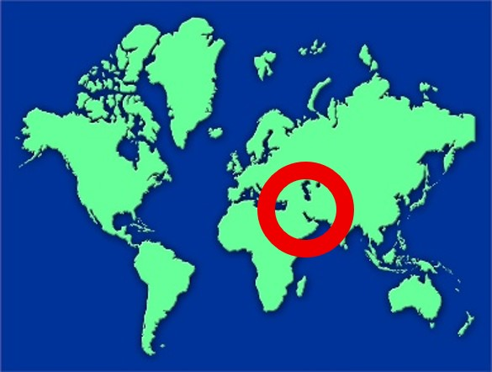
The Middle East is part of the world where a lot of fuel comes from.


Fuel is important for everyday life.


Fuel supports people to get to:
work
school
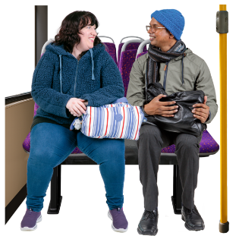
appointments like going to the doctor.

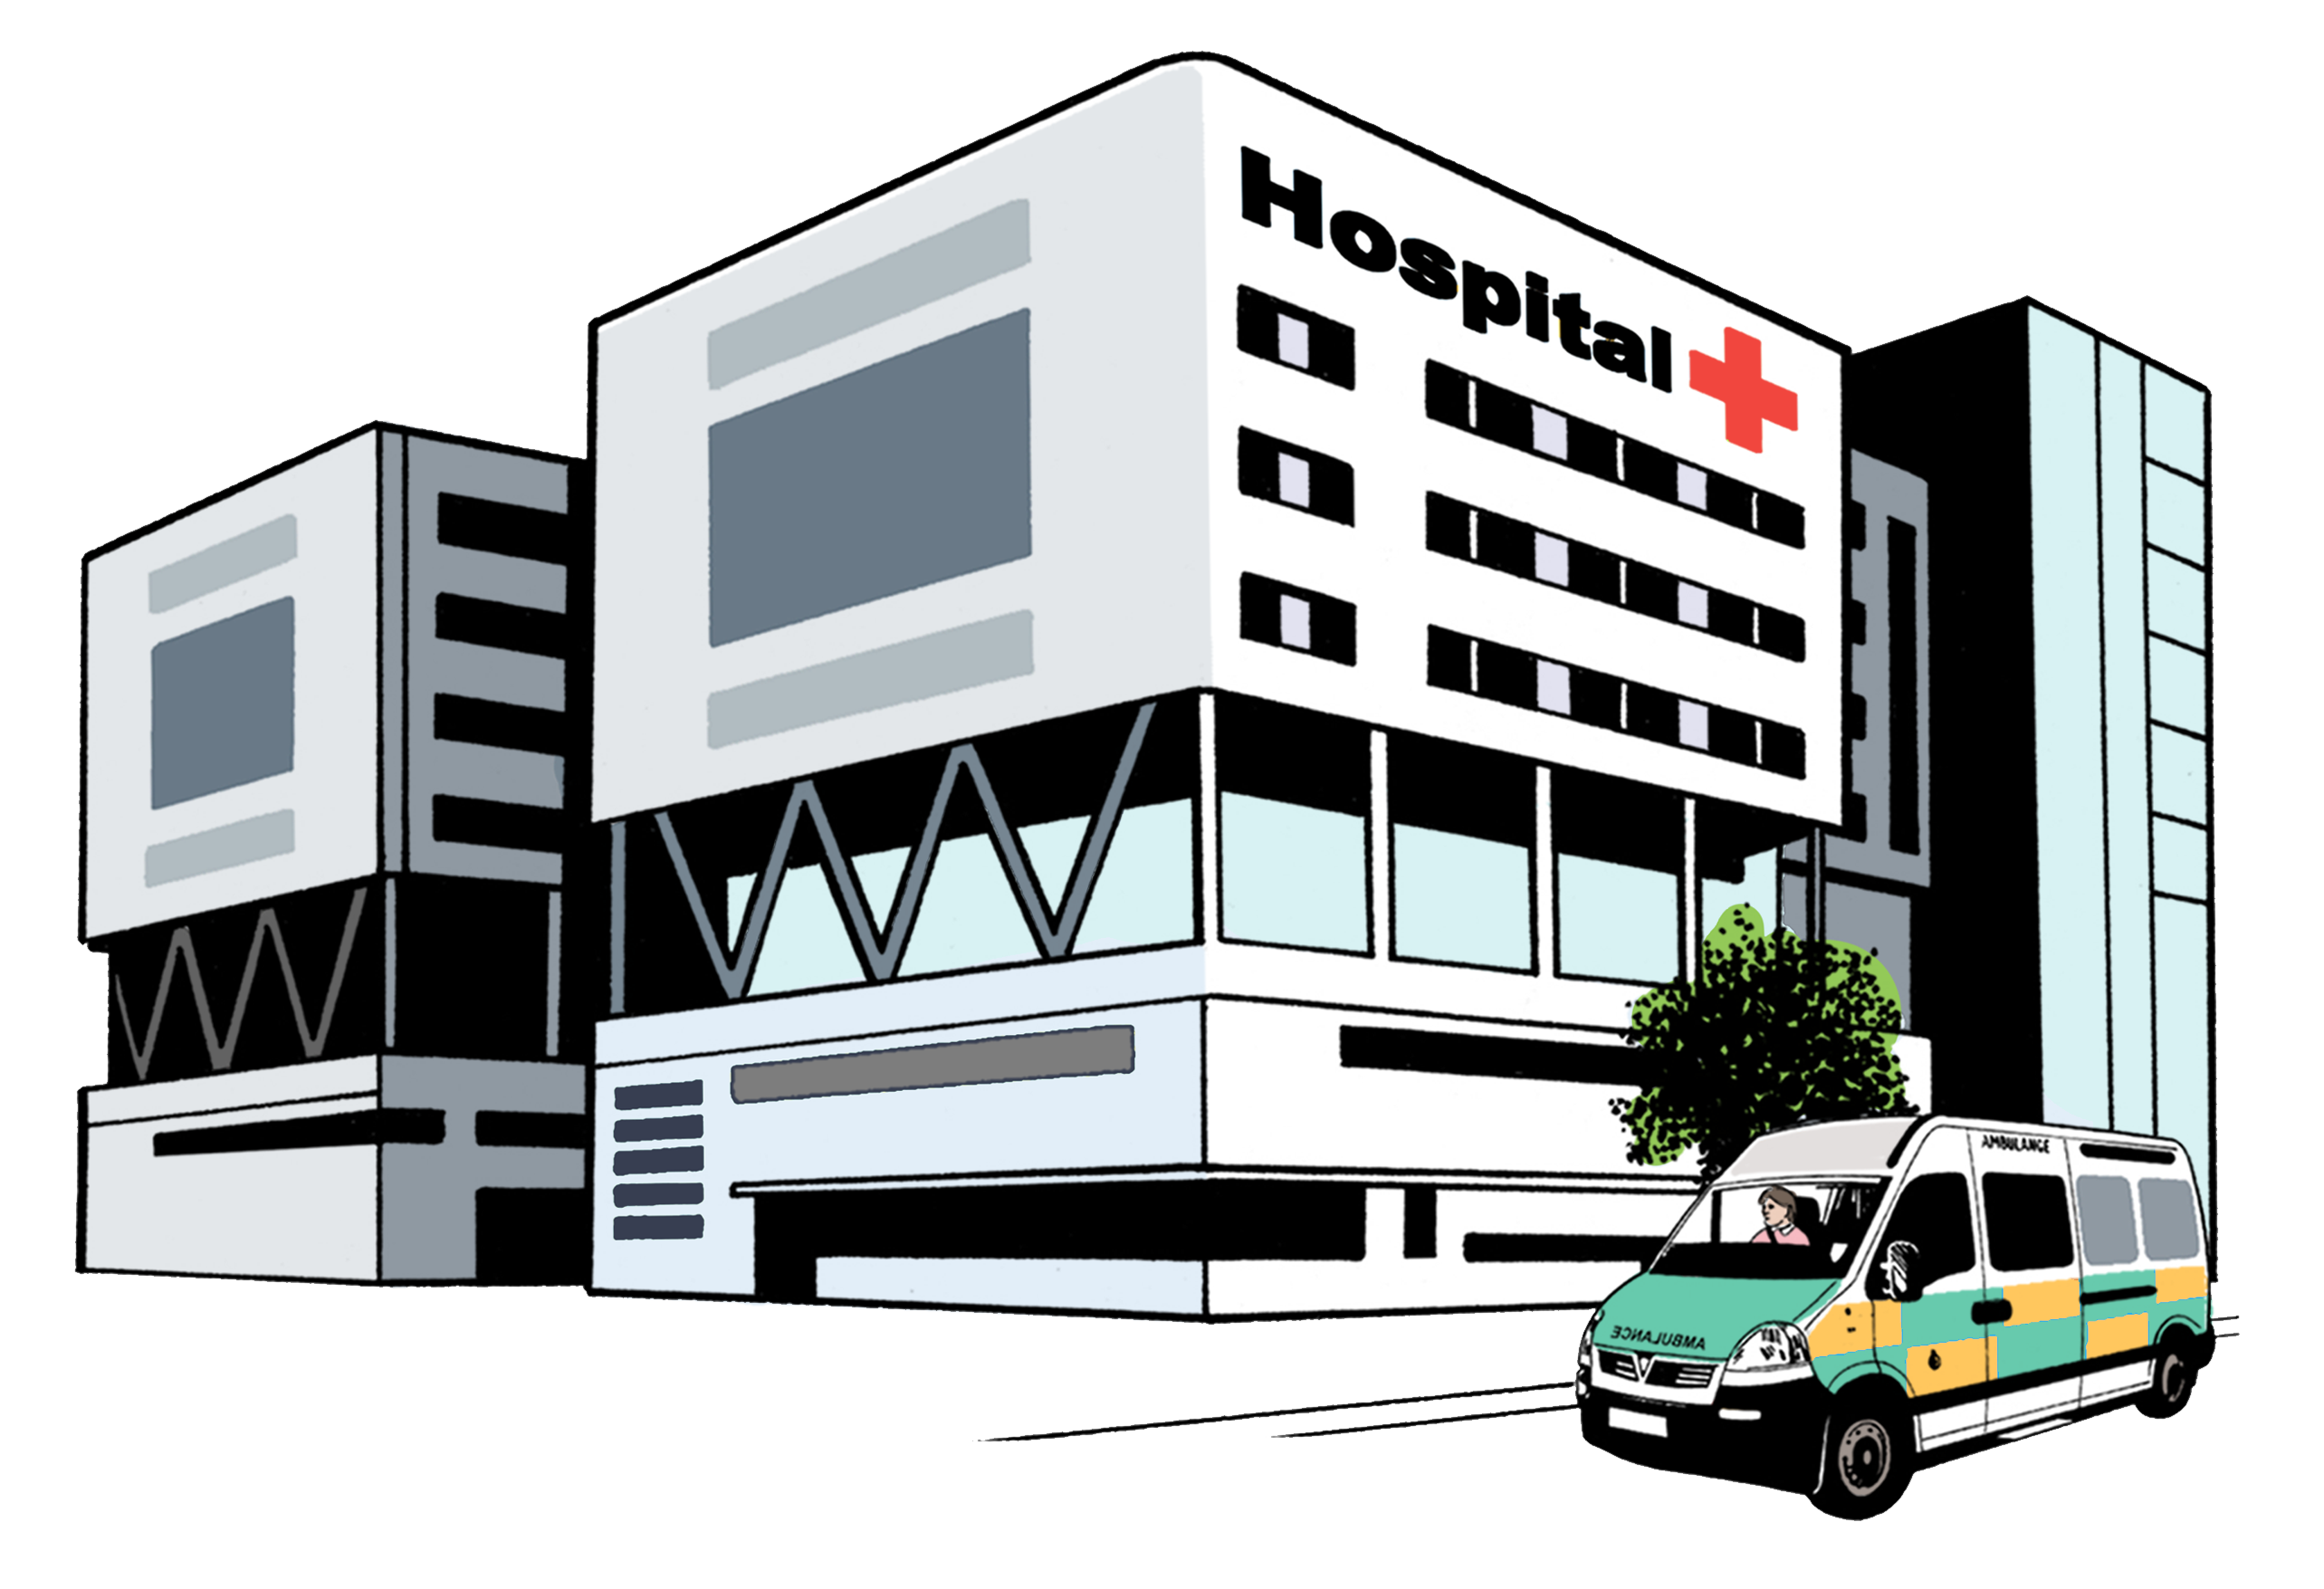
Fuel is part of running:
hospitals
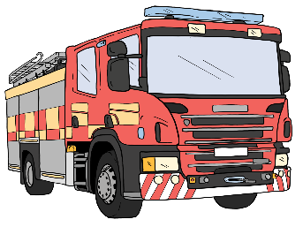
ambulances
fire engines.
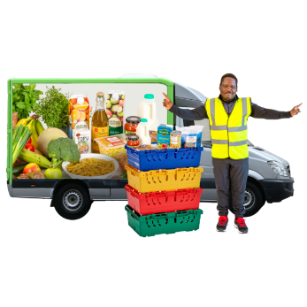

Fuel supports the delivery of important things like food.

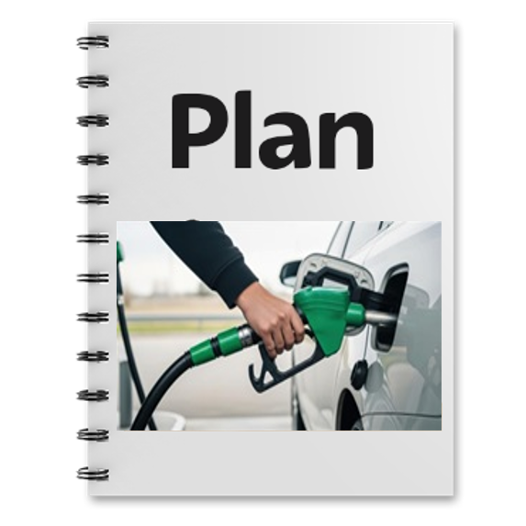
The Government has made the plan so New Zealand is ready for if fuel is harder to get.

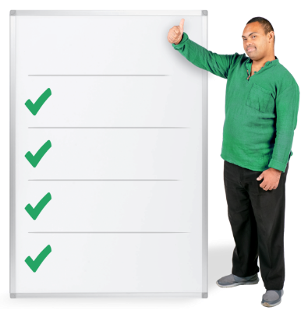
The plan has 4 phases.
Phases
1
2
3
4

Here phase means a time when we need to follow different rules about using fuel.

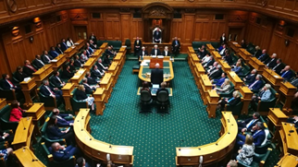
A group of Ministers will decide when to move between each phase.


A Minister is an important person who is part of the Government.

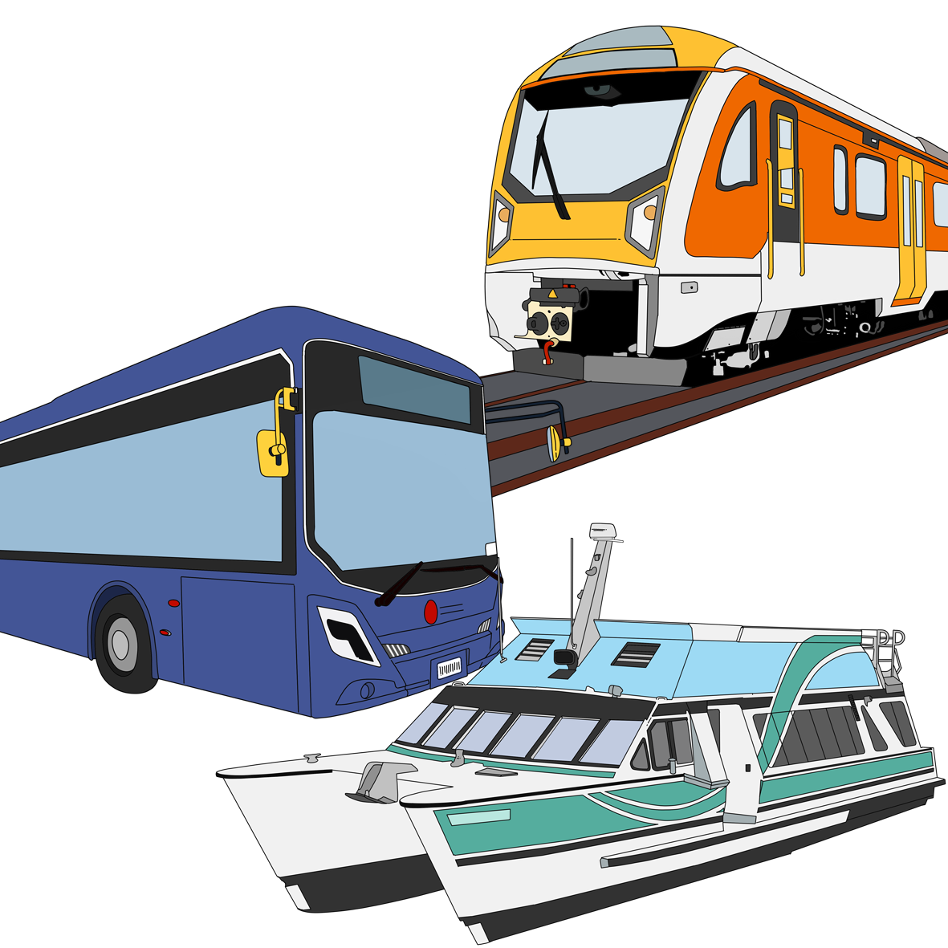
They are in charge of something the Government does like:
business
transport.

The Ministers will think about things like:
how much fuel New Zealand has
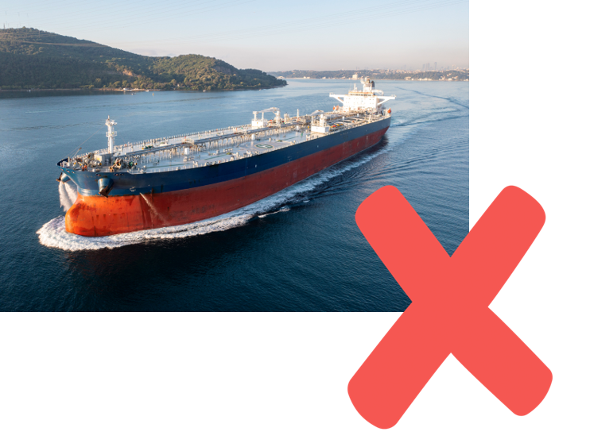
if fuel that is coming to New Zealand is:
- delayed / slow
- cancelled / not coming
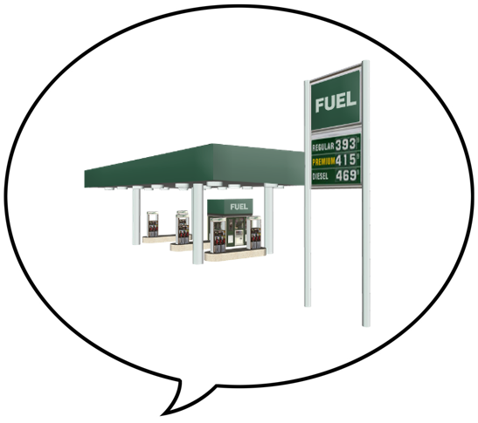
what fuel companies are saying
what is happening in other countries
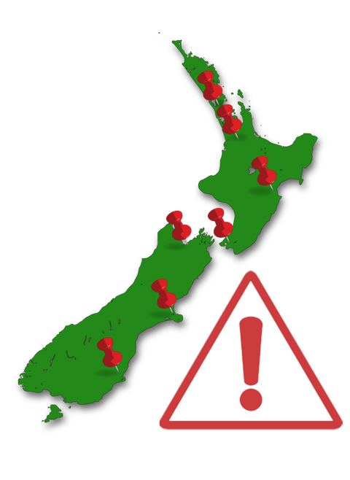
if some places in New Zealand are having a harder time than others with fuel problems.

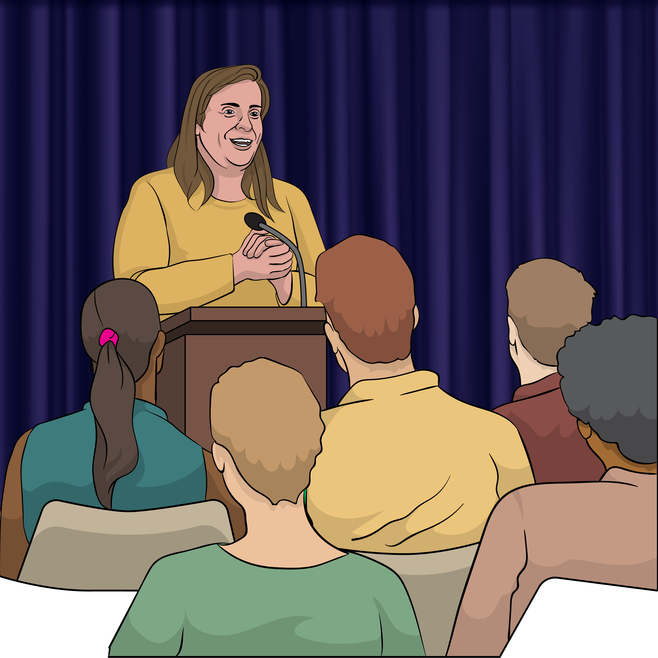
The Ministers will:
tell the public what they decide
and
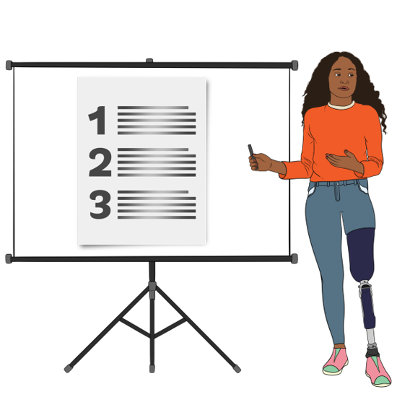
explain why they made the decision.

Phase 1: Watchful

Phases
1
2
3
4

What is happening in Phase 1?

In Phase 1:
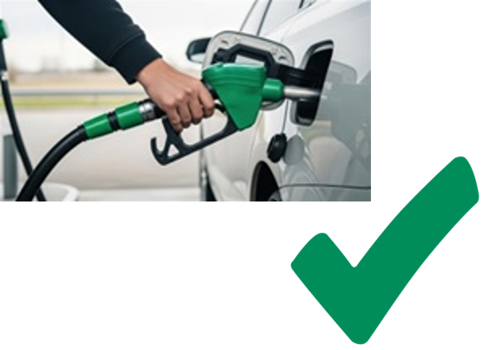
fuel is available in New Zealand
there is enough fuel for everyone
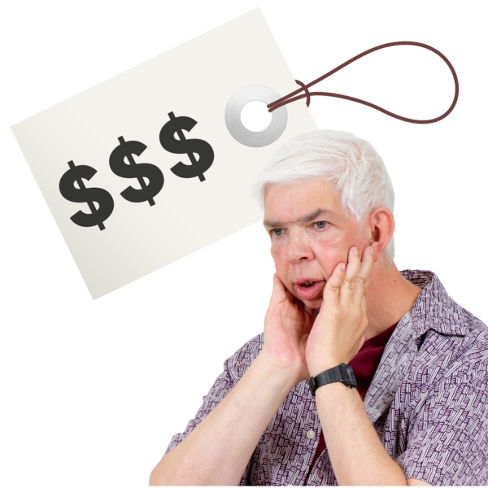
fuel prices are higher because of changes happening overseas / in other countries
the Government is:
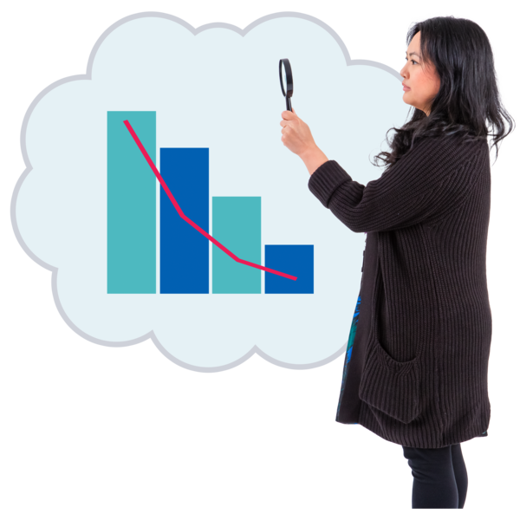
- watching what is happening
- and
- getting ready in case things change.

What will the Government do in Phase 1?
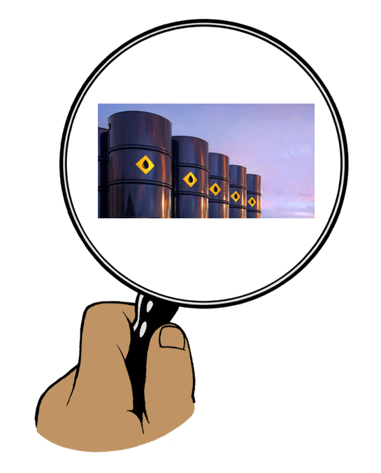
The Government will:
keep checking:
- how much fuel New Zealand has
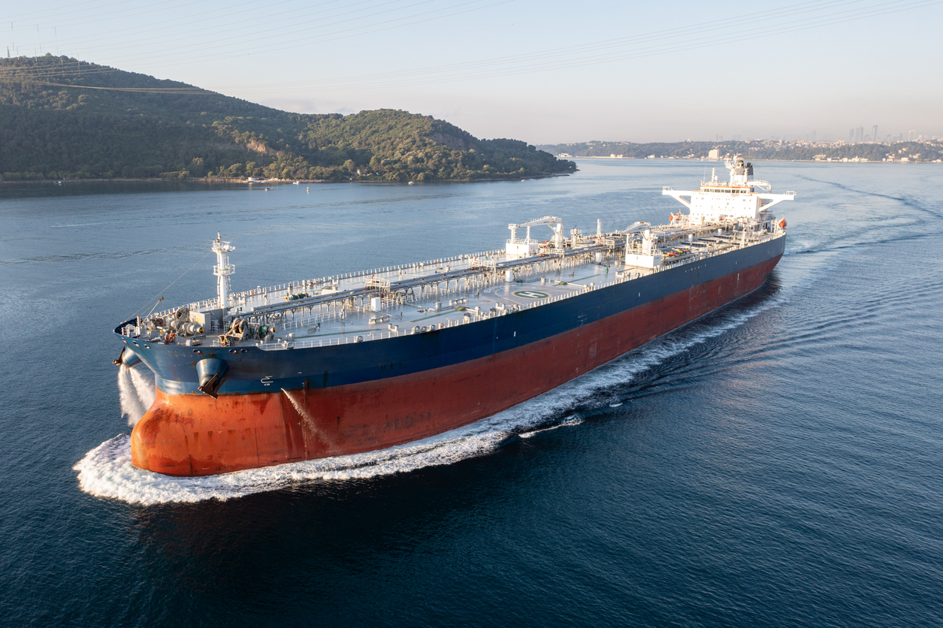
- what fuel shipments are coming to New Zealand
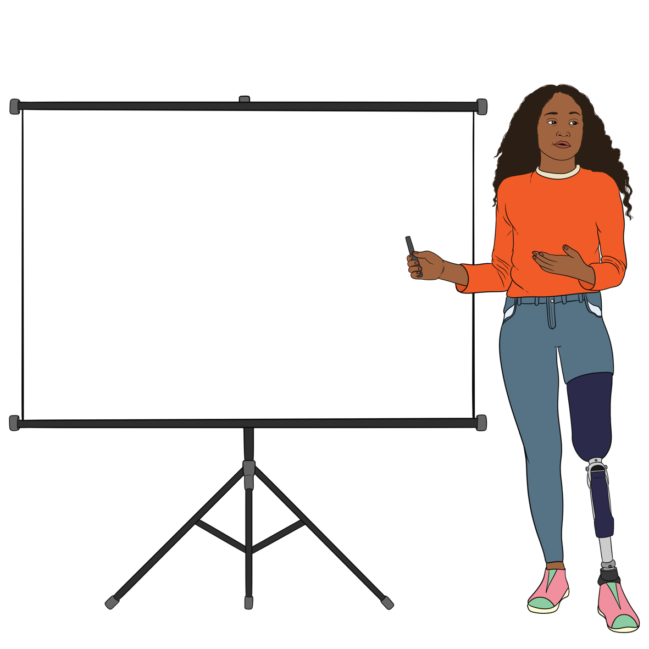
- what is happening in other countries
share fuel updates with
New Zealanders

watch what is going on with fuel by working with:
- fuel companies
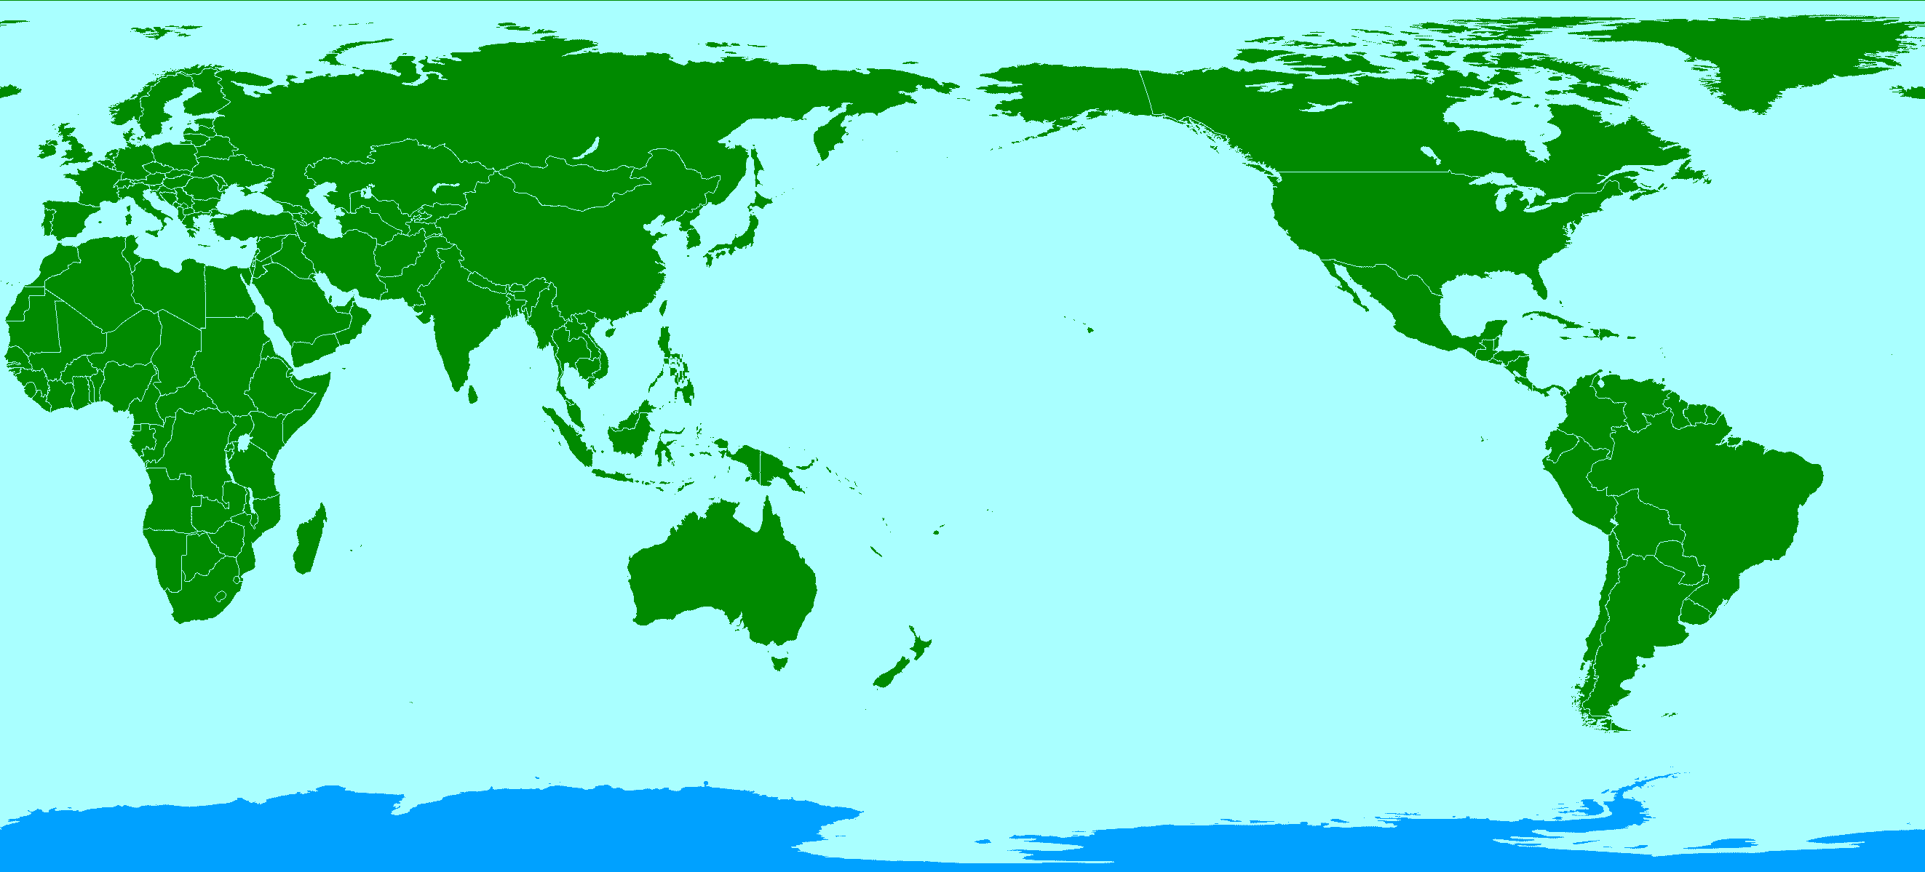
- other countries.

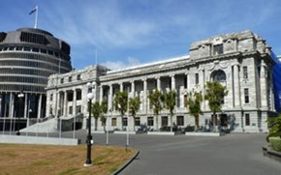
The Government will also:
get government agencies ready to use less fuel if they need to
make short-term rule changes where it helps
make plans to:
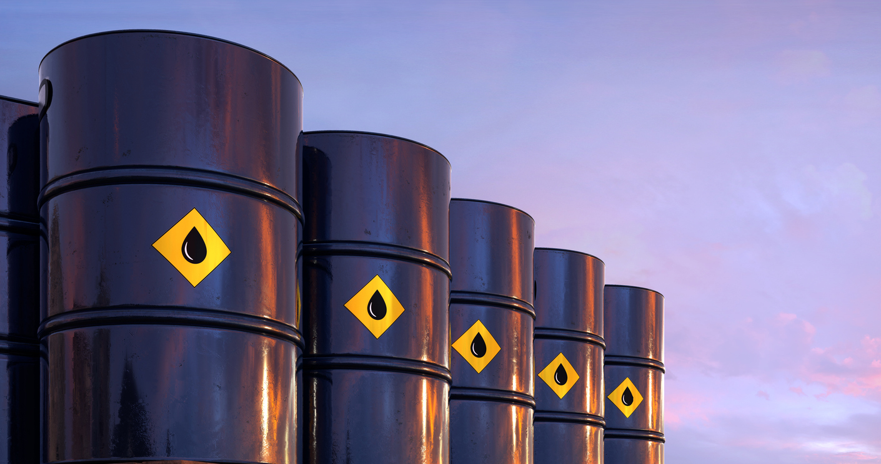
- build up fuel supplies
- be ready if there are problems with fuel supplies
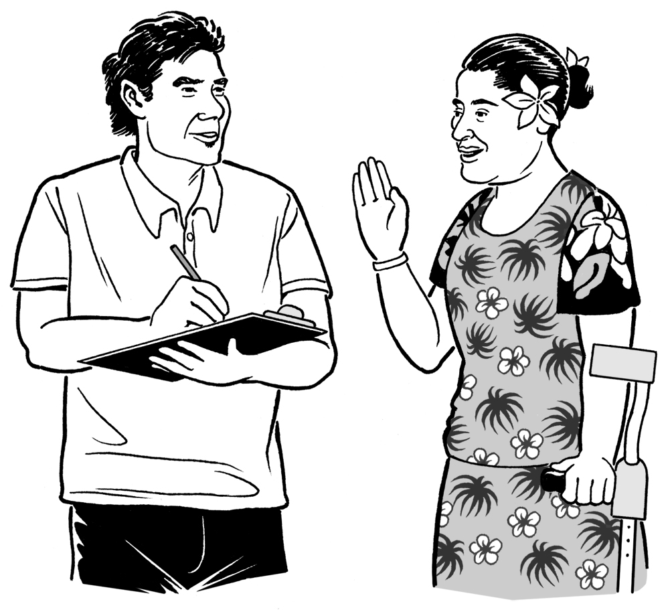
ask people for feedback on things they can do including rule changes
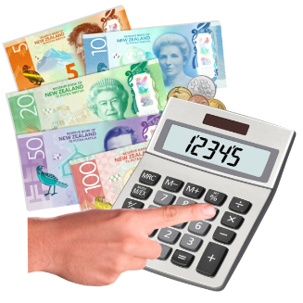
give people tips / ideas on how to save:
- fuel
- money spent on fuel.


What you can do in Phase 1

During Phase 1:
you can buy fuel as you normally do

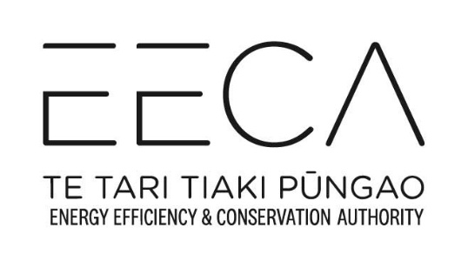
look at information about saving fuel on the Energy Efficiency and Conservation Authority / EECA website
think about ways to save fuel
check the MBIE website for updates / information.

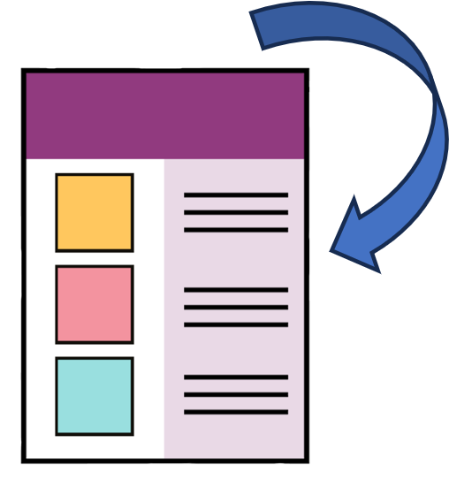
Check page 21 for information on the:
Energy Efficiency and Conservation Authority / EECA website
MBIE website.

Phase 2: Precautionary

What is happening in Phase 2?
Phases
1
2
3
4

In Phase 2:
there are some problems with fuel
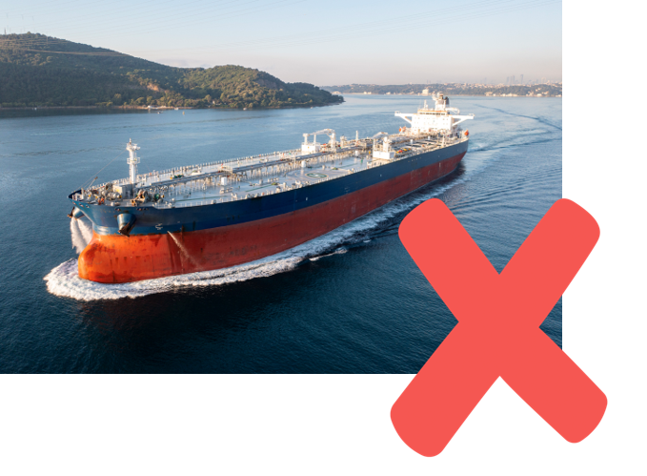
fuel deliveries to New Zealand might be delayed / slow
the government will do extra things to protect the fuel we have
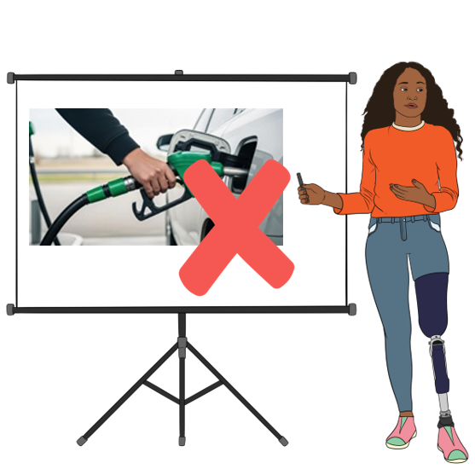
the Government will ask people to use less fuel if they can.

What will the Government do in Phase 2?
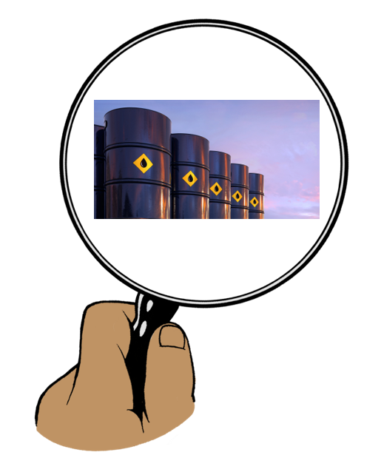
The Government will:
keep checking:
- how much fuel New Zealand has
- what fuel shipments are coming to New Zealand
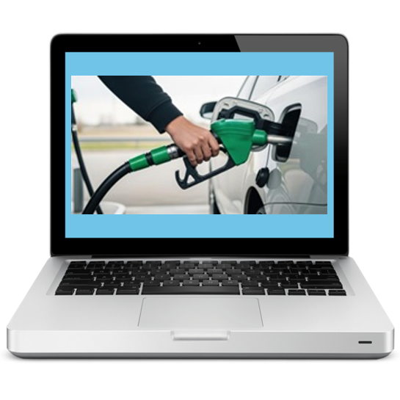
- what is happening in other countries
share fuel updates with
New Zealanders

work with:
- fuel companies
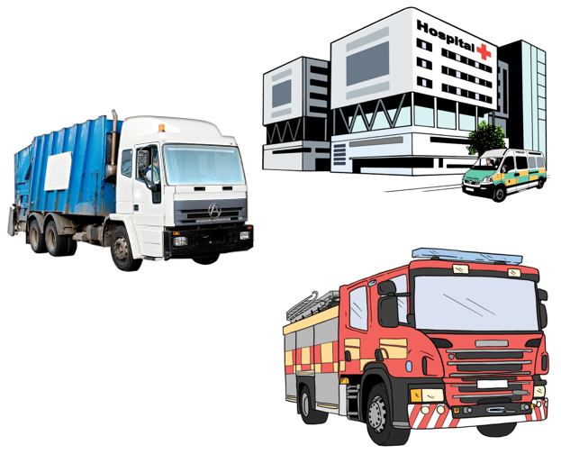
- fuel importers / people who bring fuel into the country
- groups that use a lot of fuel.
The Government will also:
work with fuel companies to make sure fuel gets to the right places
work with other countries to make sure fuel gets to New Zealand
use less fuel in the public sector
make short-term rule changes where it helps

give more advice / information to New Zealanders on how to save more fuel.

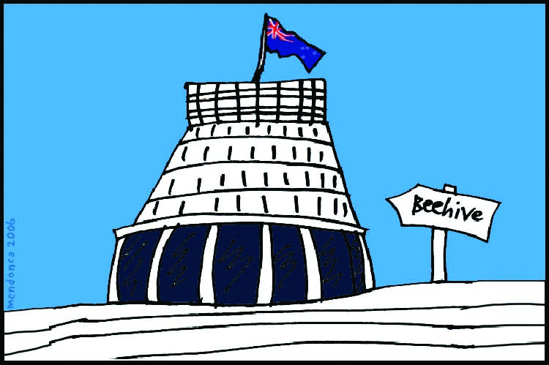
The public sector is groups of people who do work connected to the Government like government agencies.

What you can do in Phase 2


In Phase 2:
do lots of things in 1 trip like:
- going to the supermarket

- picking up children
- do lots of appointments at the same time
use public transport like buses if you can
follow fuel saving
advice / information from the Energy Efficiency and Conservation Authority / EECA
check the MBIE website for
updates / information.

Phase 3: Managed

What is happening in Phase 3?
Phases
1
2
3
4

In Phase 3:
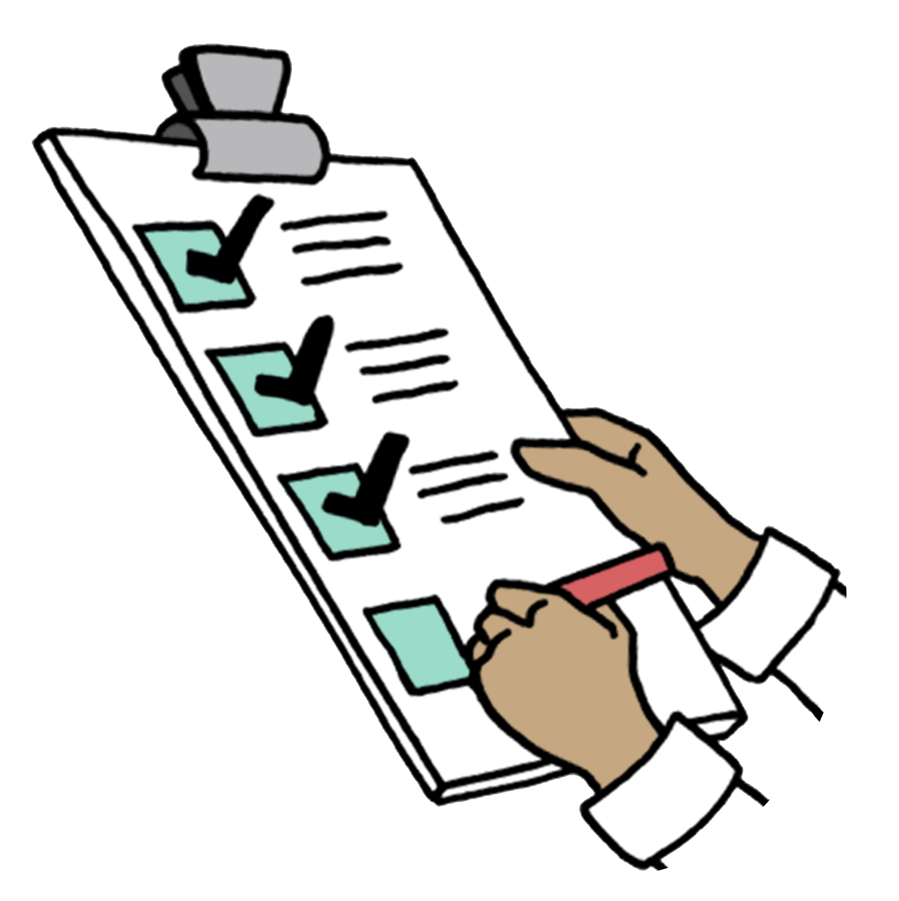
there are more problems getting fuel which may last for a long time
more things need to be done to manage fuel supply.


This phase probably will not happen.

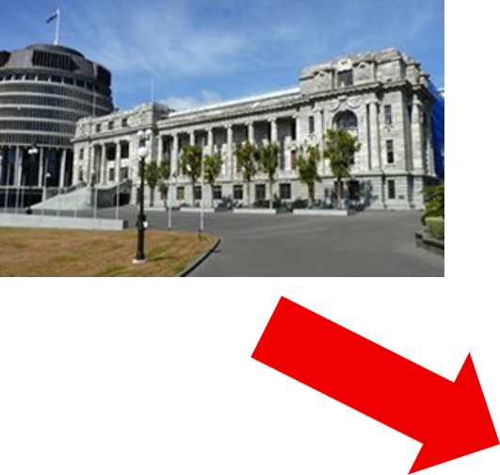
What will the Government do in Phase 3?

The Government will:
keep using less fuel in the public sector
change rules to stop problems from getting worse
use fuel reserves if needed
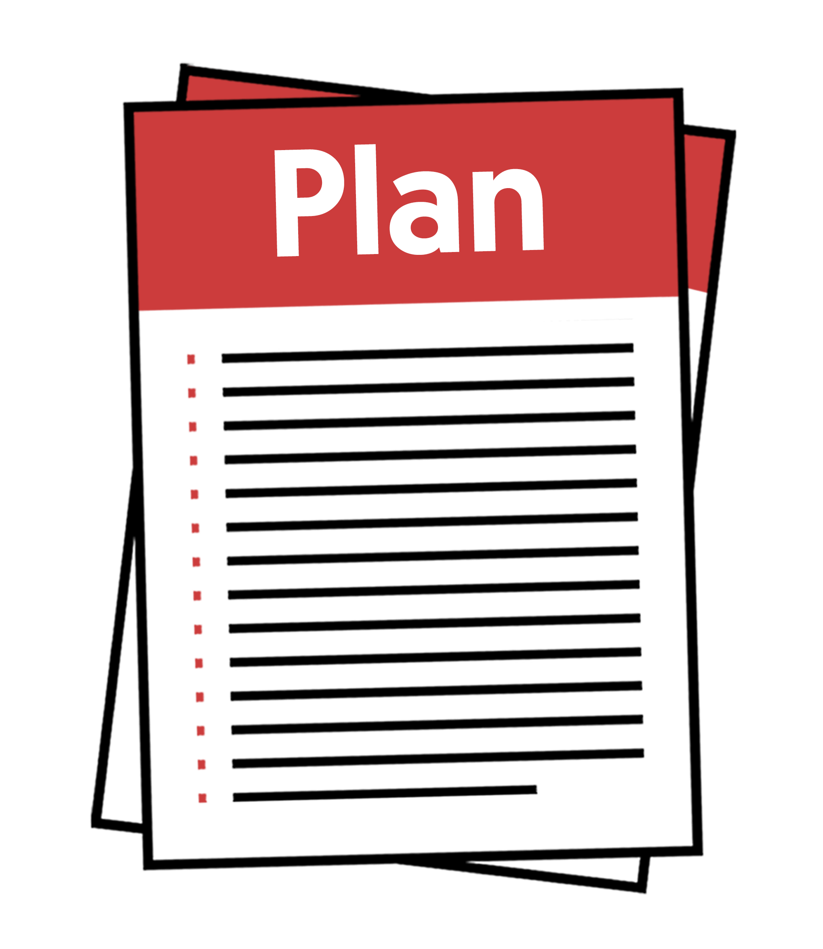
work with people who use a lot of fuel like businesses to make plans to use less fuel
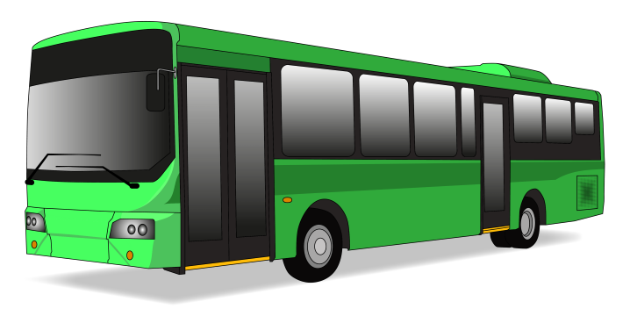
come up with ways to support people to use less fuel like increasing public transport
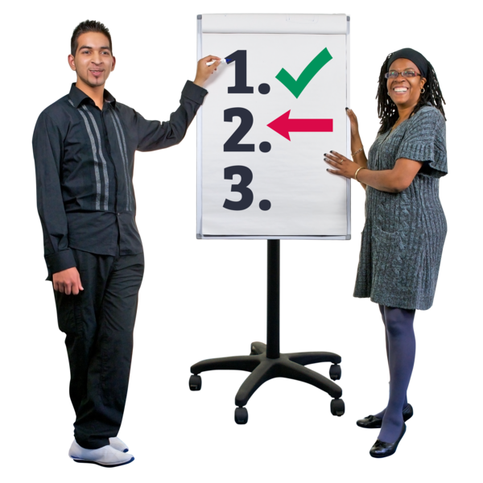
keep looking at what is going on
go back to Phase 2 as quickly as possible.

Fuel reserves mean fuel that has been stocked up to use later.

What you can do in Phase 3
In Phase 3 you can:
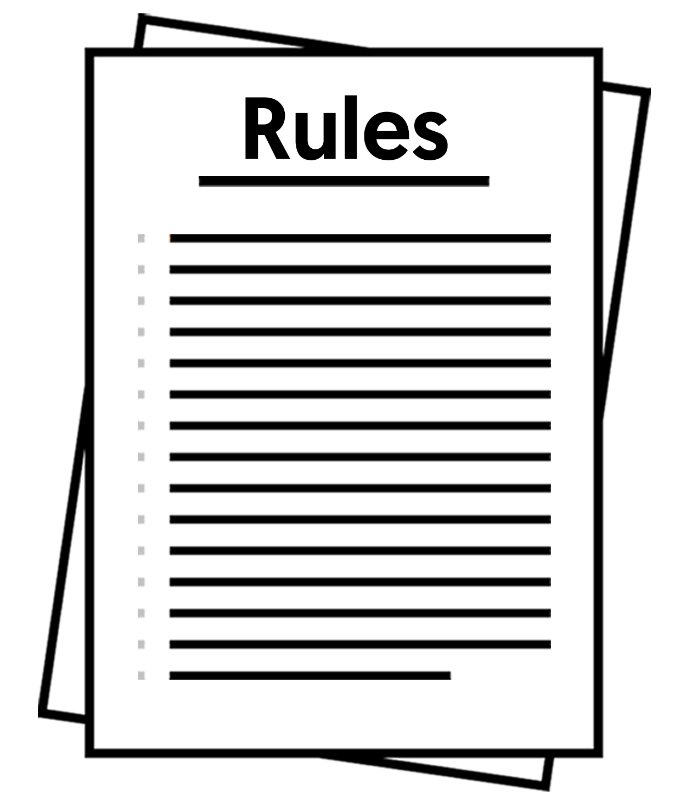
fill up your vehicle / car only when needed
follow any new rules
follow fuel saving
advice / information from the Energy Efficiency and Conservation Authority / EECA

Phase 4: Protected

What is happening in Phase 4?
Phases
1
2
3
4

In Phase 4:
there is not very much fuel
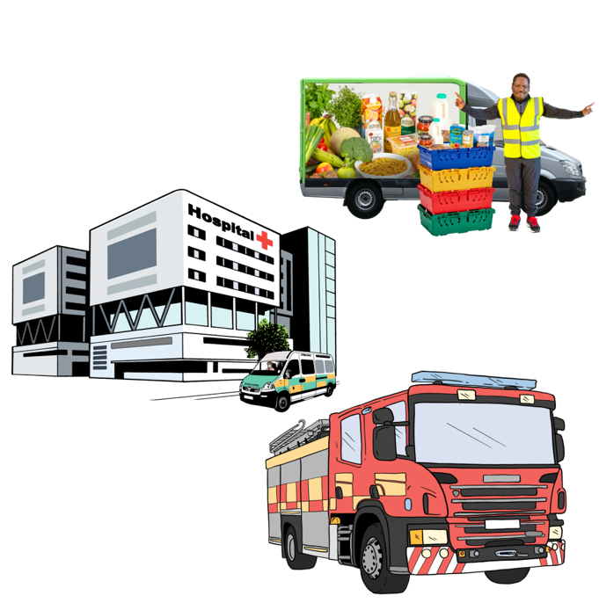
not having fuel might last for a long time
lots of work will be done to keep the most important services running.

This phase probably will not happen.

What will the Government do in Phase 4?
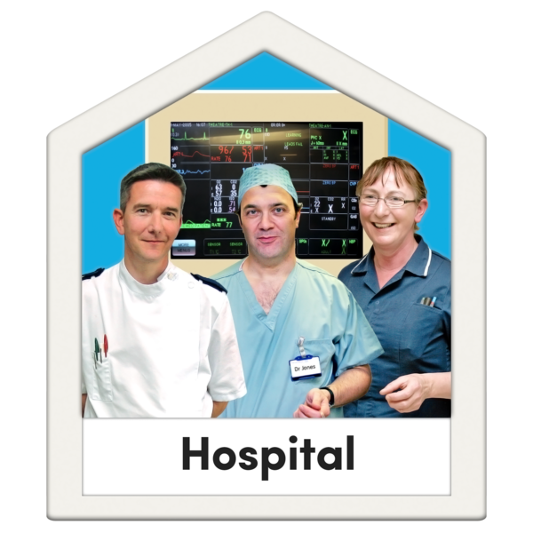
The Government will make sure there is always fuel for the most important services like:
life-saving services like hospitals
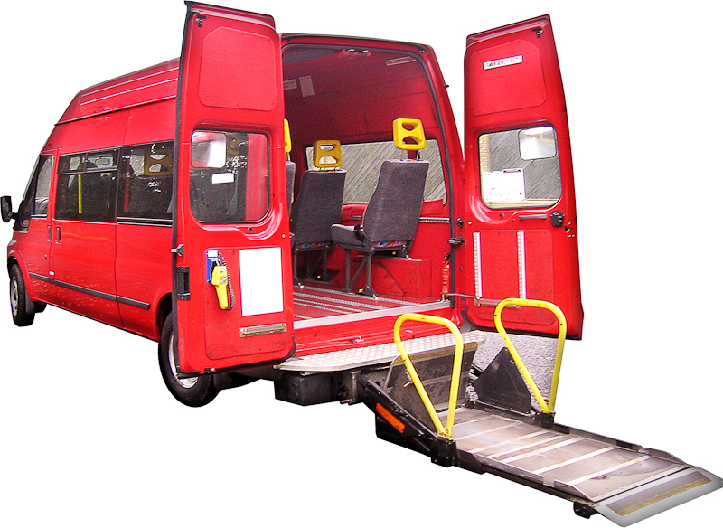
disability support services
banks
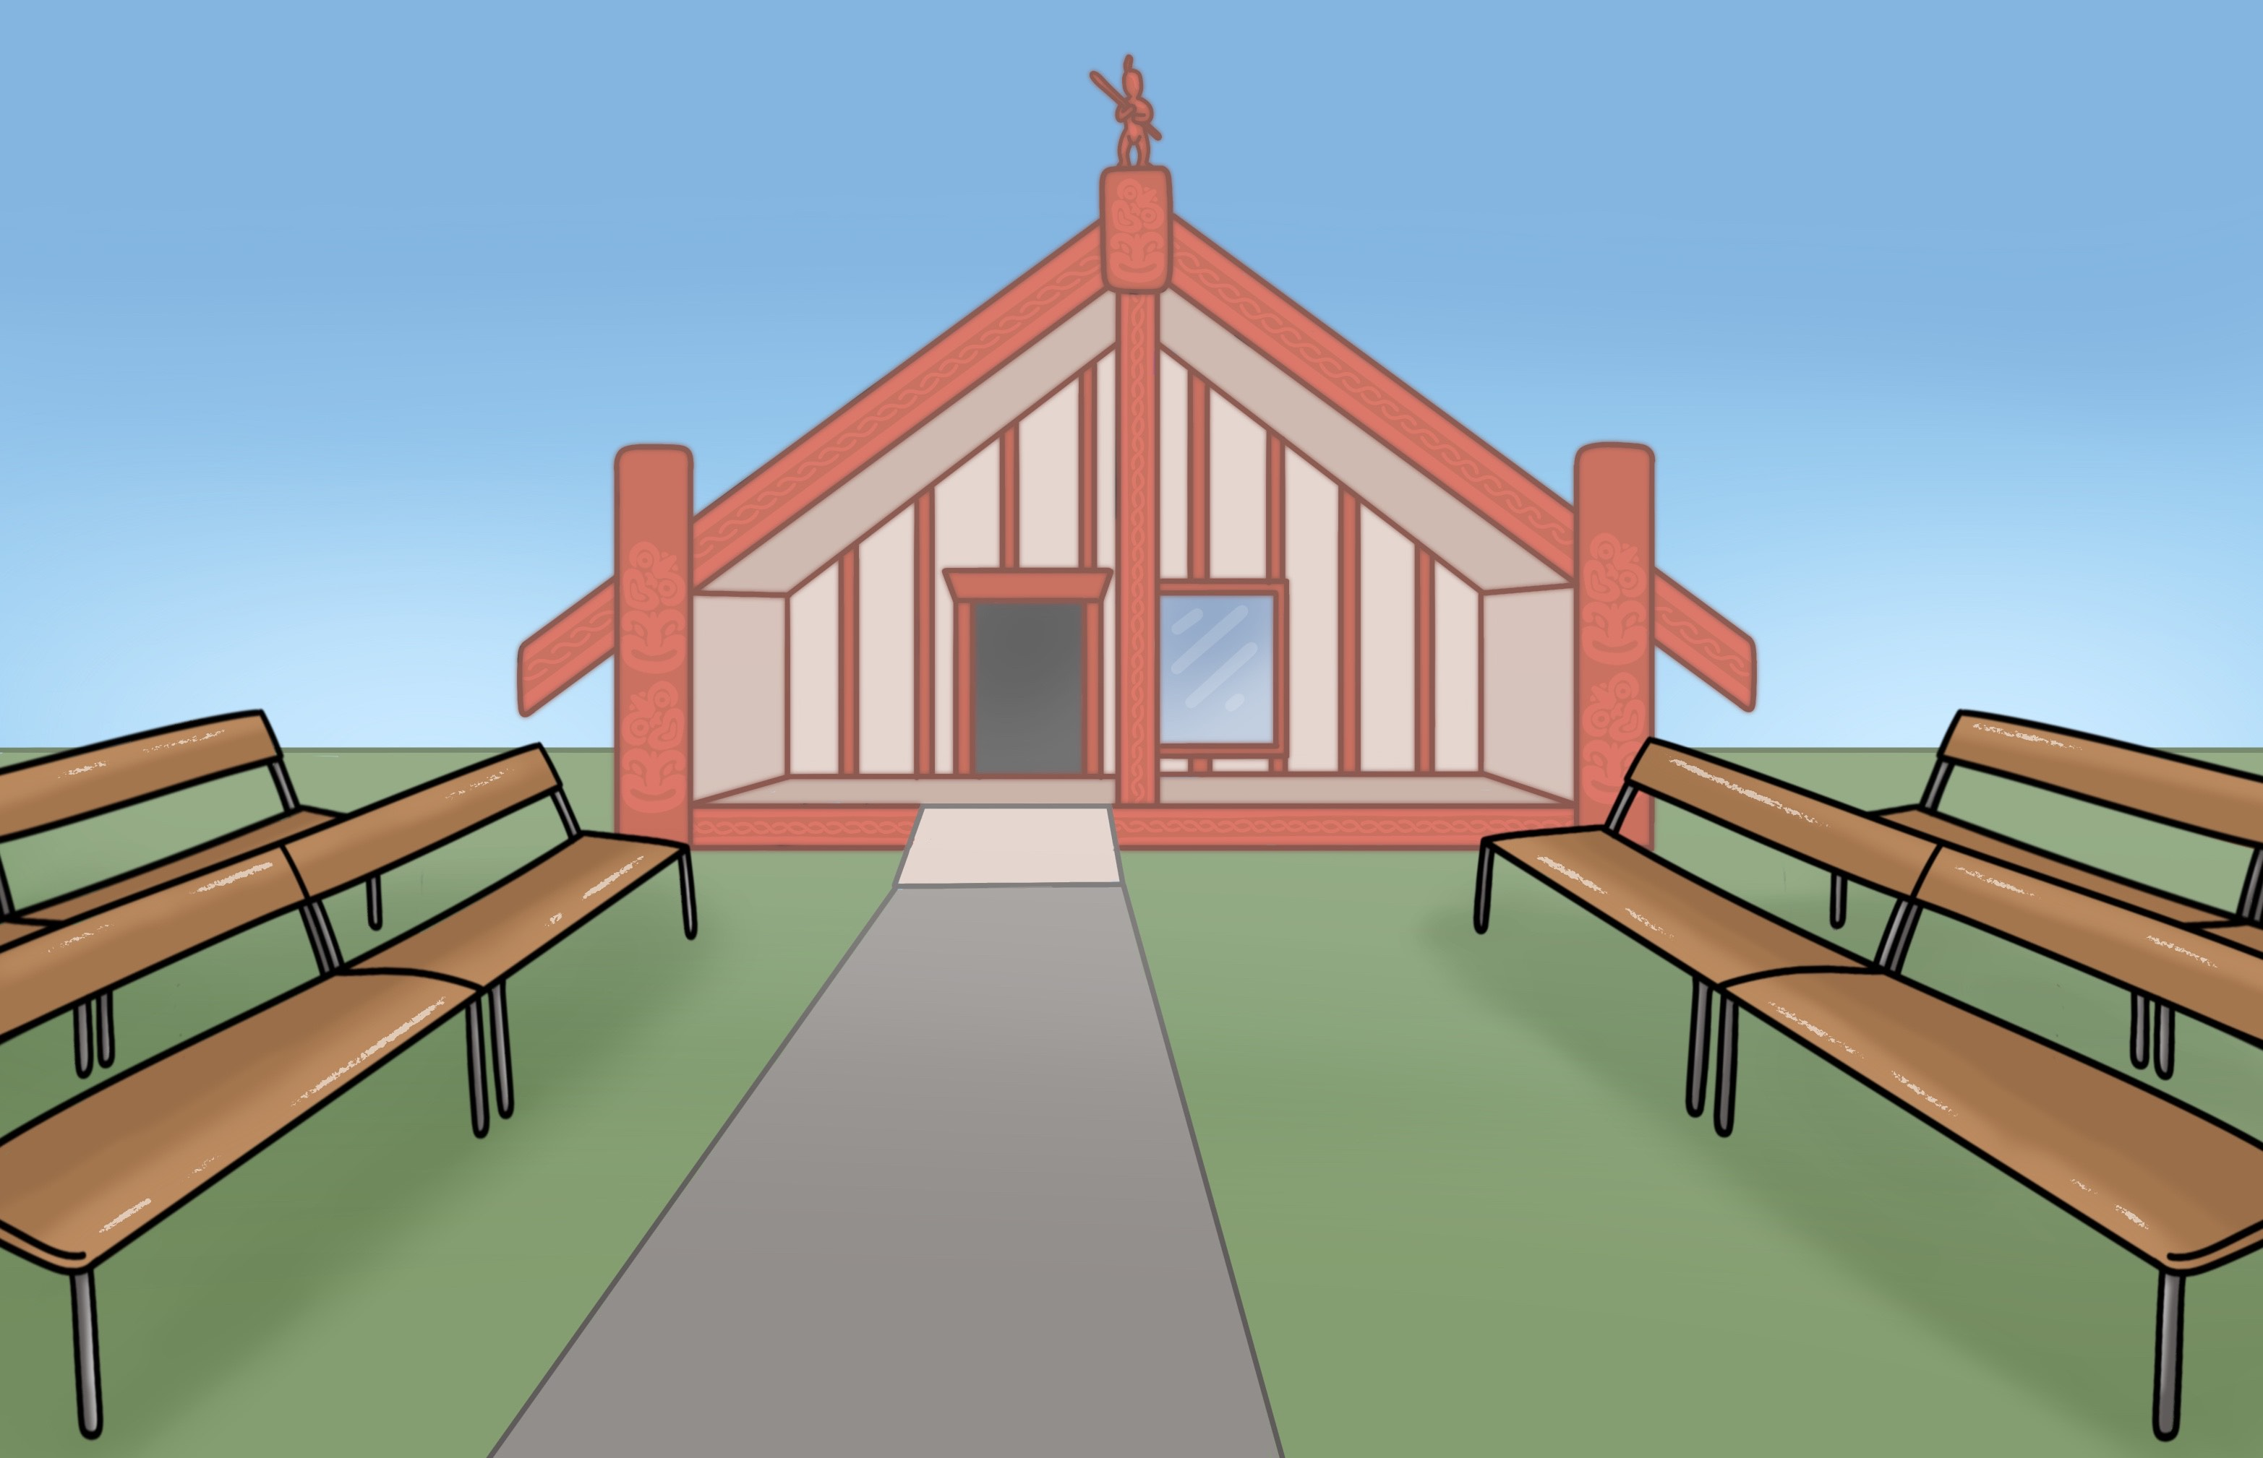
schools
marae
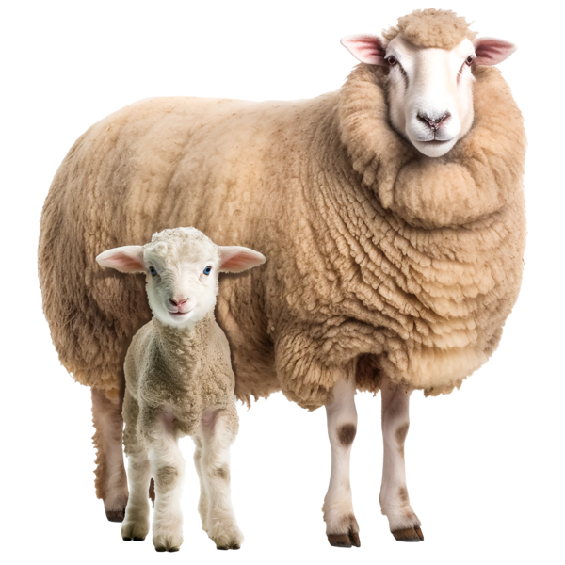
public transport
looking after animals
social services.
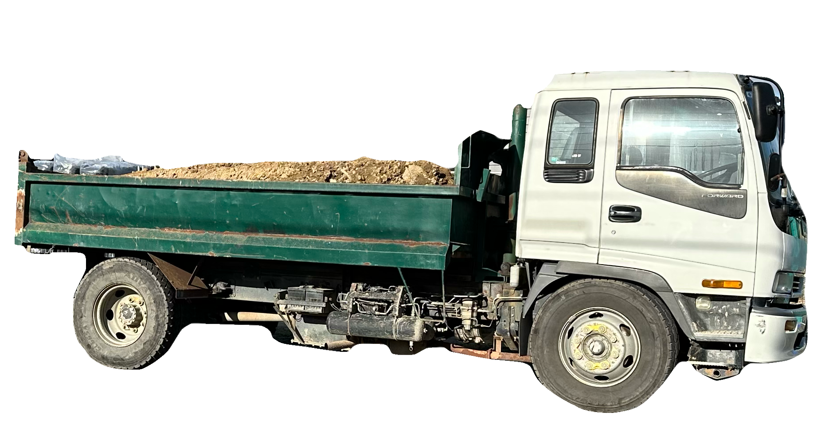
The Government will also:
make sure less fuel is used by:
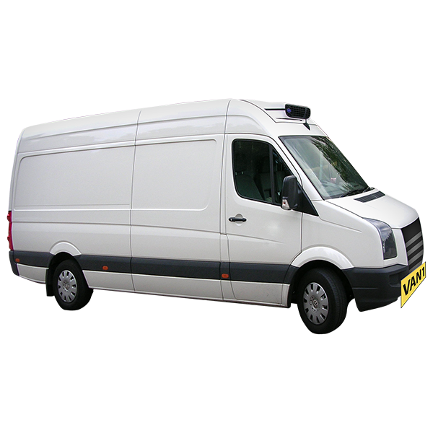
- businesses
- freight companies
- community groups
put a limit on how much fuel people can buy at petrol stations
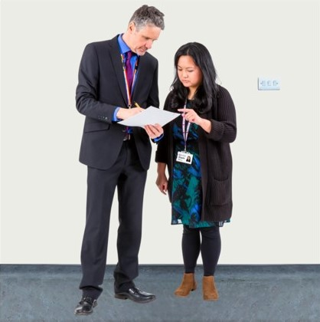
do spot checks to make sure people are following the rules
do penalties / fines if people are not following the rules
think about stronger rules to help save fuel
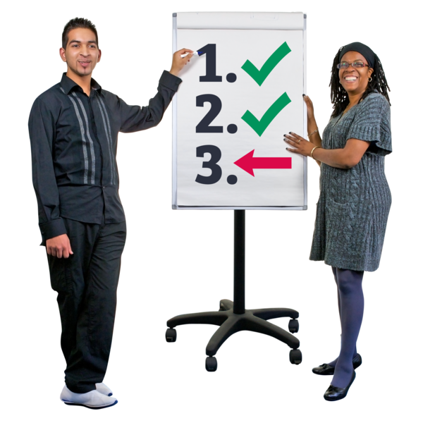
go back to another phase as soon as possible.

What you can do in Phase 4
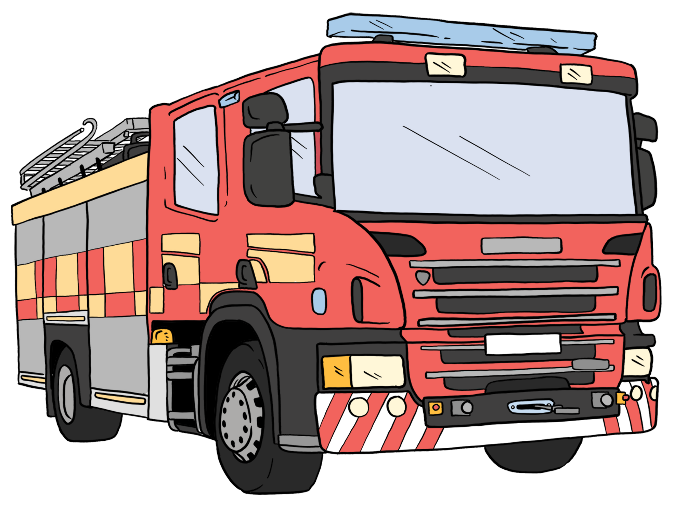
In Phase 4 you can:
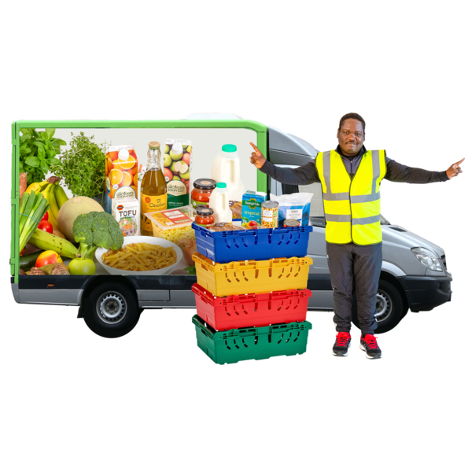
know important services will get the fuel they need
know that food supplies will get around the country
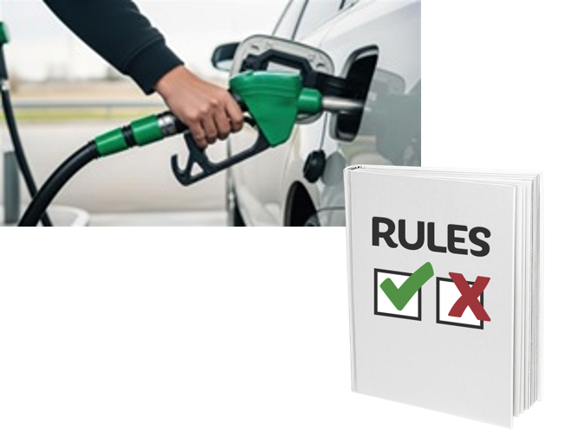
follow any new rules like how much fuel you can:
- buy
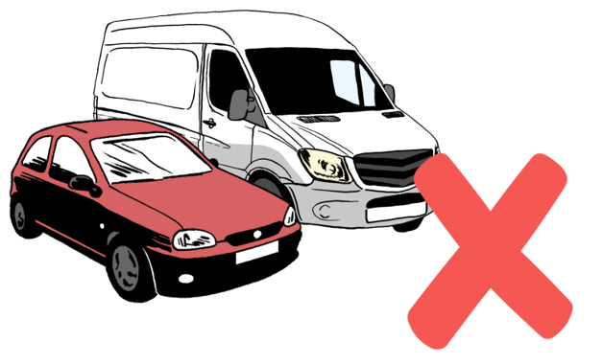
- use
not use fuel when you do not need to
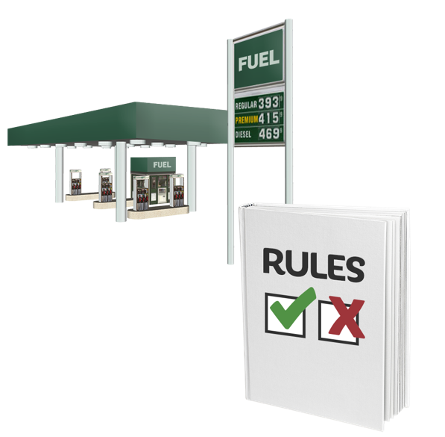
use the rules made for petrol stations.

Where to get more information

You can look at information about saving fuel from the Energy Efficiency and Conservation
Authority / EECA at this website:


https://www.eeca.govt.nz/fuel/

Some of the information on this website is in Easy Read.

In Phase 1 you can check the MBIE website for updates / information:

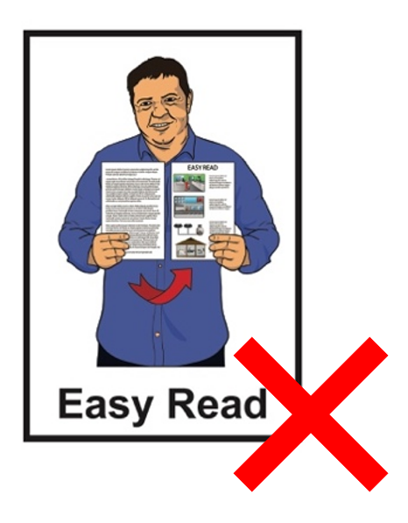
https://mbie.govt.nz/fuel

This website is not in Easy Read.

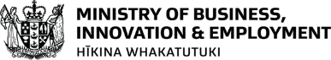
This information has been written by the Ministry of Business, Innovation, and
Employment – Hīkina Whakatuki.

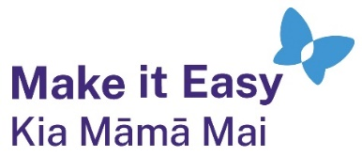
It has been translated into Easy Read by the Make it Easy Kia Māmā Mai service of People First New Zealand Ngā Tāngata Tuatahi.
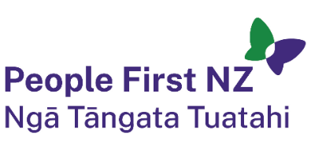
The ideas in this document are not the ideas of People First New Zealand Ngā Tāngata Tuatahi.
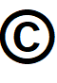
All images used in this Easy Read document are subject to copyright rules and cannot be used without permission.


Make it Easy uses images from:

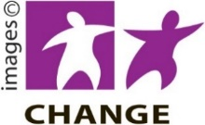
- Photosymbols

- Change Images


- Huriana Kopeke-Te Aho

- SGC Image Works

- T Wood


- Studio Rebeko

- Inga Kramer.

