
Barriers, enablers, and approaches for a more
circular economy

Report

March 2024

Research Objectives

This research project looks to identify the critical barriers and enablers to implementing a more circular economy in Aotearoa New Zealand by 2050, and how these could be addressed.

The main requirements were:
- Using a system context, identify the most critical barriers and enablers to implementing a more circular economy in Aotearoa New Zealand by 2050, reflecting in particular the implications of New Zealand's unique economic geography (small population, distance from major markets, thinly spread population, industry, and firm size structure etc) on circular activities, as well as other aspects of our ecological, cultural, and social context.
- Approaches that could address these, by providing tangible and practical examples of potential actions or interventions (not recommendations), that government or other actors could use to accelerate, or in other ways strengthen, the shift to a circular economy in Aotearoa New Zealand.
- Māori perspectives should be considered throughout, for example the relevance of te ao Māori worldviews, any barriers, or enablers particular to Māori, and opportunities for Māori business/industry to meet aspirations.
- Delivery of an engagement process/workshop, with involvement across the manufacturing industry and in collaboration with the Advanced Manufacturing ITP, to develop insights and actionable approaches about how New Zealand manufacturing can become a leading circular net-zero sector and contribute more widely to circular economy goals.

This project was delivered by The Connective, Arup and Project Moonshot from August 2023 to March 2024. With big thanks to MBIE officials and industry representatives who provided significant input.





CONTENTS

Research objectives | Page 2
Executive Summary | Page 4
Section 1: Research Approach  - Research Context  - Research Approach | Page 6  Page 7
Section 2: New Zealand Whole Economy – Research Findings  2.1 Whole Economy Introduction  2.2 Whole Economy Systems Map  2.3 Whole Economy Barriers and Enablers  2.4 Whole Economy Opportunity Areas  2.5 Whole Economy: Key Roles for Government | Page 14  Page 16  Page 17  Page 18  Page 22
Section 3: Manufacturing – Research Findings  3.1 Manufacturing Introduction  3.2 Manufacturing Systems Map  3.3 Manufacturing Barriers and Enablers  3.4 Manufacturing Opportunity Areas  3.5 Manufacturing Key Roles for Government | Page 23  Page 24  Page 25  Page 26  Page 30
Section 4: Food Sector – Research Findings  4.1 Food Sector Introduction  4.2 Food Sector Systems Map  4.3 Food Sector Barriers and Enablers  4.4 Food Sector Opportunity Areas  4.5 Food Sector Key Roles for Government | Page 31  Page 33  Page 34  Page 35  Page 38
Section 5: Built Environment – Research Findings  5.1 Built Environment Introduction  5.2 Built Environment Systems Map  5.3 Built Environment Barriers and Enablers  5.4 Built Environment Opportunity Areas  5.5 Built Environment Key Roles for Government | Page 39  Page 40  Page 41  Page 42  Page 46
References | Page 47
APPENDIX 1: Māori and a circular economy | Page 54
APPENDIX 2: Systems approaches | Page 61

Executive Summary
Circular economy transitions are a global response to a host of complex 21st century challenges that threaten – both immediately and in the longer-term – economic prosperity and resilience. A circular economy is one that designs out waste and pollution, keeps resources in use for as long as possible and recovers products and materials at the end of their lifecycle (EMF, 2024).
There are four interrelated drivers for governments and businesses to pursue more circularity: degenerating natural capital; declining finite material availability; climate risks and opportunities; and increasing competition and productivity, by stimulating innovation and creating higher-value jobs.
This research project identified the critical barriers and enablers to implementing a more circular economy in Aotearoa New Zealand by 2050, and approaches to address these. It focused on the whole economy and three sectors that can greatly benefit from becoming more circular: Manufacturing; Food; and the Built environment.
A systems approach, incorporating Mātauranga Māori, was utilised to help understand the complexity and interconnectedness of the 21st-century challenges that circularity aims to address. A systems approach can deliver: deeper understanding of critical intervention points; more value per dollar invested; avoiding unexpected harm and costs; increased innovation and productivity; and enhanced economic resilience (OPSI, 2024).
The research examined New Zealand's economic system within its distinct biophysical and social context, focusing on fundamental inputs and stocks, including raw materials, energy, water, infrastructure and technology, finance, social capital, and human capabilities. The identification of barriers, enablers, and their interconnections enabled a comprehensive understanding of the types of economic activities and interventions required to drive towards more circularity in New Zealand. Throughout this process we sought input from relevant government and industry subject matter experts and other stakeholders.
Whole Economy
Analysis of barriers and enablers for New Zealand’s economy to become more circular led to identification of the biggest opportunities for two economic pathways, ‘green growth’ and ‘steady state’.
‘Green growth’ aims for economic expansion, while addressing environmental challenges. ‘Steady state’ rests on a growing body of evidence that it’s not possible to keep growing while averting climate collapse and staying within planetary boundaries – it aims for sustainable prosperity without growth (Club of Rome, 2023). Despite appearing contradictory, in practice they do coexist. For instance, the European Commission is pursuing growth in the bioeconomy, alongside exploring how to downscale and localise production and consumption (European Parliament, 2023). Hybrid approaches like this may be the optimal pathway forward for New Zealand to drive productivity and economic diversification, amplify resilience, and protect natural capital for the long-term.
The biggest opportunity for New Zealand from a more circular economy will come from leveraging the nation's bio-based primary sector, both on land and in the ocean. This will involve lower-extraction practices and diversifying into high-value bioeconomy sectors, focusing initially on those that reduce import dependencies. Critical to this is supporting the growth of local manufacturing and securing the critical inputs, including raw materials and component parts, required for the transition.
Māori, with ownership and interest in sectors like forestry and oceans, are well positioned to lead here. This applies particularly to place-based approaches that foster self-determination and self-sufficiency, and that could offer insights into alternative models to enhance regional and national resilience. Mātauranga Māori can inform the development and brand of high-value circular products e.g. nutraceuticals. Note a shift to hapū centred enterprise rather than just iwi, that is more localised, anchored to place and informed by hapū specific Mātauranga.
Global competition poses the biggest barrier to diversification into high-value local manufacturing of New Zealand-grown biomaterials. Global prices reduce accessibility to local biomaterials, and it is challenging to compete as a small business or new industry against larger global companies (Wally, 2016). To address this, the key enabler for New Zealand is to strategically employ economic approaches with a track record globally of advancing economic prosperity while tackling 21st century challenges. These include industrial strategy, mission-oriented policy, and place-based approaches (Chang and Andreoni, 2020; Mazzucato and Kattel, 2023).
Manufacturing
The biggest opportunity for New Zealand's manufacturing mirrors that identified at the whole economy level. To leverage our significant primary sector, substituting unsustainable and high-embodied carbon materials with renewable ones like timber. Equally, there are opportunities to localise supply chains and secure critical raw materials (CRM) and component parts for New Zealand’s emerging clean tech sector. Accelerating existing transition metal recovery efforts and building regional relationships with stable trading partners will enable this.
The main barrier is the lack of policies to support existing local enterprises and innovation to become marketable at scale. For example, wood processors have competing demands for raw logs, primarily from China, where subsidies drive up the price (MBIE, 2019). Countries with successful global manufacturing sectors have implemented policies to allow local industries, in their early stages, to experiment and improve within domestic markets before facing intense competition abroad (Chang, 2011).

Food
Global trends exerting pressure on our national food sector include: international and regional regulations and policies for ‘low impact’ food products, transparency and documentation; international consumer demand for regenerative and organic food; and, domestically, declining social licence to operate for farming (mainly beef and dairy). Collectively, these trends are driving a rethink of the food system including how we grow, design, produce and consume products from start to finish.
New Zealand’s biggest opportunity is to focus on innovation upstream in the food value chain; this is where most environmental harm occurs – in particular to our freshwater, soil health and the climate, with flow on impacts to the competitiveness of exporters in an evolving trade environment where ‘green’ is the new competitive advantage. This opportunity involves scaling regenerative agriculture and aquaculture, and innovation in low-carbon food products, such as alternative proteins. These opportunities would be complemented by: new technologies and regulation to increase consumer-facing transparency; creating cross-disciplinary networks to advance innovation across the sector; and flagship place-based initiatives to test and demonstrate upstream food system solutions.

Built Environment
The built environment encompasses physical infrastructure such as buildings, transportation networks and utilities. Circular approaches design out waste, reduce volumes of virgin and toxic materials that hinder cascading use, maximise resource efficiency, and scale green infrastructure to realise the benefits of ecosystem services in urban areas. Construction and demolition waste account for up to half of all waste going to landfill (BRANZ, 2024). Much of this could be designed out up front or could be an input for new products.
Momentum is growing around modular construction, offsite prefabrication and adaptive reuse. Moving to a circular built environment will require investment in data development and digital tools, including material passports and a system to track materials through multiple lifecycles. It will also require the system-wide infrastructure needed to sort, store and deploy materials for more reuse and remanufacture rather than the current focus on recycling.

Research Approach

Research Context
Circular economy transitions are a global response to a host of complex 21st century challenges that threaten – both immediately and in the longer-term – economic prosperity and resilience. Chiefly, there are three interrelated drivers for governments and businesses globally to pursue more circular economic systems (EEA, 2023):
- Raw material availability: Geopolitical concerns, coupled with resource constraints, especially for fossil fuels and other critical raw materials, related to mining capacity, was the initial driver for a more circular economy in Europe (global leaders in circular economy) to bolster internal economic resilience.
- Climate risks and opportunities: More recently, climate change has come to the fore as a driver for the transition to more circular systems that can reduce emissions and provide resilience. This encompasses risks of continuing with BAU e.g., physical risks to land-based sectors and stricter international regulations, as well as opportunities e.g., emerging markets for green tech and meeting consumer demands.
- Degenerating natural capital: Declining health of the stocks of natural capital on which all economic sectors, and all life depends, has also more recently become a core driver of circular economy. Of such, ‘regenerate nature’ is now a key principle of mainstream circular economy initiatives.
A fourth driver for pursing a more circular economy, initially a consequence of the three above, is increasing competitiveness, stimulating innovation and creating higher-value jobs. The EU Parliament, who adopted a circular economy action plan in 2021 and released a package of actions in 2022, has identified competitiveness, innovation and an expected 700,000 new jobs in the EU by 2030 (European Parliament, 2023).
The three initial drivers shown above are complex, in the sense that they have no one cause, involve multiple interconnected elements, and exhibit non-linearity. Single-point solutions to complex problems often yield unpredictable outcomes and fall short of generating real change.
A central challenge when dealing with complexity is the underlying model for how we think about and solve problems. This model that has a long history in western thought. It seeks to compartmentalise living systems into parts and uses linear thinking and logic to make sense (McGilchrist, 2021). It has been very successful to date in driving human innovation, technological progress, living standards, and global wealth.
Today, this mainstream model for sense-making remains useful for solving simple or isolated problems. Increasingly, however, policy and decision-makers globally are realising it is unsuitable in the context of addressing complex 21st century challenges, like climate change. Indeed, there is now broad recognition that the narrow boundaries traditionally used to tighten goals and to solve problems is a root-generator of complex challenges. This is because while it makes a lot of sense to narrow boundaries to focus efforts and action, in doing so the risk is to cause harm elsewhere (Schmachtenberger, 2022).
Taking a systems approach to the underlying thinking, decision-making, policy, and ultimately transition towards a more circular economy in New Zealand supports:
- More value per dollar invested: The focus of systems approaches is to identify and strategically target leverage points to maximise value and impact. Investments at critical leverage points – the places in a system where a small shift in one thing can produce big changes in everything – can lead to more effective resource allocation (Meadows, 1999).
- Avoiding harm and costs: Systems approaches can support the identification of solutions that avoid creating more problems to deliver net-positive benefits.
- Increasing collaboration, innovation, and productivity: Radical collaboration is integral to systems approaches, which require building connection, coherence and synergies across multiple sectors and disciplines. Countries taking a systems approach to more circularity have found that collaboration fosters creative solutions, innovation and economic productivity (EIT, 2023).
- Enhanced economic resilience: Circular economy systems are often more resilient to external shocks, such as resource scarcity or changes in market conditions. A systems approach helps design circular systems that are adaptable and capable of responding to dynamic and unpredictable challenges.
See Appendix 2 for further information on systems approaches.

Research Methods
This research project aimed to identify critical barriers, enablers, and approaches to more circularity in Aotearoa New Zealand’s whole economy, with deeper analysis in three focus sectors: manufacturing; food; and the built environment.
To identify systemic barriers and enablers, and potential solutions to address these, we employed an iterative six-phase research process (see Figure 1 below), underpinned by a systems approach.
Each of the six phases employed a combination of desk-top review of already published material, and new primary research. The latter involved engagement with subject matter experts in manufacturing, the food system, and built environment, at various points in the research process.

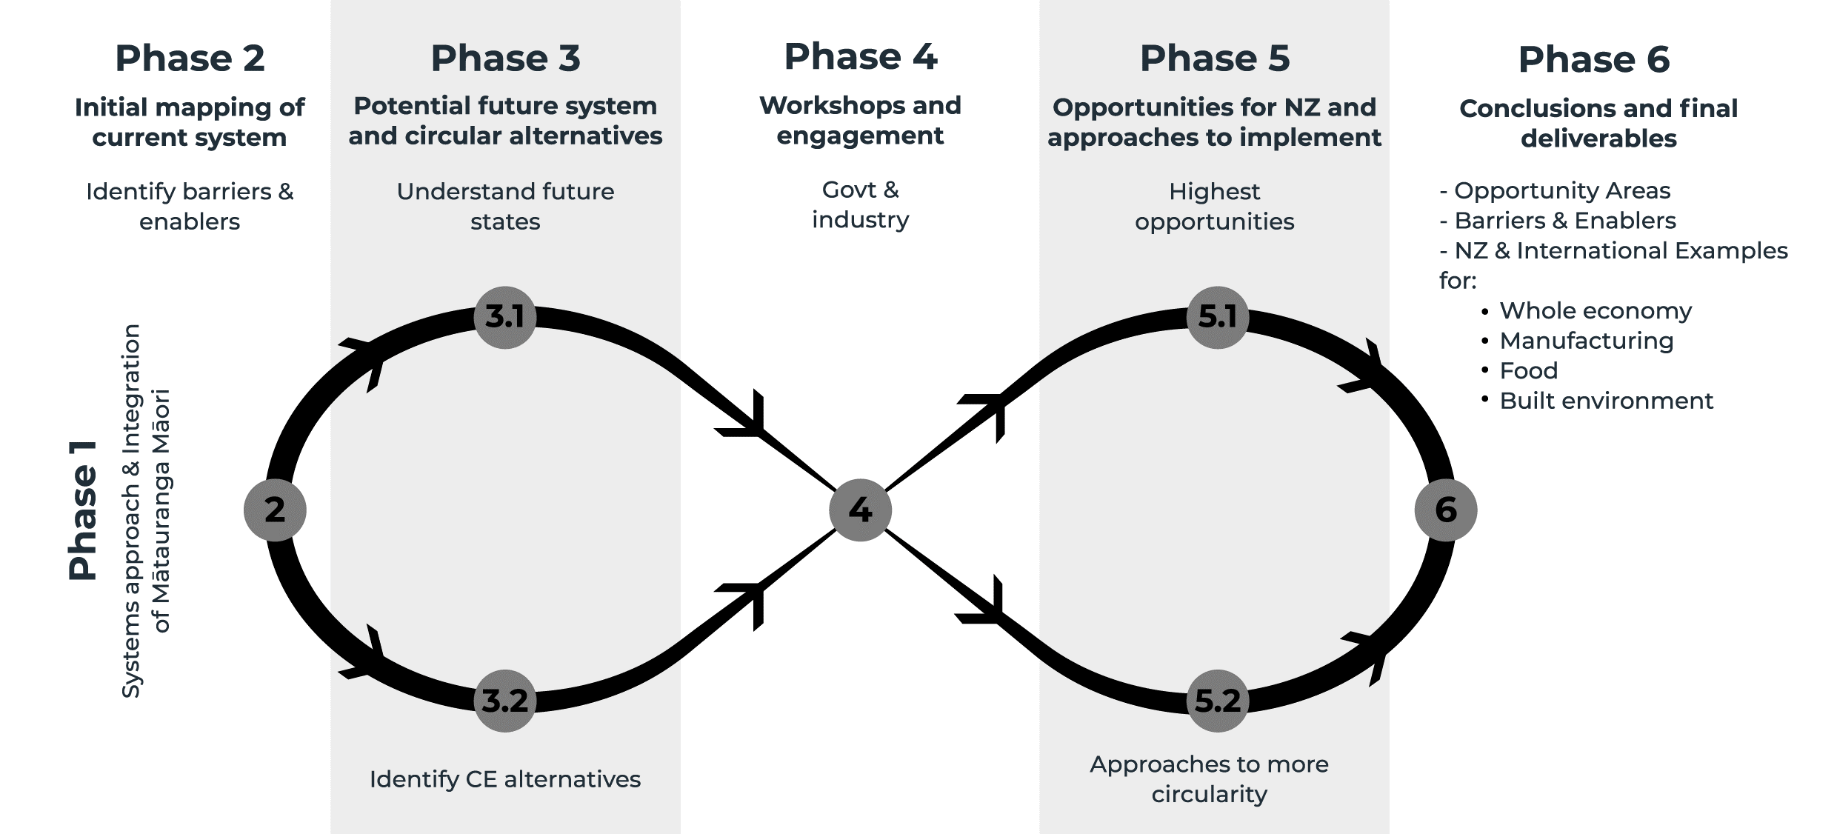
Figure 1. Six-phase research process

Phase 1: Foundations – Systems Approach and Mātauranga Māori
This phase focused on building collective and clear understanding of type of systems approach to employ, including the integration of Mātauranga Māori, to underpin all activities and final deliverables (see Appendix 2). It also involved the development of engagement plans and the identification of key stakeholders (at government, industry, and niche innovator levels) to be engaged, to help ensure the findings and final deliverables add tangible value in the immediate and longer-term.

Systems approaches in Aotearoa New Zealand – a binocular approach
While Europe is known globally as a leader in systems approaches to guide green and circular transitions, indigenous peoples have inherently systemic worldviews. New Zealand has an advantage to learn from and give standing to te ao Māori and Mātauranga Māori, to cultivate systems approaches unique to Aotearoa to address 21st century complex challenges.
Mātauranga Māori is a system of knowing, knowledge and thinking, experience and wisdom. It is anchored in holistic philosophy, values, and beliefs, where everything and everyone of the universe are interconnected through intergenerational-symbiotic relationships (whakapapa).Te ao Māori knowledge systems have developed over 1000 years of observation, applied learning and practice within Aotearoa. This knowledge has been drawn from 10,000 years of knowledge and experience from throughout Moana-nui-a-Kiwa (the Pacific).
As illustrated in Figure 2 below, we employed a dual-systems binocular approach, involving both Western systems thinking (te ao ō Te Uru) and Mātauranga Māori systems thinking. While there are multiple Western systems approaches, all seeks to ground analysis and decision-making in the complex and interconnected reality of the natural world. Those used for analysis in this report are detailed below (see Figure 3, New Zealand’s economy in biophysical and social context and Multi-level Perspectives Framework). A te ao Māori systems approach seeks to ground understanding and decision-making in sustaining (rangatiratanga), caring (manaakitanga) and protecting (kaitiakitanga) the intergeneration symbiotic relationships (whakapapa) between people, place, nature, and the wider universe.
When used in tandem, mana and respect can be given both to Western and Māori systems approaches. This dual-systems Binocular lens (see Figure 2 below) demonstrates that each lens can be applied independently or interdependently together. When used to complement each other, the ‘third space’ or view beyond, draws on the strengths of both – leading to a place of collective oranga, or wellbeing. The challenges we are facing present an opportunity for us to re-imagine, re-frame and re-set the current system in:
- The way we respond and resolve issues generated from the past
- Meeting the needs of our current generations
- The way we navigate a future of uncertainty, change, and potential significant impacts for future generations
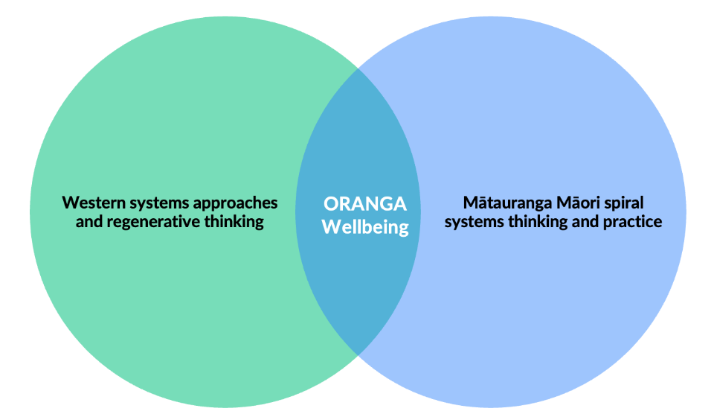
- The way we heal our relationships with nature, and with each other.

Figure 2. A binocular view of systems approach in Aotearoa New Zealand (See also Appendix 1. Māori Systems approach)
Western systems approaches: Our economy in biophysical and social context
A systems approach involves considering New Zealand's economy in its biophysical context, encompassing its soils, fresh water, oceans, and various raw materials, with energy serving as the 'master resource' enabling the utilisation of all inputs and all economic activities. How we sustain, extract, use, and dispose of these resources affects the health of the biosphere – on which on-going prosperity depends.
In 2020, the Ministry for the Environment commissioned a Planetary Boundaries assessment to offer a comprehensive view, beyond climate change. The assessment revealed that New Zealand significantly exceeds its "fair share" of impacts, in all five boundaries assessed (see Figure 3 below). Notably, in additional to climate change, the country's major transgressions (in biogeochemical flows, freshwater and biodiversity loss) relate to nitrogen and phosphorus boundaries, exceeding fair share levels by factors ranging from 4 to almost 55 times. Here, production-based transgressions outweigh consumption-based transgressions, reflecting New Zealand's substantial agricultural net exports (Andersen et al, 2020).
The Planetary Boundaries assessment provides a valuable starting point for a systems approach to circularity that places economic thinking and decision-making in its biophysical and social context. This is critical from a global equity perspective, given the disconnect between New Zealand's overshoots and global sustainability goals, including the Paris Agreement. On a practical-level, overshoots threaten the fundamental natural capital inputs and stocks on which New Zealand's economy and future prosperity depends (Figure 3).
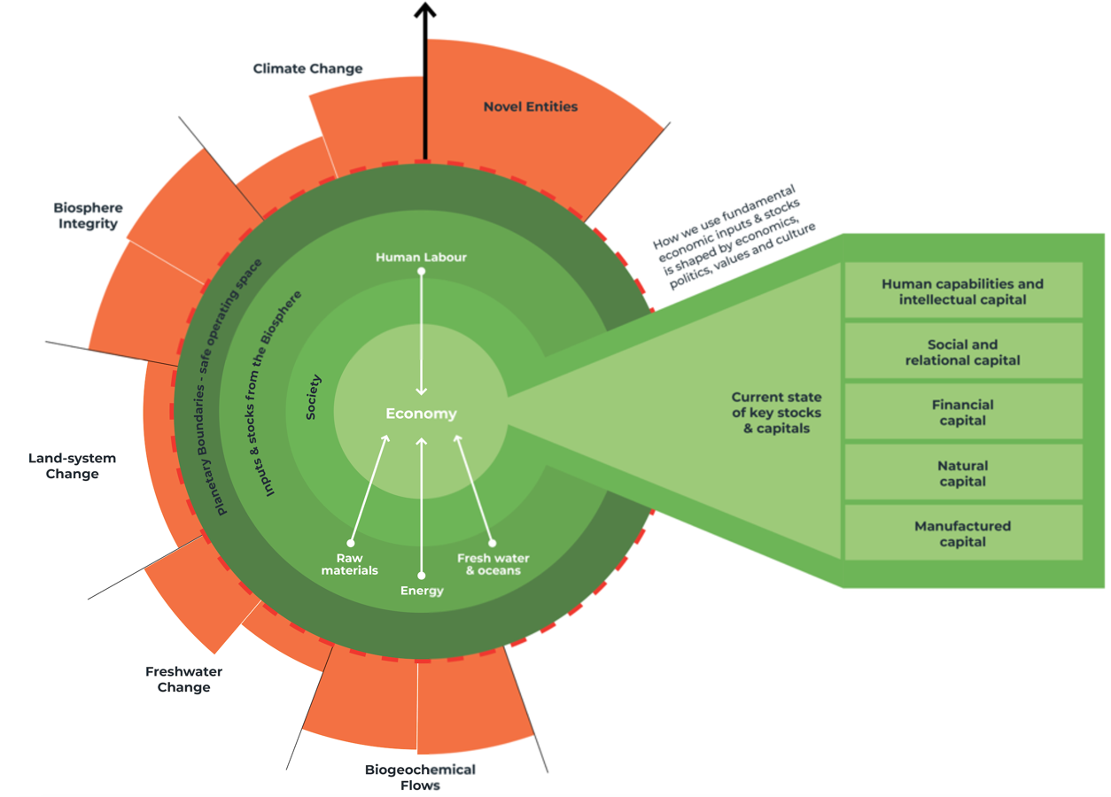
Figure 3. New Zealand’s economy in biophysical and social context
Figure 3 above provides an illustration of our economy in its biophysical and social context. It consists of critical components for decision-makers to consider in order to safeguard long-term economic prosperity and the holistic wealth of New Zealand.
- Fundamental economic inputs and stocks: These include the raw materials, energy, freshwater, oceans, and human labour on which economic activity depends. To ensure sustained prosperity, it's crucial to restore and maintain the optimal health of these resources.
- Political and economic ideals, underlying values and culture: This ‘unseen’ element shapes how we utilise fundamental inputs and stocks from the biosphere to meet human needs and wants, as well the current health of planetary boundaries and each of the five capitals.
- Five capitals: Adapted from NZ Treasury’s Living Standards Framework, understanding the current state of each capital, how they interact, and how they need to evolve, will be key to circular economic transition that produces better outcomes for all New Zealanders, our local ecosystems, and the climate.
- Planetary boundaries: As this framework becomes mainstream globally to assess the ‘fair shares’ of countries’ impacts to earth systems – New Zealand will also be held accountable.
All of the above components have guided the identification of the key barriers and enablers to a more circular economy, as well as the biggest opportunity areas for Aotearoa New Zealand.

Phase 2: Initial mapping of barriers and enablers in current system
Barriers and enablers were identified using the structure of the Multi-level Perspectives (MLP) Framework (see Appendix 2, Systems approaches). The MLP tool can support policymakers to understand the complexities of socio-economic systems and identify points of intervention to drive meaningful change (EEA, 2017). MLP has evolved from the study of real-world socio-economic transitions, acknowledging that these transitions are often non-linear and involve disruptions and resistance from entrenched interests within the current system. It operates on the premise that transitions are shaped by interactions between three interconnected levels:
- Landscape: The ‘seen’ landscape of events and trends, such as economic growth, climate change, and current business practices, that can over time place pressure on a system to change.
- Meso-level: The underlying ‘system’ that acts to ‘lock-in’ what we see at landscape level. This level consists of a network of interconnected elements, including cultural values, worldviews, and ideologies; elements of socio-economic systems (the economy, government, and communities) designed to meet human needs and wants; and tangible infrastructure and technologies.
- Niche innovations: These are the emerging practices, enterprises, policies, technologies, and products that ‘open up’ possibilities for fundamentally different ways of living together well.
Key barriers and enablers to circularity were identified and mapped against all three levels of MLP for the current state of New Zealand’s whole economy and all three focus sectors. This identification integrated the components of Figure 3 above at the meso-level, to capture social and biophysical elements that shape our current system. Barriers and enablers identified through this process informed where systemic opportunities for circularity lie in New Zealand’s economy (see Phase 4 below).
Phase 3: Potential future system and initial circular alternatives
What a ‘future’ – more circular – system for Aotearoa New Zealand will look like is unknown. To inform discussion on possible or preferred future systems for New Zealand, there is value in understanding the conversation that has emerged internationally as to whether circularity can plug-in to our existing economy (‘green growth’), or whether circularity demands a fundamentally new economy that is independent from ongoing economic growth (‘steady state’) (European Parliament, 2023; Michaux, 2019).
While there are multiple possible economic futures, two pathways were the focus of this report, ‘green growth’ and ‘steady state’. The purpose of Phase 3 was not to draw any solid conclusions, but rather to provide initial insight into how each pathway is relevant to circularity, how each can inform the identification of opportunities at whole economy, and where the two pathways can complement each other to bolster both productivity and resilience.
Phase 3 also identified a long list of examples of circular systems and practices, (‘circular alternatives’), in New Zealand and abroad.

Phase 4: Workshops and Engagement
To sense-check early research findings on barriers, enablers, and approaches to more circularity, a series of interviews were conducted, and workshops hosted for whole economy (government officials) and two focus sectors: built environment and manufacturing (industry focus). The interviews covered these areas and included interviews with food sector stakeholders and Māori economic leaders. This engagement additionally sought to ascertain existing levels of understanding and ambition for circularity, and where this research project could best add value.
More than 150 people were engaged in the various workshops and interviews over the life of this research project. Industry engagement was through industry associations, special interest groups and with individual companies covering the spectrum of manufacturing, food, built environment and Māori business from across the country. Government officials from relevant departments and crown owned entities were engaged primarily in the whole economy analysis and in providing understanding of previous, current and planned policies and government initiatives.

Phase 5: Opportunities for New Zealand and circular approaches
Phase 5 is a synthesis and analysis of key outputs from Phases 1 to 4. Opportunities for more circularity were identified at whole economy and the three focus sectors using the logic of the MLP framework. This involved analysis of the confluence of barriers and enablers identified at all three levels, in particular:
- Areas of highest pressures and opportunities at landscape level: Including macro global pressures, such as shifting international standards and regulations, as well as more localised drivers, such as climate-related risks to land use sectors.
- Shifts at the meso-level: For example, changes in underlying values and culture, new technologies, and evolving industry practices.
- Niche activities: Existing circular alternatives in New Zealand that, if given greater support, could accelerate more circularity.
Consistent with Phase 2, insights from research on the components of Our economy in its biophysical and social context (Figure 3 above) played a role in the identification of opportunity areas. For example, raw material inputs identified as inherently unsustainable or vulnerable (e.g., to supply chain shocks), were a core factor in the identification of many opportunity areas. Equally, sectors that generate high levels of waste and emissions in their supply chains are at risk, as standards and regulations globally tighten on sustainability and climate-related targets.
At whole economy-level, additional analysis was undertaken through two pathways; ‘steady state’ and ‘green growth’ (see section 2.1 below).

Phase 6: Conclusions and final deliverables
The final phase of this project involved working with officials and industry leaders to reiterate and refine the three final deliverables for the whole economy and each of the three sectors:
- Barriers and Enablers were initially identified through a mix of primary and secondary research, including through interviews with leading circular economy practitioners in New Zealand and internationally. The most critical barriers and enablers were identified through the systems mapping process (See ‘Systems Maps’ directly below and Phase 2 above).
- Systems Maps present the set of barriers and enablers to circularity identified through the research and organised into eight different domains (Government; Financial; Human Capabilities; Social; Physical infrastructure; Industry; World view; and Natural).
Each barrier and enabler is mapped to others that they influence or are influenced by, both negatively and positively. This process uses the logic of the MLP framework and the components of Our economy in its biophysical and social context (see Figure 3 and Appendix 2). The barriers to circularity and enablers of circularity are then ranked as having low, medium or strong system connections. The stronger the system connections, the more impact they can have. These in turn, fed in to the shaping of the opportunity areas.
- Opportunity Areas were also identified using the logic of MLP (see Phase 5) and were discussed and reiterated with key stakeholders. This covered the whole economy, manufacturing, the food sector and the built environment. Identification of the opportunity areas included analysis of the roles that government could play to help deliver the opportunity, both short term (next 2 years) and long term (2+ years).
This final phase included the analysis of Māori priorities against the wider findings.

New Zealand Whole Economy Findings
2.1 New Zealand Whole Economy Introduction
New Zealand has an open economy, characterised by a significant primary sector and multiple service industries. While there is considerable variation in economic activity between regions, typically major urban centres generate GDP from professional services and rural areas specialise in export-orientated primary sector activities (MBIE, 2024). While exports of raw and manufactured biomaterials generate billions annually, this is overshadowed by property-related service sectors; collectively these are the biggest share of national GDP.
New Zealand struggles with slow productivity growth, with flow-on impacts to real incomes and the ‘cost of living’ crisis (Productivity Commission, 2023). A further challenge is that standard land use practices degenerate the natural capital on which long-run economic prosperity depends. Areas of particular concern include soil and water health, linked to unsustainable use of fertilizer, and alarming biodiversity loss. New Zealand has the highest proportion of species threatened or in danger of extinction in the world (Joy, 2019). The risks here are not just physical, our trading partners and global consumers are increasingly demanding ‘low impact’ products, with transparency across the supply chain.
The circular economy offers multiple opportunities for New Zealand. Of immediate importance, the process of circular transition is associated with significant productivity gains because more circularity requires transforming the renewable energy industry and every single aspect of manufacturing (Mazzucato, 2023). It is manufacturing, over and above primary and service sectors, that lends naturally to increases in productivity because technology and chemical processes can transform production activities (Chang, 2014).
Analysis identified that New Zealand’s biggest cross-cutting opportunity lies in sourcing ‘circular resources’ locally from the primary sector and channelling them into local ‘green’ manufacturing of high-value products in the bioeconomy. This will amplify resilience, regenerate ecologies, and drive productivity growth. Realising this opportunity requires a three-fold approach: (i) harnessing biomaterials and channelling them into high-value manufacturing areas in the bioeconomy, focusing first on those to replace import dependencies; (ii) accelerate transition to regenerative and lower-extraction land and ocean practices; (iii) secure the critical raw materials, clean technologies and infrastructure required to enable bioeconomy activities.
The biggest barrier to New Zealand realising the benefits of localised and circular resources use is our open economy. This can pose challenges for manufacturers to access local biomaterials. Countries with successful global manufacturing sectors have implemented policies to allow local industries, in their early stages, to experiment and improve within domestic markets before facing intense competition abroad (Chang and Andreoni 2023; Mazzucato and Kattel, 2023).
A further consideration for New Zealand is that the logic of comparative advantage underpinning open economies is less appropriate in today’s international landscape. While exporting what you specialise in and importing what you do not works well in times of global stability and abundance, this is not the case now – nor will it be in the foreseeable future (Council of the European Union, 2024). Declining access to abiotic materials, increasing competition, volatile prices, and ongoing geopolitical tension means that ‘open’ and interconnected supply chains are vulnerable. For New Zealand to tailor policy to our current global landscape, lesson can be learnt from industrial and mission-orientated approaches to realise productive growth, more circularity and resilience (OPSI, 2024).
The global landscape driving countries to prioritise circular efforts is largely precautionary; peak oil in 2018 sparked concerns about declining finite abiotic materials; trade and commodity prices are volatile; and the dangers linked to crossing planetary boundaries are imminent and real. Notably, it is against this backdrop of concern – arising when our global economy is placed in its biophysical context – that countries leading in circular transitions are starting to examine ‘steady state’, alongside ‘green growth’ (see box 1 below). To support decision-making that is informed by this global trend, opportunities for more circularity in New Zealand were identified considering both green growth (pathway 1) and steady state (pathway 2) pathways for cross-cutting elements of our economy (see sections 2.4.3 and 2.4.3).
Box 1. Green Growth and Steady State: Green growth focuses on enhancing our current economic system with environmental and social goals, aiming to decouple growth from resource use and environmental harm. A steady state economy considers that there are ‘limits to growth’, when our economy is placed within its biophysical context (Club of Rome, 2022):
- Materials constrains: Real economic growth depends on raw material extraction, in particular fossil fuels. As finite reserves drawn down, with peak oil hitting in 2018, the need for critical raw materials (CRM) to construct renewable technologies to replace fossil fuel dependence has become urgent. The realisation that mining capacity for CRM falls far short of meeting global demand has prompted serious consideration of "beyond growth" models, such as steady state (IEA 2024; Yergin, 2023).
- No evidence of decoupling: Transitioning to a circular economy is driven by the imperative to reduce resource use and avoid exceeding planetary boundaries. A comprehensive review of real-world decoupling efforts however, commissioned by The European Environmental Bureau, concludes “there is no empirical evidence supporting the existence of a decoupling… on anywhere near the scale needed to deal with environmental breakdown…[and]… such decoupling appears unlikely to happen in the future.” (Parrique et al, 2019, p 3).
Embracing, evaluating, and drawing from green growth and steady state perspectives will enable intelligent decision-making and policy that understands the risks, viability and opportunities each offers. Importantly, green growth and steady state solutions are not mutually exclusive; rather, many of their strategies can complement each other. For example, the European Commission and many countries in Europe are actively pursuing growth opportunities in the bioeconomy, while also working to understand and implement a downscaling of production and consumption.
Examples of the latter include: The 2023 Beyond Growth Conference, organised by members of the European Parliament to discuss the need for systemic and transformative approaches beyond growth; European Commission funding to understand the role of regulations and power dynamics in downscaling the urban metabolism; Advice to governments from material scientists on the physical limits of access to abiotic and biotic materials, promoting need to downscale and localise material and energy throughput to safeguard against future shocks; Innovation in low-material input and low-energy demand technologies to safeguard against declining material availability.
This hybrid approach mirrors Horizon 2 and Horizon 3 thinking and would mean simultaneously pursuing short- to medium-term green growth strategies (Horizon 2) while strategically planning and piloting steady-state solutions (Horizon 3). This approach could be an optimal one for governments to navigate the nuances, contradictions, and uncertainties inherent in economic transition – mitigating risk and cultivating resilience to build a sustainable future for long-term prosperity.

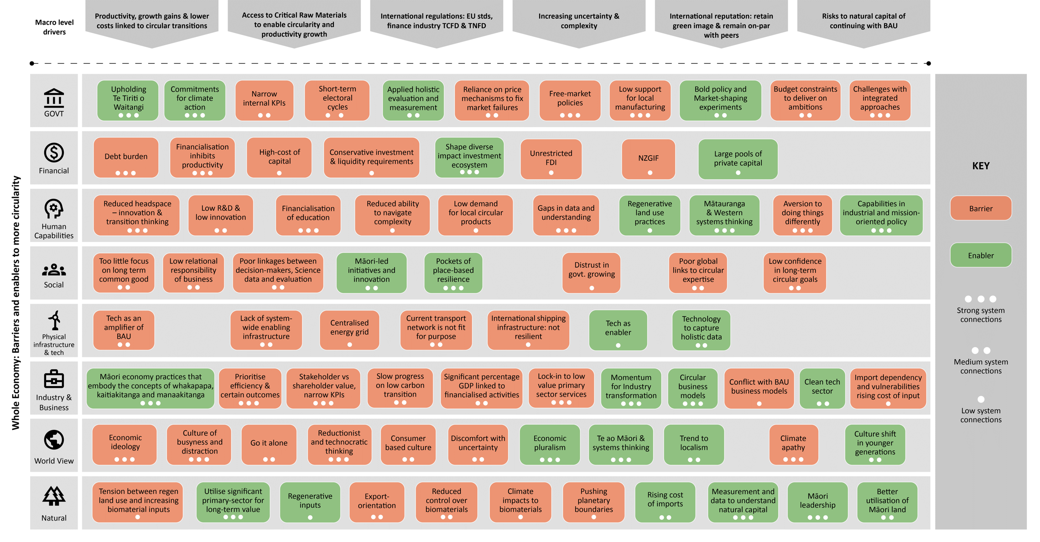
New Zealand Whole Economy Systems Map
Figure 4. New Zealand Whole Economy Systems Map. The stronger the system connection, the higher the leverage point to support a more circular economy.

Whole Economy Barriers and Enablers
    - Whole economy barriers to a more circular economy
- Low support for local manufacturing – in context of global competition – inhibits productivity growth and maintains lock-in to lower value primary and service sectors
- Information gaps and incomplete feedback loops for understanding priority focus areas
- Single issue problem solving and challenges to integrated approaches, in particular narrow internal KPIs, finance, and public/private alignment
- Lack of long-term planning and commitments from government deter investment in transition capabilities, technology and practices
- Poor linkages with global expertise in circular transitions
- Economy-wide financialisation can inhibit productive real activities and innovation.
- Low investment in innovation as percentage of GDP relative to peers
- Limited consideration of biophysical realities in economic activity and decision-making has led to a deterioration of the natural capital on which ongoing prosperity depends
- Complex and interconnected global trading environment is increasingly unpredictable
- Market-fixing mechanism (e.g., pricing) alone won’t solve complex challenges
- High private and public debt create a tension between short-term profit and investment in upfront patient capital required for transitions
- Perception that climate risks are a distant future problem – we don’t need to act now
- Challenge accessing circular transition capital and capabilities, especially for SMEs

    - Whole economy enablers to a more circular economy
- Significant underutilised primary sector to enable circular resource use
- Industry understanding that ‘circular’ is the new comparative advantage globally – working with industry to realise this opportunity in export markets
- Supporting existing pockets of place-based initiatives to build local wealth and resilience
- Filling data gaps to support intelligent decision making
- Setting broad long-term goals and commitments to circularity to align cross-sector efforts and give industry confidence
- The Māori economy is strong in priority areas for circular practice and these approaches are aligned with te ao Māori perspectives
- Mātauranga Māori and systems approaches to guide decision-making and evaluation
- Upholding Te Tiriti o Waitangi and supporting Māori leadership and aspirations in sectors with high-levels of Māori ownership or interest
- Trend to localism, including place-based and regional approaches that build resilience into local economies
- Industrial policy and mission-orientated approaches can enable productivity and circularity and support strategic industries
- Unlock significant private capital (e.g. by de-risking) to scale investment in circular innovation, technology and infrastructure
- Shape diverse impact investment ecosystem, including tailored capital to serve innovative circular solutions

  - Whole Economy Opportunity Areas
The whole economy opportunity areas analysis has two elements:
- An analysis of barriers and enablers for the whole economy and input from the more detailed analysis of the three sectors, (manufacturing, section 3; food, section 4; and built environment, section 5), to identify the biggest opportunity for New Zealand from a more circular economy; and
- An analysis of opportunities through the two pathways highlighted in section 2.1 above, ‘steady state’ approaches and ‘green growth’ approaches. The purpose of including these two approaches is to highlight not only their differences, but also to show how they can complement each other; green growth focuses on sustainable productivity, steady state resilience in our economy’s biophysical context. Hybrid approaches may be the optimal path forward for New Zealand – enabling growth and regional wealth, alongside local resilience – in the face of an uncertain global landscape, where old models are being challenged as unsustainable while alternatives are still taking shape (Council of the European Union, 2024).

    - New Zealand’s biggest opportunity
The biggest opportunity for New Zealand for a more circular economy stems from leveraging the nation's bio-based primary sector, both on land and in the ocean. This will involve lower-extraction practices and diversifying into high-value bioeconomy sectors, focusing initially on those that reduce import dependencies. Critical to this is supporting the growth of local manufacturing and securing the critical inputs, including raw materials and component parts, required for the transition.
This transition to circular resource use will amplify resilience, regenerate ecologies, and drives productivity growth.
- Amplify resilience: New Zealand depends heavily on unsustainable imports, including fossil fuels for 60% of its energy, 90% imported building materials, and phosphorus from Western Sahara (Skilling, 2022). These dependencies create supply chain risks, plus challenges for exporters, where the new global competitive advantage is ‘green’ not cost-cutting.
- Regenerate ecologies: Natural capital is our economy’s most valuable asset – without it – we don’t have an economy. Taking steps now to regenerate and protect all aspects of nature will be key to long-term prosperity.
- Productivity growth: It’s well-known that New Zealand has missed opportunities in exporting many primary sector materials raw when value could be maximised by processing biomaterial locally.
Realising this opportunity for circular resource requires a three-fold approach.
First, New Zealand has a substantial, yet underutilised, primary sector both on land and oceans. The opportunity is to strategically harness biomaterials to process into high-value products – focusing on high-growth bioeconomy sectors (see MBIE bioeconomy reports), and prioritising those that will mitigate risk in highly-import dependent sectors, such as energy, construction, and agriculture. This would require, for example, scaling energy from bio-material wastes, expanding timber and mass-timber processing, and substituting unsustainable imports of phosphorus and Palm Kernel Extract with seaweed-based fertilizers and animal feeds. Notably, there is cross-cutting opportunity for Māori to lead in sectors with high-levels of Māori ownership or interest, such as forestry and oceans. In line with the hybrid approach discussed above, this opportunity for Māori sits at two levels (i) place-based initiatives grounded in local tikanga to enhance the wellbeing and resilience of whānau and whenua in place; (ii) high-value circular products, with the Mātauranga Māori brand (e.g., nutraceuticals from indigenous species).
Second, to un-lock primary sector potential for high-value biomaterials, it's crucial to accelerate transition to low-extraction regenerative land and ocean practices that are resilient to climate scenarios. This will not only safeguard natural resources but will also position processors to command premium prices for ‘low impact’ products overseas. ‘Low impact’ sustainable products, transparency and trust are projected to be key competitiveness advantages, as younger generations take an increasing share of total purchasing power (Reichheld, et al. 2023). Significant efforts are needed to improve New Zealand's compliance with planetary boundaries for land use, biogeochemical flows, biodiversity, and freshwater. Data and transparency play a pivotal role here, given that what is measured is typically managed (Stiglitz, 2018). Data that will serve as the cornerstone of a systems approach for land- and ocean- based businesses, providing them with the necessary evidence-based insights to surface, understand, and analyse the interdependencies between natural systems and human actives. In turn, this will set them up to thrive in a future where data-driven and systemic business practices will be essential to meet strong regulatory and consumer demand for transparent and low-impact supply chains.
Third, New Zealand’s needs to stay ahead of the global challenge of mining capacity for critical raw materials falling short of demand (IEA 2024; Yergin, 2023). At a macro scale, the flow on consequence is that there will not be enough materials to build the clean technologies and infrastructure required for a global circular transition (Michaux, 2019). For New Zealand, the risk – in the form of volatile supply and high prices – is access to the ‘inputs’ critical to enabling a high-value biomaterials sector. Most obviously, these inputs include the infrastructure required for priority areas within the bioeconomy (e.g., mass timber processing equipment and technology to measure and understand impacts to planetary boundaries). Less obvious, but important in the context of global demand for circular and transparent supply chains from end-to-end, is to decarbonise our currently fossil fuel dependent transport system and process heat. Inputs here would include renewable technology and public transport infrastructure, alongside critical raw materials (CRM) for our emerging clean tech sector.
While New Zealand is considering expanding mineral mining, including CRM, it is worth understanding that globally, mining generates the most waste and ecological harm of all human activities. This is a tension inherent to circular economy, which aims to design out waste, yet requires the products of mining to build more circular technologies and infrastructure. A responsible approach to mining, (e.g., mining for materials critical to NZ only, avoiding sites of ecological significance, and identify comprehensive strategies to mitigate environmental and social harm), aligned with accelerating efforts in raw materials recovery and remanufacturing, could deliver more in the long term.


    - Pathway 1: Green Growth
Green Growth envisages a future where economic expansion is decoupled from carbon emissions and other environmental harms, alongside improved prosperity and wellbeing for the majority. Globally, country’s transitioning to a circular economy widely employ green growth approaches in the short term.
Core areas | Biggest opportunities and why
  Energy | Expand renewables and decarbonise transport and process heat  Energy is the primary driver of real economic growth. For growth to be ‘green’, renewables must expand to decouple growth from harmful fossil fuels. With 60% of New Zealand's energy from imported fossil fuels, mainly for transport and heat, we face obstacles to circularity and vulnerability to supply shocks amidst peak oil and market volatility.
  Raw materials | Utilise significant bio-material sectors to diversify into high-value manufactured products  Green growth requires detaching growth from non-renewable abiotic materials. Practically, this is also prudent, given insufficient mining capacity to meet global demands this decade. Expansion of biomaterials aligns with national growth strategies, fostering innovation, productivity and resilience.
  Fresh water | Apply Circular Economy of Water approach and capitalise on shifting global water patterns  Some agricultural practices risk our green advantage by not meeting global demand for circular water management (e.g. irrigation in dry regions harms rare ecosystems). There is, however, opportunity to capitalise on projected rainfall increases in some areas, cultivating high-value crops suited to wet conditions to fill market gaps as other agricultural practices decline.
  Oceans | R&D to identify high-growth opportunities with low ecological impact – scale and export using Mātauranga Māori brand  New Zealand's blue economy offers opportunities for sustainable economic growth that is low extraction and high value. Leveraging Mātauranga Māori (led by and for Māori) presents an opportunity to differentiate products in the global market.
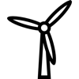  Infrastructure & technology | Climate scenario-resilient infrastructure to enable scaling of circular activity  Circular infrastructure provides a backbone for more circular economic activity that is more resilient to external shocks, including more extreme climate-related events.
  Finance | Mobilise private wealth to accelerate circular transition at multiple scale  Transitioning to a circular economy requires investments beyond government capacity. New Zealand possesses untapped private wealth that can be mobilised through incentives to scale investment in a way that meets the diverse capital needs of circular initiatives at various scales.
  Human and social capital | Establish Circular Economy Living Labs to leverage systems approaches and innovation  Addressing complex issues like transitioning to a circular economy requires new approaches that activate multiple ‘parts’ of a system simultaneously. Living Labs are collaborative hubs, acting to identify, experiment, incubate, improve and scale circular initiatives.

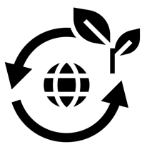
    - Pathway 2: Steady State
Steady state advocates for economies independent from growth, prioritising instead human and environmental well-being. Countries are turning to this model as aligning economics with biophysical limits suggests there are not enough resources to enable infinite growth. Further, evidence points to the impossibility of decoupling at the necessary scale to avoid environmental breakdown.
Core areas | Biggest opportunities and why
Energy | Downscale consumption of energy for resilience  Globally, the Energy Return on Investment EROI of fossil fuels is declining, with ‘peak oil’ in 2018 and extraction becoming difficult. This has been a key driver for renewable transitions. The challenge is that renewable energy has a much lower EROI as it depends on building renewable technologies that require critical raw material inputs. It may be challenging for renewables to meet current energy needs, let alone support ongoing expansion of energy demand.
Raw materials | Low extraction primary sectors that enhance ecosystems, while mitigating dependencies on unsustainable inputs.  Safeguard against the risk of shifting the burden of economic expansion from abiotic to biotic materials. Countries leading circular transitions realise that assuming renewable biomaterials can replace non-renewable abiotic materials overlooks the need to scale down land use extraction to stay within planetary boundaries.
Fresh water | Place-based catchment management  Place-based catchment management prioritises the life-sustaining essence of water over economic value. It aims to identify connections between water flow and ecosystem well-being, guiding human activities to align with natural processes. This approach is relevant for Māori, who see water as a taonga.
  Oceans | Socially and ecologically just blue future to enhance the mauri of coastal communities and marine ecosystems  Our underdeveloped ocean economy is an opportunity to test economic models that prioritise health and resilience of ecosystems and communities.
Infrastructure & technology | Scale green infrastructure, invest in public transport, get smart with brownfield development  A steady-state perspective in urban design aims to reduce resource consumption. Green infrastructure enhances local access to water, food, and energy, lessening reliance on external sources. Prioritising public transportation is key to cutting fossil fuel dependence. Opting for brownfield over greenfield developments saves materials and costs.
Finance | Prioritise the role of money as an enabling tool for value creation  Financial deregulation enabled the generation of ‘money from money’, contributing to the gap between economic activity (measured by GDP) and tangible value creation. The role of money must be prioritised as an ‘enabling tool’ to support green transitions and value over ‘money from money’.
Human and social capital | Foster cultures of ‘enough’ and non-consumptive happiness  A challenge for steady state is consumer culture that depends on expanding inputs from biosphere to meet social metrics of success. Modern psychology understands that consumption beyond core needs erodes, not improves, wellbeing. Rather, it is the strength of our connections, time spent in nature, and the pursuit of individual capabilities that matter the most.

  - Whole economy: Key Roles for Government
Immediate / short term (Next 1-2 years)
- Smart Public Procurement and long-term supply contracts to lead market demand and productivity growth – circular resource use and manufacturing as a priority
- Continue to build and share data and information gaps on New Zealand’s fundamental economic inputs and stocks to understand of priority focus areas for future success
- Collaboration with industry at their request to identify shared challenges to circularity and solutions – including incentives and support
- Collaboration with Māori at their request to identify shared challenges to circularity and solutions – including incentives and support
- Public circular demonstration projects – support market by demonstrating feasibility and benefits
- Crowd in private capital to priority opportunity areas e.g. to bring R&D in the bioeconomy to market
- Regulation to bring maximum pesticide limits in line with key EU export countries – alongside guidance and incentives for sustainable inputs to primary sector
- Streamline / reduce regulation for circular and regenerative land use projects
- Continue and increase R&D in circular solutions to remain on par with peers
- Support supply of critical biomaterials to domestic manufacturing to enable productivity growth

Longer-term (2+ years)
- Employ horizon scanning and systems thinking, to improve decision-making in contexts of complexity and uncertainty
- Identify critical inputs (CRM, component parts, infrastructure, and technology) required for transition and plan to ensure supply
- Support place-based circular initiatives that aim for greater resilience and self-sufficiency, in particular whānau and hapū led
- Implement material passports
- Invest in system-wide enabling infrastructure (e.g., urban water infrastructure to enable density; decentralised energy; low-carbon transport network; regional biodigesters; infrastructure to pilot circular R&D)
- Utilise a diversity of economic approaches, focusing on industrial policy and mission orientated approaches to support strategic areas in the bioeconomy (e.g, to reduce import dependencies and high-value products) to succeed
- Explore portfolios of policies, targeting multiple elements of a system in tandem to drive desired change – employ a ‘sense-learn-adapt’ approach to remain agile and effective in the context of complexity
- Future focused (10+ years) taskforce to explore more radical policies and beyond growth models, such as steady state, that would not be acceptable now but may be pivotal to sustaining economic resilience in the long term
- Actively shape New Zealand’s emerging impact investment sector, to ensure it meets the diverse capital needs of circular initiatives and measures impact holistically for net-positive value creation
- National-level blended funds to attract capital from institutional investors such as pension funds, endowments, and insurance companies
- Conditional FDI to maximise benefits to New Zealanders and to enable circular transition

Manufacturing Findings

  - Manufacturing Introduction
The manufacturing sector in New Zealand spans various industries, categorised into seven subsectors: Food & Beverage, Machinery & Equipment, Metals, Chemicals & Refining, Paper & Wood, Plastics & Rubber, and Others. While 'Advanced' Manufacturing incorporating robotics, AI, and machine learning is emerging, it remains relatively new in New Zealand.
Dominated by small and medium enterprises and employing 10.7% of the workforce, manufacturing is the second largest employer of Māori and Pacific people. The subsectors collectively contribute around 10-11% to GDP, although this has declined significantly from 30% in the 1970s (MBIE, 2023). This decline is attributed to market liberalisation in the mid-1980s, which opened the economy up to foreign competition. Combined with New Zealand's remote geography, this has hindered the sector's productivity through to the present day (Walley, 2016).
The shift towards more circular practices in manufacturing will drive increasing competitiveness, innovation and higher-value jobs while tackling the challenges circularity seeks to solve. Manufacturing significantly impacts the types of raw materials extracted, as well as their design and processing, across various products and services that fulfil human needs and wants. It's during this initial phase of the value chain, known as the 'take-make' stage, where the greatest harm to the climate and biosphere occurs. By adopting innovative manufacturing techniques focused on renewable inputs and design for reuse and recyclability, manufacturing can limit harm. Further, manufacturing can extract value from waste, creating new markets and simulating new economic activity.
Although emissions directly linked to manufacturing in New Zealand may appear small relative to other sectors, this is largely because many manufactured goods are imported. This trend is not unique to New Zealand but is common among developed nations. However, it is crucial to consider imports when evaluating efforts to decouple economic growth from carbon emissions and other environmental impacts. Further, New Zealand's manufacturing sector faces environmental concerns, with process heat accounting for one-third of total energy consumption and 8% of gross emissions.
The biggest opportunity for New Zealand's manufacturing sector lies in leveraging its significant but underutilised primary sector, substituting unsustainable and high-embodied carbon materials with renewable ones, like timber.
The main barrier is the lack of policies to support local enterprises and innovation to become marketable at scale. This presents challenges, in particular for SMEs, hindering access to raw materials due to pricing competition. For instance, the wood processing sector has competing demands for raw logs, primarily from China, where subsidies enable processors to pay higher prices (MBIE, 2019). Additionally, manufacturing struggles to compete with imports from larger and more established international markets. Many countries with successful global manufacturing sectors have implemented policies to protect industries in their early stages, allowing them to experiment and improve within domestic markets before facing more intense competition abroad (Chang and Andreoni 2023).

  - Manufacturing Systems Map
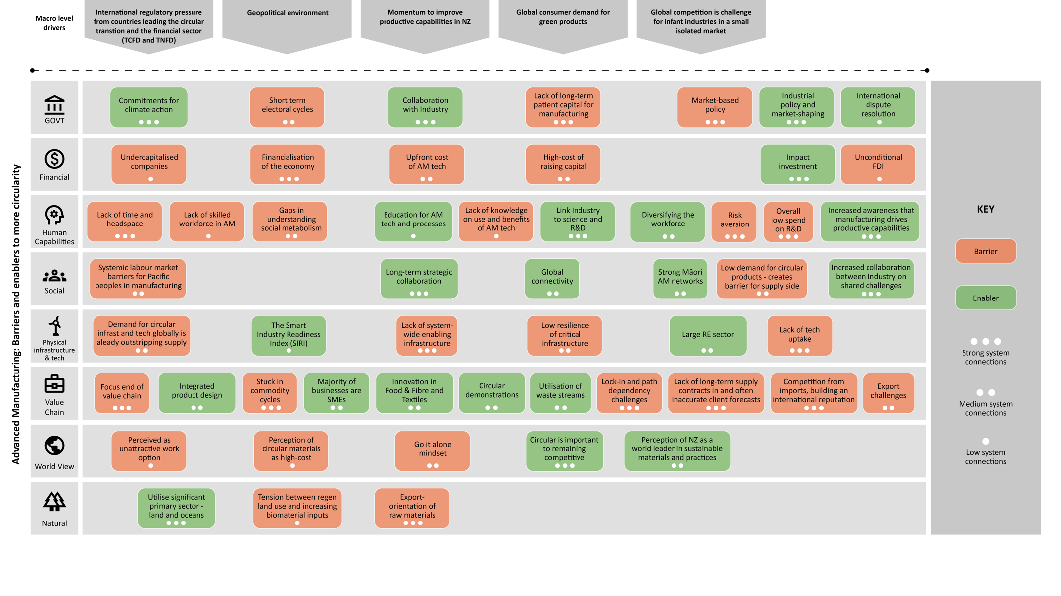
Figure 5. New Zealand Manufacturing Systems Map. The stronger the system connection, the higher the leverage point to support a more circular economy
  - Manufacturing Barriers and Enablers

    - Manufacturing barriers to a more circular economy
- Undercapitalised SMEs plus high cost of capital
- Low venture capital availability in New Zealand
- Low workforce skills and capabilities in manufacturing
- Competitive behaviours between companies prevents collaboration on shared challenges
- Export-orientation inhibits domestic access to bio-materials
- Lack of strategic market-shaping by Govt
- Negative perception of manufacturing by workforce and business finance
- Poor existing knowledge of true benefits of circular material use
- Some trade agreements make building local supply chain resilience more challenging
- Limited support for early stage innovators

    - Manufacturing enablers to a more circular economy
- Global market pressures for low-carbon and green products (e.g., regulatory drivers and disclosure requirements) – poor alignment is a risk to New Zealand’s brand
- Government support – R&D, commercialisation and growth
- SME dominated sector – small and agile
- Pockets of niche innovation (e.g., food, cleantech, mass timber and textiles)
- Government initiatives that support more circular business e.g. Industry 4.0 and better data for material flows
- Policies to support manufacturing sectors critical to New Zealand’s success, as trading partners do

  - Manufacturing Opportunity Areas
    - Manufacturing Opportunity Area 1: Utilise extensive bio-based resources to manufacture high-value products and increase productivity
Why?
- Opportunity to add more value to our bio-resources (oceans, agriculture and forestry) as majority of raw bio-materials are manufactured abroad
- New Zealand’s manufacturing sector can apply global trends to drive productivity through greater innovation, via technology and chemical processes into higher-value products. This in turn can support economic diversification and a higher skilled workforce
- Increase economic resilience and meet low-carbon targets by manufacturing goods for import-dependent sectors (e.g., construction is 90% dependent on imports, including timber – despite significant local forestry resources).
- Utilisation of waste from forestry and agriculture, opportunity to valorise by manufacturing into new bio-based materials. Opportunity for New Zealand global leadership.

Focus areas:
- Scale timber manufacturing, including high-value mass timber for use in domestic market (substitute for high-embodied carbon building materials), and for exports.
- Manufacturing of ‘alternative meat and dairy’ plant proteins
- Identify and support high-value manufacturing in the ocean economy (e.g., nanocellulose from seaweed processing residue)
- Utilising residual organic material streams into bio-based materials (e.g., forestry waste into biochar and bioplastics)
- Plan to secure near and long-term supply of New Zealand bio-materials to support manufacturing growth

Examples in New Zealand  - Agrisea: turning seaweed residue into Nanocellulose  - Kelpn: seaweed feed into bio-plastic  - Daisy Lab: precision fermentation  - Woodtek: Mass Timber Construction | Global examples  - Stora Enso: bio-based materials  - Binderholz: Mass Timber Solutions  - Evoware: Biobased packaging  - Materiom: bio-based alternative materials

    - Manufacturing Opportunity Area 2: Strengthen national and regional value and supply chains for economic resilience and growth
Why?
- Covid-19 and subsequent geo-political events have highlighted the fragility of New Zealand’s supply chains. Especially for import dependent sectors such as energy, construction, machinery and equipment.
- Supply chain fragility and competition for resources are projected to increase globally. This has led to many governments ‘on-shoring’ critical sectors
- Opportunity for New Zealand to enhance the connectivity of local and regional supply chains to enhance resilience and growth.

Focus areas:
- Localising value/supply chains, focusing on: Existing Māori efforts to diversify local economies; forestry and timber processing; localised supply chains for blue economy and food and beverage – co-benefits for food security and regional wealth creation; emerging cleantech sector; and circular recovery of critical materials.
- Identify and implement demonstration pilots for co-location and industrial symbiosis and Special Activation Precincts.
- Regionalism – build strong relationships with countries in Oceania to ensure secure supply of critical raw materials and technologies required for low-carbon transition

Examples in New Zealand  - Kawerau industrial symbiosis  - Whare Ora: localised Māori led and owned forest-to-build models  - Naturepac: biodegradable plant-based packaging | Global examples  - Fit 4 Circularity industry platform in Luxembourg  - UK National Industrial Symbiosis Platform  - UK/Australia supply chain resilience to manage critical supply chain risks  - Australia Modern Manufacturing Strategy

    - Manufacturing Opportunity Area 3: Protect New Zealand’s brand and ability to charge a premium for exports
Why?
- New Zealand’s clean green image is viewed by industry as a comparative advantage
- This image has become more valuable considering global momentum to tackle climate change (e.g., TCFD), plus strong consumer demand for ‘green’ products.
- Our image is threatened by increasing awareness that New Zealand’s land use practices and processing of bio-resources are not that ‘green’. Food and beverage at risk.
- Opportunity for New Zealand to develop world leading practices in the regenerative production of bio-materials and circular design to preserve our green image brand
- ‘Green’ is expected to become the future comparative advantage and earning a premium

Focus areas:
- Build on existing industry and niche activity in regenerative land and ocean practices
- Phase out unsustainable imports e.g. unsustainable fertiliser and irrigation
- Mātauranga Māori led exports led by and for Māori
- Bio-polymers for pharmaceutical and biomedical applications
- Sustainable wood treatment and processing into high-value timber products, including mass timber; innovating in re-use and remanufacture
- Technology to increase transparency across the supply chain – standardised data capture and measurement
- Introducing material passports to show that New Zealand’s materials come from sustainable sources

Examples in New Zealand  - Fonterra brand low-carbon milk footprint  - Bioplastics & compostable packaging, e.g., Anew & EarthPac Co  - Turtle Boots | Global examples  - Nordic Innovation: circular resources and support for Nordic businesses  - Holland Circular Hotspot: connects companies, researchers local authorities  - Biohm: uses mycelium to produce high-impact and high-performance solutions

    - Manufacturing Opportunity Area 4: Recovery and remanufacturing to support a resilient low-carbon economy
Why?
- Global gap between supply and demand for critical materials to manufacture low-carbon technologies, especially the precious metals in nearly all renewable energy technologies, including wind turbines, solar panels and fuel cells
- Given rising prices and volatility of markets for these metals – it’s prudent to invest in more circularity to recover and reuse these materials to feed growing niche innovators in New Zealand’s Cleantech sector
- It’s important to incorporate the ability to remanufacture into the design of bio-materials
- Reuse and remanufacture is essential as renewable bio-materials are not sufficient to replace current demand for abiotic materials.
- Reduce reliance on global supply chains that are becoming less dependable
- Help meet New Zealand’s net-zero, biodiversity, waste reduction and other commitments

Focus areas:
- Support existing niche innovators in clean tech. Metal recovery will feed other clean technologies, such as renewable energy. This applies to building existing cleantech (e.g. solar) as they move through their first service lifecycle and for remanufacturing
- Timber manufacturing and remanufacturing as construction become more low carbon, there is opportunity in wood-based construction products and components
- Sectors with significant single uses, e.g. health care and plastics used in construction.
- R&D and expansion of advanced manufacturing technologies such as additive manufacturing and utilisation of AI can enable resource-efficient manufacturing
- Product certification: There is particular demand from consumers for food and bio-extractives for human health. Timber and other bio-materials also

Examples in New Zealand  - Mint Innovation: natural biomass to extract valuable metals, such as gold, silver, copper and tin from e-waste  - Zincovery: decarbonizing zinc recycling  - Red Stag Timber: timber re-manufacturing to recover high-value products  - Medsalv: Repurposing medical equipment | Global examples  - Renault Re-Factory: Repair, remanufacture and recycling of transportation products and components  - Rinovasol: innovation in PV recycling  - Zero Waste Scotland – Training and skills programmes for manufacturing  - Foresso: Low carbon manufacturing

    - Manufacturing Opportunity Area 5: Circular business models to drive innovation and mitigate under-capitalisation of manufacturing SMEs
Why?
- Alternative circular business models such as “product-as-a-service” can drive innovation, aligning business imperatives and wider social and environmental drivers
- They can also help mitigate the current challenge of under-capitalised SMEs, moving business capex to opex
- Circular business models in manufacturing can add revenue streams by valorising by-products and waste streams and drive the design of more efficient and durable products
- These models can remove the “split incentive” issue between asset owners and operators
- Due to the large number of SMEs in New Zealand, there is an opportunity to quickly adapt their business models and take advantage of new markets

Focus areas:
- Consumer goods e.g. textiles and consumer apparel, electronics and packaging
- Capital goods e.g. manufacturing equipment and healthcare
- Construction and building components e.g. lighting, HVAC systems, flooring and facade

Examples in New Zealand  - Zilch: Provides e-mobility as a service  - Alsco NZ: Professional clothing and uniform as a service  - ANEW: collection and upcycling of bio-based water bottles | Global examples  - RePack and Algramo: Reusable packaging as a Service  - Signify: Lighting as a Service  - Siemens: Equipment as a service  - Capital Equipment Coalition: Industry leaders (e.g. Enel, Microsoft, Philips) - exploring practical implementation of circular approaches and business models

  - Manufacturing: Key Roles for Government

Short term (Next 1-2 years)
- Government procurement to lead market – Has been a critical driver for all leading circular economy nations
- Targeted R&D grants for circular inputs, design and remanufacturing
- Incentivise and support industry collaboration on shared challenges at their request
- Crowd in investment
- Support access to domestic markets to improve and expand. Circular guidance incentives for industry
- Expand producer stewardship legislation
- Consistent Circular labelling and support for New Zealand brand globally – particularly for food and bio-extractives for human health
- Ongoing flow of information about global trends and best practice to guide industry focus areas and govt support

Medium to long-term (2+ years)
- Policies to support and protect manufacturing sectors critical to New Zealand’s success, as our trading partners do e.g. Conditional FDI and performance-based subsidies
- Pan-sector bio-refinery that can take multiple feedstocks from multiple sectors
- Shared infrastructure for pan-sector recovery and reuse of abiotic materials
- Introduction of material passports to boost value of New Zealand products and brand
- Ban landfill for priority and critical materials and components
- Demonstrations in Industrial Symbiosis (e.g., metal recovery and clean tech)

Food Sector Findings

  - Food Sector Introduction
According to the OECD, the term ‘food systems’ refers to all the elements and activities related to producing and consuming food, and their effects, including economic, health, and environmental outcomes.
In New Zealand, our food system contributes to almost 50% of greenhouse (GHG) emissions, with dairy, cattle and sheep the biggest contributors. A further consideration, from an equity perspective, is that despite producing a high quantity of quality food, New Zealand faces food insecurity challenges. Largely, this is a problem of purchasing power, impacting around 20% of New Zealanders, including an estimated one in five children, and affecting in particular Māori and Pasifika peoples, and those with disabilities or living in low-income households (Soliman and Greenhalgh, 2020; Growing up in New Zealand, 2023).
The Ellen MacArthur Foundation (2023) provides some startling facts about the global food system:
- Globally we have degraded a third of our agricultural land
- It takes 1,000 years to build 3cm of topsoil
- We have 60 harvests left globally (annual)
- 95% of our food comes from soil
Locally, perhaps the biggest driver for change in New Zealand is the current state of our soil. In economic terms, around 17% of New Zealand’s GDP depends directly on our soils. Soil also underpins multiple other values, including biodiversity, carbon storage, and our own health and wellbeing (Booth, et al, 2019). The health of this fundamental aspect of natural capital for New Zealand is undermined by current land use practices; 192 million tonnes of soil are lost every year from erosion, 44% of this is from pasture. Further, soil quality and health has declined due to over application of fertilizer (MFE, 2018).
Additional global drivers include: (a) international consumers demanding regenerative and organic food, with low impact across the supply chain; (b) a local consumer and media critique of the farming (mainly beef and dairy) industry damaging their social license to operate; and (c) international and regional regulations and policies, which demand reduced impact on the environment, transparency and documentations.
New Zealand’s siloed land use, that intensifies specific functions within each compartment, is producing a set of monocultures (e.g., beef, lamb, dairy, kiwifruit). This approach risks harming multiple aspects of our food system (Hall, 2018). Soil, water, land degradation, and emissions associated with the food system, for instance, are now well-known and discussed. International regulations are pushing those who export food to the European Union (EU) to adhere to new and strict climate regulations. For example, the recently ratified NZ-EU free trade deal saw most of the questions from the EU parliament to New Zealand in advance of signing were climate and environment related. Further, multi-nationals such as Nestlé and MARS have set ambitious climate change targets and are looking to New Zealand to reduce their ‘scope three’ emissions.
There are also regulations in New Zealand that demand change of practices, especially on the farm. The Zero Carbon Amendment Act 2019 (Zero Carbon Act) sets separate long-term emission reduction targets for long-lived and short-lived GHG emissions, including a target for biogenic methane. In particular, the emissions reduction targets set out in the Zero Carbon Act aim to reduce all GHG emissions, except biogenic methane, to net zero by 2050; and reduce gross biogenic methane emissions 10% below 2017 levels by 2030 and 24-47% by 2050.
The Essential Freshwater package, introduced in 2020, contains rules and regulations to stop further degradation of New Zealand’s freshwater resources, improve water quality within five years, and restore freshwater ecosystems to a healthy state within a generation. The Resource Management (National Environmental Standards for Freshwater) Regulations 2020 implement part of the package – and sets requirements for activities posing risks to freshwater and freshwater ecosystems. The standards set minimum requirements for feedlots and other stockholding areas; define requirements for managing intensive winter grazing of forage crops; restrict further agricultural intensification until the end of 2024; set a cap on the application of synthetic nitrogen fertiliser at 190 kilogrammes per hectare; and require reporting of fertiliser use.
All of the above landscape pressures, both local and global, converge to create an opportunity and momentum to shift to a food system underpinned by circular economy principles. A circular economy for the food system means natural resources (soil, water, biodiversity, nutrients) must be effectively used and managed within planetary boundaries. This means rethinking the food system and how we grow, design and consume produce and products from start to finish. This would encompass:
- Transition to more regenerative food production – including biomass-based organic fertilizers and animal feeds. Such action would be significant to mitigate New Zealand’s current planetary boundary overshoots. Further, regenerative practices can protect soil health for the long-term and amplify its carbon sequestration services.
- Products designed around circular inputs and ingredients, packaging design, and coordination.
- Optimal management of resources and closing loops. For example, reducing food waste as well as changing diets towards less highly processed food, more vegetable consumption and less animal protein. Moreover, it is important to make use of residue streams, such as tomato stalks, beet pulp and stale bread to minimise biomass loss from a system.
As a result of the increasing global and domestic pressures, there exist in New Zealand several innovation opportunities that present leverage points for change in the larger system. These include driving support for innovation at the upstream end of the food value chain, using new technologies and regulation to increase consumer-facing transparency, creating cross-disciplinary networks to advance innovation across the sector, and designating a flagship city to investigate and model a shift to a regenerative urban food system for the country.
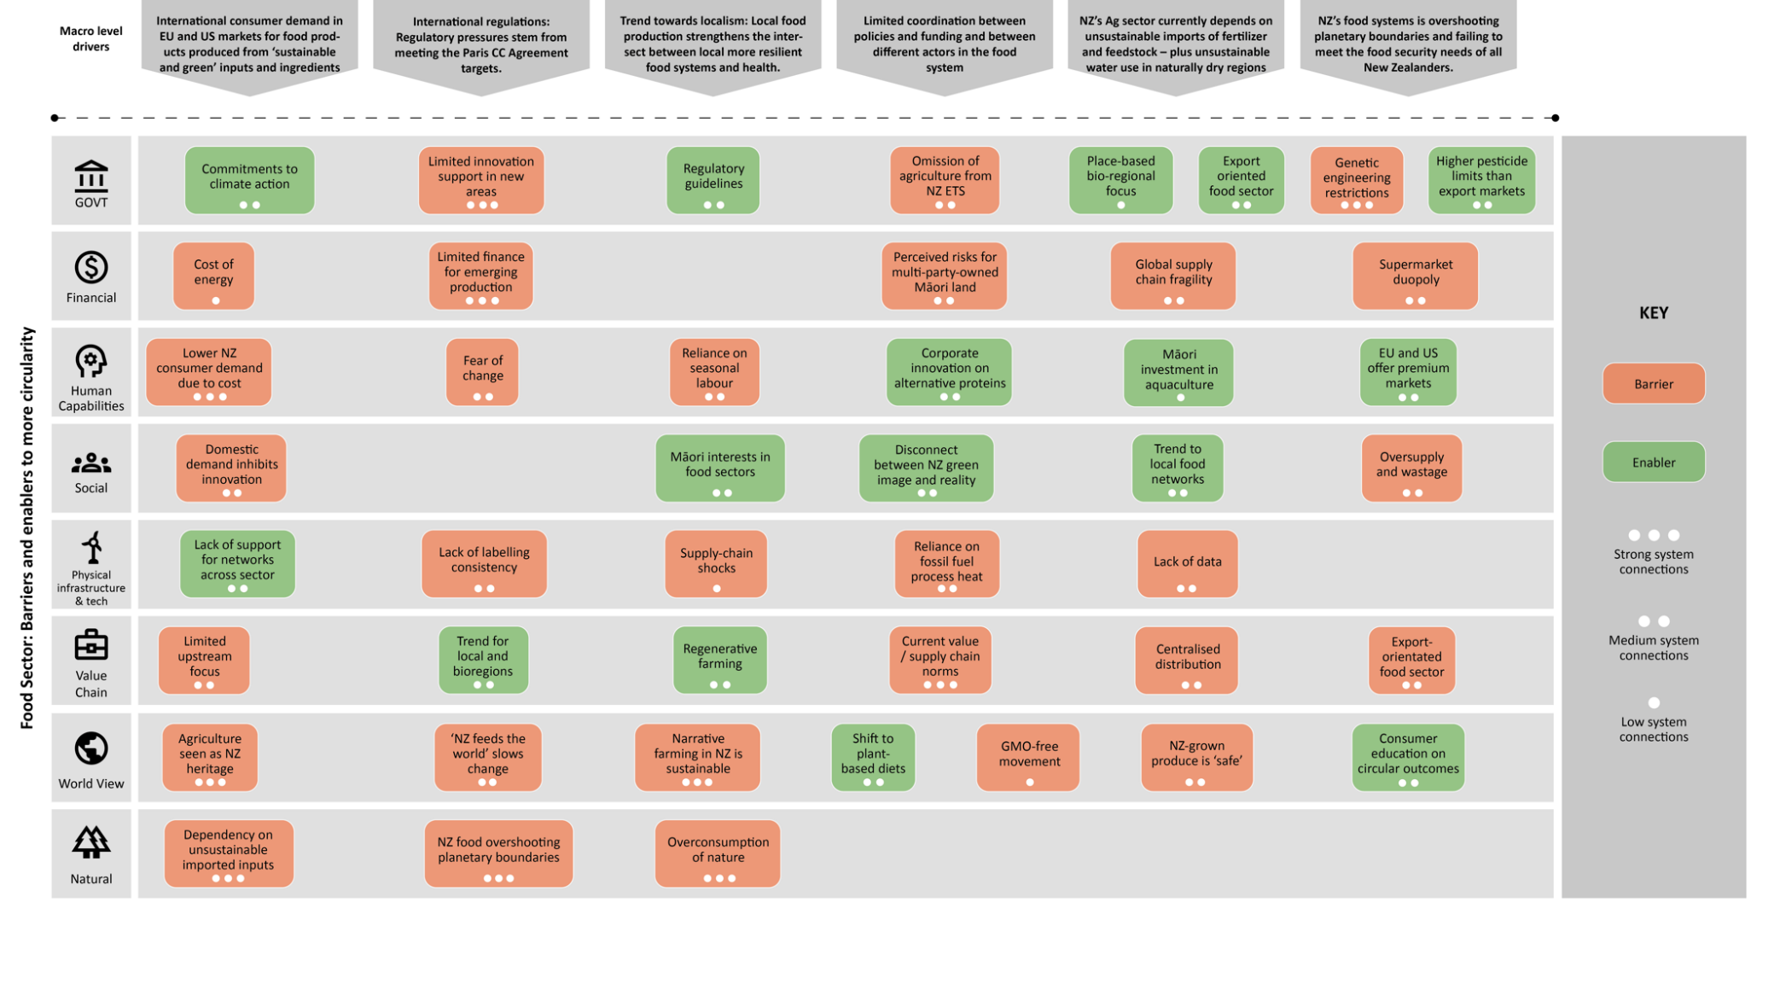
  - Food Sector Systems Map
Figure 6. New Zealand Food Sector Systems Map. The stronger the system connection, the higher the leverage point to support a more circular economy

  - Food sector Barriers and Enablers
    - Food sector barriers to a more circular economy
- Limited focus on upstream – inputs and design
- Investment and support flows into conventional food production
- Export-orientated food sector, but poor domestic food sovereignty
- Dependency on unsustainable imported inputs – fertilizer and stock feed (e.g. PKE)
- Demands of domestic consumers out of sync with demands of global markets in the US and EU
- Limited coordination between policies and funding and between different actors in food system

    - Food sector enablers to a more circular economy
- Global and national regulatory pressures
- Global consumer demand for transparency in food value chain
- Global consumer demand for products created from sustainable, chemical free ingredients and inputs
- Increased support for R&D
- Trend towards localism - intersect between local more resilient food systems and health
- Agriculture’s loss of social license to operate based on growing awareness of the disconnect between ‘green’ image of New Zealand food system and reality

  - Food Sector Opportunity Areas
    - Food Sector Opportunity Area 1: Upstream Innovation - Increase R&D and innovation in upstream segment of food value system to reinforce New Zealand international competitive position and protect natural capital
Why?
- Most harm occurs upstream: land use practices, inputs, design and processing
- New Zealand’s Agriculture sector currently depends on unsustainable imports of fertilizer and feedstock – plus unsustainable water use in naturally dry regions.
- Need for upstream solutions to:
- Protect New Zealand’s natural capital for the long-term
- Address global regulatory pressure and consumer demand for sustainable and climate smart-food production
- Close gap between international best practice and current state circular food system innovation in New Zealand
- Protect New Zealand’s green image internationally and to maintain competitive
- Challenge current New Zealand focus on downstream waste recovery and recycling to instead focus on inputs e.g. feedstock and business model redesign
Focus areas:
- Upstream circular solutions (products and practices) R&D and expansion:
- Expand regenerative farming and aquaculture
- Transition to foods that build soil health (e.g., legumes grow well in New Zealand)
- Local and sustainable inputs (e.g., biofertilizer)
- Renewable energy
- Circular food product design (e.g., plant-based meats).
- Consider: downstream impacts of food e.g. poor nutrition due to ultra-processed food and concentrated power of supermarket duopoly.

Examples in New Zealand  - Calm the Farm: farmer-led data co-operative prioritising enhancement of biodiversity with new income | Global examples  - Danone financial & technical support to 100k farmers  - Nestlé investment for farmer transition  - UK govt sustainable farming incentives

    - Food Sector Opportunity Area 2: Meta-network - Cross-sector participatory meta-network of food system actors to create efficiencies and support the transition to low-emission, regenerative and ethical food production
Why?
- New Zealand’s food system is overshooting planetary boundaries and failing to meet the food security needs of all New Zealanders.
- If current food production practices continue, there is a real risk (exacerbated by climate impacts) that New Zealand’s food system will irreversibly degrade the natural capital on which it depends. Soil health is a concern that is arguably not addressed in current food policy, with soil lifespans shorter than a century in most continents.
- Pockets of cross-disciplinary transition networks exist – but are under resourced, under supported and fragmented.
Focus areas:
- Through support and connect existing food stakeholder groups (e.g. Quorum Sense NZ, NZ Food Network, Aotearoa Food Rescue Alliance AFRA etc) and cross-disciplinary food system groups in one ‘transition network’ and online platform.
- Model data on value creation benefits of the transition (cost saved, emissions, water use and quality, biodiversity, soil health).
- Support better understanding on aquaculture

Examples in New Zealand  - Quorum Sense - a diverse network of regenerative food system actors  - NZ Food Network  - Aotearoa Food Rescue Alliance | Global examples  - C40 Food Systems Network to develop sustainable and healthy food systems

    - Food Sector Opportunity Area 3: Real-time traceability - Increase transparency and traceability to meet consumer demand and global regulatory frameworks
Why?
- Pressure from global regulatory frameworks (e.g., EU import requirements, TCFD, TNFD)
- Increasing citizen awareness that New Zealand is not as green as its image implies
- Demand for ‘green’ food products, transparency and trend towards “provenance stories”
- Consumers willing to pay more for transparency
- Increased transparency could allow for the discussion on the need to shift consumption patterns (e.g., tonnes of bread wastage in New Zealand - could buy freshly frozen bread to minimise waste). Real time data showing food flows could help accelerate this change.
- Growth of plant-based and lab-grown alternative proteins equals more pressure on New Zealand agriculture to remain competitive
- New Zealand’s green image is an asset – enabling expansion into global markets
- Protect and build brand to maintain future prosperity of the food sector
- Pressure from EU and US for food to be transparent, chemical-free and sustainable
- Lack of labelling consistency is confusing for consumers

Focus areas:
- Various organisations, including Auckland Council and the Kai Commitment are attempting to get upstream and downstream food data. Real-time data would enhance visibility of flows through the system and help consumers and food stakeholders make more informed decisions
- Digital tech innovation to enable transparency and traceability from farm-to-fork (e.g., RFID tags) - however will need more capability and skills
- Industry is in a unique position to drive uptake of regenerative practices, consistent measurement and transparency (e.g., farm practices, fertilizer inputs, water use, etc.)
- To build brand, focus on products that emphasise: New Zealand provenance stories – including connecting our Māori, multigenerational farming, and Pacific stories to the food we produce; cannot be produced in other countries such as Māori indigenous products (e.g., Kawakawa which has medicinal properties); Innovation in food product development that utilises local ingredients.

Examples in New Zealand  - Foodprint app aim to rescue 60% of the food waste and redirect it to consumers  - Wool: ZQ Natural Fibre is fully traceable back to the individual farms | Global examples  - Unilever transparency and traceability initiatives  - Circularise’s blockchain-based digital passport technology platform  - Kecipir app provides a chain of custody in the Indonesian market

    - Food Sector Opportunity Area 4: Place-based resilience - Develop place-based, circular food systems to improve resilience and food security
Why?
- While industrial food systems have driven economic development and urbanisation – it is globally recognised they that are not fit for a more circular 21st century. Principally, this is because BAU food production is a major source of emissions and biodiversity loss, alongside declining human health linked to increased consumption of chemicals and processed foods.
- Place-based / city-level food security, where healthy food is grown regeneratively and locally where appropriate is global best practice to address the above complex challenges
- New Zealand has serious food insecurity challenges and related significant health costs.
- 80% of all food will be consumed in cities by 2050 and some circular food systems require scale. This may mean we need to build on our Trans-Tasman / Pacifica partnerships to create regional circular systems for food.
- Conversely, there is a large and growing interest in community gardens and regenerative and urban food initiatives which would help create a resilient food system
- Funding is currently directed at reducing methane in animals – as opposed to wider systems transformation
- A place-based approach considering bioregions aligns with a te ao Māori approach

Focus areas:
- There is already a large and growing interest in community gardens (with over 200 in New Zealand) with Innermost Gardens in Wellington used in 2019-20 by over 4,700 people, processing over 7 tonnes of food waste and sequestering over 26,000 tonnes of CO2e (as well as providing home-cooked meals to people during lockdown). However, these gardens are fragmented and lack support. With support and as part of a larger network these would help create community resilience across New Zealand and a more resilient food system (consider Covid or Cyclone Gabrielle).
- Note: A focus on cities does not obviate the need for addressing rural food poverty. Rather it considers cities as an artificial bioregion for which inputs, stocks, flows and outputs can be better controlled or influenced for circular outcomes.

Examples in New Zealand  - Approximately 204 community gardens are scattered around New Zealand  - Recent coordinated efforts for food packaging circularity - Reuse Aotearoa | Global examples  - Sky Greens Singapore: World’s first low-carbon, hydraulic-driven vertical farm  - Brooklyn Grange, New York: One of the largest rooftop soil farms in the world

  - Food sector: Key Roles for Government

Short term (Next 1-2 years)
- Smart policy mix to support niche innovations, especially upstream (inputs, ingredients, food production practices and design):
  - Targeted R&D grants for regenerative farming, circular inputs, design and remanufacturing
  - Incentivise collaboration on industry shared challenges
  - Support access to domestic markets to improve and expand
  - Government procurement to lead market
- Regulation to bring maximum pesticide limited in line with key export countries (US, EU)
- Tighter and more streamlined food regulations from farm-to-fork
- Use policy tools (WMA, WMF) to support meta-network of local regenerative food networks (e.g., targeted grants and access to underutilized land) and actors across the food value chain
- Select city to support as Flagship Partner with C40 Food System Network
  - Set targets (e.g., 30% food produced regeneratively in city pre—urban areas)
  - Smart procurement
  - Incentives and education
- Take science-based approach to ensure policies help New Zealand stay within planetary boundaries e.g. using Planet Price or Planetary Accounting Network

Longer term (2+ years)
- Investment in digital passports and traceability technology – partner with international governments who are already leading this (e.g., Netherlands)
- Legislate for more sustainable land and water use practices and provide one-off grant funding for agroforestry, cover-cropping and reduced tillage
- Include agriculture in ETS and ensure consistent approach to environmental / climate regulations
- Partner with international Governments on circular initiatives and maintain the ban on exporting livestock
- Review regulatory environment for precision fermentation – a key innovation area
- Support consistent and transparent food labelling, partnering with existing leaders (e.g., Eco Choice Aotearoa)
- Support local organic composting and seed production facilities as well as financing replanting of streams, wetlands and marginal lands

Built Environment Findings

  - Built Environment Introduction
The built environment encompasses the planning, design, construction, and management of physical infrastructure such as buildings, transportation networks, and utilities. It extends from residential and commercial spaces to public infrastructure projects. In a circular economy framework, the built environment aims to design out waste, reduce volume of virgin and toxic materials that hinder cascading use, maximize resource efficiency, and actively regenerate living systems (ARUP, 2016).
The circular economy is vital for the built environment sector as it addresses the significant environmental impacts associated with construction and demolition activities, including resource depletion, pollution, and carbon emissions. By adopting circular principles, such as reusing materials, designing for disassembly, and incorporating renewable resources, the sector can reduce its ecological footprint and better manage key concerns around staying within future carbon budgets, resilience to unknown impacts of climate change, supply chain disruption and demographic shifts.
The built environment sector is a major contributor to global resource consumption and waste generation and accounts for a significant portion of energy consumption and greenhouse gas emissions worldwide. In New Zealand, the built environment is responsible for 20% gross emissions (Thinkstep, n.d.). Construction and demolition waste accounts for up to half of all waste going to landfills, many of which are valuable materials with further lifespan potential (BRANZ, 2024). Around 470,000 tonnes of construction waste generated annually: 78% sent to landfill/clean fill; 14% recycled; 8% reused. Of the materials that are recycled, concrete possesses the highest rate (44%), however, recycling of concrete is typically to low-value processes, such as use as crushed aggregate.
Overall, there are many missed opportunities to capture the value of secondary materials in multiple cycles. Moving to a circular built environment will require investment in digital tools, such as material passports; a system to track materials through multiple lifecycles; and, the infrastructure needed to sort, store and deploy materials to support reuse, remanufacture (as opposed to current practical which generally jumps to recycling, which is very low on the waste hierarchy).
Efforts to promote circularity in the built environment have been underway internationally for well over a decade. While initial efforts focused on waste reduction, material reuse, and energy efficiency, more mature markets are looking at circular business models such as Lighting/facades/aircon as a service. Momentum is growing around modular construction, offsite prefabrication and adaptive reuse with traction demonstrating the potential for circular practices to improve resource efficiency and reduce environmental impacts. However, broader systemic changes are needed to scale up circular solutions and overcome existing barriers to adoption. While New Zealand can learn much from previous endeavours they will need to be contextualised. Particular consideration should be given to our geographic isolation, import dependency challenges, and absence of system-wide enabling infrastructure to support circular efforts.
Key opportunities identified for New Zealand’s built environment are to: extract more value out of New Zealand’s timber resources via mass timber and Modern Methods of Construction; scale up the renovation wave and unlock more than $116 billion worth of benefits; increase utilisation of urban space and buildings to capture value; incentivise and enable the recovery and reuse of construction and demolition material through the use of physical and digital tracking; and upgrade existing infrastructure and building sustainable new infrastructure.
  - Built Environment Systems Map
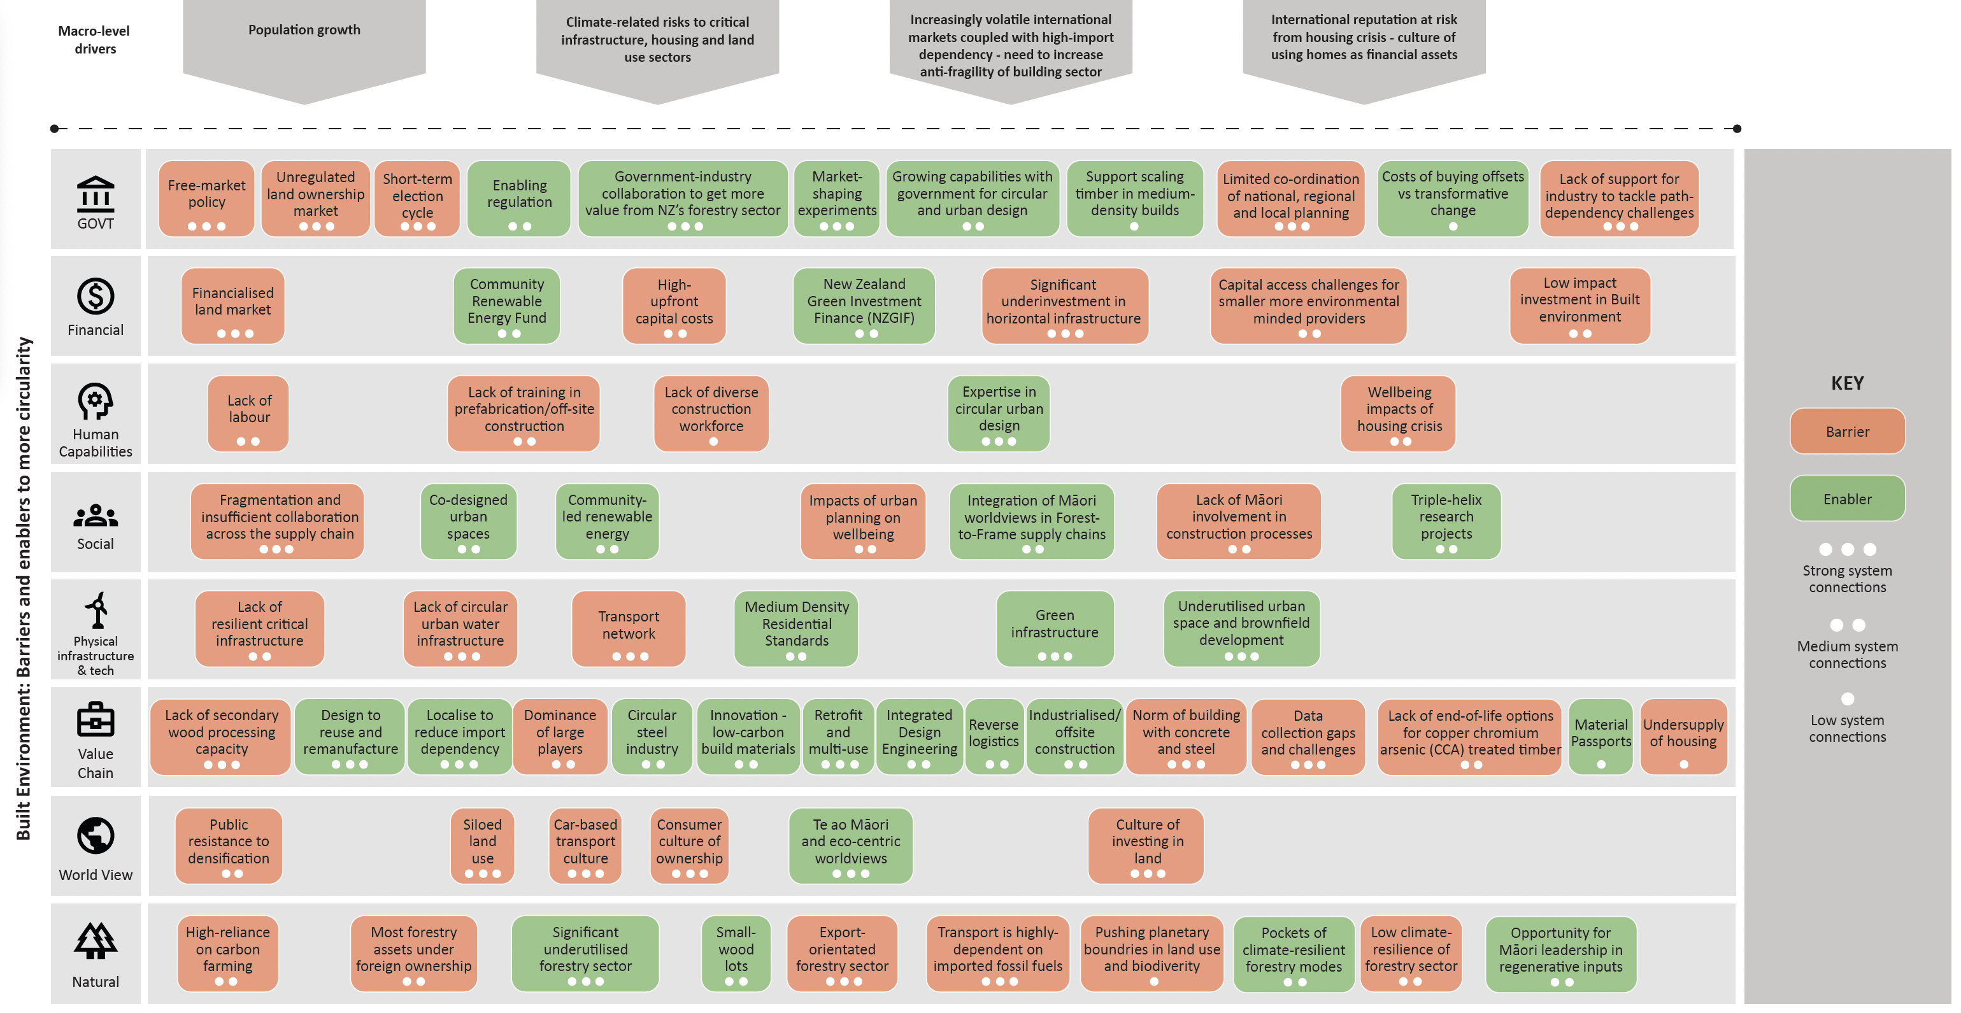
Figure 7. New Zealand Built Environment Systems Map. The stronger the system connection, the higher the leverage point to support a more circular economy

  - Built Environment Barriers and Enablers
Built Environment barriers to a more circular economy
- Lack of overarching circular economy legislation/strategy that provides solid foundation for innovation and risk taking
- Lack of infrastructure required for reverse logistics / storage to move up the waste hierarchy
- Preference for free-market and export-orientation of bio-materials
- Lack of support and regulatory frameworks to overcome path dependency challenges
- Sector labour gaps, particularly for new high-skilled roles
- Insufficient collaboration across supply chains
- Lack of secondary wood processing capacity
- Capital intensity of offsite construction
- Lack of access to capital
- Traditional public perception of medium to high density and re-used materials
- Need for consistent and reliable collection of data across supply chains
- Lack of end-of-life options for copper chromium arsenic (CCA) treated timber

Built Environment enablers to a more circular economy
- Pockets of innovative policy to shape markets, and more sustainable built environment
- Significant drivers beyond low carbon – resilient construction industry, the housing crisis, and critical infrastructure
- Innovation in mass timber and other bio-based materials
- Increased support for R&D
- World Green Building Council Circular Playbook
- Large and growing forestry stocks
- Utilization of Mātauranga Māori in the built environment
- Industrialised offsite construction to increase construction sector productivity

  - Built environment opportunity areas

    - Built Environment Opportunity Area 1: Extract more value out of New Zealand’s timber resources via mass timber and Modern Methods of Construction (MMC)
Why?
- Import dependency: 90% of all construction products sold in New Zealand are imported either as a finished product or manufactured locally using imported components
- Export-orientated forestry sector, with most logs exported raw: New Zealand has been talking for decades about more value from its forestry sector to build regional wealth
- Mass timber and MMC are opportunities to add-value, decrease supply chain fragility, and significantly improve the speed, sustainability, and efficiency of builds
- Practice climate smart forestry to balance the tension between conservation & production
- Mass timber has the additional benefits of being substitutable for high-embodied carbon concrete and steel in medium and high density builds. It is also resilient to earthquakes and easily re-usable
- Despite benefits, path dependency and regulatory challenges are barrier to uptake
- Use non-polluting options for treatment of wood (i.e., safer alternatives to copper chromium arsenic (CCA), which is still allowed in New Zealand (Australia, the US and the EU have stopped or restricted the use of CCA))
Focus areas:
- Invest in on-shore wood processing capabilities
- Support existing niche innovators in MMC (e.g., off-site and modular)
- Expand mass timber production and use in domestic built environment
- Utilisation of small wood lots through engaging owners to aggregate their offering to achieve better prices and strengthen their negotiating power

Examples in New Zealand  - Mid-Rise Wood Construction partnership  - Timber Unlimited partnership  - Spanbild  - Genuis Homes  - Hikurangi Enterprises  - Evergreen Modular | Global examples  - Top Hat – UK  - Timberage - US  - Policy change: raw log export to local wood manufacturing - US

    - Built Environment Opportunity Area 2: Scale up the renovation wave and unlock more than $116 billion worth of benefits
Why?
- The best way to avoid emissions is to use assets already in the building stock
- Research conducted by Business and Economic Research Limited (BERL) in 2023 and commissioned by BRANZ, showed that a massive investment retrofit programme targeting 400,000 homes in New Zealand would drive $116 billion worth of benefits to households.
- Many homes in New Zealand are not meeting the heating and energy needs of its users, resulting with cold, draughty and damp spaces and high energy cost as well as high health service bills
- Need for renovation and retrofit of all building types (commercial and public), to address their age and seismic concerns

Focus areas:
- Large-scale and neighbourhood scale retrofit (not individual houses)
- Large landlords e.g. Kāinga Ora and Community Housing Providers
- Domestic blocks and high rises

Examples in New Zealand  - Warmer Kiwi Homes programme  - Deloitte Centre – 1 Queen Street  - Uni Auckland building adaptive reuse  - Kāinga Ora Retrofit Programme | Global examples  - Energiesprong – the Netherlands  - The Sinfonia project - Italy and Austria  - Community Scale Retrofit - UK

    - Built Environment Opportunity Area 3: Increase utilisation of urban space and buildings to capture value
Why?
- New Zealand recognizes the need to increase building density through its Medium Density Residential Standards (MDRS)
- A more circular economy can promote higher density building development which can be resource- and land-efficient, and can utilise existing brownfield land within urban areas
- Opportunity to increase the value of existing building assets through Adaptive Reuse; that is to update the built asset for a new purpose, rather than the asset remaining vacant
- Multiple unused sites in New Zealand cities (e.g., post-industrial, abandoned construction sites, unused or uninhabited spaces)

Focus areas:
- Public procurement as a leverage point
- More dense and compact urbanism – integrated green spaces
- Multi-use spaces which combine different uses throughout the day (day - night) and year (working period - nonworking period) avoid the need for new builds and support circularity of space (spatial use)
- Adaptive reuse strategies can include converting post-industrial sites and buildings as well as office-to-residential conversion

Examples in New Zealand  - Factory adaptive reuse, Auckland  - Hayman Kronfeld Building, Auckland | Global examples  - Planning code update change of use - UK  - Brownfield regeneration - Amsterdam  - Universeine development project – France

    - Built Environment Opportunity Area 4: Incentivise and enable the recovery and reuse of construction and demolition material through the use of physical and digital tracking

Why?
- Construction and demolition waste accounts for up to half of all waste in New Zealand’s landfills
- Around 470,000 tonnes of construction waste generated annually: 78% sent to landfill/clean fill; 14% recycled; 8% reused
- Of the materials that are recycled, concrete possesses the highest rate (44%), however, recycling of concrete is typically low-value processes, such as for use as crushed aggregate
- Missed opportunity to capture the value of such secondary materials

Focus areas:
- Develop infrastructure to enable reuse of building components. This includes both physical and digital infrastructures (including circular supply, resale and reuse market platforms).
- Stimulate the use of secondary materials in construction - for example through development of secondary material criteria within procurement, requirement of a ‘circular economy statement’ for developments.
- Implementing material passports to track where materials come from as well as where they go after buildings have been demolished, increasing the likeliness of companies recycling and reusing materials.
- The government can mandate material passports to check against compliance with low carbon building targets, procurement and reuse/recycling.
- AEC (architects, engineers, manufacturers and construction companies) actors need to work together from the project start to unlock benefits arising from Integrated Design Engineering. Up to 80% of a product’s environmental impact is determined in the design phase. To embed circularity as a central design consideration, there needs to be design for disassembly (e.g., reversible and/or bio-based adhesives and connections).

Examples in New Zealand  - Civilshare – construction exchange platform  - HERA - developing a steel circularity passport to facilitate structural steel reuse  - NZ Steel 80% recycling with target of 100% | Global examples  - Bryden Wood - Europe  - Excess Materials Exchange - UK  - BAMB (Buildings as material banks)  - Madaster – Material passports platform  - France – Pre-demolition audits regulations

    - Built Environment Opportunity Area 5: Upgrade existing infrastructure and build sustainable new infrastructure
Why?
- Improving energy efficiency of existing infrastructure can have a better environmental impact than building new buildings
- When new infrastructure is required to allow for other sectors to grow (e.g. transport links), it is important to design for circularity using sustainable materials and designing for easy repair and reuse.
- There is currently low resilience of critical infrastructure which needs to be improved so other sectors can function to their maximum potential

Focus areas:
- Existing infrastructure which is not energy efficient and has poor resilience to potential hazards
- New infrastructure which will allow for growth of other sectors, sustainable mobility and enhance regional accessibility
- Services – improving efficiency of operations through digitisation
- Nature based infrastructure

Examples in New Zealand  - The New Zealand Upgrade Programme  - City Rail Link  - Future-fit infrastructure outcomes | Global examples  - Sustainable Carparks - Australia  - Parkes Precinct Circular Strategy - Australia  - Bridge renovations – Netherlands  - Multipurpose critical infrastructure - UK

  - Built Environment: Key Roles for Government

Short term (Next 1-2 years)
- Smart Public Procurement to lead market demand
- Public demonstration projects
- Education and training - programs to develop a skilled workforce
- Financial incentives to support uptake – tax breaks, grants, subsidies, risk share.
- Significant increase in landfill gate fees for C&D waste
- Promote use of secondary material processing and expand facilitating infrastructure
- Crowd in private capital to develop regional upcycling
- Targeted grants for R&D in upcycling technologies and infrastructure
- Cross-government agency collaboration to unlock systemic change across the built environment value chain

Longer-term (2+ years)
- Consistent and broad standards for re-used materials
- Material Passports to track material sustainability, reuse and recycling
- Streamlined and cheaper permitting for new Modern Methods of Construction sites and expansion
- Update building code regulation and standards, to incentivise lower waste and embodied carbon design and construction
- Circular regulatory frame for areas such as renovation practices and integrating green infrastructure

References

Andersen, L., Gaffney, O., Lamb, W., Hoff, H., Wood, A. (2020). A safe operating space for Aotearoa New Zealand: Translating the planetary boundaries framework. Stockholm Resilience Centre, Potsdam Institute for Climate Impact Research, and Mercator Research Institute on Global Commons & Climate Change. A report commissioned by MFE. Available at:
https://environment.govt.nz/publications/a-safe-operating-space-for-new-zealandaotearoa-translating-the-planetary-boundaries-framework/

Alonso-Jiménez, A. and González-Barros, M. (2022). The paradox of the circular economy in the raw materials industry. E3S Web of Conferences: 10th International Conference on Life Cycle Management. Available at:
https://www.e3s-conferences.org/articles/e3sconf/abs/2022/16/e3sconf_lcm2022_01003/e3sconf_lcm2022_01003.html

ARUP (2016). The Circular Economy in the Built Environment. Available at:
https://www.arup.com/perspectives/publications/research/section/circular-economy-in-the-built-environment

BRANZ (2024). Material use: Minimising waste. Available at:
https://www.level.org.nz/material-use/minimising-waste/#:~:text=Construction%20and%20demolition%20waste%20makes,of%20four%20tonnes%20of%20waste.

BRANZ (2024). Material use: Construction and demolition produce large amounts of waste. Available at:
https://www.level.org.nz/material-use/minimising-waste/#:~:text=Construction%20and%20demolition%20waste%20makes,to%20government%20and%20council%20documents.

Chang, H. (2011). Industrial Policy: Can We Go Beyond an Unproductive Confrontation. Annual World Bank Conference on Development Economic. Available at:
https://www.rrojasdatabank.info/wbdevecon10-9.pdf

Chang, H. (2014). Economics: The user’s guide. Bloomsbury Publishing.

Chang, H. and Andreoni, A. (2020). Industrial policy in the 21st century. Journal of Development and Change, 51 (2). Available at:
https://eprints.soas.ac.uk/32055/3/Andreoni_Industrial%20Policy%20in%20the%2021st%20Century.pdf

Club of Rome (2022). Limits and Beyond. Available at:
https://www.clubofrome.org/limits-to-growth/limits-and-beyond/

Club of Rome (2023). A post-growth Europe critical to survive and thrive, urge over 400 civil society groups and experts. Available at:
https://www.clubofrome.org/impact-hubs/reframing-economics/post-growth-open-letter/#:~:text=This%20calls%20for%20a%20democratically,both%20in%20and%20beyond%20Europe

Council of the European Union (2024). Forward Look: Managing Uncertainty. Available at:
https://www.consilium.europa.eu/media/69285/forward-look-2024_10-january-2024_web.pdf

Department of the Prime Minister and Cabinet (DPMC) (2023). Strengthening the resilience of Aotearoa New Zealand’s critical infrastructure system Ensuring Aotearoa New Zealand has a secure platform for a productive, sustainable, and inclusive economy. Available at:
https://consultation.dpmc.govt.nz/national-security-group/critical-infrastucture-phase-1-public-consultation/user_uploads/discussion-document--strengthening-the-resilience-of-nzs-ci-system.pdf

EEA (European Environment Agency) (2019). Sustainability transitions: policy and practice. European Environment Agency Report, No 09/2019. Available at:
https://www.eea.europa.eu/publications/sustainability-transitions-policy-and-practice

EEA (European Environment Agency) (2017). Perspectives on transitions to sustainability. European Environment Agency Report, No 25/2017. Available at:
https://www.eea.europa.eu/publications/perspectives-on-transitions-to-sustainability/file

EEA (European Environment Agency) (2024). Accelerating the circular economy in Europe State and outlook 2024. Available at:
https://www.eea.europa.eu/publications/accelerating-the-circular-economy/file

EIT (European Institute of Innovation and Technology) (2023). How radical collaboration is transforming food systems in Ireland. Available at:
https://eit.europa.eu/news-events/news/how-radical-collaboration-transforming-food-systems-ireland

EMF (Ellen MacArthur Foundation) (n.d.). How the circular economy can help us stay within planetary boundaries. Available at:
https://www.ellenmacarthurfoundation.org/articles/how-the-circular-economy-can-help-us-stay-within-planetary-boundaries

EMF (Ellen MacArthur Foundation) (2015). Growth within: A circular economy vision for a competitive Europe. Available at:
https://www.mckinsey.com/capabilities/sustainability/our-insights/growth-within-a-circular-economy-vision-for-a-competitive-europe

EMF (Ellen MacArthur Foundation) (2024). What is a circular economy? Available at:
https://www.ellenmacarthurfoundation.org/topics/circular-economy-introduction/overview

Escobar, Arturo (2020), Pluriversal Politics: The Real and the Possible. Duke University Press.

European Parliament (2023). Beyond Growth 2023 Conference. Available at:
https://www.beyond-growth-2023.eu/#:~:text=The%20Beyond%20Growth%202023%20Conference,of%20ideas%20around%20post%2Dgrowth.
European Parliament (2023). Beyond Growth: Pathways to sustainable prosperity in the EU. Available at:
https://www.europarl.europa.eu/RegData/etudes/STUD/2023/747108/EPRS_STU(2023)747108_EN.pdf

European Parliament (2023). Circular economy: definitions, importance and benefits. Available at:
https://www.europarl.europa.eu/topics/en/article/20151201STO05603/circular-economy-definition-importance-and-benefits

Dooley K., Keith H., Larson A., Catacora-Vargas G., Carton W., Christiansen K.L., Enokenwa Baa O., Frechette A., Hugh S., Ivetic N., Lim L.C., Lund J.F., Luqman M., Mackey B., Monterroso I., Ojha H., Perfecto I., Riamit K., Robiou du Pont Y., Young V. (2022). The Land Gap Report 2022. Available at:
https://www.landgap.org/

Giampietro, M. and Mayumi, K. (2018). Unravelling the complexity of the Jevons paradox: The link between innovation, efficiency and sustainability. Frontiers: Energy Resilience and Sustainable Energy Systems; Volume 6. Available at:
https://www.frontiersin.org/articles/10.3389/fenrg.2018.00026

Growing up in New Zealand (2023). Now we are Twelve: Snapshot 3 – food insecurity. Available at:
https://www.growingup.co.nz/now-we-are-twelve

Haberl, H. et al. (2020). A systemic review of the evidence of decoupling of GDP resource use and GHG emissions, Part II: synthesizing insights. Environ. Res. Lett. 15 065003. Available at:
https://iopscience.iop.org/article/10.1088/1748-9326/ab842a

Hall, D. (2018). (June 2018). The Interwoven World, Te Ao i Whiria: Toward an Integrated Landscape Approach in Aotearoa New Zealand. Discussion paper. Auckland: The Policy Observatory. Available at:
https://thepolicyobservatory.aut.ac.nz/

Hickel, J. (2016). To deal with climate change we need a new financial system. The Guardian. Available at:
https://www.theguardian.com/global-development-professionals-network/2016/nov/05/how-a-new-money-system-could-help-stop-climate-change#:~:text=When%20it%20comes%20to,year%2C%20it%20plunges%20into%20crisis.

IEA. (2024). Net Zero by 2050: A roadmap for the global energy sector. Available at:
https://www.iea.org/reports/net-zero-by-2050

Iacovidou, E., Hahladakia, J., and Purnell, P. (2021). A systems thinking approach to understanding the challenges of achieving the circular economy. Waste and Biomass Management & Valorisation, Volume 28. Available at:
https://link.springer.com/article/10.1007/s11356-020-11725-9

Jośe et al. (n.d.). Industrial policy, productive transformation and jobs. Available at:
https://www.ilo.org/wcmsp5/groups/public/---dgreports/---inst/documents/publication/wcms_315664.pdf
Joy, M. (2019). Despite ‘green’ image, NZ has world’s highest portion of species at risk. The Conversation. Available at:
https://theconversation.com/despite-its-green-image-nz-has-worlds-highest-proportion-of-species-at-risk-116063#:~:text=Nowhere%20is%20the%20loss%20of,may%20well%20be%20an%20underestimate

Kallis, G. (2019). Degrowth. Columbia University Press.

Kattel, R. and Mazzucato, M. (2018). The economics of change: Policy and appraisals for missions, market shaping and public purpose. UCL Institute for Innovation and Public Purpose (IIPP). Available at:
https://www.ucl.ac.uk/bartlett/public-purpose/sites/public-purpose/files/iipp-wp-2018-06_1.pdf

Mazzucato, M. (2019). The Value of Everything. Penguin Books.

Mazzucato, M. and Mikheeva, O. (2020). The EIB and the new EU missions framework: Opportunities and lessons from the EIB’s advisory support to the circular economy. UCL Institute for Innovation and Public Purpose (IIPP). Available at:
https://www.eib.org/attachments/press/eib-and-new-eu-missions-framework-report-18-nov-en.pdf

Mazzucato and Kattel (2023). Mission-orientated industrial strategy. UCL Institute for Innovation and Public Purpose (IIPP). Available at:
https://www.unido.org/sites/default/files/unido-publications/2023-04/IID%20Policy%20Brief%202%20-%20Mission-oriented%20industrial%20strategy%20-%20Final.pdf

MBIE (2014). Productivity spillovers from foreign direct investment in New Zealand. Available at:
https://www.mbie.govt.nz/dmsdocument/5776-productivity-spillovers-from-foreign-direct-investment-in-new-zealand

MBIE (2018). Research, Science and Innovation: System Performance Report.
https://www.mbie.govt.nz/dmsdocument/1499-research-science-and-innovation-system-performance-report-2018#:~:text=According%20to%20the%20OECD%20and,system%2Dchange%20in%20this%20area.

MBIE (2019). Overview Paper on key factors for consideration in attracting new investment to the sawmilling sector in New Zealand. MBIE Forestry and wood processing spotlight report series. Available at:
https://www.mbie.govt.nz/business-and-employment/economic-development/sector-reports-series/forestry-and-wood-processing-spotlight-report-series/

MBIE (2023). Advanced Manufacturing ITP. Available at:
https://www.mbie.govt.nz/business-and-employment/economic-development/industry-policy/industry-transformation-plans/advanced-manufacturing/

MBIE (2023). Measures for Transition to an Expanded and Highly Renewable Electricity System. Available at:
https://www.mbie.govt.nz/dmsdocument/26909-measures-for-transition-to-an-expanded-and-highly-renewable-electricity-system-pdf

MBIE (2023). Minister Briefing Paper: Proactive release of market integration/economic modelling reports to inform the NZ Battery Project Indicative Business Case. Available at:
https://www.mbie.govt.nz/dmsdocument/27764-nz-battery-project-update-on-the-three-portfolio-component-technologies-proactiverelease-pdf

MBIE (2024). Circular economy and bioeconomy. Available at:
https://www.mbie.govt.nz/business-and-employment/economic-development/circular-economy-and-bioeconomy/

MBIE (2024). Regional Economic Activity Web Tool. Available at:
https://webrear.mbie.govt.nz/summary/new-zealand?accessedvia=waikato

McGilchrist, I. (2021). The Matter with Things: Our Brains, Our Delusions, and the Unmaking of the World. Perspectiva Press.

Meadows (1999). Leverage points: Places to intervene in a system. Sustainability Institute. Available at:
https://donellameadows.org/archives/leverage-points-places-to-intervene-in-a-system/

Michaux, S. (2021). The Mining of Minerals and the Limits to Growth. Geological Survey of Finland. Available at:
https://tupa.gtk.fi/raportti/arkisto/16_2021.pdf

Michaux, S. (2019). Restructuring the circular economy into the resource balanced economy. Geological Survey of Finland. Available at:
https://tupa.gtk.fi/raportti/arkisto/3_2021.pdf

MFE (2018). Our Land. Available at:
https://environment.govt.nz/facts-and-science/environmental-reporting/?limit_4988=12

MOT (2022). New Zealand freight & supply chain issues paper Preparing our freight and supply chain system for the future. Available at:
https://consult.transport.govt.nz/policy/new-zealand-freight-and-supply-chain-issues/

NZ Landcare Trust (2020). Community Catchment Management. Available at:
https://landcare.org.nz/wp-content/uploads/2022/09/Community-Catchment-Guide.pdf
Productivity Commission (2023). Productivity by the numbers. Available at:
www.productivity.govt.nz

OECD (n.d.). What is green growth and how can it help deliver sustainable development? Available at: https://www.oecd.org/greengrowth/whatisgreengrowthandhowcanithelpdeliversustainabledevelopment.htm

OPSI (Observatory of Public Sector Innovation) (2024). Systems approaches working towards holistic solutions. An official website of the OECD. Available at:
https://oecd-opsi.org/work-areas/systems-approaches/
Parrique T., Barth J., Briens F., C. Kerschner, Kraus-Polk A., Kuokkanen A., Spangenberg J.H. (2019) Debunking Green Growth: Evidence and arguments against green growth as a sole strategy for sustainability. European Environmental Bureau, Institute For Future-fit Economics, and Deutscher Naturschutzring. Available at:
https://eeb.org/library/decoupling-debunked/

Pauleit, S., Ambrose-Oji, B., Andersson, E., Anton, B., Buijs, A., Haase, D., ... & van den Bosch, C. K. (2019). Advancing urban green infrastructure in Europe: Outcomes and reflections from the GREEN SURGE project. Urban forestry & urban greening, Volume 40, 4-16. Available at:
https://www.sciencedirect.com/science/article/pii/S1618866718303352

Reichheld, A., Peto, J. Ritthaler, C. (2023). Sustainability demands are rising. Harvard Business Review. Available at:
https://hbr.org/2023/09/research-consumers-sustainability-demands-are-rising

Richardson, K., et al. (2023). Earth beyond six of nine planetary boundaries. Science Advances Volume 9, Issue 37. Available at:
https://www.science.org/doi/10.1126/sciadv.adh2458

Schmachtenberger, D. (2022). "Sensemaking, Uncertainty, and Purpose.” The Great Simplification #31. Available at:
https://www.youtube.com/watch?v=kTFqnPEyweE

Sharpe, S. (2023). Five Times Faster: Rethinking the science, economics, and diplomacy of climate change. Cambridge University Press; 1st edition.

Skilling, D. (2022). Supply chains to the last bus stop on the planet: An international perspective on strengthening New Zealand’s supply chain resilience. Prepared for the New Zealand Productivity Commission. Available at:
https://www.productivity.govt.nz/assets/Inquiries/resilience/Supply-chains-to-the-last-bus-stop-on-the-planet.pdf

Soliman and Greenhalgh (2020). Rethinking New Zealand’s food security in times of disruption. Manaaki Whenua – Landcare Research, New Zealand. Available at:
https://www.landcareresearch.co.nz/assets/Publications/Policy-Briefing-Guidance-Papers/Policy-brief-27_Rethinking-NZs-food-security.pdf

Sooriyamudalige, N. et al. (2020) Barriers and enablers for supply chain integration in prefabricated elements manufacturing in New Zealand. International Journal of Construction and Supply Chain Management.

Stiglitz, J. (2018). Beyond GDP. Project Syndicate. Available at:
https://www.project-syndicate.org/commentary/new-metrics-of-wellbeing-not-just-gdp-by-joseph-e-stiglitz-2018-12

Stiglitz, J. (2019). Neoliberalism must be pronounced dead and buried. Where next? The Guardian. Available at:
https://www.theguardian.com/business/2019/may/30/neoliberalism-must-be-pronouced-dead-and-buried-where-next

Thinkstep (n.d.). The carbon footprint of New Zealand’s built environment. Available at:
https://www.thinkstep-anz.com/resrc/reports/the-carbon-footprint-of-new-zealands-built-environment/

Ülgen, F. (2019). Innovation Dynamics and Financialisation. Journal of Innovation Economics and Management. Available at:
https://www.cairn.info/revue-journal-of-innovation-economics-2019-2-page-133.htm

UNEP (2022). Guidance on Resource Efficiency and Circular Economy Target Setting. Available at:
https://www.unepfi.org/wordpress/wp-content/uploads/2023/04/Resource-Efficiency-and-CE-Target-Setting.pdf

UN (2023). Facts and Figures, Our Current Lifestyles are Unsustainable. Available at:
https://www.un.org/en/actnow/facts-and figures#:~:text=Current%20lifestyles%20are%20unsustainable&text=Resource%20extraction%20has%20more%20than,biodiversity%20loss%20and%20water%20stress

Wahl, D. (2016). Designing Regenerative Cultures. Triarchy Press.

Walley, J. (2016). Observations on the real economy in New Zealand: Interactions of complexity, scale and globalisation in a small, open economy. Auckland: The Policy Observatory. Available at:
https://thepolicyobservatory.aut.ac.nz/__data/assets/pdf_file/0015/74310/John-Walley-report-on-economic-complexity-v3.pdf

Yergin, D. (2023). Age of big shovels. Project Syndicate. Available at:
https://www.project-syndicate.org/magazine/critical-minerals-metals-us-europe-china-by-daniel-yergin-2023-09

Zhang, L. (2019). A critical review of material flow, recycling technologies, challenges, and future strategy for scattered metals from minerals to wastes. Science Direct. Available at:
https://www.sciencedirect.com/science/article/pii/S0959652618324090

APPENDIX 1: Māori and a Circular Economy

Tirohia te taumata moana, ka whakatere atu ai tatou ki tua
Look to the distant horizon, and set sail for what lies beyond

Overview
This project looks to identify barriers, enablers, and approaches to more circularity in Aotearoa New Zealand’s ‘whole economy’ (higher level analysis), with deeper analysis in three focus sectors: manufacturing, food, and the built environment.

As part of the project requirements Māori perspectives were considered throughout, for example the relevance of te ao Māori worldviews, any barriers, or enablers particular to Māori, and opportunities for Māori business/industry to meet aspirations.

We employed a dual-systems binocular approach, underpinned by Western regenerative systems thinking (te ao ō Te Uru) and te ao Māori systems thinking. A Western regenerative systems approach seeks to ground analysis and decision-making in the complex and interconnected reality of the natural? world. A te ao Māori systems approach seeks to ground understanding and decision-making in sustaining (rangatiratanga), caring (manaakitanga) and protecting (kaitiakitanga) the intergeneration symbiotic relationships (whakapapa) between people, place, nature and the wider universe.

When used in tandem, mana and respect can be given both to Western systems approaches and to te ao Māori systems lens. This dual-systems Binocular lens demonstrates that each individual lens can be applied independently or interdependently together. When used to complement each other, the ‘third space’ or view beyond, draws on the strengths of both – leading to a place of collective oranga, or wellbeing.

The challenges we are facing, present an opportunity for us to, re-imagine, re-frame and re-set the current system:
- In the way we respond and resolve issues generated from the past,
- In meeting the needs of our current generations,
- In the way we navigate a future of uncertainty, change and potential significant impacts for future generations,
- In the way we heal our relationships with nature, and with each other.

Problem Definition: Responding to the Intergenerational Impacts of ‘Squarisation’
Iwi/ Hapū/ Māori Communities and Whānau are working to heal and regenerate the state of oranga - wellbeing of people, place and nature, from the long-reaching impacts of colonisation, westernisation and urbanisation (ie squarisation).

We are all seeking a return to ’source’ our ūkaipo – ‘mai ngā pito o ngā tāonenui ki te rauru o Papatūānuku’. The imposition of square-linear systems thinking on our indigenous circular-spiral systems have had a long-reaching impact over many generations.

The effects of this trauma have manifested in the state of ill-being of Māori, the over representation of our people in prison, poor health, our children in state care, and poverty.
The poor state of our bio-ecological systems across the country, mirror the stress on nature, causing the degradation of its mauri. The impacts on people, place and nature, reflect the state of degradation, disconnection, displacement and alienation of whakapapa.

Solution Focus: Re-circularisation through Te Ao Māori Circular-Spiral System Approaches
Mātauranga Māori is a system of knowing/ knowledge and thinking/ experience and wisdom.
It's anchored in a holistic philosophy, values and beliefs, where everything and everyone of the universe are inter-connected through intergenerational-symbiotic relationships (whakapapa).
Te ao Māori knowledge systems have developed over 1000 years of observation, applied learning and practice within Aotearoa. This knowledge has been drawn from more than 10,000 years of knowledge and experience from throughout Moana-nui-a-Kiwa.

Iwi, hapū, Māori communities and whānau are responding to a number of challenges including: Whānau and the cost-of-living crisis; COVID-19 (response and recovery); Housing; Recovery from natural disasters; Inequity and Poverty; and Recovering from the impacts of colonization, westernisation and urbanisation.

From a Māori perspective these issues are interconnected, and the solutions sit within a Te ao Māori systems approach centred on the pursuit of Oranga/ Wellbeing, not just for Māori, for all peoples of Aotearoa New Zealand.

As we consider how we may navigate towards a more circular economy, for Māori, aligned to our response to climate change, vulnerability, adaption and resilience are not new concepts for Māori – they form a key part of the collective lived experience over many generations and in the way they have lived in Aotearoa for more than a thousand years.

Shifting from Square-linear systems to Circular-spiral system Approaches: Two Shifts and a Convergence
A shift to a more circular approach within Aotearoa New Zealand requires us to co-navigate that pathway with the Crown and Māori and society as a whole. This can described as two shifts and a convergence. One shift is within a Western Systems context, from linear to regenerative thinking; the other shift sits within a Te ao Māori Systems context, a return to circular-spiral thinking from squarisation. The convergence, occurs when the two systems come together and forms a dual-systems binocular lens centred on achieving collective Oranga, or wellbeing.

Systems approaches in Aotearoa New Zealand – a binocular approach
While Europe is known globally as a leader in systems approaches to guide green and circular transitions, it is important to acknowledge that indigenous peoples have inherently systemic world views and values. New Zealand has an advantage to learn from and give standing to te ao Māori and Mātauranga Māori, to cultivate systems approaches that are unique to Aotearoa New Zealand in order to address 21st century complex challenges in place.

In doing so, mana and respect can be given both to European systems approaches and to a Te ao Māori circular-spiral systems lens. The Dual-Systems Binocular lens demonstrates that each individual lens can be applied independently or interdependently together. When used to complement each other, the ‘third space’ draws on the strengths of both – leading to a place of collective oranga, or wellbeing.
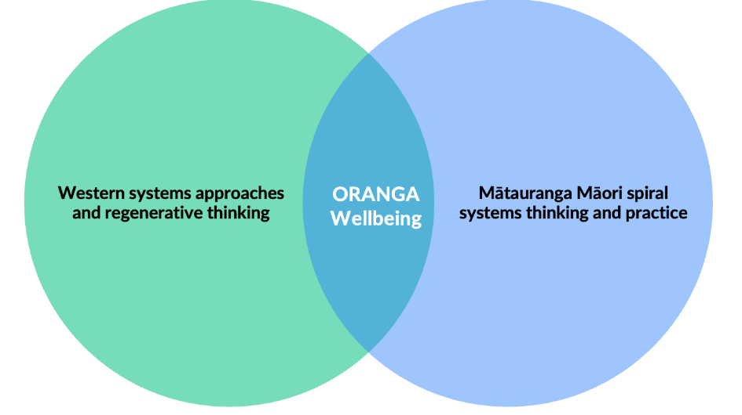

Kia Whakahaumaru Te Mahinga – Safe Operating Space
Through the Western Regenerative Systems Lens A Safe Operating Space for Aotearoa New Zealand provides a valuable starting point for a systems approach to circularity that re-grounds our economic thinking and decision-making in biophysical and social constraints.
The Living Standards Framework four capitals will guide the identification of interventions by diverse actors, including government, the private sector, communities, and the social and natural sciences.

Aligned with the Dual Systems – Binocular Lens approach, Atawhai Tibble provided a Te ao Māori anchored perspective that is complimentary to the Living Standards Framework called, Ngā Rāwa E Ono – The 6 Tribals Capitals Model.

Te Ao Māori Systems and the Circular Economy
The Māori Economy and Māori enterprise are largely circular in nature – more spiral in essence. Traci Houpapa, Chair, Federation of Māori Authorities. “I believe in the spiral economy where there’s regeneration and growth.” Traci went on to capture the essence of the session when she said, “It’s about the western world catching up.”
It is important to note, that there is not a single Te Ao Māori circular-spiral lens. While there are common values and concepts shared across Te Ao Māori thinking, differences in relationships to people, place and nature, experiences and circumstances shape and inform different lens.
Each iwi, hapū and whānau (Māori enterprise) are likely to have an existing circular-spiral lens that is anchored by their own set of values, knowledge and whakapapa. Within this context, the Te Ao Māori lens of the dual-systems binocular lens acts as a place holder, and not to define or determine a universal Te ao Māori circular-spiral.
We have identified at least five Te ao Māori circular-spiral models.
- Te Takarangi – Te ao Māori reflection of the Doughnut Economics Model.
- Huri Rawa, Hauri Rauna – Circular Indigenomics: A Māori Philosophy and Pragmatist Approach to Circular Economies.
- Te Whai Oranga – Mātauranga Māori/ Whakapapa Centred Regenerative Model of Wellbeing.
- He Ara Waiora – Te Ao Māori Wellbeing and Living Standards Framework (Treasury)
- Me Tū ā-Uru – Relational Framework

Te Tiriti o Waitangi and a Shift to a Circular Economy
Te Tiriti o Waitangi, alongside He Whakaputanga o te Rangatiratanga o Nu Tirini are seen by Māori as important source of Aotearoa New Zealand’s constitutional framework.
There has been much work undertaken over the last 40 years exploring the creation and context of Te Tiriti o Waitangi, and the evolution of a considerable body of Treaty jurisprudence since 1975 by the Courts inculding the Waitangi Tribunal.
While there has been a strong focus of the Crown responding to historical Treaty issues, there has been a signficant shift to focus on contemporary Treaty of Waitangi issues, including how the Crown takes into account of Māori rights and interests as well as identifying opportunities to protect and enable those rights.
A current example is the New Zealand-European Union Free Trade Agreement. While the agreement like other agreements from 2001, recognise the status of Tiriti o Waitangi, it also provides for Māori trade and cooperation, and includes references to Te ao Māori, Mātauranga Māori and other Māori concepts.
While a number of Māori organisations (Federation of Māori Authorities, Te Taumata and Iwi Chairs Forum) remain optimistic about the potential positive impacts for Māori trade with the European Union, others (Ngā Toki Whakarururanga and Wai 262 Taumata Whakapūmau) are concerned about the level of protection of Māori treaty rights and Māori intellectual and property rights, and fuller participation of Māori in negotiations as the Crown's Treaty partner.
Successful implementation will be dependent on, continued Māori participation, engagement as a Treaty partner, investment and resourcing, Māori-centred trade facilitation, and bringing greater enablement of Māori value-chain development domestically.

Crown-Māori Work Programmes: There is a significant amount of work currently being undertaken as part of the broader Crown-Māori Relations context.
He Kai Kei Aku Ringa
He kai kei aku ringa can also describe the intrepid migration of the ancient sailors who crisscrossed the Pacific, searching for new opportunities in trade and discovering new products.
He kai kei aku ringa is possible when:
- Māori experience a transformational change in economic performance.
- Māori experience a transformational change in socio-economic outcomes; and
- New Zealand experiences a transformational change in national economic direction.
The strategy was refreshed in 2023 and contains 5 objectives:
- Te Taiao: A low emissions, circular and climate resilient Māori economy as a prerequisite for Māori wellbeing.
- Mana Tuku Iho: Māori identity in the economy enables Māori success.
- Mana Tauutuutu: Supporting economic prosperity as a key enabler of community and whānau sustainability.
- Mana Āheinga: Māori are enabled to chart their own course for the future.
- Mana Whanake: Building foundations for the future.

Circular Economy and Bioeconomy:
- Actions to create greater circularity and develop our bioeconomy will also need to uphold Te Tiriti o Waitangi, apply te ao Māori and mātauranga Māori principles, and protect Māori interests.
- Enable Māori to shape and benefit from the transition to a circular economy and thriving bioeconomy
- The Strategy will uphold Te Tiriti and be informed by te ao Māori and mātauranga Māori.

Te Tumu mō te Pae Tawhiti: Whole-of-government response to issues raised in the Wai 262 Inquiry Report. The work programme seeks to create sustainable economic opportunities based on Aotearoa New Zealand’s unique place in the world, galvanise economic activity, enhance cultural identity and protect and restore the wellbeing of our environment.
A Tika Transition to a Circular Economy: The Me Tū ā-Uru action plan for a flourishing and abundant environment proposes an approach which prioritises balanced and healthy relationships between people and te taiao/ nature. It proposes a relational, Tiriti-based approach to environmental governance centred on Oranga-Wellbeing and balanced long-term relationships;
- Among people
- Between people and te taiao
- Between tangata whenua, tangata Tiriti and the Crown
The action plan was developed as part of New Zealand's Biological Heritage National Science Challenge.
Another outcome of this work, A Tika Transition to a Flourishing Aotearoa – Guidance to inform a 'tika' transition, can be drawn on, as part of a Tiriti-based approach to shifting to a Circular Economy.

Māori Economy and Māori Enterprise
The Māori Economy is a diverse, yet interconnected system, that embraces individual employment and incomes.

The Māori Economy is inextricably linked to Oranga – Wellbeing. Anchored within a set of Te ao Māori values that encompasses the wellbeing of people, place and nature.

The Māori Economy and Māori Enterprise are already circular-spiral in nature.

The Māori Economy can underpin and act as a catalyst to anchor and help transform Aotearoa New Zealand's economy to become more circular

A key element of the Māori Economy is Māori Enterprise, which can be viewed in an integrated way, Iwi/ Hapū Enterprise (tribal enterprise), Whānau Enterprise (Māori SMEs) and Kaupapa Enterprise (Inter-tribal/ Sector/Industry based Enterprises).

Treaty claims can be perceived as an impediment to western linear economic development in terms of challenges to extraction of natural resources, fossil fuels, minerals etc.

There needs to be a shift in mental models from square to circular as most claims centre on the ethic of kaitiakitanga-guardianship which could sit at the heart of a binocular circular economy

Need for greater investment and access to capital for Māori enterprise.

A shift to hapū centred enterprise rather than just iwi - more localised, anchored to place and informed by hapū specific Mātauranga.

A concern that Mātauranga Māori is becoming more academic/ homogenised and favoured by the Crown as opposed to whakapapa centred collective Mātauranga that sits with hapū and whānau.

Enablers and Barriers For Māori
- Engagement with Māori identified the following cross-cutting barriers and enablers most relevant to Māori:
- Māori land utilisation will become more important given it is predominantly located within the foothills, as opposed to coastal areas impacted by physical climate-related risks (e.g., sea level rise and storm surges). This will refocus population are density.
- Shifts to covered food production. This disruption will come at a cost.
- Big shift to Food and Fibre (increasing productivity/economies of scale) presently only large economic sector driving change in NZ context.
- Building economic resilience must be a priority at a time where major longstanding geo-political instability forecasted.
- Free Trade Agreements that have just been signed off by the EU and the reference to the Treaty and Māori trade and cooperation elements are important and world leading creating a level playing field for the whole of NZ for which all exporters will benefit.
- Ahu Whenua Trusts need to concentrate their energy on regional and local government - more relevant to their diversification interests and resolving legislative barriers - rather than central government.
- Increase investment in R&D rather than relying on government grants and be willing to risk investments in new ideas from the next generation.
- Climate migrants will impact on our rangatiratanga.
- Converting pasture into protein is a huge global opportunity - we have a competitive advantage. What do we need to do to put that into place?
- We are also observing a significant shift within the Whānau Ora area, where there is an increasing focus on the development of whānau – social/ business enterprise as part of wellbeing pathways with whānau.
APPENDIX 2: Systems Approaches
Our economy in biophysical and social context
A systems approach requires placing New Zealand’s economy in biophysical context. All economic activity depends on healthy soils, fresh water, oceans, and raw materials (encompassing minerals from the earth, biomaterials, and animal-based materials). Energy is known as the ‘master resource’ because it enables the utilization of all the former inputs. How we’re currently extracting, using, and disposing of these fundamental inputs to meet human needs and wants impacts the health of the biosphere.
For both Māori and many Pākehā, humans are viewed as part of the biosphere, meaning our well-being is directly linked to the health of ecosystems, rivers, oceans, and climate. Globally and in New Zealand, the condition of the biosphere is deteriorating. To help us better understand and to reverse this phenomenon, the Planetary Boundaries Framework identifies nine key processes regulating Earth's stability – defining “a safe operating space” for human development (Figure 4). Crossing these boundaries is a direct result of a take-make-waste economy and increases the risk of significant and irreversible environmental change. This framework is widely adopted in global discussions on circularity, serving as a tool to assess the impacts of conventional production and consumption practices (Circle Economy Foundation, 2023).
In 2020, the New Zealand Ministry for the Environment commissioned a Planetary Boundaries assessment of Aotearoa from the Potsdam Institute for Climate Impact Research, the Stockholm Resilience Centre, and the Mercator Research Institute on Global Commons and Climate Change. The resulting report, titled "A Safe Operating Space for Aotearoa New Zealand," aimed to offer a comprehensive view of multiple environmental systems beyond climate change to inform policy. The assessment of five boundaries revealed that, like other developed nations, New Zealand significantly surpasses its "fair share" of impacts. Notably, the country's major transgressions are related to nitrogen and phosphorus boundaries, exceeding fair share levels by factors ranging from 4 to almost 55 times. In both cases, production-based transgressions outweigh consumption-based transgressions, reflecting New Zealand's substantial agricultural net exports.
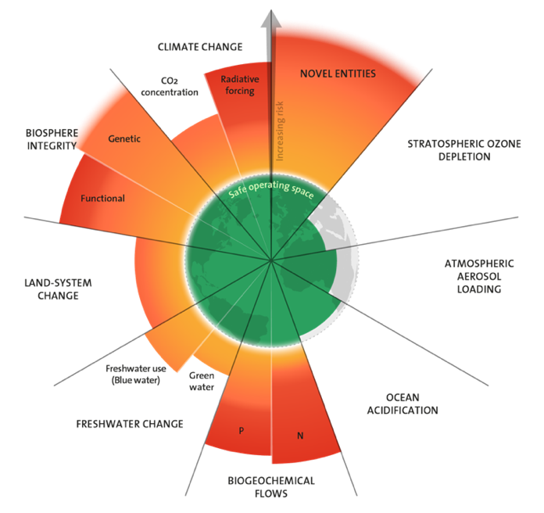
Figure 1. The Planetary Boundaries Framework defines the ‘safe operating space’ for human development, based on the planet’s nine bio-physical processes. It provides a science-based reference of the risks that human interventions will substantially alter the Earth’s system and has been influential in supporting understanding that that a focus on climate change alone is not sufficient for sustainability. In September 2023, a team of scientists quantified for the first time all nine complex earth systems, finding that six have been transgressed (Richardson et al., 2023).

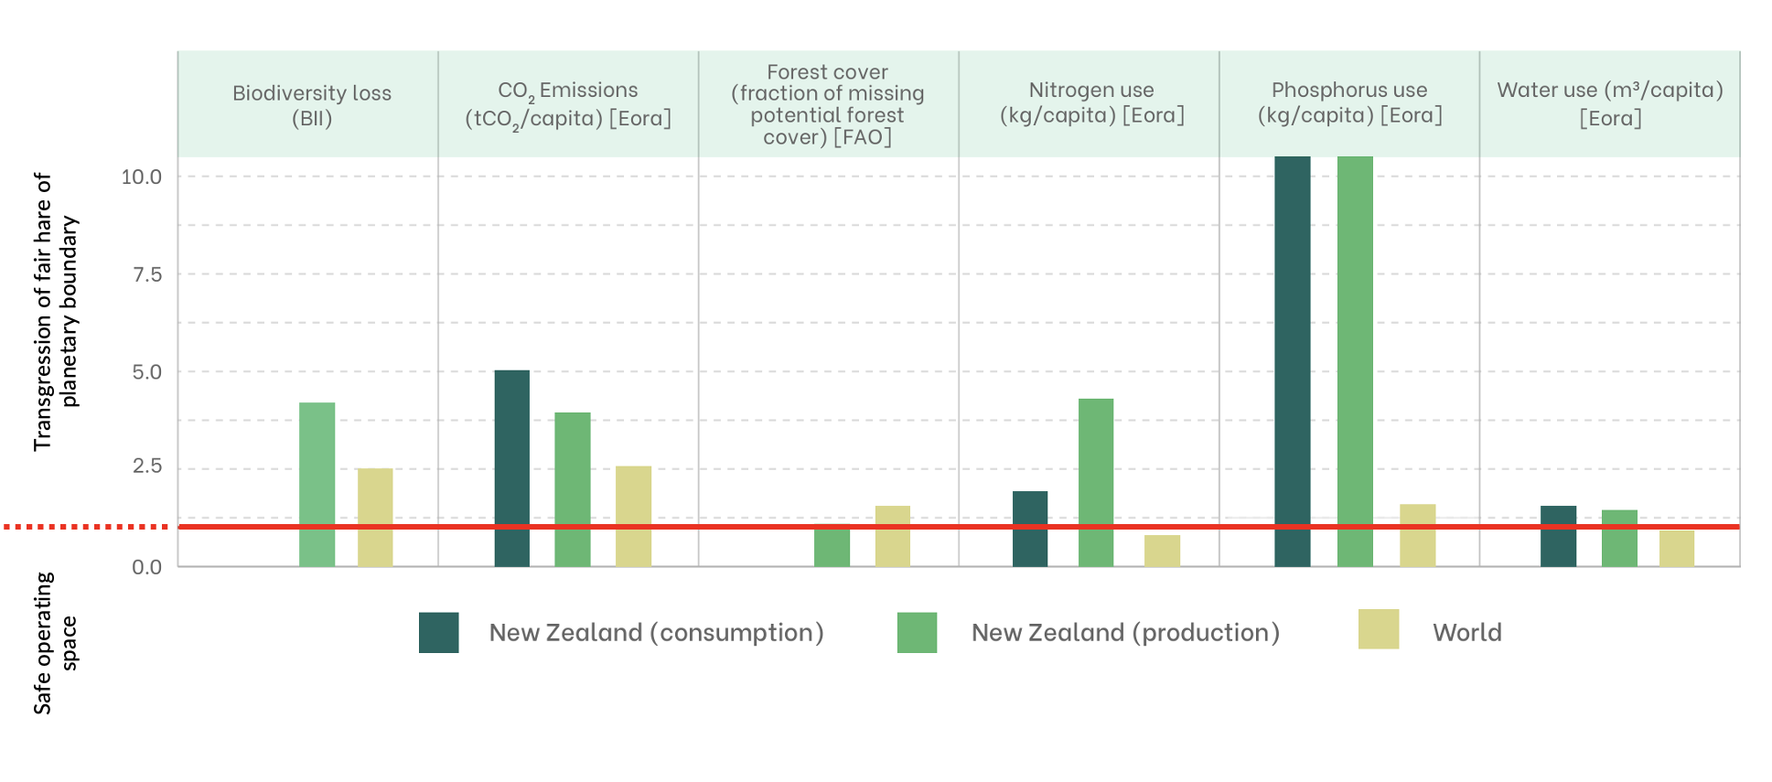
Figure 2. The red line marks the normalised planetary boundary (translated to national fair shares), set at 1 on a common scale of 0–10 to allow for comparison. The safe operating space is under 1, over 1 mark a transgression of the boundary. The dark green bars show New Zealand’s national consumption-based and the lighter-green bars and production-based performance, compared with the global average.
A Safe Operating Space for Aotearoa New Zealand provides a valuable starting point for a systems approach to circularity that re-grounds our economic thinking and decision-making in biophysical and social constraints. This is critical, first from a global equity perspective; the report notes a significant disconnect between New Zealand’s Planetary Boundary overshoots and global ambitions in multilateral agreements, such as the Paris Agreement and Convention on Biological Diversity, to create a sustainable and resilient future for all. Second, and more immediately, the offshoots threaten fundamental inputs to Aotearoa’s economy and future prosperity.
Figure 3 bellow illustrates the components of our economy in its biophysical and social context. These encompass:
- Fundamental economic inputs and stocks: These include the raw materials, energy, fresh water, oceans, and human labour on which economic activity depends. To ensure sustained economic prosperity, it's crucial to restore and maintain the optimal health of these resources. From a systems perspective, it's best to focus circular efforts on resource inputs since waste and emissions primarily originate upstream in value chains. The core issues lie in the type of resources used, mostly finite materials that generate pollutants during utilisation, extraction practices and quantities, and product designs that hinder upcycling efforts.
- Political and economic ideas, underlying values and culture: The lens of political economy supports understanding of how policies, resource distribution, incentives, and power dynamics influence how we use fundamental inputs from the natural world to meet human needs and wants. It also sheds light on the current status and health of five key capitals (below). Political economy operates on global and local scales. New Zealand is deeply integrated into the global market economy and is influenced by global geopolitical trends and agreements. These global forces interact with local institutions, politics, culture, and values, shaping a unique political economy specific to New Zealand.
- Five capitals: The use of fundamental economic inputs, shaped by political economy, results in our current state of five capitals (based on The Living Standards Framework); human capabilities, social and relational capital, infrastructure, natural capital, and financial capital. Each of these components of ‘wealth’ is influenced not only by evolving political economy, values, and culture, but also each other. For instance, green public infrastructure and predestination is a well-studied driver of deeper social cohesion and individual wellbeing (Pauliet et al., 2019). Further, the capitals are not passive; each has power to shape political economy, values, and culture – with flow on implication to our relationship with biosphere, and with each other. Understanding the current state of each capital, how it is evolving, and how it needs to evolve, will be key to circular economic transition that produces better outcomes for all New Zealanders, our local ecosystems, and the climate.
- Planetary boundaries: As this framework becomes mainstream globally to assess the ‘fair shares’ of countries’ impacts to earth systems, New Zealand as a member of the OECD, trading partner with the European Union, and signatory to multiple international environmental agreements, will not avoid scrutiny. The most obvious risks, associated with our current overshoot, is to New Zealand’s ‘green’ and ‘clean’ image, which is a comparative advantage globally for exporters and can increasingly command premium prices.
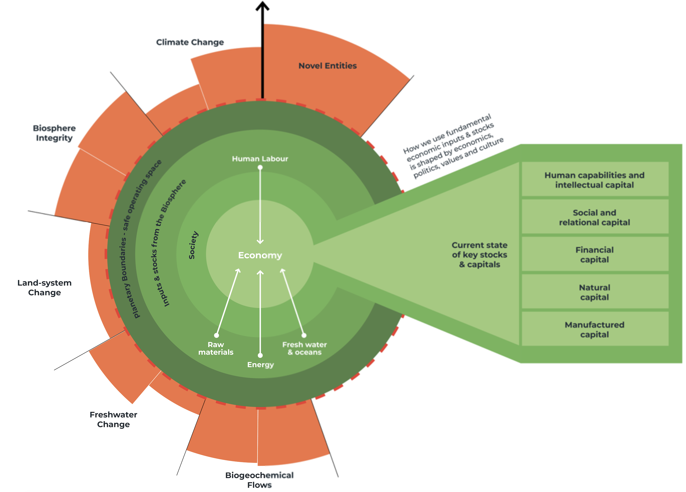
Figure 3, Our Economy in biophysical and social context. Aotearoa’s economy in biophysical and social context, provides an illustration of the components of understanding for decision-makers to build and consider in order to safeguard long-term economic prosperity and the holistic wealth of New Zealand.
Global movement towards integrated investment and decision making
Data serves as the foundational cornerstone of a systems approach, providing the necessary evidence-based insights to surface, understand, and analyse, the intricate interdependencies within a complex system. There is a rapidly growing global recognition that our existing linear economy has significant gaps in information flows that are critical to the long-term success of our economies and societies. There is a need to establish feedback loops that are essential for informing better decision-making for businesses and investors in the context of planetary boundaries. This is reflected in the increase in disclosure requirements through organisations such as the International Sustainability Standards Board (ISSB) and programmes such as the Taskforce for Climate-related Financial Decisions (TCFD), the Taskforce for Nature-related Financial Disclosures (TNFD) and the World Economic Forum’s Stakeholder Capitalism Metrics.

This systemic shift in thinking is also reflected in the significant momentum behind the six capitals approach in Integrated Reporting which offers a more comprehensive perspective on value creation and underscores the interconnectedness between economic, social, and environmental aspects of society. Putting each of these capitals on a similar level of importance delivers a more balanced approach to measuring fundamentals of success and grounds the economy of the future in tangible biophysical and social realities that moves past the flawed metrics in our current system.

The economy of the future necessitates an holistic understanding of how inputs and stocks are interlinked within the broader context. A systems-oriented approach not only aligns with the principles of more sustainable development but also positions businesses to thrive in a future where data-driven decision-making is essential for navigating the intricate relationships between raw materials, energy, fresh water, oceans, society, etc.

Mapping of barriers and enablers in current system
Barriers and enablers have been identified using the Multi-level Perspectives (MLP) Framework (figure 2). The MLP framework is a simple yet effective tool for policy makers to build a clear understanding of complex socio-economic systems, and where to intervene to drive meaningful change. MLP has been developed from observation of how real world significant socio-economic transitions happen over time. It operates on the premises that these transitions are shaped by interactions between three interconnected levels:
- Landscape: The ‘seen’ landscape of events and trends, such as economic growth, climate change, and business as usual practices, that can over time place pressure on a system to change.
- Meso-level: The underlying ‘system’ that acts to ‘lock-in’ what we see at landscape level. This level consists of a network of interconnected elements, including cultural values, worldviews, and ideologies; elements of socio-economic systems (the economy, government, communities) designed to meet human needs and wants; and tangible infrastructure and technologies.
- Niche innovations: These are the emerging practices, enterprises, policies, technologies, and products that ‘open up’ possibilities for fundamentally different ways of living together well.
Critical barriers and enablers to circularity were identified at all three levels of the MLP framework, with figure three This was undertaken at a high level for whole economy, with deeper analysis for the three focus sectors. Notably, the identification of barriers and enablers against MLP provides insight as to where systemic opportunities for circularity lie in New Zealand’s economy (see Phase 4).
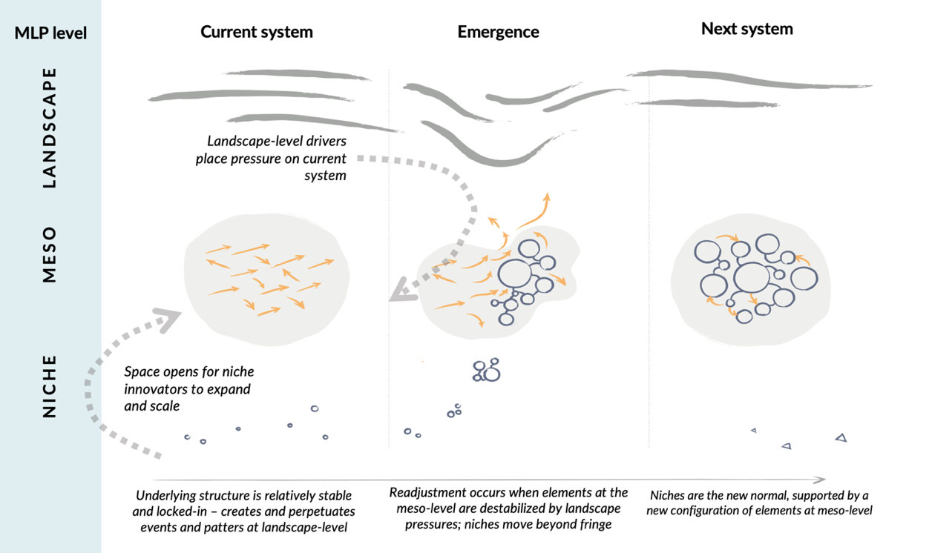
Figure 4. The MLP Framework shows that systems change over time, from the current to future system, when there are concurrent developments at all three levels. Pressures at the landscape level (e.g., climate change) starts to cause actors in a position of power to question ‘business as usual’ practices and norms, leading to interventions into meso-level elements (e.g., new regulations, technologies, education), which ‘opens up’ space for previously fringe niche innovations to become more mainstream, and, over time, the new normal.
Guiding principles for systems approaches
Criteria or principles for systems approaches provide a useful framework to guide thinking, decision-making, problem-solving. The following table outlines those typically applied for both a western systems and Māori systems lens.

Interconnectedness | Acknowledge and seek to understand the relationships and interdependencies among various components within a system, whether it's a biological organism, a social structure, or an ecological environment. For Māori, interconnectedness speaks to the speak to the interconnectedness and interdependencies of whakapapa-based relationships between people, place and nature and intergenerational relationships.
Holistic | The focus is on the health of the whole system, not the health of individual component parts in isolation. This requires wide over narrow boundaries in conserving and solving problems and pursuing goals.
Non-Linearity | Linear cause-and-effect thinking often falls short in capturing the nuanced and dynamic interactions within systems. Systems approaches involves recognising feedback loops, emergent properties, and the non-linear nature of relationships. Through a Mātauranga Māori lens, this applies also in time and space.
Emergence | Complex systems exhibit properties or behaviours that cannot be predicted solely by understanding individual components. This entails that while we can make best efforts to understanding a system, ultimately it is impossible to predict the outcomes of our intervention ahead of time.
Precaution | As a result of the non-linearity and non-predictability of complex system, precaution, as a principle, is crucial; acknowledging the limits of our understanding, and recognizing the potential for unforeseen consequences in complex systems. This applies especially when dealing with situations where the dynamics involve non-linearities and intricate feedback loops that are characteristic of complex systems (e.g. the climate system that is not fully understood).
Dynamic Adaptability | Solutions to problems need to be flexible and responsive to changing circumstances. This requires a shift away from the norm whereby solutions are selected, implement, and evaluated ex-post – to a sense-learn-adapt approach that is able to be dynamic in response to real world feedback.
Multiple Perspectives | This includes recognizing diverse viewpoints, understanding the subjective experiences of individuals within a system, and appreciating the complexity that arises from different perspective

The Planetary Boundaries Framework identifies nine key processes regulating Earth's stability, defining “a safe operating space” for human development. Crossing these boundaries is a direct result of a take-make-waste economy and increases the risk of significant and irreversible environmental change. This framework is widely adopted in global discussions on circularity, serving as a tool to assess the impacts of conventional production and consumption practices (Circle Economy Foundation, 2023).
Financial capital, as an enabler of tangible value creation, has been split from physical manufactured capital. These two capitals are combines in Treasury’s Living Standards Framework
Property-related sectors include: Owner-occupied property operation; Rental, hiring and real estate service; and Construction.
The European Commission has estimated that circular transition will see productivity increase by up to 3% annually, translating into a GDP increase up 7% relative to BAU development scenarios
Countries leading the circular transition are targeting manufacturing because a circular economy requires a shift from linear production, which relies on finite abiotic materials, with mining causing the most waste and ecological damage out of all industries, to ‘green’ manufacturing and technologies that utilise renewable biomaterials and energy to meet human needs.
Financialisation, the growing influence of financial interests, markets, actors, and institutions in economies, is widely recognised as having adverse effects on real economic growth tied to productive activities (Mazzucato, 2018). Evidence suggests that financial growth doesn't drive real growth; instead, it often hampers it. Speculative short-term perspectives dominate decision-making in enterprises, guiding financial strategies toward quick profits without much regard for long-term production needs (Ülgen, 2019).
This trend is evident in the rapidly growing global recognition that our existing linear economy has significant gaps in information flows that are critical to the long-term success of our economies and societies. Demand for holistic data to inform better decision-making for businesses and investors in the context of planetary boundaries is reflected in the increase in disclosure requirements. These include: the International Sustainability Standards Board (ISSB), the Taskforce for Climate-related Financial Decisions (TCFD), the Taskforce for Nature-related Financial Disclosures (TNFD), the World Economic Forum’s Stakeholder Capitalism Metrics), stricter EU import regulations.
Circular technologies, in particular renewables and electrical transport systems, require many-fold the metals of conventional fossil fuel dependent technologies. For example, typical electric car requires six times the minerals of a conventional car, an onshore wind farm requires nine times more minerals than a gas-fired power plant with a similar output.
Scope 3 emissions are the result of activities that are not owned or controlled by a company but are nevertheless related to the generation and transportation of a company's products, for example, emissions related to the production of food, fertilizers, and pesticides.
The nine planetary boundaries were first identified by Johan Rockström of the Stockholm Resilience Centre, and a group of 28 internationally renowned scientists in 2009. It has since been revised and reiterated several times for greater accuracy.
Circular Gap Reports, produced by the Circle Economy Foundation, utilise the PB framework in their well-known country-level ‘Circularity Gap’ reports is by downscaling the boundaries to identify the “fair share” of impacts to earth systems, based on the size of the population compared with the global population.
Europe, as part of its Green New Deal and leadership role in the global climate action, in introducing increasingly strict import standards for the sustainability of imported products.

