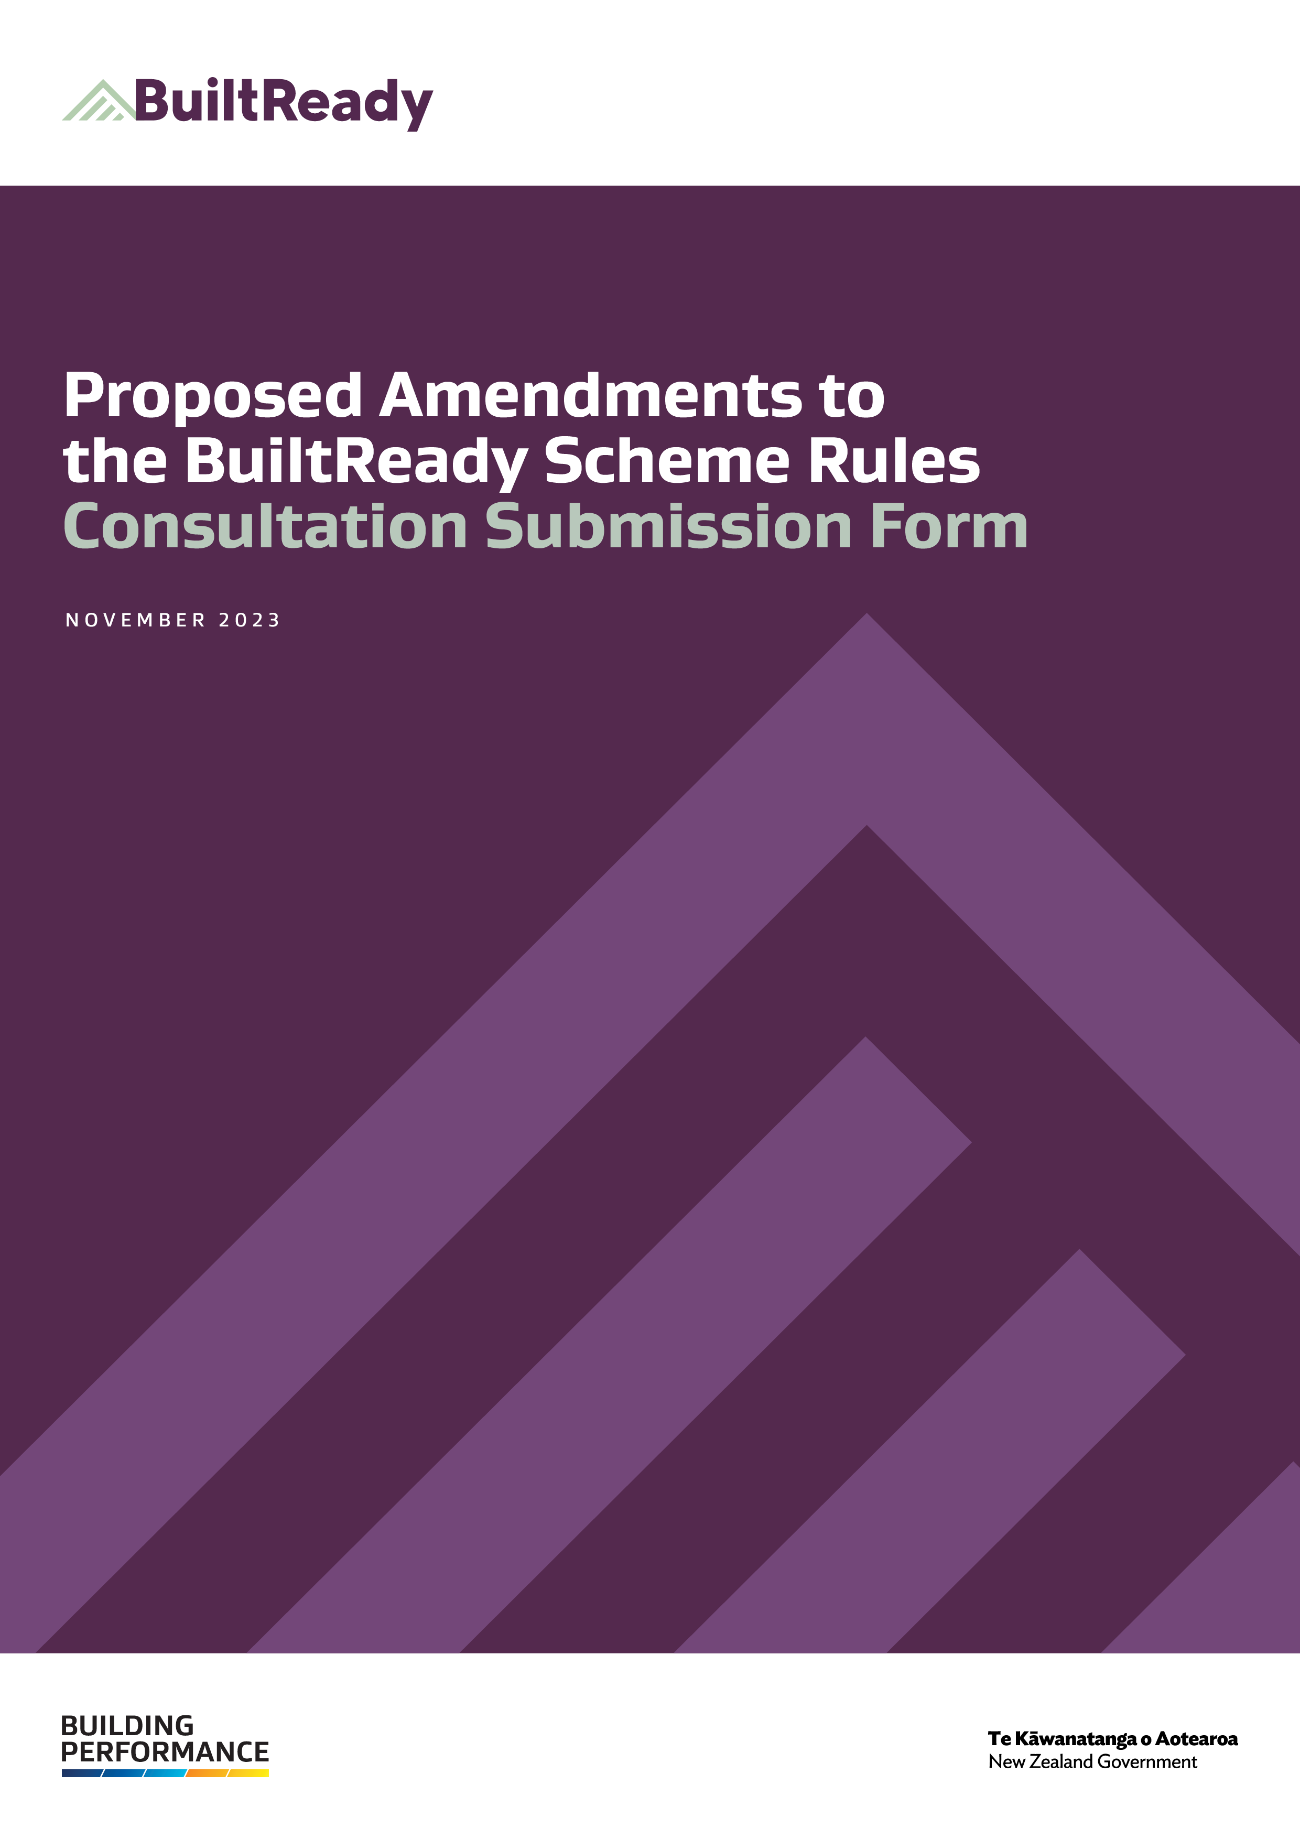
How to submit this form
This submission form can be used to provide your feedback on the Ministry of Business, Innovation and Employment’s (MBIE’s) consultation on proposed amendments to the BuiltReady scheme rules for modular component manufacturers.
Please send us your completed form by 5pm on 12 December 2023.
When completing this submission form, please provide comments and reasons explaining your choices. Your submission may respond to any, or all of the proposed amendments. Where possible, please include evidence to support your views – for example, references to independent research, facts and figures, or relevant examples.
Your feedback provides valuable information and informs decisions about the proposed scheme rules. We appreciate your time and effort in responding.
- You can provide your feedback by completing a survey online via www.mbie.govt.nz/have-your-say or
- You can download a form at www.mbie.govt.nz/have-your-say and either:
  - email the completed form to:
building@mbie.govt.nz with the subject line ‘BuiltReady consultation 2023’, or
  - post it to:
BuiltReady consultation 2023
Building System Performance
Building Resources and Markets
Ministry of Business, Innovation and Employment
PO Box 1473, Wellington 6140
New Zealand
If you have any questions about the submissions process, please email us at building@mbie.govt.nz

Use and release of information
The information provided in submissions will contribute to MBIE’s development of the BuiltReady scheme rules. We may contact submitters directly if we require clarification of any matters in submissions.
Your submission will also become official information, which means it may be requested under the Official Information Act 1982 (OIA). The OIA specifies that information is to be made available upon request unless there are sufficient grounds for withholding it. If we receive a request, we cannot guarantee that feedback you provide us will not be made public. Any decision to withhold information requested under the OIA is reviewable by the Ombudsman.
Please set out clearly in the cover letter or email accompanying your submission if you have any objection to the release of any information in the submission and, in particular, which parts you consider should be withheld and reasons for withholding this information. MBIE will take such objections into account and consult with submitters when responding to requests under the OIA.
Private information
The Privacy Act 1993 establishes certain principles with respect to the collection, use and disclosure of information about individuals by various agencies, including MBIE. Any personal information you supply to MBIE in the course of making a submission will only be used for the purpose of assisting in the development of the MCM scheme rules. Please clearly indicate in the cover letter or email accompanying your submission if you do not wish your name or any other personal information to be included in any summary of submissions that MBIE may publish.

Submitter information
MBIE would appreciate if you would provide some information about yourself in the section below. If you choose to do so, this information will be used to help MBIE understand the impact of our proposals on different occupational groups. Any information you provide will be stored securely.

Your name, email address, phone number and organisation
Name:

Organisation:

Email address:

Phone number:

☐ | - The Privacy Act 2020 applies to submissions. Please tick the box if you do not wish your name or other personal information to be included in any information about submissions that MBIE may publish.
☐ | - MBIE may upload submissions, or a summary of submissions received to MBIE’s website at www.mbie.govt.nz. If you do not want your submission or a summary of your submission to be placed on our website, please tick the box and type an explanation below:

I do not want my submission placed on MBIE’s website because… [insert reasoning here]

Please check if your submission contains confidential information
☐ | - I would like my submission (or identifiable parts of my submission) to be kept confidential and have stated my reasons and grounds under section 9 of the Official Information Act that I believe apply for consideration by MBIE.

[insert response here]

Questions

Part 2: Accreditation body requirements
Part 2 of the rules for the MCM accreditation body include a requirement to notify MBIE of any proposed limitations to a certification body’s scope of accreditation; to conduct an audit on an accredited certification body if requested by MBIE (outside its usual surveillance cycle); and to provide MBIE with reports regarding its assessments, audits and investigations of certification bodies.
MBIE is proposing one new scheme rule for the accreditation body:
- Using the BuiltReady brand.
With the proposed rule around use of the BuiltReady brand, the accreditation body may use the BuiltReady brand, provided they follow the format and conditions of use provided for in the Schedule 1 of the scheme rules.

Using the BuiltReady brand
1. Do you agree with the proposed rule that the accreditation body may use the BuiltReady brand, provided they do so in accordance with Schedule 1?
☐ Yes, I agree with the proposed rule that the accreditation body may use the BuiltReady brand, provided they do so in accordance with Schedule 1
☐ No, I don’t agree with the proposed rule that the accreditation body may use the BuiltReady brand, provided they do so in accordance with Schedule 1 (please elaborate below)
☐ Not sure/no preference
[insert response here]

2. Would you be able to implement this?
☐ Yes, I would be able to implement this
☐ No, I wouldn’t be able to implement this (please elaborate below)
☐ Not sure/no preference
[insert response here]

3. Are there any barriers to following this rule?
☐ Yes, there are barriers to following this rule (please elaborate below)
☐ No, there aren’t barriers to following this rule
☐ Not sure/no preference
[insert response here]

Part 4: MCM certification body requirements
Part 4 covers the ongoing, detailed requirements that a certification body must continue to meet and maintain once accredited.
MBIE is proposing one new scheme rule for the MCM certification body:
- Using the BuiltReady brand.
With the proposed rule around use of the BuiltReady brand, the MCM certification body may use the BuiltReady brand, provided they follow the format and conditions of use provided for in Schedule 1 of the scheme rules.

Using the BuiltReady brand
4. Do you agree with the proposed rule that the MCM certification body may use the BuiltReady brand, provided they do so in accordance with Schedule 1?
☐ Yes, I agree with the proposed rule that the MCM certification body may use the BuiltReady brand, provided they do so in accordance with Schedule 1
☐ No, I don’t agree with the proposed rule that the MCM certification body may use the BuiltReady brand, provided they do so in accordance with Schedule 1 (please elaborate below)
☐ Not sure/no preference
[insert response here]

5. Would you be able to implement this?
☐ Yes, I would be able to implement this
☐ No, I wouldn’t be able to implement this (please elaborate below)
☐ Not sure/no preference
[insert response here]

6. Are there any barriers to following this rule?
☐ Yes, there are barriers to following this rule (please elaborate below)
☐ No, there aren’t barriers to following this rule
☐ Not sure/no preference
[insert response here]

Part 6: Certified modular component manufacturer requirements
Part 6 covers the requirements for certified MCMs, which includes making sure that the modular components identified in its scope of certification continue to be manufactured in accordance with the quality plan and that the MCM’s processes and quality management system are effectively implemented.
MBIE is proposing two new scheme rules for modular component manufacturers:
- Mandating use of MBIE’s current manufacturer certificate template.
The proposed rule to mandate the use of MBIE’s provided manufacturer certificate template is to ensure consistency of BuiltReady manufacturer certificates across the country, both for trust in the BuiltReady scheme and ease of use in consenting decisions.
In addition to using MBIE’s current manufacturer certificate template, manufacturers must not change the structure and the design of the certificates.
- Using the BuiltReady brand.
With the proposed rule around use of the BuiltReady brand, the modular component manufacturer may use the BuiltReady brand, provided they follow the format and conditions of use provided for in the scheme rules.
Under the proposed rule for modular component manufacturers, there would be additional requirements around using the BuiltReady brand centred around the scope of certification. If a modular component manufacturer uses the BuiltReady brand, they must state the scope of certification and not use the BuiltReady brand for advertising other services beyond the scope of certification.

Mandating use of MBIE’s current manufacturer certificate template

- Do you agree with the proposed rule to mandate the use of MBIE’s provided manufacturer certificate template?
☐ Yes, I agree ☐ No, I disagree ☐ Not sure/no preference
[insert response here]

- Is the proposed rule to mandate the use of MBIE’s current manufacturer certificate template clear and workable? If not, what changes would you suggest?
☐ Yes, I agree ☐ No, I disagree ☐ Not sure/no preference
[insert response here]
Using the BuiltReady brand
9. Do you agree with the proposed rule that the MCM may use the BuiltReady brand, provided they do so in accordance with Schedule 1?
☐ Yes, I agree with the proposed rule that the MCM may use the BuiltReady brand, provided they do so in accordance with Schedule 1
☐ No, I don’t agree with the proposed rule that the MCM may use the BuiltReady brand, provided they do so in accordance with Schedule 1 (please elaborate below)
☐ Not sure/no preference
[insert response here]

- Is the proposed rule to require modular component manufacturers to state their scope of certification while using the BuiltReady brand, as well as only using the BuiltReady brand in relation to services they offer under their scope of certification, clear and workable?
☐ Yes, I agree ☐ No, I disagree (please explain below)
☐ Not sure/no preference
[insert response here]

11. Are there any barriers to following this rule?
☐ Yes, there are barriers to following this rule (please elaborate below)
☐ No, there aren’t barriers to following this rule
☐ Not sure/no preference
[insert response here]

Schedule 1: Use of the BuiltReady brand (format)
Schedule 1 of the BuiltReady scheme rules lays out the formatting requirements if one of the scheme participants chooses to use the BuiltReady brand for marketing and advertising purposes.
It is not required to use the BuiltReady brand – however, if one of the scheme participants chooses to use the BuiltReady brand, they must follow the relevant rule and use it in accordance with Schedule 1.

- Are there any comments on formatting of the BuiltReady brand you’d like to add?
[insert response here]

Thank you again for your time in responding to this consultation.

