New Zealand Telecommunications Relay Services Beyond June 2019

Public consultation document

First published: February 2018

Commerce, Consumers, Communications Branch

Ministry of Business, Innovation & Employment

PO Box 1473

Wellington 6140

New Zealand

www.mbie.govt.nz

CC By Creative Commons logoCrown copyright ©.

This public consultation document is licensed under the Creative Commons Attribution 4.0 International licence. In essence, you are free to copy, distribute and adapt the work, as long as you attribute the work to the Ministry of Business, Innovation and Employment, and abide by the other licence terms. To view a copy of this licence, visit <http://creativecommons.org/licenses/by/4.0/>. Please note that no departmental or governmental emblem, logo or Coat of Arms may be used in any way which infringes any provision of the [Flags, Emblems, and Names Protection Act 1981](http://www.legislation.govt.nz/act/public/1981/0047/latest/whole.html#dlm52216) or would infringe such provision if the relevant use occurred within New Zealand. Attribution to the Ministry of Business, Innovation and Employment should be in written form and not by reproduction of any such emblem, logo or Coat of Arms.

Important notice: The opinions and proposals contained in this document are those of the Ministry of Business, Innovation & Employment and do not reflect government policy. The Ministry does not accept any responsibility or liability whatsoever whether in contract, tort (including negligence), equity or otherwise for any action taken as a result of reading, or as a result of reliance placed on the Ministry because of having read, any part, or all, of the information in this discussion document or for any error, inadequacy, deficiency, flaw in or omission from the consultation document.

Table of Contents

**Section 1: Introduction and Context4**

Introduction4

Background4

**Section 2: Current Services and Usage7**

Current Services7

Relay Service Usage7

**Section 3: The Future of New Zealand Relay Services14**

Availability14

Accessibility15

Affordability17

Fit for purpose19

Other issues20

**Submissions Template22**

# Section 1: Introduction and Context

***Introduction***

1. Through its contracted providers, the Government provides a Telecommunications Relay Service (the relay service) for deaf, hearing impaired, speech impaired and deafblind[1] New Zealanders. A full summary of the services currently provided is included in paragraph 18.
2. The current contracts for the provision of the relay service are due to expire on   
   30 June 2019. To ensure the effective delivery of the relay service beyond this date, the Ministry of Business, Innovation and Employment (MBIE) is seeking your views on what services and equipment are required to meet the needs of users, and how the services and equipment offered may need to change in light of technological developments.
3. The responses to this consultation will assist us in the procurement of an effective relay service from 1 July 2019. As such, we strongly encourage responses from users of the relay service and their representative bodies, telecommunications and relay service providers, stakeholders and other interested parties to the questions outlined in this document.

***Background***

1. Sensory impairments (hearing and vision loss) affect 11 per cent of New Zealanders. According to the Statistics New Zealand’s Disability Survey 2013, an estimated 484,000 people are limited in their everyday activities by sensory impairments that assistive devices such as hearing aids or glasses do not eliminate. Hearing impairment affects 380,000 people (9 per cent of the total population) and vision impairment affects 168,000 people (4 per cent). Having difficulty speaking (and being understood) because of a long-term condition or medical problem affects 3 per cent of the total population[2].
2. A more recent report commissioned by the National Foundation for the Deaf (NFD) on the Social and Economic Costs of Hearing Loss in New Zealand, set out that the prevalence of hearing loss in New Zealand was estimated to be 880,350 people in 2016 – approximately 19 per cent of the population[3].
3. Those with sensory impairments may have trouble communicating via traditional telecommunications. To help bridge this divide, the relay service in New Zealand was established in 2004 to provide equivalent telecommunications access to deaf, hearing impaired, deafblind or speech impaired people by making available a range of text based telecommunications services free of charge[4]. It also aimed to enable greater participation by users in the workforce and community, and address telephone service access inequalities. Over time, new services, such as CapTel and the Video Interpreting Service (VIS), have been added to the relay service, offering an even wider variety of communications tools for those who need them.
4. CapTel services enable a deaf or hearing impaired person (user) to speak directly with a hearing person through a CapTel telephone. The hearing person’s speech is transcribed by a specially trained operator, and the text is relayed via the internet to a screen on the user’s CapTel phone in near real time. The VIS links any deaf or hearing impaired person who uses New Zealand Sign Language (NZSL) with a Video Interpreter (VI) and a hearing person. The user and VI sign to each other on a video screen. The VI will then talk to the hearing person on the telephone, or through video if they are in the same location as the user, and relay the conversation between the two parties.
5. A New Zealand Relay Advisory Group (NZRAG) was established alongside the relay service and is comprised of representatives from each of the user communities. This includes deaf, hearing impaired, speech impaired, deafblind and parents of children with communication disabilities[5]. Its role is to provide service and technical feedback to the providers of the relay service and the Government, offer suggestions on outreach opportunities, provide feedback for possible product enhancements and attend outreach events as may be required.
6. Since the establishment of the relay service, advances in communications technologies have increased the range of mainstream products and services, such as smartphones, tablets and laptops, with advanced accessibility features suitable for people with disabilities. Video chat applications (apps) such as Apple’s ‘Facetime’ and Microsoft’s ‘Skype’ allow NZSL[6] users the opportunity to chat directly with friends and family. Companies too are offering a broader range of ways for their customers to interact with them, such as via social media and through online chat applications.
7. There are also an increasing number of other applications and technological developments that provide additional accessibility options for communicating. For example, apps are now available that that transcribe spoken words into text, and that recognise common sounds (such as a doorbell, fire alarm or telephone), alerting the user so that they can take action. Further innovative technologies in development include gloves that can translate American Sign Language into text, and improvements in voice recognition technology that may one day eliminate the need for a dedicated relay service.
8. These technological advancements have positively impacted on the accessibility of communications for many people who are deaf, hearing impaired, deafblind or speech impaired. However, there remains a role for government to continue to support people with sensory impairments in having equal access to communication technologies.
9. In particular, the Government’s Disability Strategy 2016 - 2026, aims for New Zealand to be ‘*a non-disabling[7] society – a place where disabled people have an equal opportunity to achieve their goals and aspirations, and all of New Zealand works together to make this happen*.’ The Disability Action Plan will be the primary vehicle for implementing the Disability Strategy. The current four year Disability Action Plan 2014-2018, is set to be reviewed and updated in 2018.
10. To complement this overarching vision, the Government’s objective in providing a relay service from 1 July 2019, agreed in consultation with NZRAG members, is to ensure that the relay service meets the needs of users in facilitating the access of deaf, hearing impaired, deafblind and speech impaired people to New Zealand society and the economy. Specifically, we want to ensure that the relay service is:

* **Available:** to those who need it, when they need it, regardless of where they live
* **Accessible:** widely known, easy to access and straightforward to use
* **Affordable:** for users whilst offering value for money for the Government
* **Fit for purpose:** compatible with mainstream technologies and networks and keeps pace with technological advancements.

***Submissions Process***

1. You are invited to make a written submission on the issues raised in this public consultation document. Specific questions are listed at the end of the relevant sections, and a submissions template is attached as an appendix to this document.
2. New Zealand Sign Language users are also able to make a video submission in NZSL. For further information please visit <http://www.mbie.govt.nz/info-services/sectors-industries/technology-communications/communications/telecommunications-relay-service/>.
3. The closing date for submissions is **5:00pm, Friday 13 April 2018**. If you use more than one service, please be sure to provide feedback on any or all of these as you see fit.

## Section 2: Current Services and Usage

***Current Services***

1. The current providers of the relay service are:

* Sprint Accessibility NZ (Sprint). Sprint is contracted to provide text-based relay services, speech to speech services and captioned telephone services (CapTel). These services are delivered from a contact centre in Auckland, New Zealand, managed by Communication Services for the Deaf, Inc. (CSD); and
* Communication Services for the Deaf (CSD). CSD provides the Video Interpreting Service (VIS)[8] from the same contact centre as Sprint’s relay services above.

1. The services currently provided, and their hours of availability are outlined in the table below:

|  |  |  |
| --- | --- | --- |
| **Type of Service** | **Description** | **Hours of Availability** |
| Teletypewriter to Voice (TTY) | Enables a TTY user to type their conversation to a Relay Assistant (RA) who then reads the typed message to a standard phone user (hearing person). The RA relays the hearing person's spoken words by typing them back to the TTY user | 24/7 |
| Voice Carry-Over (VCO) | Enables a Deaf or hearing impaired person (user), who prefers to use their own voice, to speak directly to the party they are calling. The RA will type the voice responses back to the user who reads the typed message on a TTY screen | 24/7 |
| Hearing Carry-Over (HCO) | Enables people who are speech impaired (user) to use their hearing abilities to listen directly to the other party. The RA voices the typed responses from the user to the hearing person, who then speaks directly to the user without RA interaction | 24/7 |
| Mobile Text Relay Service | Enables a Deaf or hearing impaired person (user) to make a relay call using a mobile text application called ‘TexMee’ on their smartphone or tablet to communicate with hearing people. The User types a message into the mobile application, which is read by a RA to a standard phone user. The standard phone user then responds, and the RA types the message back to the user | 24/7 |
| Internet Relay | Allows users to place relay calls using a web browser via a computer, laptop or tablet with an internet connection | 24/7 |
| CapTel and WebCaptel | Allows a Deaf or hearing impaired person (user) to speak directly with a hearing person through a CapTel telephone, or through a computer, laptop, tablet or via the web-browser on a smartphone. The hearing person’s speech is transcribed by a specially trained operator, and the text is relayed via the internet to a screen on the user’s CapTel phone in near real time | Seven days per week  7am – 10pm |
| Video Interpreting Service (VIS) | Links any Deaf or hearing impaired person who uses New Zealand Sign Language (user) with a Video Interpreter (VI) and a hearing person (including staff from government agencies). The hearing person may be in the same room as the user, or in another location (including overseas). The user and VI sign to each other on a video screen. The VI will then talk with the hearing person on the telephone, or through video if they are in the same location as the user, and relay the conversation between the two parties | Monday to Friday  8am – 8pm |
| Speech to Speech and Video-Assisted Speech to Speech | Enables a person with a speech impairment to communicate over the telephone using his or her own voice or a voice synthesizer. Specially trained Relay Assistants (RAs) act as the speech-impaired user's voice. The RA will listen and repeat the speech-impaired user's message to the other party as necessary. Video-Assisted Speech to Speech also connects the user via Skype, enabling the RA to also see visual cues during the conversation that improve the quality of the call | Monday to Friday 7:30 am - 9:00 pm  Saturday 9:00 am - 5:00 pm |

1. In additionto the above services, CSD is also contracted to manage a pool of specialised equipment, including TTY and CapTel phones, telebraillers, and a range of associated visual or sensory alert devices, for relay users. The pool was established to ensure that specialist equipment was available at an affordable price for those who need it.

***Relay Service Usage***

1. In line with broader telecommunications trends, use of relay services has also changed over the years with a steady decline in traditional text-based ‘legacy’ relay services, such as hearing and voice carry-over, in favour of newer services including VIS, mobile text relay and CapTel. The number of TTYs being issued to users in recent years has gradually declined. The chart below (figure 1) shows the trends in relay service usage (excluding VIS minutes) over the last ten years.

*Figure 1*

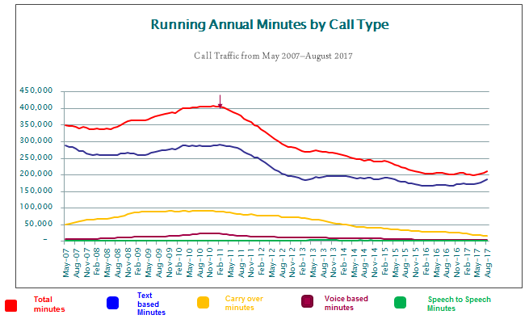

1. Use of mobile text relay has steadily increased over time, whilst use of internet relay has generally decreased (though the number of internet relay minutes has recently increased), as shown in figure 2 below. The increase in mobile text relay usage is likely to be attributed to the general trend towards smartphone use with this service providing ease of access on the move via the ‘TexMee’ [9] app.

*Figure 2*

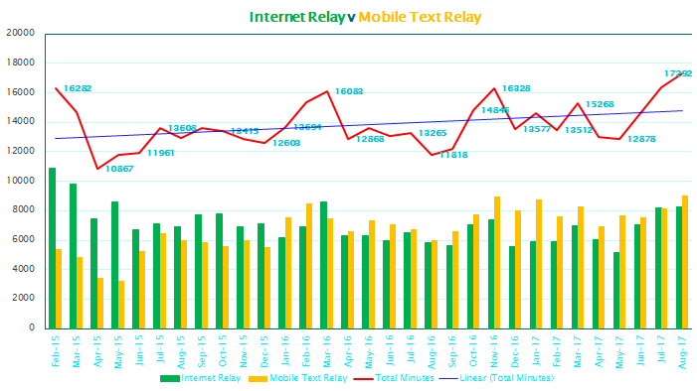

1. Figure 3 below illustrates the steady decline in the use of voice and hearing carry-over minutes. Factors that can be attributed to this decline are that HCO serves a small group of speech impaired users, who also have the option to use other services, such as speech to speech. VCO users, who tend to be those with hearing impairments, may have also transferred over to alternative services that enable text-based responses[10].

*Figure 3*

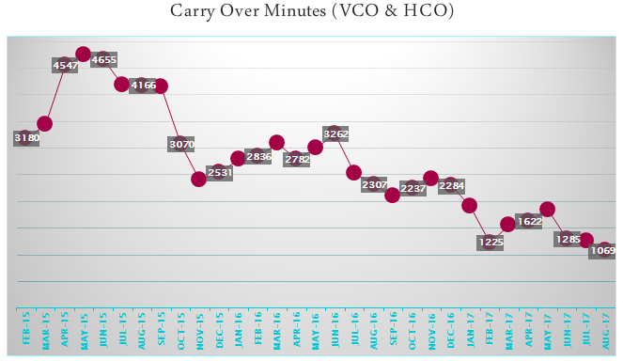

1. Speech-to-speech service minutes have remained broadly steady in recent years with only a small number of regular users of the service. One of the factors that could explain the low take-up of this service is that there is no representative body in New Zealand for people with speech disabilities. As such, it is possible that there are more limited opportunities for promotion of speech-to-speech services to those who may benefit from them. Alternatively, there may simply be alternative services available for use other than those offered by the relay service.

*Figure 4*

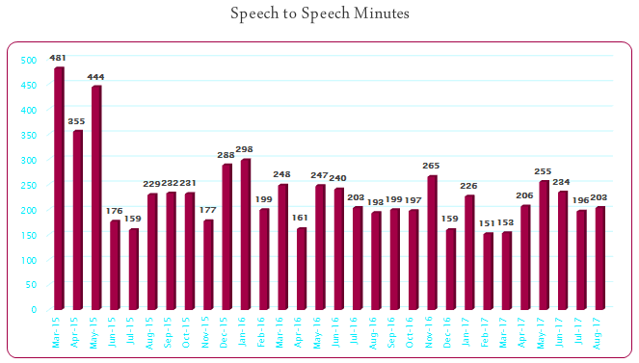

1. CapTel generates the most usage minutes of current relay services, with CapTel phones being the most widely used and distributed piece of relay equipment. CapTel enables the user to both hear the conversation and read the transcribed text on the phone’s screen.

*Figure 5*

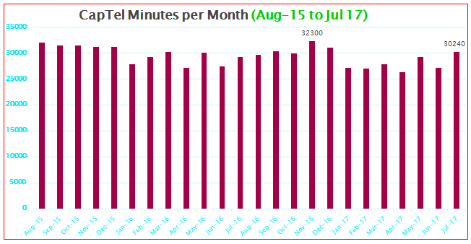

1. Interestingly, WebCapTel services have steadily declined, despite working in the same manner as CapTel. In the first quarter of the 2016/17 financial year 880 minutes were recorded, and by the final quarter of the same year this had declined to only 180 minutes.
2. Despite the relatively short period of time since VIS was introduced, it has had high uptake, with the remote service (named VRI in figure 6 below) primarily used for communicating with professional services and government agencies. VIS has proved to be particularly popular as it enables the deaf community to use NZSL to interact with a range of people and organisations, breaking down the communications barriers they may otherwise face. It is often difficult for deaf people to book a face to face interpreter for meetings, so VIS also offers a useful alternative in many situations.

*Figure 6*

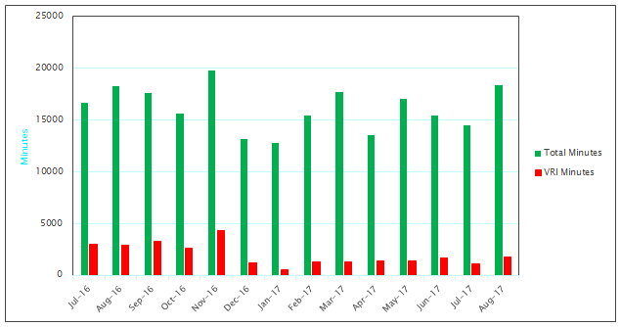

***Observations and trends***

*Relay service users are increasingly using personal devices to access the relay service*

1. Personal devices for communication such as mobile phones, tablets and computers have been widely utilised as equipment for the use of certain mobile or web-based relay services. Mobile text relay utilises the ‘TexMee’ app that the user accesses from their smart phone or tablet. Web based services, such as WebCapTel and internet relay, require a device that can connect to a web browser, while video-based relay services (VIS, video assisted Speech-to-Speech) require a computer or tablet with video messaging capability (e.g. Skype). The increasing use of personal devices to access relay services demonstrates a movement away from fixed-line based services mirroring similar trends within the general population.

*The number of hearing impaired New Zealanders is likely to increase over time*

1. Like most of the developed world, New Zealand has an ageing population. By 2036 it is projected that around one in 4.5 New Zealanders will be aged 65+, around 1,258,500 people, representing a 77 per cent increase from 2016[11]. According to the NFD, people over the age of 65 years are three times more likely to suffer from hearing loss than younger adults, with 50-60 per cent of people in Australia and New Zealand over 60 years of age living with hearing loss[12].

*The number of deaf New Zealanders is likely to decrease*

1. According to Deaf Aotearoa’s report, Deaf Way, the number of deaf people in New Zealand is gradually declining due to improved medical care, mainstreaming, rapidly increasing cochlear implants and genetic science. It notes that the signing deaf community is also ageing, and that the size of the community is slowly shrinking at both older and younger ends. Nevertheless, the report argues that there will always be people who communicate visually and for whom NZSL is their inevitable choice for interacting with the world, adding that whilst demand for interpreters may fall, it won’t be for many more decades[13].

*Deaf New Zealanders tend to make full use of new technologies*

1. The report acknowledges the value provided by technology to help with communication, and notes that deaf participants are generally eager to embrace new technologies as they emerge. The mobile phone with text capacity is now considered the most important communication tool for deaf people – including those who have difficulty with written English.

# Section 3: The Future of New Zealand Relay Services

1. We have received a great deal of positive anecdotal feedback on the benefits of the relay service and the difference it has made to the lives of those who use it. The addition of services like VIS and CapTel have been broadly welcomed by the deaf and hearing impaired communities, and New Zealand continues to compare favourably internationally in terms of the range of relay services offered.
2. However, the upcoming expiration of the contracts to deliver the relay service provides a useful opportunity to consider its future in light of technological developments, and to explore the issues with the existing service that have been raised with us by NZRAG members and other stakeholders. We have set out the issues, and the questions on which we are seeking views, within a framework of the overarching objectives we are pursuing in respect of the relay service from 1 July 2019.

**Availability**

***The relay service should be available to those who need it, regardless of where they live.***

1. With an increasing number of relay services and applications now being delivered or supported via the internet, one of the challenges the service may face in the future is ensuring that relay service users have access to the necessary underlying telecommunications networks and infrastructure.
2. New Zealand is well placed in terms of broadband infrastructure through the government’s Ultra-Fast Broadband (UFB) and Rural Broadband Initiative (RBI) programmes. This infrastructure provides users with the required connectivity needed to access the relay services that are delivered online. UFB will be available to 87 per cent of New Zealanders by the end of 2022, which will place New Zealand in the top five countries in the OECD[14] for the percentage of population with access to fibre-to-the-premises. To complement UFB coverage, which is occurring in predominantly urban areas, RBI is using a range of technologies to allow hundreds of thousands of rural homes and businesses to access new or improved broadband services.
3. The majority of relay services are available to users on a 24/7 basis ensuring access to a wide range of communications at all times. However, some services, including VIS, have limited hours of service. This means that users of these services – in particular, deaf users who prefer to communicate in NZSL - have less opportunity to make social calls to friends and family members or access other services/activities. This issue has been highlighted to us as particularly problematic by representatives of the NZRAG.
4. VIS is currently available from 8am to 8pm Monday to Friday with no availability at weekends. This is more limited than CapTel services which are available seven days a week between 7am and 10pm.

**Questions**

* **What is your view of the current availability of the relay service (i.e. are you able to access the relay service when you need it)?**
* **If you have encountered problems, what are these and what impact have they had?**
* **What changes could be made to relay services to improve their availability and why?**

**Accessibility**

***Relay services should be widely known, easy to access and straightforward to use***

***Promotion and awareness of the relay services***

1. Promotion of the relay service is currently the responsibility of two dedicated Promotions Managers – one each for Sprint and CSD. The Promotions Managers undertake outreach and community engagement work, and manage social media pages which promote the relay service. Videos and other collateral have been produced to promote services and the benefits they offer to users of the relay service.
2. There is an [option checker](https://www.nzrelay.co.nz/Users) on the homepage of the NZ Relay website to help users identify the services that will be most appropriate for them. Further information about each of the services offered and how they work in practice is also available to enable users to make an informed choice. Previous outreach initiatives have resulted in the acceptance of relay service calls by government agencies, NZ Police and a wide range of service providers such as banks, utility and telecommunications providers.
3. Despite this, we understand from NZRAG members that there remains a lack of awareness within the user community of the services offered by the relay service, and that users are not clear about the differences between the services offered and which ones are most suitable for them. We understand that there is also a lack of awareness within the wider community of the services that are available for communicating with those with sensory impairments, with many people unaware that they can make calls via the relay service to interact with someone who is deaf, hearing impaired, speech impaired or deafblind.
4. In light of this, we consider that promotion should remain a key component of the relay service, and that in order to provide maximum benefits to those who need it, there is an ongoing role for service providers to promote and explain the services offered by NZ Relay and undertake targeted outreach activities to raise awareness.

**Question**

* **What additional measures or initiatives could be introduced to increase awareness of the relay service and its benefits to users of the service and the wider community?**

***Ease of access and use***

1. Technological developments have changed the way that we as consumers access communications. For many New Zealanders, fixed line telephones (landlines) are giving way to mobile devices and we are increasingly accessing data, services and interacting with others via our personal devices wherever we are. Accessibility improvements in mass market devices such as smart phones, laptops and tablets now provide an easy way for many with sensory impairments to communicate whilst on the move.
2. The amount of mobile data we are consuming grew strongly in 2016, with OpenSignal reporting that New Zealand mobile users were spending 63 per cent of their time connected to WiFi rather than cellular networks (third highest in the world), compared with 60 per cent in the US, 53 per cent in the UK and 51 per cent in Australia. The Commerce Commission reports that more people access the internet on a smartphone than any other device, and that 95 per cent of all phones sold are now smartphones[15].
3. In order to continue to offer equality of access to communications for deaf, hearing impaired, deafblind and speech impaired New Zealanders, we think it is important for relay services to keep pace with such developments. At present, some, though not all, relay services can be accessed whilst on the move: mobile text relay; internet relay; WebCapTel; and VIS.

**Questions**

* **If you had the choice between accessing a relay service from a fixed device at home or from your mobile, laptop or tablet, which would you prefer and why?**
* **What specific relay services would you like to see available on your mobile, laptop or tablet and why?**
* **For those relay services that are available on your mobile, laptop or tablet already, are there any improvements that could be made that would make them easier to use and why?**
* **Are there any other issues related to ease of access and use with the current relay service that we should consider?**

**Affordability**

***The relay service should be affordable for users whilst offering value for money for the Government***

1. NZRAG members have highlighted that the costs of connectivity, equipment and using voice minutes or data to make relay service calls can act as a barrier to using the relay service - especially for users on low incomes.

***Calls to mobiles***

1. Under the existing contracts, only calls to national landlines (excluding premium numbers) are provided free of charge to users. Calls to premium, international and mobile numbers are possible using the relay service, but the user must have registered for a pre-paid calling card which is charged per call at the user’s expense. Feedback from NZRAG members is that an increasing number of people only have mobile phones rather than landlines, resulting in additional costs to relay service users, compared to those without communications impairments that have access to free minutes as part of mobile phone packages. NZRAG have also told us that pre-paid calling cards are inconvenient and confusing in terms of the different rates and complex charging schemes written in long statements of terms and conditions.
2. According to the Commerce Commission, an increasing number of households are purchasing naked broadband services[16], using their mobiles rather than landlines for voice calls as well as over-the-top (OTT[17]) services such as Skype. The Commission considers that landline calling has been substituted for mobile calling and the use of OTT services, as evidenced in the steady decline in landline minutes over the last decade[18]. In March 2017, a survey of 2258 New Zealand mobile phone users by customer research agency Canstar Blue found that 20 per cent of respondents didn't have a landline[19].
3. We recognise that the increasing prevalence of mobile phones adds an increasing cost burden on to many relay service users to make calls that previously would have been free of charge if they were made from a landline. We also recognise that having no free access to call mobiles puts those with communications impairments at a disadvantage to the wider community who are able to make use of free voice minute allocations from retail service providers. Given that landline ownership is expected to further decline in the coming years, affordability in terms of relay calls to mobiles is an issue that warrants consideration as part of the upcoming procurement exercise.

***The costs of accessing connectivity***

1. One of the issues raised as a barrier to using the relay service is the cost associated with paying for a home broadband connection and sufficient mobile data to utilise the VIS, in addition to the cost of buying a computer or mobile device.

1. In general, the price of computers and mobile devices has decreased significantly over the years facilitating uptake and use by New Zealanders. There is an increasingly competitive market for mainstream or contemporary communication devices with smartphones available for about $200, and a range of older style standard mobile phones available at about $70. There is also an increasing range of mobile tablets available for around $300 (Wi-Fi only) or $400 (Wi Fi and 4G)
2. Across the board in New Zealand, whilst the costs of comparable utilities for consumers increased in 2016, the cost of telecommunications services decreased. On average in 2016, households spent $135 per month on telecommunications services, compared with $201 for household energy, $677 for grocery food and $183 for petrol. Of those household bills, only telecommunications services and petrol showed a decrease in expenditure between 2013 and 2016. The estimated annual total household spend on telecommunications services was $2.74 billion, down by 3% from $2.82 billion in 2013[20].
3. Market research by InternetNZ in June 2017 found that 93 per cent of Kiwis have access to the internet, either at home or at work, or both, and that fewer than one in ten (six per cent) have no internet access. The research also found that concerns about the cost of access to the internet had decreased by 5 per cent over the last year (from 42 per cent to 37 per cent)[21].
4. Prices for mobile services in New Zealand have decreased significantly in recent years. The Commerce Commission’s 2017 Telecommunications Market Monitoring Report notes that a ‘low user’ bundle (includes 50 minutes of calls and 100 MB of data a month) is priced at $13, 49 per cent below the OECD average and 37 per cent below Australia. A ‘serious user’ bundle (includes 200 minutes of calls and 2 GB of data month) is priced at $33, 31 per cent below the OECD average and 3 per cent above Australia[22].
5. Despite improvements in this space, we recognise that the cost of connectivity may be a barrier for some relay service users. To address this, we will continue to explore the various ways this could be addressed. Many players in the industry have implemented arrangements or initiatives aimed at reducing the costs of connectivity for those who may not be able to afford them. Vodafone has introduced flexible plans where customers can select the amount of voice minutes, texts and data they want. This is of relevance for relay user communities who may not need to purchase voice minutes. Spark operates Spark Jump, a partnership strategy with IT providers to provide cheap broadband access to low income families, primarily aimed at educational use. 2degrees has zero-rated all data used by Blind Foundation clients who access its BookLink app on 2degrees’ mobile network.

**Questions**

* **Are the costs of connectivity a barrier to you accessing and using the relay service?**
* **If so, what are the specific problems you have encountered and what impact has this had?**
* **What changes could be made to the relay service to improve its affordability and why**

**Fit for Purpose**

***The relay service should be compatible with mainstream technologies and networks and keep pace with technological advancements.***

1. Since the relay service began in 2004, much has changed. Technology has developed significantly, changing the methods we use to communicate with one another – both in terms of the devices we use and how we choose to interact.
2. For example, how we access services, and our interactions with companies, is rapidly changing. A number of utility/service providers are now encouraging customers to contact them via online chat applications or through social media, rather than through using traditional call centres. The availability of these communications methods allows people who might have previously used the relay service to contact companies and organisations directly needing far less support.
3. There are also changes underway in relation to the underlying telecommunications infrastructure over which relay services are provided. The technology that currently supports the public switched telephone network (PSTN) is being replaced by Spark, with a new platform based on Internet Protocol (IP) that allows better integration of various services such as internet, video and mobile services.
4. We have also seen the wider deployment of a range of software developments in recent years, such as Total Conversation, which offer an improved experience for those with sensory impairments by enabling multiple communications channels over one platform. Other advances include the ability to provide each relay user with his/her own individual number to enable calls to be made directly to them rather than to the Relay Centre itself. Once a call is made, the technology enables the Relay Centre to intercept it to provide the communications assistance required. This function would allow organisations such as IRD to call back a user directly, allowing those with communication impairments the ability to utilise the call-back features offered by a number of large organisations.
5. The functionality, accessibility and affordability of communications equipment has also increased significantly since the introduction of the relay service in 2004. This has created the opportunity for many relay users to take advantage of mainstream software and apps to contact family, friends and business. It is likely that in some circumstances, these services have, or will soon, become direct substitutes for some relay services.
6. The changing nature of technology raises a number of issues when considering what the relay service will look like in the next five or so years, in particular what the upcoming network changes mean for older legacy equipment such as TTYs that have seen a significant decline in use in recent years. Norway for example has recently announced an intention to stop offering analogue-based relay services from 28 March 2018 with all relay services being delivered over the internet after that date. Other countries are increasingly prioritising the delivery of relay services through mainstream devices, utilising platforms that offer multiple communication channels on one call.
7. Over time, improvements in voice recognition technology are likely to significantly reduce the cost of providing re-voicing, however we anticipate that there will remain a need for NZSL interpreters and relay assistants for several years.
8. When considering the future of the relay service, it is important to remember that whilst advances in mainstream equipment have been transformational, there remains a proportion of relay service users that require specialist equipment to access communications. Such equipment includes braille readers and type-pads or other modifications to standard equipment to accommodate other physical disabilities. Whilst it may be possible to transition some users from legacy equipment on to more mainstream devices and services, there will be some for whom this is not possible, or extra support is needed.

**Questions**

* **Are there any particular features or changes that you think should be made to the relay service to ensure it continues to offer a good experience to users and why?**

* **Are there any relay services or equipment that you consider are no longer relevant and could be phased out or discontinued? If so, what measures or support would need to be provided to transition users to other services or mainstream devices?**
* **Have you ever discontinued use of any of the relay services? If so which service or services, and why?**

**Other Issues**

***Access to Emergency Assistance***

1. In New Zealand the 111 emergency telephone number receives calls from fixed and mobile networks. NZ Police receive emergency calls made by deaf users from TTYs and fax machines to dedicated emergency Freephone (0800) numbers. There are few genuine calls to these emergency numbers, with the call volumes reducing as the use of these technologies has declined. There is currently no video calling service available for deaf people to access Police or other emergency service providers.
2. For deaf, hearing impaired, deafblind or speech impaired New Zealanders, there is also a text-based system (111 TXT) for direct communication with NZ Police in an emergency[23]. The 111 TXT service has about 1100 registered users. While texts are prioritised, delays in answering can still occur due to the performance of the networks involved and availability of answering staff.
3. The NZ Relay Centre is not responsible for handling any emergency calls and therefore does not have priority queuing or other special capabilities in place for such calls. Relay users are advised not to use the relay service to make emergency calls.
4. While the issue of emergency calling has been raised by members of the user community, we are not proposing to include emergency calling as a part of the relay service. Emergency calling remains and will continue to be the responsibility of emergency services; however we will coordinate with providers to ensure that these services are accessible to relay service users.

**MBIE welcomes responses on the future of relay services in New Zealand that cover issues not specifically addressed in this consultation document.**

**New Zealand Telecommunications Relay Services Beyond 2019: Submission template**

The closing date for submissions is **5.00pm, Friday 13 April 2018.**

You can make a submission by emailing RelayConsultation@mbie.govt.nz or by posting your feedback to:

NZ Relay Project Team

ICT Policy & Programmes

Ministry of Business, Innovation & Employment

PO Box 1473

Wellington 6140

New Zealand

If you post your submission, please also send it electronically if possible (as a PDF or Microsoft Word document).

New Zealand Sign Language (NZSL) users are also able to make video submissions in NZSL. For Further information please visit <http://www.mbie.govt.nz/info-services/sectors-industries/technology-communications/communications/telecommunications-relay-service/>.

**Please complete the following contact details:**

|  |  |
| --- | --- |
| **Your name:** |  |
| **Your email address:** |  |

**Is your submission on behalf of an organisation?**

√

|  |  |
| --- | --- |
|  | Yes |
|  | No |

If yes, please write the name of the organisation and your position here:

|  |
| --- |
|  |

If you or your organisation do not wish your name to be included in any summary of submissions that the Ministry may publish, please advise here:

No, I do not want my name / organisations name published in any summary of submissions

If you or your organisation object to the release of any information contained in this submission, please advise here:

|  |
| --- |
|  |

**If completing as an individual, which region do you live in?**

√

|  |  |  |  |
| --- | --- | --- | --- |
|  | Northland |  | Wellington |
|  | Auckland |  | Tasman |
|  | Waikato |  | Nelson |
|  | Bay of Plenty |  | Marlborough |
|  | Gisborne |  | West Coast |
|  | Hawke’s Bay |  | Canterbury |
|  | Taranaki |  | Otago |
|  | Manawatu-Wanganui |  | Southland |
|  | Outside New Zealand. Please specify location: | | |

**If completing as an individual, which age bracket do you (or the person you are completing the form on behalf of) fall into?**

√

|  |  |  |  |
| --- | --- | --- | --- |
|  | Under 18 |  | 45 – 54 |
|  | 18 – 24 |  | 55 – 64 |
|  | 25 – 34 |  | Over 65 |
|  | 35 – 44 |  | Prefer not to disclose |

**If you are comfortable doing so, please tick any communications disabilities that apply to you, the person you are completing this submission on behalf of, and/or the body of people you or your organisation represents:**

√

|  |  |
| --- | --- |
|  | Deaf |
|  | Hearing Impaired |
|  | Speech Impaired |
|  | Deafblind |
|  | Other (please specify) |
|  | Prefer not to disclose |

**Are you a hearing recipient of relay calls, or user of the VIS?**

√

|  |  |
| --- | --- |
|  | Yes |
|  | No |

**Are you a user of New Zealand Sign Language?**

√

|  |  |
| --- | --- |
|  | Yes |
|  | No |

**Are you a user of any of the relay services? If so, please tick which services, and the frequesncy with which you use them, below:**

√

|  |  |  |  |  |  |
| --- | --- | --- | --- | --- | --- |
|  | Every day | Several times a week | Once a week | 1-3 times a month | Less than once a month |
| Teletypewriter to Voice |  |  |  |  |  |
| Voice Carry Over |  |  |  |  |  |
| Hearing Carry Over |  |  |  |  |  |
| Mobile Text Relay |  |  |  |  |  |
| Internet Relay |  |  |  |  |  |
| CapTel |  |  |  |  |  |
| Web CapTel |  |  |  |  |  |
| Video Interpreting Service |  |  |  |  |  |
| Speech to Speech |  |  |  |  |  |
| Video-Assisted Speech to Speech |  |  |  |  |  |

If you are a user of the relay service, please describe the purposes for which you use it. For example, for social/personal calls, to conduct business, to use interpretation services for appointments:

|  |
| --- |
|  |

If you are not a user of the relay service, please describe your interest in this public consultation:

|  |
| --- |
|  |

**Which of the current services were you aware of prior to completing this submission? Please tick the services below:**

√

|  |  |  |  |
| --- | --- | --- | --- |
|  | Teletypewriter to Voice |  | CapTel |
|  | Voice Carry Over |  | Web CapTel |
|  | Hearing Carry Over |  | Video Interpreting Service |
|  | Mobile Text Relay |  | Speech to Speech |
|  | Internet Relay |  | Video-Assisted Speech to Speech |

|  |
| --- |
| **Availability of Services – *Please let us know if your comments relate to a specific service*** |

1. What is your view of the current availability of the relay service (i.e. are you able to access the relay service when you need it?

|  |
| --- |
|  |

1. If you have encountered problems, what are these and what impact have they had?

|  |
| --- |
|  |

1. What changes could be made to relay services to improve their availability, and why?

|  |
| --- |
|  |

|  |
| --- |
| **Accessibility – *Please let us know if your comments relate to a specific service*** |

1. What additional measures or initiatives could be introduced to increase awareness of the relay service and its benefits to users of the service and the wider community?

|  |
| --- |
|  |

1. If you had the choice between accessing a relay service from a fixed device at home or from your mobile, laptop or tablet, which would you prefer and why?

|  |
| --- |
|  |

1. What specific relay services would you like to see available on your mobile, laptop or tablet and why?

|  |
| --- |
|  |

1. For those relay services that are available on your mobile, laptop or tablet already, are there any improvements that could be made that would make them easier to use and why?

|  |
| --- |
|  |

1. Are there any other issues related to ease of access and use with the current relay service that we should consider?

|  |
| --- |
|  |

|  |
| --- |
| **Affordability – *Please let us know if your comments relate to a specific service*** |

1. Are the costs of connectivity a barrier to you accessing and using the relay service?

|  |
| --- |
|  |

1. If so, what are the specific problems you have encountered and what impact has this had?

|  |
| --- |
|  |

1. What changes could be made to the relay service to improve its affordability and why?

|  |
| --- |
|  |

|  |
| --- |
| **Fit for Purpose – *Please let us know if your comments relate to a specific service*** |

1. Are there any particular features or changes that you think should be made to the relay service to ensure it continues to offer a good experience to users and why?

|  |
| --- |
|  |

1. Are there any relay services or equipment that you consider are no longer relevant and could be phased out or discontinued? If so, what measures or support would need to be provided to transition users to other services or mainstream devices?

|  |
| --- |
|  |

1. Have you ever discontinued use of any of the relay services? If so which service or services, and why?

|  |
| --- |
|  |

|  |
| --- |
| **Any Other Comments – *Please let us know if your comments relate to a specific service*** |

1. What other comments do you have about New Zealand Telecommunications Relay Services?

|  |
| --- |
|  |

**Thank you for taking the time to complete this submission. Your feedback is appreciated.**

**Publication of submissions**

Written submissions may be published at [www.mbie.govt.nz](http://www.mbie.govt.nz). We will consider you to have consented to publication by making a submission, unless you clearly specify otherwise in your submissions.

In any case, all information provided to the Ministry in response to this discussion document is subject to the Official Information Act 1982 (OIA)**. Please advise if you have any objection to the release of any information contained in a submission**, and in particular, which part(s) you consider should be withheld, together the with reason(s) for withholding the information.

**In particular, please clearly indicate in your submission if you do not wish your name and any other identifying details to be included in any summary of submissions that the Ministry may publish, or in any responses to OIA requests.**

The Ministry will consider all such objections when responding to requests for copies and information on submissions to this document under the OIA. Please note that in certain circumstances information you have provided us may be required to be released to a requester under the OIA, even if you would prefer it to be withheld.

The Privacy Act 1993 establishes certain principles with respect to the collection, use, and disclosure of information about individuals by various agencies including the Ministry. It governs access by individuals to information about themselves held by agencies. Please contact us if you would like a copy of, or to correct, any of your personal information. Any personal information you supply in the course of making a submission will be used by the Ministry only in conjunction with the matters covered by the documents.

1. Deafblind people have a unique disability because they have lost the use of two main sensory functions – their sight and their hearing. The loss of both sensory functions impacts on each other and means that a deafblind person may experience varying degrees of difficulty with communicating, with mobility and carrying out daily activities.
2. Statistics New Zealand Disability Survey: 2013
3. Listen Hear, <https://www.nfd.org.nz/help-and-advice/listen-hear-new-zealand-report/>
4. Section 70, Telecommunications Act 2001, <http://www.legislation.govt.nz/act/public/2001/0103/76.0/DLM126860.html>
5. New Zealand Relay Advisory Group (NZRAG), <https://www.nzrelay.co.nz/About/Advisory>
6. NZSL is an official language of New Zealand used by some 20,000 New Zealanders, approximately 4,000 of whom are deaf people who use NZSL as their first or preferred language. As the natural language of the deaf community in New Zealand, NZSL reflects the country’s culture and includes signs for Māori terminology and concepts unique to New Zealand. NZSL is the 12th most frequently used language, out of approximately 190 languages currently used in New Zealand (Census 2006).
7. The New Zealand Disability Strategy 2016 – 2026 sets out that the term ‘non-disabling’ is about removing the barriers in society that disable people with impairments. It is stronger and more meaningful than ‘enabling’, which will only help disabled people get around barriers rather than remove them completely.
8. From 1 July 2016, the former Video Relay Service (VRS) and Video Remote Interpreting Service (VRI) were combined into one service – the Video Interpreting Service (VIS).
9. Mobile Text Relay. <https://www.nzrelay.co.nz/Services/MobileTextRelay>
10. Voice Carry Over <https://www.nzrelay.co.nz/Services/VoiceCarryOver>
11. StatisticsNZ <http://archive.stats.govt.nz/browse_for_stats/population/estimates_and_projections/NationalPopulationEstimates_HOTPAt30Jun17.aspx>
12. National Foundation for the Deaf (NFD)
13. Deaf Way Report by Deaf Aotearoa: <http://deaf.org.nz/images/misc/Deaf-Way-Report-Final.pdf>
14. The Organisation for Economic Co-operation and Development
15. Commerce Commission Annual Telecommunications Monitoring Report 2016
16. A naked broadband service is a fixed-line broadband service provided without a traditional analogue voice service also being provided over the same line
17. Over-the-Top (OTT) services refer to content and applications provided from a third party and delivered to an end-user device, leaving the retailer responsible only for transporting IP packets
18. Commerce Commission Annual Telecommunications Monitoring Report 2016
19. Survey of landline use in New Zealand <http://www.nzherald.co.nz/nz/news/article.cfm?c_id=1&objectid=11810607>
20. Commerce Commission Annual Telecommunications Monitoring Report 2016
21. [What Kiwis think of the Internet in New Zealand](https://internetnz.nz/2017-internet-research), InternetNZ, June 2016
22. Commerce Commission Annual Telecommunications Monitoring Report 2017
23. NZ Police advises users of 111 TXT that there are sometimes delays on the mobile phone network which may result in texts not getting through straight away which introduces an uncertainty about whether the text has been successfully received and acted on. If this happens in an emergency and users don’t get a text back from NZ Police in 2 minutes, they should contact 111 a different way.