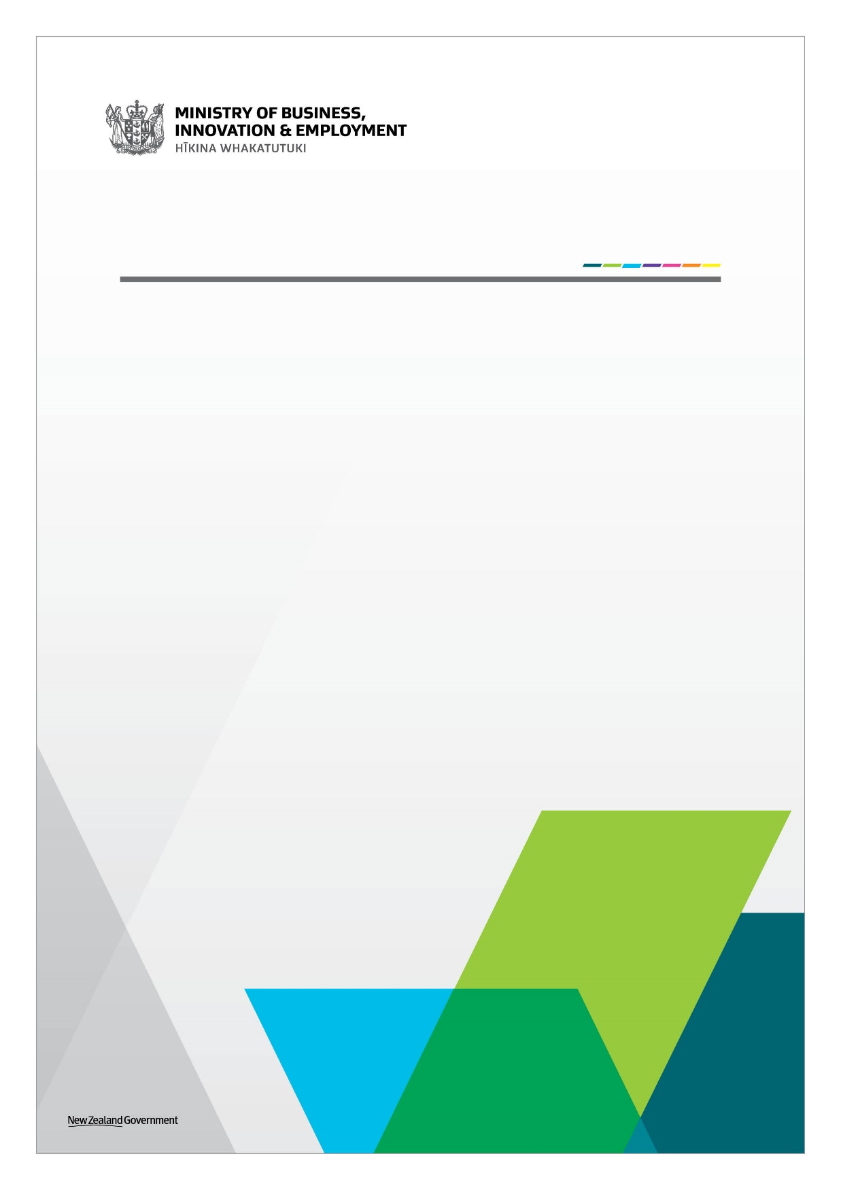
Strategic Tourism Assets Protection Programme
Application Form
June 2020
Strategic Tourism Assets Protection Programme: Completing this form
If you need any assistance with completing this form, please contact us at strategictourismassets@mbie.govt.nz.
Please complete the form electronically, and attach the following:
☐ Your bank account details and third party verification (such as a bank statement or screenshot of your internet banking)
☐ Two years of profit and loss statements
☐ Your GST number
Submit your completed application to strategictourismassets@mbie.govt.nz. Proposals must be received by MBIE no later than 5pm on Thursday 18 June, 2020.
Note: There is a 20MB size limit. For larger applications, please separate them into different emails.
For exceptional circumstances, there is scope to assess out-of-round applications, if they are considered urgent and funding is needed outside of the scheduled funding round. Please make this clear in your application.
Proposal checklist
Before you apply be sure to complete the following:
☐ Check the MBIE website to ensure you have downloaded the most recent version of each document.
☐ Read the supporting information on the MBIE website.
When filling out this form please ensure:
☐ All answers are typed into the space provided for each section in font no smaller than size 10 point.
☐ You provide the information required for each question.
☐ You have read and understood the declaration details outlined in Section 4 and have signed the declaration.

Evidence
When MBIE assesses proposals against the eligibility and/or the assessment criteria, we will consider whether the evidence provided supports the claims, as well as the quality of that evidence. Where questions ask for evidence to support claims, it is highly recommended that you provide reference sources that attest the accuracy and quality of the evidence.
MBIE will assess the application using the information provided by the applicant.

Section 1: Proposal and applicant key details
Please enter answers in the right-hand column.
Applicants’ key details
Business Legal Name:
Business Trading Name:
Entity Type: |  | Choose an item.
Business address, including postcode:
Business Website:
Key point of contact’s name and role:
Email Address: |  |  | Telephone:
What is the primary activity of your business? | Choose an item.
This project will be based in the region of (if multiple please pick National and specify): | Choose an item.

Section 2: Eligibility
Please read this section carefully:
The programme objective is not to protect all tourism assets, but only those of significance to New Zealand and/or its regions. You must meet all three of the eligibility criteria below to qualify for the Strategic Tourism Assets Protections Programme (STAPP).
2.1 Eligibility criteria
1: Is the asset a tourism asset?  For the purposes of this Programme the definition of a tourism asset has been adapted from the statistical definition of a tourism characteristic industry use in the Tourism Satellite Accounts to describe tourism operations in scope. | Tourism Operations - a tourism characteristic business is one where either:  - at least 25 percent of the operations’ output is purchased by tourists, or the operations output includes a tourism-characteristic product.  Yes ☐ No ☐  Tourism Assets: you must meet one of the following types of assets:  - Attractions – this includes activities and natural attractions  - Access – the means of access to the tourism asset (note assets eligible under Ministry of Transport funding are not eligible for STAPP)  - Amenities – services and facilities.  Intangible assets (for example intellectual property) can be considered eligible if they fit into the three asset categories  Attraction ☐ Access ☐ Amenity ☐
2: Is the asset a tourism asset of strategic significance (national or regional, cultural, environmental and/or historic)? | An asset is likely to be considered strategic and eligible for the STAPP if it:  - Is a nationally and/or internationally recognised, AND  Yes ☐ No ☐  - Is a key attraction for New Zealand or a region of New Zealand, AND  Yes ☐ No ☐  - Is responsible for significant visitation to the region where it is located and in its absence, visitation to the region would be significantly diminished, AND  Yes ☐ No ☐  - Generates significant spill over benefits to the region where it is located. Spill over benefits to the community (regional or New Zealand) means that the benefits of the tourism asset are shared with other businesses (including non-tourism businesses).  Yes ☐ No ☐
3: Has the applicant exhausted all other avenues of support (government broad-based and private)?  Note: businesses with applications to Government funds (e.g. the Provincial Growth Fund) are eligible, but the STAPP will not provide support for the same purpose. | Applicants must be able to demonstrate that there is both a need for support to safeguard the asset and they have exhausted alternative options for support.  - Are there insurmountable costs/challenges to pausing and resuming operations?  Yes ☐ No ☐  - Is the applicant reliant to a high degree on revenue from visitor flows that are currently severely reduced?  Yes ☐ No ☐  - Is the applicant facing severe financial stress, for example unable to meet the minimum costs necessary to survive/hibernate until demand recovers and/or re-pivot their offering to the domestic market? For example, have other sources of cash flow, working capital been exhausted?  Yes ☐ No ☐

The following tourism assets are not eligible for STAPP:
- assets that do not meet all three eligibility criteria
- assets that can be readily repurposed
- assets that are eligible for support via other sector-specific COVID-19 recovery packages (such as the transport and aviation support package).
- assets which are new capital developments or upgrades
- assets which are a generic features of the tourism system, such as food and beverage, accommodation, transport and retail. Exceptions could include assets that are iconic, of notable cultural, environmental and/or heritage status, and/or feature prominently within the conservation landscape, and/or are uniquely critical elements of the tourism supply chain.

Section 3: Business situation
3.1 What is your tourism asset?
In this section, we want to understand the level of government support you are looking for and how this will be used to protect your business or specific asset(s).
In your response, please provide as much detail as possible.
What asset(s) are you looking to protect?
e.g. facilities, capability, intellectual property
What makes the asset(s) strategically important to your region and/or New Zealand?
What type of funding is this application for? | Choose a funding type...
Amount of funding sought (excl. GST)
Please provide a breakdown of how this funding will be spent. In your answer, please cover:
- Wages for staff
- Operating expenditure
- Fixed costs
- Repairs and maintenance
- Any other ways you intend to spend the funding
If your application includes assets in multiple regions, please indicate allocation for each region.
Has this funding been sought from other sources (e.g banks, investors)?
How would you like to receive the funding?
e.g. quarterly payments over two years
Please note that funding will not be allocated in an up-front lump sum, and is subject to conditions.
If your application is successful, how many of your staff will you retain?
E.g retaining 35 critical FTE

What efforts have you undertaken to make the strategic asset more sustainable (e.g. paying staff at or above the living wage, monitoring and reducing waste)?
‘Sustainable’ includes environmental, social and economic sustainability.
If your application is successful, how many of your staff will you still have to make redundant?
How much would it cost to ‘hibernate’ your asset for the next 12 months?
What is the minimum amount of funding to ensure that the asset can operate at minimum viability?

3.2 Previous business situation
We want to understand your situation prior to COVID-19.
In your response, please provide as much detail as possible.
What were your visitor numbers in 2019?
What was your estimated split between domestic and international visitors in 2019? e.g. 75% domestic, 25% international.
Looking at your international market, please estimate the proportion of visitors from each country
e.g. 60% Australian, 30% Chinese, 10% other
What was your business revenue in 2019? | [Please provide profit and loss statements for the last two years to support this section]
How many staff did you employ in 2019 (please break this down seasonally if applicable)?
e.g. 50 FTE in summer, 25 FTE in winter
3.3 Current business situation
In this section, we want to understand your current situation and how it has been impacted by COVID-19.
In your response, please provide as much detail as possible.
On 13 May 2020, New Zealand moved to Alert Level 2. Since then, at what capacity have you been operating relative to 2019 levels?
What is your expected change in business revenue for 2020, compared to 2019?
Since COVID-19, how have you adapted your business to continue trading?
For example:
- Changing prices
- adapting to the domestic market
- additional borrowing from the private market (e.g. your bank)

How many staff have you made redundant as a result of COVID-19? | [Please exclude any seasonal changes in staffing]
What (if any) COVID-19 Government support have you accessed? | [Examples may include the MSD Wage Subsidy scheme, Department of Conservation Redeployment Scheme, and the IRD Small Business Loans].
Given the current situation, what is the current outlook for your business?

Section 4: Declaration by lead applicant
The contracting entity is compliant and will continue to comply with all applicable laws, regulations, rules and professional codes of conduct or practice including but not limited to health and safety and employment practices
Yes: ☐ No: ☐
Has this activity ever been declined Crown Funding in the past?
Yes: ☐ No: ☐
Has the applicant or the contracting entity ever been insolvent or subject to an insolvency action, administration or other legal proceedings?
Yes: ☐ No: ☐
Has any individual in the Applicant’s team (including the Applicant’s Leadership Team, directors, partners, or trustees, or any key members of the project) ever been insolvent or subject to an insolvency action, administration or other legal proceedings, or actively involved in any organisation which has?
Yes: ☐ No: ☐
Has any individual in the Applicant’s team (including the Applicant’s Leadership Team, directors, partners, or trustees, or any key members of the project) ever been adjudged bankrupt or is an undischarged bankrupt?
Yes: ☐ No: ☐
Has any individual in the Applicant’s team (including the Applicant’s Leadership Team, directors, partners, or trustees, or any key members of the project) ever been under investigation for, or been convicted of, any criminal offence?
Yes: ☐ No: ☐
Are there any actual, potential or perceived conflicts of interest that the applicant or any of the key personnel have in relation to this project.
“In a small country like ours, conflicts of interest in our working lives are natural and unavoidable. The existence of a conflict of interest does not necessarily mean that someone has done something wrong, and it need not cause problems. It just needs to be identified and managed carefully…” https://www.oag.govt.nz/2007/conflicts-public-entities
Yes: ☐ No: ☐

If you answered “Yes” to any of the above questions, please provide a description below:

By completing the details below, the applicant makes the following declarations about its application to the Strategic Tourism Assets Protection Programme (“application”):
☐ The statements in the application are true and the information provided is complete and correct, and there have been no misleading statements or omissions of any relevant facts nor any misrepresentations made;
☐ I have secured all appropriate authorisations to submit the application, to make the statements and to provide the information in the application;
☐ I have obtained the permission of each member of the Applicant’s team to provide the information contained in this application and those individuals are aware of, and agree to, the Terms and Conditions of applying for the Strategic Tourism Assets Protection Programme;
☐ I understand that the application is subject to the Official Information Act 1982 (the OIA). The OIA enables MBIE to withhold information under certain conditions. Where possible, MBIE will consult with the application should an OIA request be received;
☐ The applicant warrants that it has no actual, potential or perceived conflict of interest (except any already declared in the application) in submitting the application, or entering into a contract to carry out the project. Where a conflict of interest arises during the application or assessment process, the applicant will report it immediately to MBIE by emailing strategictourismassets@mbie.govt.nz; and
☐ I understand that the falsification of information, supplying misleading information, or the suppression of material information in this application, may result in the application being eliminated from the assessment process and may be grounds for termination of any contract awarded as a result of this application process.
☐ The applicant consents to the Strategic Tourism Assets Protection Programme undertaking due diligence including any third party checks as may be required to fully assess the application.

Signature of applicant
This acknowledgment must be signed by a person with the legal authority to commit your organisation to a transaction (e.g. Chief Executive)
Name
Title
Organisation

Signature

Date

Section 5: Attachments

[Attach here, as a PDF, any additional information you consider necessary to support your application. Note that there is a 20MB size limit]

