Section C: Proposals Seven to Ten - Enforce immigration and employment law
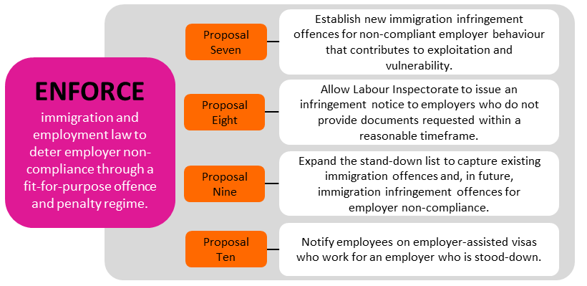
Most employers and businesses in New Zealand obey the law in employing and managing temporary migrant workers. But some do not, and their behaviour can have significant impacts on the migrant’s well-being and their finances. These employers and businesses can also undercut others who do obey the law.
To reduce exploitation, New Zealand needs to enforce employer compliance with minimum employment standards and immigration law through a fit-for-purpose offence and penalty regime. This will help to deter employers who might exploit migrants. When employers do break the law, New Zealand needs to be able to respond in a robust, proportionate and efficient way. Workers and the public also need to have confidence that effective and timely action will be taken against exploitation.
How are employers who don’t comply with the law penalised currently?
Penalties for employer non-compliance in the migrant exploitation space sit mainly in employment and immigration law.
Minimum employment standards are requirements in employment law, such as the Holidays Act 2003, the Minimum Wage Act 1983 and the Wages Protection Act 1983. The standards include the minimum wage, annual leave entitlements and protections against premiums charged for jobs. The Labour Inspectorate generally enforces minimum employment standards through a civil penalty regime. Cases of exploitation can also be put to the Employment Relations Authority or prosecuted through the courts. Figure 5 below provides a diagram of the current ‘penalty toolkit’ under employment law.
Meanwhile, the Immigration Act 2009 provides sanctions for employers who:
- employ migrants who are not entitled to work
- are responsible for serious failures under the laws listed above, and
- are responsible for coercion or control behaviours, such as preventing employees from leaving the job, or holding their passports.
There are significant penalties for employers who are found guilty. Figure 6 below provides a diagram of the current ‘penalty toolkit’ under immigration law and policy.
Figure 5: Toolkit used by Labour Inspectorate to penalise non-compliance
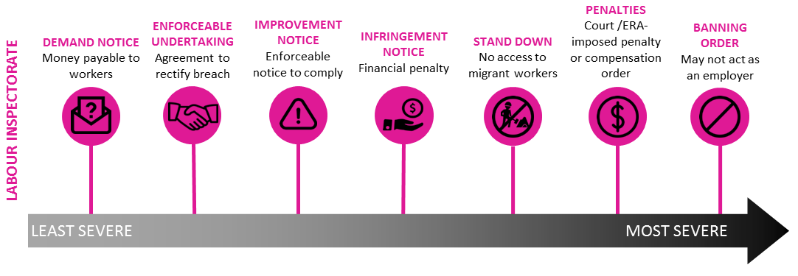
Figure 6: Toolkit used by Immigration New Zealand to penalise non-compliance
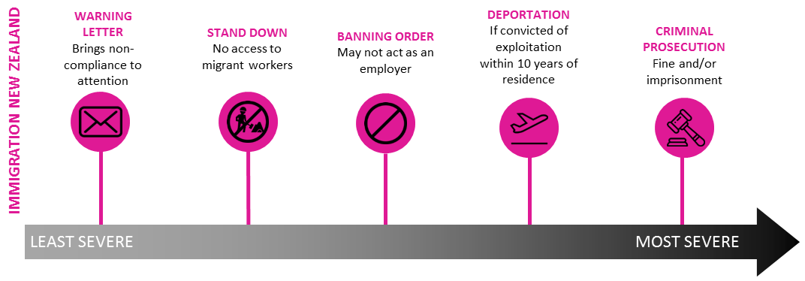
The Labour Inspectorate, between 1 May 2018 - 20 April 2019, took the following actions related to migrant exploitation:
• issued 34 infringement notices
• issued 86 improvement notices
• made 14 enforceable undertakings
• made 20 applications to the Employment Relations Authority
• made 1 application to the Employment Court
• made 1 application to the higher Courts
Immigration New Zealand (INZ) prosecuted 15 cases of exploitation between January 2012 and December 2017.

What is the problem with how current penalties are applied?
At the moment, some employers are not always deterred from non-compliance, or penalised. There are limitations on how government agencies can respond to migrant exploitation. The reasons for this include that there are some gaps in the current employment and immigration toolkit that limit our ability to respond quickly, efficiently and proportionately to less severe breaches of employment law.
The subsections below go into more specific aspects of the problem, and how we propose to address them to better enforce compliance.
What do we propose to do?
We have four proposals which we are seeking your feedback on:
- Establish new immigration infringement offences for wrongful behaviour by employers that contributes to exploitation and vulnerability.
- Allow the Labour Inspectorate to issue an infringement notice to employers who do not provide documents requested within a reasonable timeframe. This is a small change to the existing employment penalty toolkit.
- Expand the stand-down list to capture existing immigration offences and, in future, immigration infringement offences for employer non-compliance.
- Notify those employees on employer-assisted visas who work for an employer who is stood-down.
These proposals will enhance our toolkit to better enforce compliance with minimum employment standards. They will help deter exploitation, and enable wrongful behaviour to be penalised more effectively and in a way that is proportionate to the level of non-compliance.
Figure 7 below gives a summary of what the new approach would look like.
Figure 7: Overview of the proposed response to non-compliance
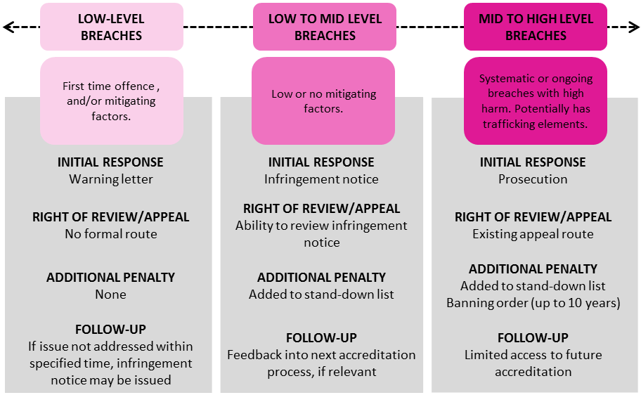

Proposal Seven: Establish new immigration offences for employer behaviour that contributes to exploitation and vulnerability
An infringement regime creates lower level offences for certain aspects of immigration law and policy. We propose to expand the current immigration infringement regime to incorporate non-compliant employer behaviour that is linked to, or increases the risk of, migrant exploitation. We would do this by establishing new immigration offences. The infringement offences would be for lower-level breaches. If an employer committed an offence, INZ would be able to issue an infringement notice to that employer. That notice would require the employer to pay a fee.
The expanded infringement regime would provide an additional tool where enforcement action should be taken against an employer but where the other tools are not proportionate, timely or cost effective.
We are considering what specific behaviours might be included as infringement offences. These might include, for example:
  - failing to provide information or documents when requested by an Immigration Officer (because failing to do this can make it harder to investigate migrant exploitation).
  - employing workers who are not entitled to work in New Zealand, or who are in breach of their visa conditions (because these actions put workers in a vulnerable position).
  - paying less than the salary documented in a visa application (which puts workers in a vulnerable position and may show that the application included false information).
There will be costs relating to the establishment and running of the regime, but it is expected to be an efficient use of investigative resource. The process for users is straightforward, and does not entail complex review processes, or cost of legal representation (unless desired).
The costs of an infringement regime would mostly fall on non-compliant employers, who might also face an additional penalty of being put on the stand-down list (refer Proposal Nine). However, there would also be some administrative cost to INZ in setting up and operating the infringement regime; these costs are currently being scoped.

7A. Question: Do you think INZ should be able to issue infringement notices when an employer does not comply with immigration law and policy, and exploits temporary migrant workers or makes them vulnerable to exploitation?
☐Yes
☐No
☐Unsure
7Ai. Supplementary question if you answered YES: What kind of behaviours do you think should result in an infringement notice?
Click here to enter text.
7Aii. Supplementary question if you answered YES: What do you think are the factors (if any) that INZ should take into account when deciding whether to issue an infringement notice? For example:
- the level of harm done (that is, how bad was the behaviour and its effects)
- whether this is repeat or first time offending by the employer (whether or not they got an infringement notice or any other penalty in the past)
- any previous infringement notices that the employer has received, or if this is the first
Click here to enter text.

7Aiii. Supplementary question if you answered YES: How do you think penalties (the fees) should vary depending on the situation, such as the size of the business, or some other aspect? Please describe what factors should determine how penalties could vary.
Click here to enter text.

7Aiv. Supplementary question if you answered NO: Why do you think INZ should not set up a new infringement regime? You might wish to outline what you see the costs and disadvantages (cons) of an infringement regime.
Click here to enter text.

Proposal Eight: Allow the Labour Inspectorate to issue an infringement notice to employers who do not provide documents requested within a reasonable timeframe
The Labour Inspectorate currently has a ‘toolkit’ of penalties such as enforceable undertakings, improvement notices and various monetary penalties. Generally the toolkit provides the right tools, and remains fit for purpose to deter and penalise wrongful behaviour. However, some employers are slow to provide (or try to delay providing) documents when these are requested by a Labour Inspector (e.g. wage and time records or employment agreements). This can cause delays in finalising the case, and potentially prevents agencies from enforcing the law.
We propose a small change to the existing infringement regime – allowing the Labour Inspectorate to issue an infringement notice to employers who do not provide requested documents within a reasonable time. We believe this would provide a stronger incentive for employers to keep documentation required under existing legislation. There would be some additional cost to the Labour Inspectorate to implement the proposal but this is not considered to be substantive.
8A. Question: Do you think the Labour Inspectorate should be allowed to issue an infringement notice to employers who do not provide requested documents within a reasonable timeframe?
☐Yes
☐No
☐Unsure

8Ai. Supplementary questions, if you answered YES: What do you think would be a reasonable timeframe for providing documents?
Click here to enter text.

8Aii. Supplementary questions, if you answered YES: What should the penalty be for not providing information?
Click here to enter text.

Proposal Nine: Expand the stand-down list to include existing immigration offences and, in future, immigration infringement offences for employer non-compliance
Employers who are penalised for non-compliance with employment law can be put on a stand-down list for between six to 24 months. The stand-down list is a collaboration between the Labour Inspectorate and Immigration New Zealand (INZ), and was established in April 2017. More information can be found here: https://www.employment.govt.nz/resolving-problems/steps-to-resolve/labour-inspectorate/employers-who-have-breached-minimum-employment-standards/
The criteria for going on the list apply to an employer who has received an infringement notice or penalty, or has been taken to the Employment Relations Authority. Once an infringement notice or penalty has been determined, Employment Services can apply a stand-down period (the length of which relates to the severity of the breach). There is no ability to challenge the stand-down itself, but employers have access to existing review mechanisms for the penalty that resulted in a stand-down period.
The stand-down list has costs for the employer: while they are on the stand-down list, they cannot support a visa application for a migrant worker, or seek accreditation as an employer from INZ, or apply for an Approval in Principle to employ migrant workers. The stand-down list is published on www.employment.govt.nz, and so the employer’s reputation can also be affected (another type of penalty). The inability to hire temporary migrant workers could have negative impacts on an employer’s business, although significant impacts would raise concerns as to why the employer is not able to attract New Zealand residents and citizens and instead must rely on overseas workers, and how sustainable the business is.
There is anecdotal evidence that the stand-down list is increasing compliance with the law: it encourages employers who rely on a migrant workforce to obey employment law; and few employers have been placed on the list more than once. The government agencies that use or refer to the stand-down list find it is cost-effective, simple for employers to understand and for government agencies to administer.
The stand-down policy provides some protection for migrant workers who may have been employed by poor employers otherwise, by preventing those migrants from working for that employer, and by publicising the employer’s non-compliance.
There are however opportunities to increase the impact of the list, to enforce compliance with the law, by capturing other kinds of wrongful behaviour that would place workers at risk. Employers convicted of Immigration Act 2009 offences, for example, might be put on the stand-down list. In other words, offences against the Immigration Act would form other criteria for the stand-down list.
An example of an employer being placed on the stand-down list (based on a real example)
A restaurant company was put on the stand-down list for 12 months after the Employment Relations Authority found they had breached employment law. The company had neglected to prevent or correct a breach of minimum standards, and had failed to accurately record and pay for all the hours worked by employees. The case that led to the stand-down involved a trainee manager. The manager’s salary was set at such a low level that when she worked overtime, it meant that her salary was equivalent to being paid less than the minimum wage.
The stand-down applied to a large number of stores across New Zealand that were owned by the company. In addition, when the company was put on the stand-down list it had just recruited migrant workers whose visa applications were being processed by INZ. Some of those workers withdrew their applications, and INZ gave the others additional time to find new job offers.

9A. Question: Do you know where to find a copy of the stand-down list?
☐Yes
☐No
☐Unsure

9B. Question: Do you think we should expand the stand-down list’s criteria, so that it includes breaches of the Immigration Act and immigration policies?
☐Yes
☐No
☐Unsure
9Bi.Supplementary question, if you answered YES: Are there any particular immigration offences that you think should be part of the stand-down list’s criteria?
☐Yes – which? Click here to enter text.
☐No
☐Unsure

9Bii. Supplementary question, if you answered YES: As well as offences under immigration law and policy, are there offences under other laws or policies that you think should also be included in the stand-down list (for example, breaches of health and safety law)?
Click here to enter text.

Proposal Ten: Notify employees on employer-assisted visas who work for an employer who is stood-down
This proposal is related to Proposal Nine. If a migrant worker’s visa expires while their employer is on the stand-down list, that worker will not be granted a further visa linked to that employer. Currently, INZ does not systematically advise employees that their employer has been added to the stand-down list (although the list is published on the Employment Services website). This means, for example, that a worker might not know before their visa expires that they need to seek a job with a different employer when they reapply for a visa.
An opportunity exists to make sure that INZ notifies employees who are on Employer-Assisted visas that their employer is on the stand-down list. For example, a letter would be sent to those migrants whose visa expires during the stand-down period. The letter would give advice on what the stand-down means, and what the migrant worker might do next. The advantage of this option is that it would help the migrant to understand the process and to have time to consider their options.
The administrative cost of this proposal is likely to be low. It is hoped that the process for writing and sending notices to the employees would be largely automated, and would likely be overseen by an existing team within MBIE.
10A. Question: Do you think we should notify temporary migrant workers whose visas are linked to their employer if their employer is put on the stand-down list?
☐Yes
☐No
☐Unsure

10Ai. Supplementary question, if you answered YES: What information should we be providing to migrant workers when their employer is put on the stand-down list?
Click here to enter text.

10Aii. Supplementary question if you answered YES: How else can we best support temporary migrant workers who are working for that employer?
Click here to enter text.

Other options you might suggest
We are interested to hear if you have any other ideas on how to improve the ways we can enforce compliance with the law, including by deterring exploitation and penalising non-compliance. Your ideas do not necessarily need to focus on what government can do. You might want to consider what others, such as industry, can do.
Section C, Final Question:
Do you have any other thoughts on how to improve the ways we can deter and penalise employers’ non-compliance with immigration and employment requirements?
Click here to enter text.

Submitter Questionnaire - Tell Us About Yourself
If you are writing a submission on multiple sections of the discussion document, please only fill this questionnaire out once, and send all sections in one email or envelope.
In order to make sure that the views of different groups, sectors, and regions are properly
shown in any analysis, please provide some preliminary information about your submission.
Questions that are marked * are mandatory. The other questions are optional.

* AA. What sector(s) are relevant to your work or business, or other interest? You can tick more than one.
☐General submission - no specific sector  ☐Aged Care  ☐Construction  ☐Finance  ☐Education  ☐Energy  ☐Forestry  ☐Healthcare (other than aged care)  ☐ICT | ☐Labour hire  ☐Manufacturing  ☐Natural resources  ☐Petroleum and minerals  ☐Retail  ☐Tourism and hospitality  ☐Transport and freight  ☐Viticulture and horticulture  ☐Other (please specify) Choose an item.

* BB. Which region(s) do your responses most closely relate to? You can tick more than one.
☐All regions  ☐Auckland  ☐Bay of Plenty  ☐Canterbury  ☐Gisborne  ☐Hawke’s Bay  ☐Manawatu-Whanganui  ☐Marlborough  ☐Northland | ☐Nelson  ☐Otago (Other than Queenstown lakes)  ☐Queenstown lakes  ☐Southland  ☐Taranaki  ☐Tasman  ☐Waikato  ☐Wellington  ☐West Coast

* CC. Which of the following most closely describes you? Please tick one.
☐Employer - *Please tell us the size of business by total number of employees.
☐1-10 | ☐10-19 | ☐20-49 | ☐50-99 | ☐100-499 | ☐500+
☐Employee - New Zealander citizen or resident
☐Employee - Temporary work visa holder - What type of visa do you hold?
☐Essential skills
☐Post-study work visa
☐Partner of a visa holder
☐Special purpose
☐Talent
☐Other (please specify) Click here to enter text.
☐Employee - Study visa holder
☐Employee - Visitor visa holder
☐Employee – Other (please specify) Click here to enter text.
☐Industry organisation
☐Economic development agency
☐Licenced immigration advisor
☐Union
☐Non-Governmental Organisation (NGO)/Social services provider
☐Local Government
☐Other (please specify) Click here to enter text.

* DD. FOR EMPLOYERS ONLY - Is your business primarily any of the following? (tick as many as apply)
☐Franchisor
☐Franchisee
☐Primary contractor or other contractor that engages subcontractors
☐Subcontractor
☐Labour hire provider
☐If none of the above, please briefly describe your business Click here to enter text.
☐Don’t know or would rather not say.

* EE. FOR EMPLOYERS AND EMPLOYEES ONLY - Are you currently living in New Zealand?
☐Yes
☐No

*FF. FOR EMPLOYERS AND EMPLOYEES ONLY - Did you come to New Zealand as a migrant?
☐Yes
☐No
* GG . FOR EMPLOYERS AND EMPLOYEES ONLY IF ANSWERED YES FOR FF - Where did you come from?
Choose an item.

* II. If you are submitting on behalf of an organisation, what is the name of that organisation?
Click here to enter text.

* JJ Would you prefer your submission, either in part or in full, be withheld from public release? (Personal information such as your name and contact details would not be released).
☐No, the contents of my submission are able to be publicly released in full.
☐Yes, please withhold my entire submission from any public release of submissions.
☐Yes, please withhold private or confidential information as indicated in my submission within square brackets. I do not need to be consulted further regarding public release of submissions.
☐Yes, private or confidential information has been indicated in my submission within square brackets. Please consult me before releasing my submission as part of a public release.

The following questions are optional so you don’t have to answer them. We are asking them to help with analysing the submissions and how different groups in the communities might view the proposals.
KK. If you are making a submission as an individual, what is your gender?
☐Male
☐Female
☐Other – please specify: Click here to enter text.

LL. If you are making a submission as an individual, what is your age group?
☐Under 19 years
☐20–29 Years
☐30–39 Years
☐40–49 Years
☐50–59 Years
☐60–69 Years
☐Over 70 years

The following questions are optional. We are asking them in case we want to contact you to ask for some clarification on your answers, or if your submission is requested under an Official Information Act request.
What is the name of the person completing this submission?
Click here to enter text.

What are your contact details?
Email (preferred) Click here to enter text.
Phone Click here to enter text.
Alternative contact Click here to enter text.

