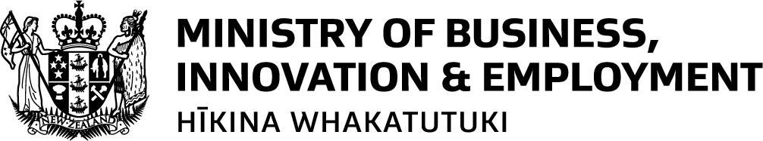

Regional Tourism Boost Fund – Round 3

Expression of Interest Application Form
This Expression of Interest (EOI) form is the first step of the application process for Round 3 of the Regional Tourism Boost Fund. You must complete and submit this form in the first instance. Successful EOI applicants will be invited to complete a detailed application.

Please review the Regional Tourism Boost – Round 3 (RTB3) Guidance document and the Eligibility and Assessment criteria on the MBIE website before completing this application form.

- Applications must meet all of the RTB3 eligibility criteria

Please complete the application form and email to regionalevents@mbie.govt.nz by 9.00am on Monday 6 July 2026

REGIONAL TOURISM BOOST FUNDING – ROUND 3
EXPRESSION OF INTEREST APPLICATION FORM
APPLICANT DETAILS | Lead RTO
APPLICANT DETAILS | RTO Partners  (minimum of 2 required)
APPLICANT DETAILS | Airline partner and/or travel provider or platform
APPLICANT DETAILS | Accommodation Provider(s)
APPLICANT DETAILS | Other Commercial Providers
PROPOSAL DETAILS | Proposed target market(s)
PROPOSAL DETAILS | Overview of the campaign (including the delivery approach) and timeframe
PROPOSAL DETAILS | Expected cost and co-funding (if any)
PROPOSAL DETAILS | Expected impact of the campaign (e.g., level of increased international arrivals)

