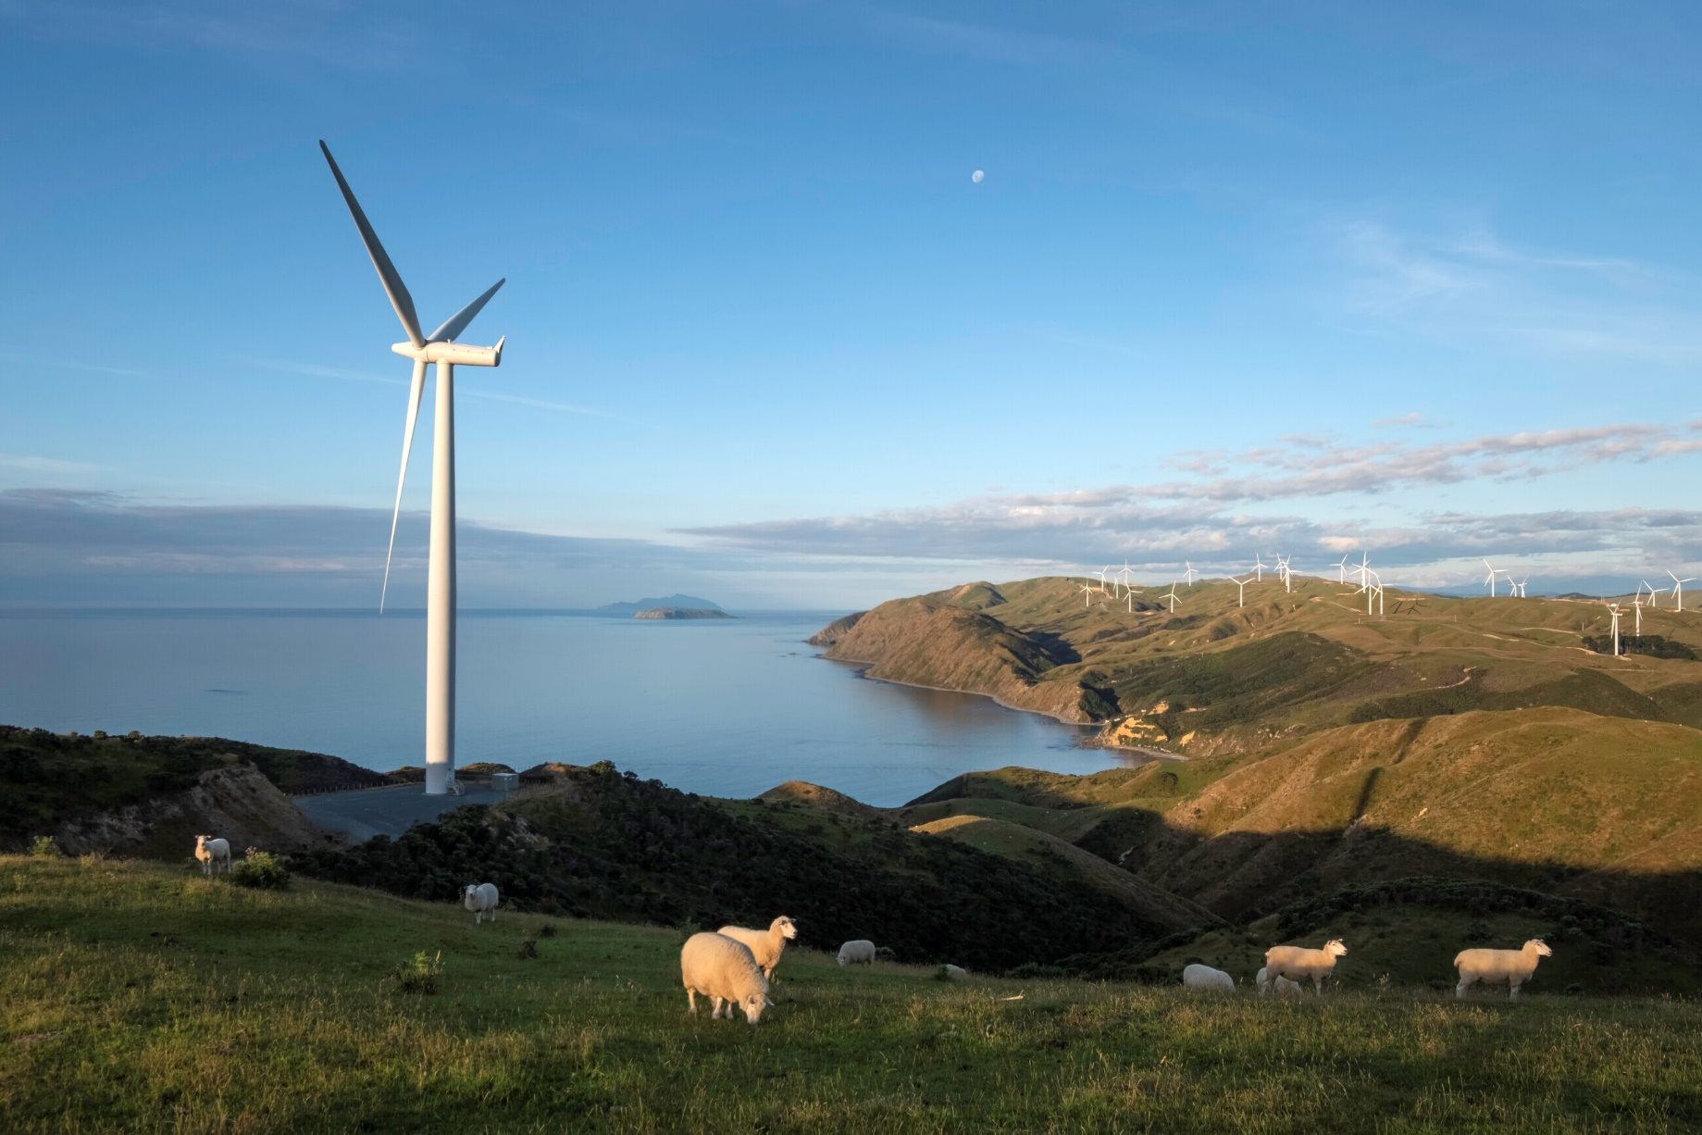
Record wind generation for September quarter
New Zealand Energy Quarterly
September 2023 Summary
Electricity generation from wind reached 920 GWh in the quarter ending September 2023, an increase of 19.1 per cent on the same quarter last year.

Mercury’s Turitea wind farm reached full capacity at the end of June 2023. Increased capacity and strong winds helped generation from wind reach eight per cent of New Zealand’s total electricity generation for the quarter.
Overall, the share of electricity generation by renewable sources for the quarter was 84.1 per cent, a drop of 5.5 percentage points on the same period last year. Hydro generation decreased 10.6 percent due to lower rainfall and planned outages at hydroelectric plants.
To meet demand, electricity generation from coal increased by 90 per cent and from gas by 47 per cent when compared to the previous September quarter. This contributed to a 64.4 per cent increase in greenhouse gas emissions from electricity generation.
Jet fuel use continued to increase this quarter as domestic and international tourism rebounds from the COVID-19 pandemic downturn.
MBIE has made improvements to quarterly reporting of energy-related emissions. Emissions from electricity generation separated by gas type (CO₂, CH₄ and N₂O) to allow a distinction to be made between short-lived and long-lived greenhouse gases.

Read more information on energy use in New Zealand here.

Summary charts

Electricity generation from hydroelectric and geothermal sources
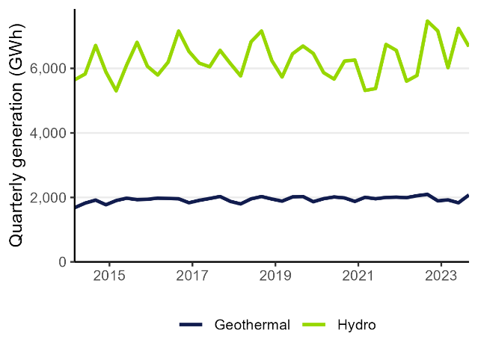

Electricity generation from coal and gas
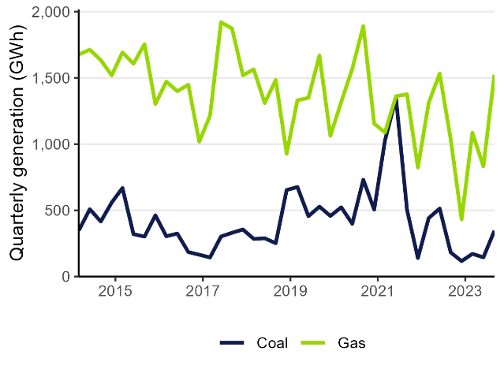

CO₂-e emissions from electricity generation
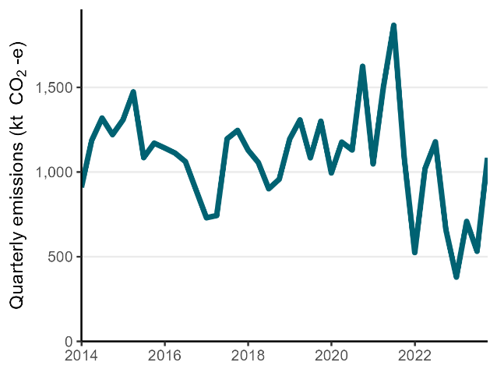

Electricity generation from solar and wind sources
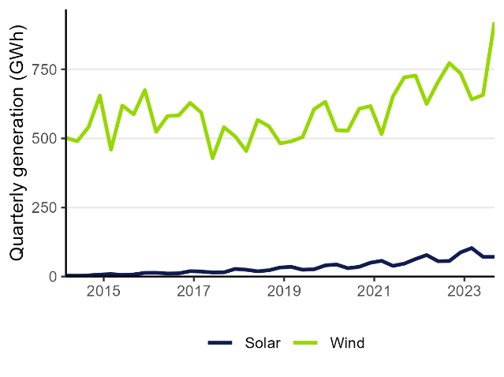

Electricity from renewable sources
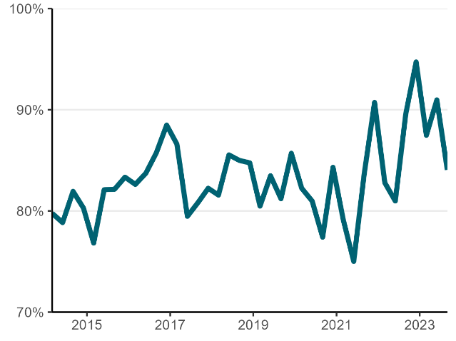

Jet fuel consumption
