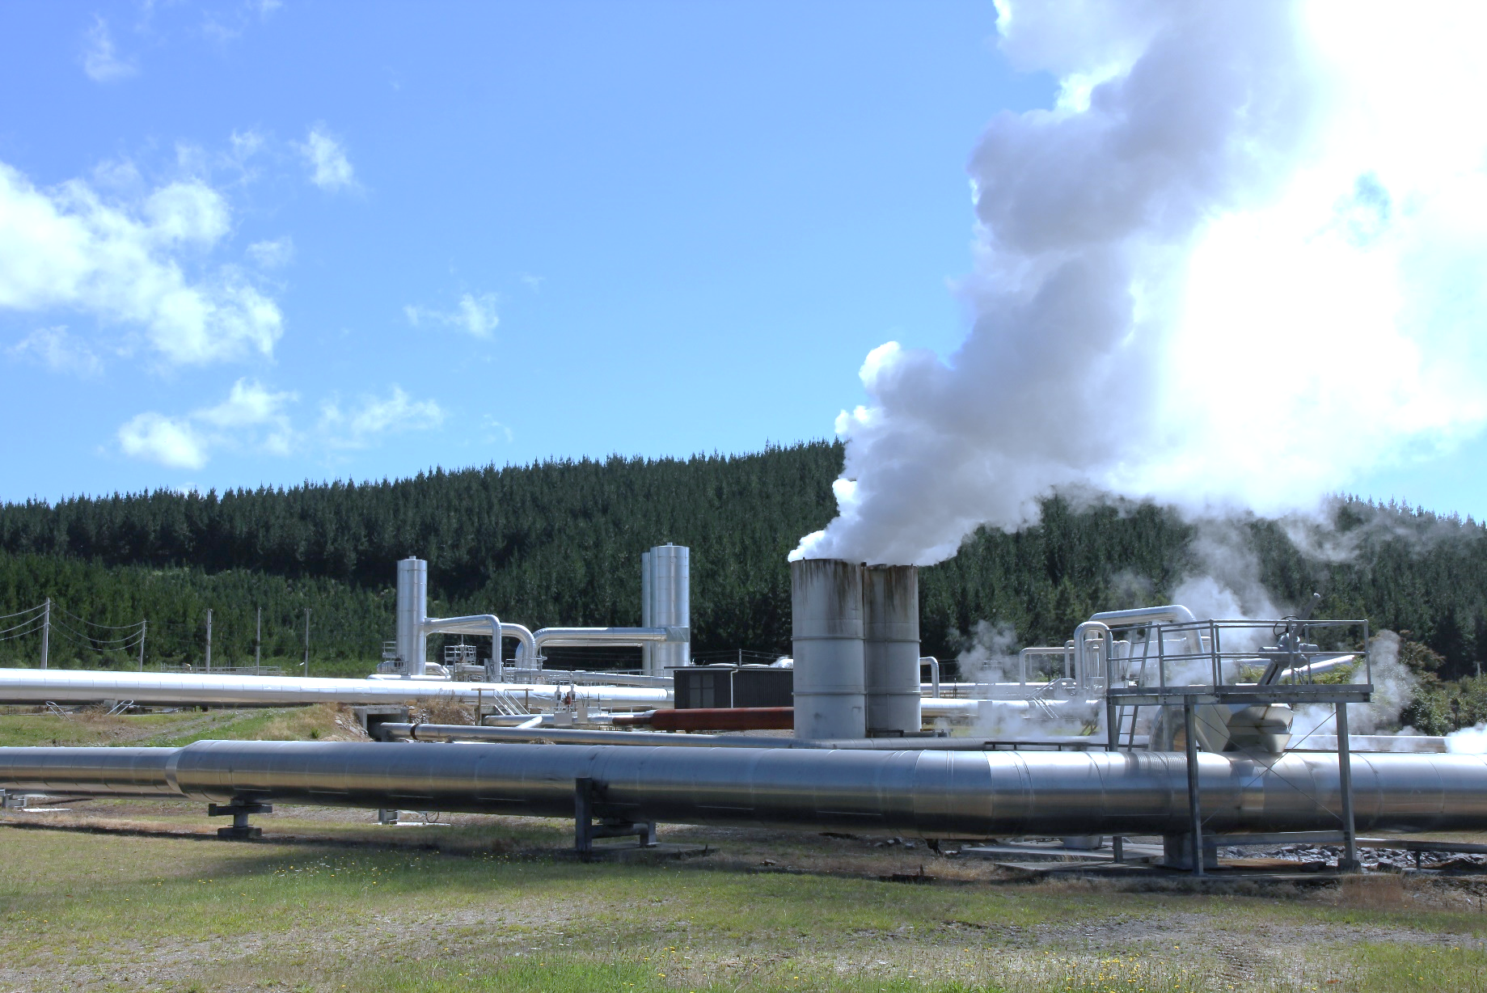**Geothermal generation hits another record high**

**New Zealand Energy Quarterly**

**June 2025 Summary**

Hydro generation was down 6.8% the June 2024 quarter, with lower hydro storage in April contributing to this. This reduction in hydro generation was compensated for with an increase in generation from other renewable sources. Additions to geothermal generation capacity over the past year (Tauhara in May 2024 and Te Huka 3 in October 2024) saw geothermal generation hit a record 2,471 GWh in the June 2025 quarter (enough to meet the annual electricity use of over 300,000 households), up 12.6% from the June 2024 quarter. Wind generation was also up 17.6%, while capacity additions also contributed to a 48.7% increase in generation from solar.

The combination of increased generation from renewable sources and lower electricity demand (meaning that less supply was required) saw a reduction in the level of electricity generation required from non-renewable sources. As a result, generation from gas and coal generation were both down (by 0.9% and 38.3% respectively) and the share of electricity generation from renewable sources increased 2.7 percentage points to 84.1%.

National electricity consumption fell 4.0% from the June 2024 quarter. Contributing to this was lower electricity use by New Zealand Aluminium Smelters due to its demand response agreement being in effect. Additionally residential electricity consumption was down 4.0% on the previous June quarter, which had seen increased electricity use by households in response to a cold snap in May 2024.

Total gas use in the economy was down 19.8%, with the quarter seeing Methanex pausing operations at its Motunui facility for 8 weeks to free up gas for electricity generation.

Coal imports increased from 71.5 kilotonnes in the June 2024 quarter to 539 kilotonnes in the June 2025 quarter as shipments of coal arrived in the country to increase the stockpile for electricity generation.

Petrol and diesel prices fell due to decisions by OPEC+ to increase their output, along with the removal of the Auckland Regional Fuel Tax on 30 June 2024. Petrol prices decreased 10.3% to 255 cents per litre, while diesel retail prices decreased 14.4% to 181 cents per litre.

### Quarterly summary charts

|  |  |
| --- | --- |
| **Electricity generation by source** | Electricity generation from geothermal |
| Stacked area chart showing quarterly electricity generation in gigawatt-hours by hydro, non-renewables, and other renewables from 2000 to June quarter 2025. Hydro is the main source and remains relatively steady over time. Other renewables gradually increase over time, replacing non-renewables as it grows. | Line graph showing quarterly geothermal electricity generation in gigawatt-hours from 2000 to June quarter 2025. Generation starts increasing from around 2009, and with a sharp jump in generation in 2024. |
| Electricity consumption | Gas use by purpose |
| Multi-line graph showing quarterly electricity consumption in gigawatt-hours across residential, commercial, and industrial sectors from 2015 to June quarter 2025. Residential consumption shows strong seasonal ups and downs but gradually increases over time. Commercial consumption remains relatively stable with minor fluctuations, while industrial gradually decreases overtime and with minor fluctuations as well. | Stacked area chart showing gas use in petajoules from 2000 to June quarter 2025, broken down into electricity generation, industrial use, other uses, and non-energy use. Overall energy use trends downward, with fluctuations across categories. |
| Petrol and diesel prices | |
| Line graph showing real prices per litre of diesel and petrol from 2000 to June quarter 2025. Both fuel types show significant volatility, with petrol generally higher than diesel over time. Following a sharp spike in 2022, both prices have been decreasing steadily over the last three years. | |