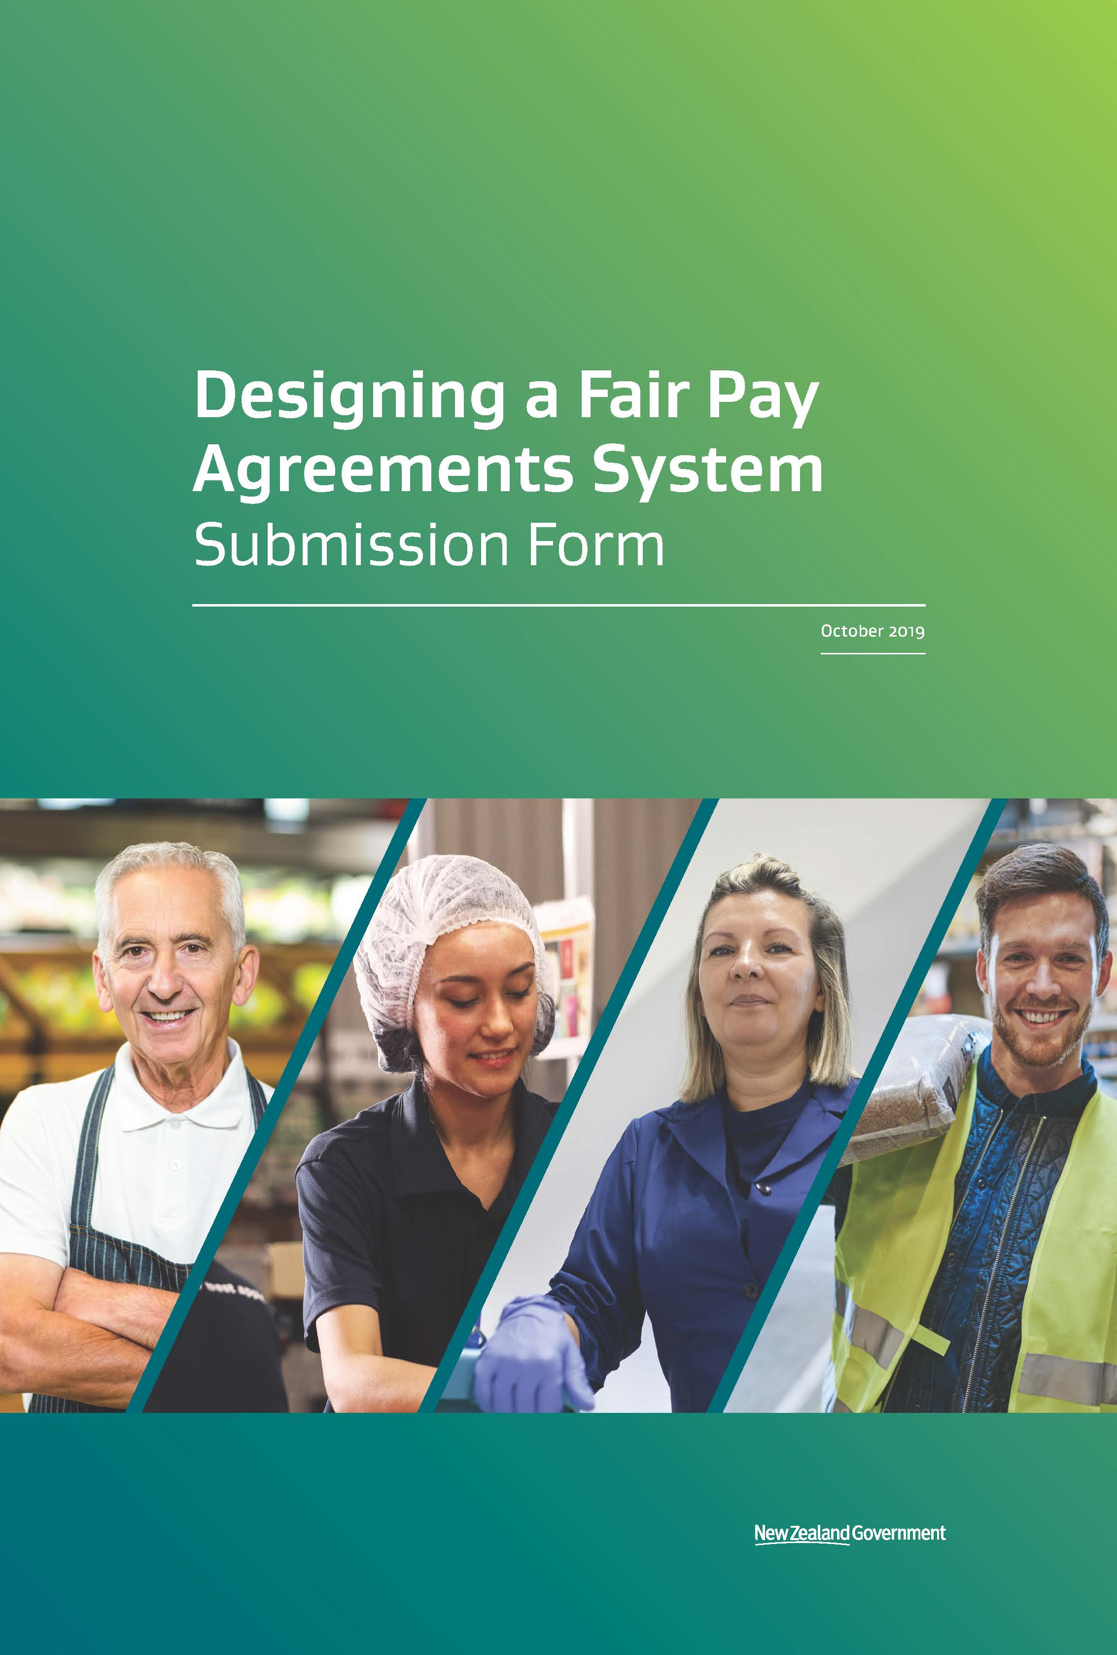

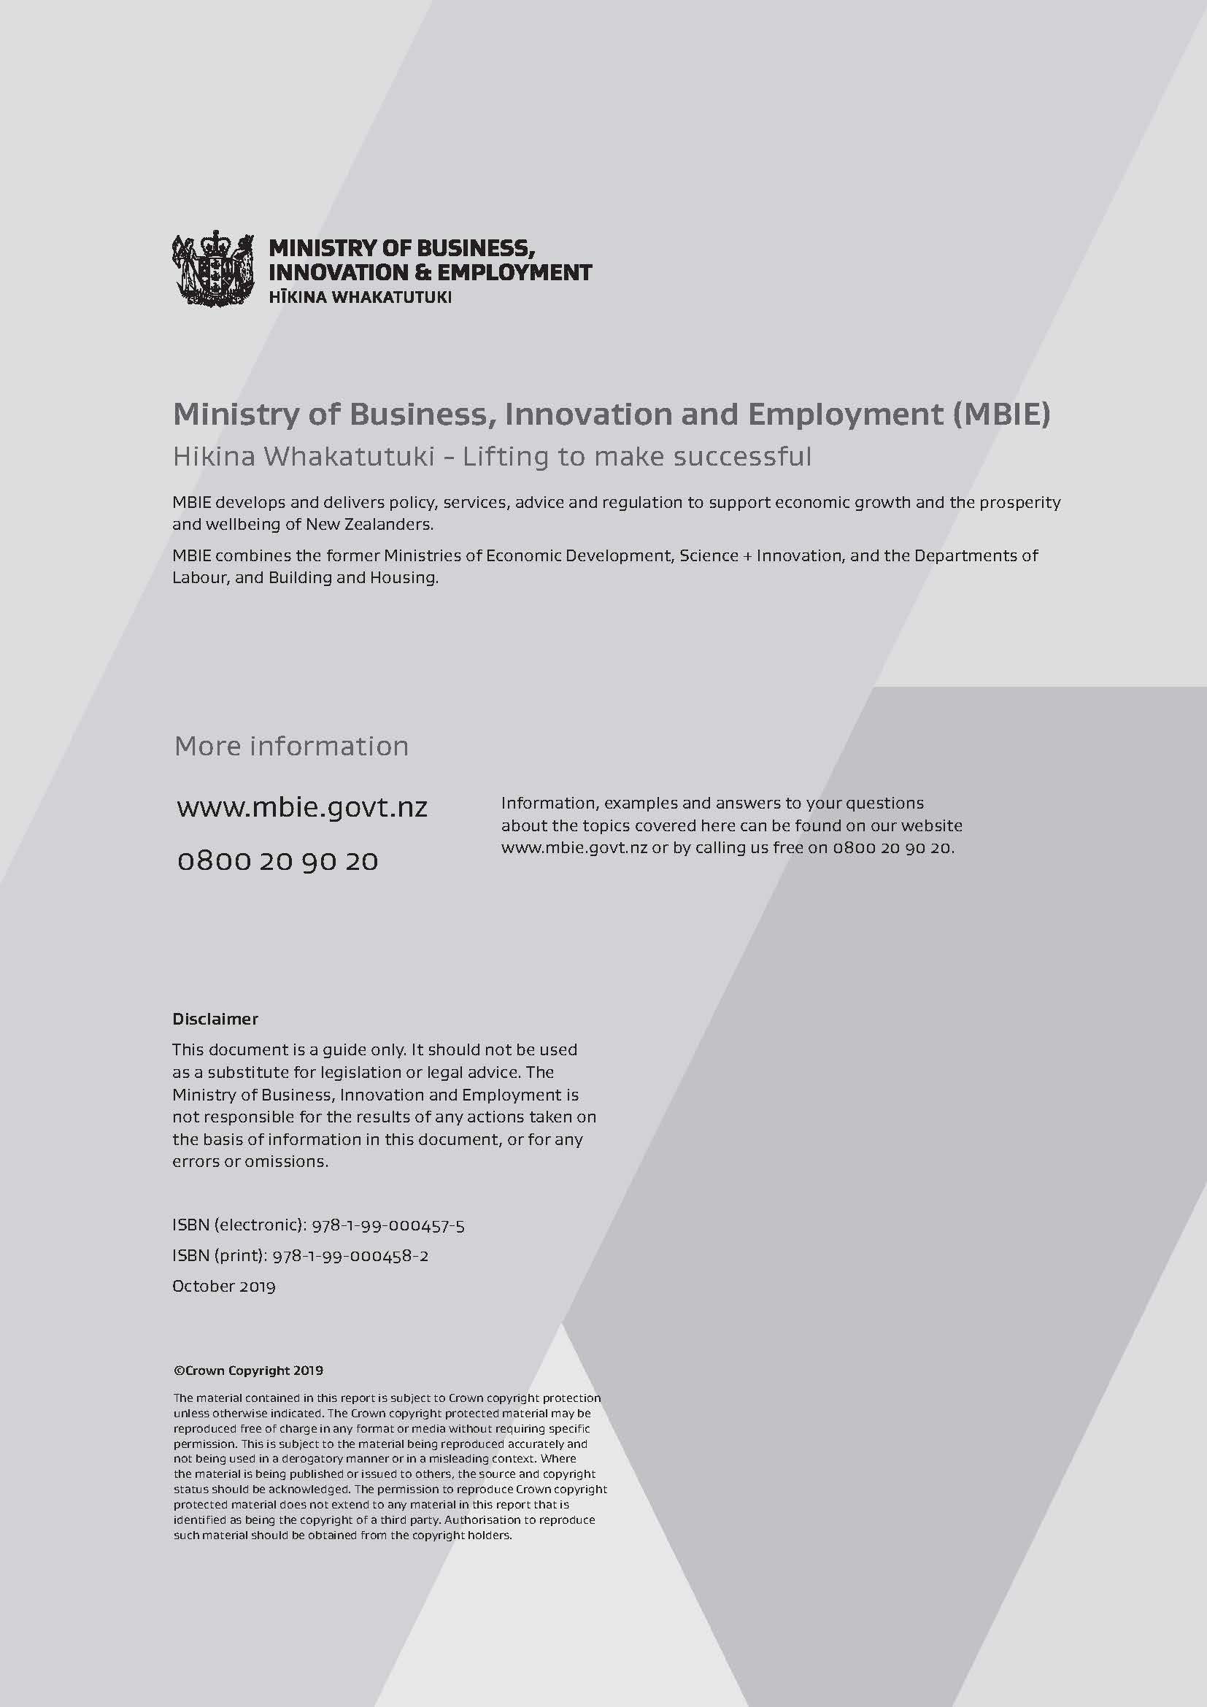

Submission Form

How to provide us with feedback
The Ministry of Business, Innovation and Employment is collecting written submissions to gather a range of views on how Fair Pay Agreements might work in practice and how they could impact different groups.
We need to hear what you think about the options for an FPA system by no later than 5pm on 27 November 2019.
This submission form brings together all the questions asked throughout the discussion document, with page references, so you can go back and look at the relevant topic as necessary.
We know there are a few questions – but you don’t have to answer them all if you don’t want. If you only feel the need to comment on a few areas of the consultation that are relevant to you, that’s OK.
When you’re finished, email the completed submission form to: FairPayAgreements@mbie.govt.nz
If you can’t email the submission, you can post it to:
Employment Relations Policy
Ministry of Business Innovation and Employment
PO Box 1473
Wellington 6145
If you email us your submission, there is no need to post a hard copy as well.

Use and release of information
Your feedback will contribute to the final design of the FPA system.
Your submission will be kept by the Ministry of Business, Innovation and Employment (MBIE) and will become official information. This means that a member of the public may request a copy of your submission from us under the Official Information Act. We may publish the submissions, and any submission summary or analysis report we create as a result of this process may also mention your submission.
If you do not want all or part of your submission to be released or included in an MBIE submission summary or analysis report, please tell us which parts and the reasons why. For example, you may not want members of the public knowing something that happened to you personally. Your views will be taken into account:
- in deciding whether to withhold or release any information requested under the Official Information Act; and
- in deciding if, and how, to refer to your submission in any submission summary or analysis report we create.

Privacy
The Privacy Act governs how we collect, hold, use and disclose personal information provided in your submission. You have the right to access and correct this personal information.
Any personal information you supply to MBIE in the course of making a submission will be used by MBIE only in conjunction with matters covered by this document.
Please clearly indicate if you do not want your name to be included if MBIE publishes the submissions or a summary of submissions.

Submitter information
What is the name of the person completing this submission?
If you are submitting on behalf of an organisation, what is the name of that organisation?
Please indicate if you would like your name and/or organisation details to remain confidential if we publish your submission or a summary of submissions.
☐ Yes, do not publish my name with my submission.
☐ No, publish my name with my submission.
Please provide us with at least one method of contacting you, in case we need to discuss your submission further.
Email
Phone
Postal address
Alternative

What sector(s) does your submission most closely relate to, if applicable? (for example, which sector you may work, operate or be a representative in)
☐ Agriculture, forestry and fishing ☐ Information media and telecommunications
☐ Mining ☐ Financial and insurance services
☐ Manufacturing ☐ Rental, hiring and real estate
☐ Electricity, gas, water and waste services ☐ Professional, scientific and technical services
☐ Construction ☐ Administrative and support services
☐ Wholesale trade ☐ Public administration and safety
☐ Retail trade ☐ Education and training
☐ Accommodation and food services ☐ Health care and social assistance
☐ Transport ☐ Arts and recreation services
☐ Other (please specify)
☐ N/A
Which of the following most closely describes your perspective as a submitter?
☐ Employer ☐ Employee
☐ Union representative ☐ Sector representative
☐ Employer body ☐ Local government
☐ Other (please specify)
We want to ensure we are hearing views from a range of stakeholders. If you or your organisation identifies with an ethnicity, you can choose to indicate this below.
☐ Māori ☐ New Zealand European
☐ Samoan ☐ Cook Island Māori
☐ Tongan ☐ Niuean
☐ Chinese ☐ Indian
☐ Other (please specify)

Initiation

Questions that relate to initiating an FPA
When an FPA can be initiated
Do you think that either a representation or a public interest test is needed to initiate an FPA? Or do you think that applicants should need to pass both a public interest test and a representation test to initiate an FPA? If not, what would you recommend instead?
The representation threshold test
Is 10% a reasonable threshold to ensure that applicants have some support from their sector or occupation before negotiating an FPA? If not, what do you think a reasonable threshold would be?
How should an applicant group need to prove that they have reached a representation threshold? (such as through signatures, membership etc.)
Do you think applicants should be able to trigger bargaining by gaining a set number of supporters? If so, what do you think an appropriate number would be?
Do you think that employers should be able to initiate an FPA bargaining process in their sector?
How should employers be counted in a representation test – by number or by proportion of the relevant employees that they employ?
If employers are counted by number, what do you think would be the best way to classify and count them?
The public interest test
What problems do you think an FPA is best suited to address?
What do you think should need to be demonstrated by an applicant group to prove that an FPA will be in the public interest?
What do you think of the criteria about problematic outcomes and potential for more sectoral coordination? If you disagree, please indicate which other criteria you think should be included or if a different approach would be better.
How much evidence should the applicants be responsible for providing, and what should need to be collected independently by the assessing authority?
What indicators do you think a decision maker should take into account when applying the public interest test?
Should the list of indicators be open, providing the decision maker flexibility to look at other factors to assess the two broad criteria?
Is there a particular indicator, or a group of indicators, that should be given extra weight when deciding if a sector or occupation is in need of an FPA?
Should the indicators be updated regularly? If so, how regularly, and by whom?
Do you think the decision maker should have absolute discretion to decide that the public interest has been met? If not, why not? What do you think the threshold should be?
Do you think the public interest test should be available on-demand to anyone, or should a list of allowed sectors or occupations be set in the law?
If the sectors and occupations able to bargain for an FPA are pre-selected in law, which sectors and occupations do you think we should assess against the test first? Are there any that should not be selected? Why?
If a pre-selected list of sectors and occupations was re-evaluated periodically, how often do you think this should be done?
Affected employers and employees will need to be notified that bargaining has been intiated
Do you think that the government, employers, employer organisations and unions should all play a role in notifying people that FPA bargaining has been initiated?
Do you think that employers should have responsibility for informing employees that an FPA has been initiated? Why or why not? If not, who do you think should do this instead?

Coverage: deciding who an FPA should apply to

Questions that relate to coverage of an FPA
Defining and renegotiating who will be covered by the terms of the new agreement
Do you think that applicants should need to define the coverage of their proposed FPA in terms of the occupations and sectors concerned?
Do you have any comments on the use of ANZSCO and ANZSIC to define coverage? Do you think that there are better alternatives?
Do you think that parties should be able to bargain different coverage, with any significant changes needing to pass the initiation tests? If so, should there be any restrictions to prevent the test being used to delay an FPA?

Should there be restrictions on the permissable grounds for changing coverage during bargaining? If so, what should they be?
Parties bargaining for limited time‐bound exemptions from an FPA
In what circumstances do you think a temporary exemption from an FPA may be warranted?
If included, should exemption clauses be mandatory, or permissible?
Should the bargaining parties be allowed to negotiate additional, more specific exemptions above those set in law?
What do you think is a reasonable maximum length of time that an employer should be exempted from the terms of an FPA?
Should an exemption be able to apply to an entire FPA, or just certain terms?
Allowing parties to negotiate for regional variations in a national FPA
Do you think that parties should be allowed to negotiate regional variations in the minimum terms of an FPA?

If they are included, what do you think a good level for regional variations could be – regions (regional councils and unitary authorities), territorial authorities (city and district councils) or something else? Should this specificity be set in law or left to the parties to decide?
Allowing separate regional FPAs
Do you think that parties should be able to initiate bargaining towards an FPA for specific regions? What, in your view, are the risks of allowing this?
If regional FPAs are allowed, should parties be able to change the regional coverage during bargaining?
Do you think there are particular sectors or occupations which could benefit from, or be harmed by, regional FPAs?

The Bargaining Process

Questions that relate to the bargaining process
Parties must bargain in good faith
Do you think that a duty of good faith should apply to bargaining parties in their dealings with each other and any government bodies as part of the FPA process?
Should a duty of good faith for FPA bargaining involve the same responsibilities as under the current Employment Relations Act? What new responsibilities, if any, will be needed?
The scope of terms and conditions to be included in agreements could be set in law
What do you think of having mandatory and excluded categories?
What do you think of the mandatory topics?
What terms, if any, should be in the excluded category?
What do you think of the alternative option to have only mandatory and permissible categories?
Should any of the items in the permissible and mandatory lists be in a different category?
Do you think that in the event of a bargaining stalemate, the determining body should only be able to set the mandatory terms of the FPA?
Who can represent affected parties at the bargaining table
Do you think that unions and employer organisations should be the major bargaining representatives as is normal?
Should there be a limit on the number of representatives at the bargaining table?
Should other interests be represented? E.g. non-unionised workers, funders or future entrants to the market. Should this be by agreement of the major bargaining parties?
How should bargaining representatives be selected? Is there a role for Government in ensuring the right mix of parties is at the table?
How the costs of bargaining could be shared
Which of the three options for bargaining costs do you agree with, and why? Is there another option which you consider is best?
If a bargaining fee or levy is introduced, how should non-members be identified?
If a bargaining fee or levy is introduced, should the charge be made for all employees/employers as of a certain date? Would there need to be exceptions for certain circumstances? If so, which circumstances?
Could there be good reasons for departing from the current situation where bargaining parties cover the costs of bargaining?
Active support during the bargaining process
Do you think that a ‘navigator’ should be provided to support the bargaining parties?
What skills do you think would be most useful for a navigator to have?
Do you think the navigator should have any additional functions than those described?
Should the navigator role be performed and resourced by the government?
Should the parties be allowed to provide their own navigator, or refuse to have one altogether, if they agree to it?
Do you agree that the bargaining representatives should have the primary responsibility for communicating with the parties they represent?
At which stages of the FPA process should there a requirement to communicate with the employers and employees under coverage of the agreement? (eg. initiation, application for determination etc.)
How much oversight should the government have over the communication process?
Do you think that the principal nationwide employer and worker organisations (BusinessNZ and the New Zealand Council of Trade Unions) should support the bargaining parties to communicate with members?

Dispute resolution: resolving a bargaining stalemate

Questions that relate to dispute resolution
Overall system
Do you think that we should make use of the existing employment relations dispute resolution system for FPAs?
Mediation: a fresh view on a bargaining stalemate
In the event of a bargaining stalemate, should it be mandatory for parties to enter into a formal mediation process before they can seek a determination?
Should mediators be able to provide non-binding recommendations to the bargaining parties? Are there any other functions which a mediator, but not a navigator, should have?
Determination: The final process for resolving a deadlock
What should count as a bargaining stalemate?
Should circumstances be set in law, or should parties need to agree that they have reached a stalemate?
Do you think that there should be a determination process in the event of a bargaining stalemate? If not, would there be sufficient incentives for parties to reach an agreement?
Do you think that the Employment Relations Authority is the most appropriate organisation to carry out the determination function?
Do you think that the determining body should only be able to set terms for the mandatory topics of an FPA?
What role do you think the determining body should have in relation to bargaining stalemates for permissible FPA terms, if any? Should the determining body be able to set terms for permissible matters with the consent of the bargaining parties? Should it be able to make recommendations?

Do you think that the determining body should be able to ask for advice from experts to assist it in making its determinations?
Should the panel of experts need to be demonstrably independent from the bargaining parties?
If a panel of experts is consulted, should their advice be public or strictly confidential? Should experts be protected from liability for their advice?
Appeal rights in the dispute resolution system will be limited to matters of law
Should appeal rights be limited in any way? If so, what sort of limitations would be appropriate?
Do you think that appeal rights should be limited to matters of law only?

Anti-competitive behaviour

Questions that relate to anti-competitive behaviour
Market impact test
Should FPAs be subject to a market impact test or should potential impacts be addressed by other means?
If not, is there another way to address market impacts (such as consideration during negotiations)?
Do you think that the results of the market impact test should be subject to appeal? If so, what sorts of limitations would be appropriate?
The scope of consideration for a market impact test
What potential impacts of an FPA should be considered in the market impact test? What information would be required to assess these impacts? Are there any impacts which should not be considered?
Should there be a maximum time limit on how long the market impact test should take?
How feasible do you think the market impact test would be for a government body to assess?
How risks and benefits could be weighted
How do you think potential risks and benefits should be assessed? Are some negative outcomes justified if the end result will be an overall benefit?
Where the FPA fails the market impact test
Should the government body have discretion to send agreements back to the bargaining parties or the determining body if they fail the market impact test?
If the decision maker can send agreements back to the bargaining parties, should they be able to give recommendations?
Is there a role for further market impact tests after agreements are enacted?
Do you think that there should be an ongoing role for the market impact test after the agreement is put into force? If so, do you think a post-enactment market impact test would need to differ from the initial market impact test in any way?
If there is a market impact re-evaluation test, should it be available through an application process or another way? If on-demand, should there be an application fee or some other necessary criteria to pass before the test can be requested?

Conclusion: putting an agreement into force and recovering costs
Questions that relate to finalising an FPA and cost recovery
Ratification: voting to approve an FPA
Do you think that FPAs should need to be ratified by a majority of employers and workers who will be affected?
Do you think that a majority of voters is a more workable requirement than a majority of all affected parties?
How should employer votes be counted: one vote per business, or votes as a proportion of workers employed in the covered sector?
How do you think the Government should support a ratification process?
What should happen if an agreement does not pass ratification? Should parties return to bargaining?
What should happen if some terms and conditions are determined by the determining body and others are agreed by the parties? Should the whole agreement need to be ratified, or just the terms agreed by the parties?
Enactment: putting the agreement into force
Should the Government be allowed to change any terms of an FPA in the process of enacting it through regulations? If so, on what grounds?
What do you think is the best way to ensure that people are able to easily find information about FPAs?
We are seeking views on the most suitable mechanism for enforcing an FPA
What should happen if a person or group thinks that the minimum terms set by an FPA are not being met?
Do you think the Labour Inspectorate should have the ability to enforce minimum terms set by an FPA?
Cost recovery
Do you think that the costs of dispute resolution in the FPA process should be consistent with the current system?
Aside from dispute resolution, do you think there are any functions or services in the FPA process for which it would be inappropriate to charge a fee?
What would be an appropriate share of costs between the government and bargaining parties for the other functions (excluding dispute resolution)?

