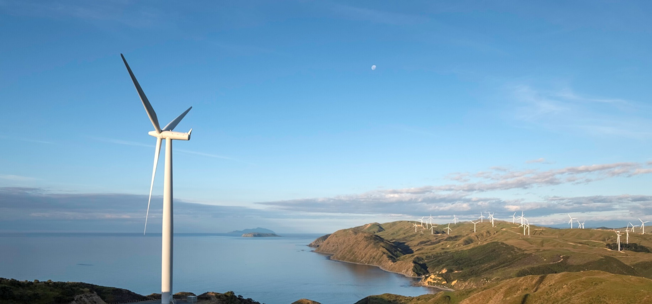
Increased renewable generation capacity for December quarter
New Zealand Energy Quarterly
December 2023 Summary
The renewable share of electricity generation was 90.3 per cent for the October to December 2023 quarter.
Electricity generation from wind reached a record high of 977 GWh for the quarter and represents an increase of 32.9 per cent compared to the same period last year. There was also a record of 125 GWh of electricity generation from grid connected solar for the quarter.
The Harapaki Wind Farm and the Kaitaia solar farm began operation this quarter, which contributed to the increase in renewable generation. Grid connected solar capacity increased from 2.1 MW to 23.7 MW, and wind capacity will increase by 176MW once the Harapaki Wind Farm is fully operational.
The renewable share of electricity generation remained high, despite hydro inflows being lower than average. Hydro generation was 12 per cent lower than in the previous year’s December quarter, largely due to low rainfall.
The lower hydro inflows resulted in an increase in coal and gas use to meet demand. Despite this, coal and gas-based generation made up just 3.5 per cent and 6.1 per cent of total generation respectively.
Greenhouse gas emissions from electricity generation increased by 352 kt CO₂-e (93 per cent) when compared to the same period in 2022. This increase was driven largely by the increase in coal-fired generation.
International aviation fuel use increased 51 per cent on the previous year’s December quarter. This continued the longer term trend and recovery from the drop caused by travel restrictions in response to the COVID-19 pandemic.

Read more information on energy use in New Zealand here.

Summary charts

Electricity generation from hydroelectric and geothermal sources
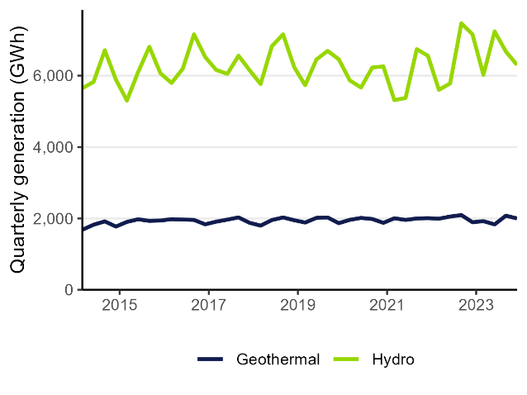

Electricity from renewable sources
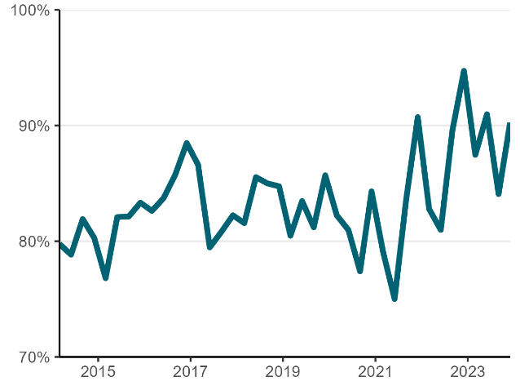

Electricity generation from coal and gas
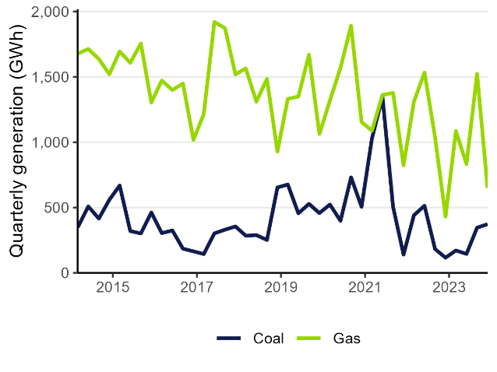

Electricity generation from solar and wind sources
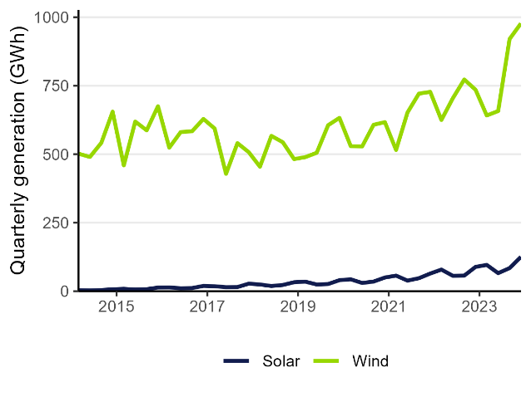

CO₂-e emissions from electricity generation
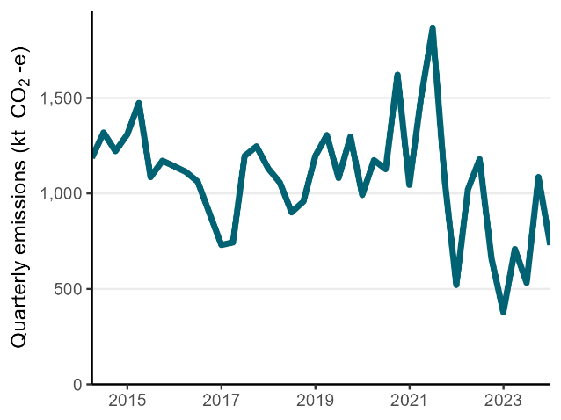

Jet fuel consumption
