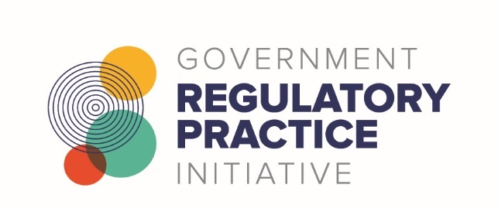

Investigations Community of Practice Registration Form

Use this form to register as a member of the G-REG Investigations Community of Practice.

We are collecting this information to ensure that you are informed about and supported to participate in community activities.

This information will be stored in a secure location within the G-REG Secretariat team accessed only by members of the team as necessary. Should you wish to access, edit, or delete your information at any time please email g-reg@mbie.govt.nz.

Please note, you will be added to a community Teams channel, your name, email, and any other public details attached to your Teams account will be visible to others.

Member information
(* fields are mandatory)

*Name
Job Title
Organisation
*Email
Phone

Please tell us a bit about yourself

What would you like to get out of belonging? Is there anything you are particularly keen on getting from or giving to the community?

As a member, you agree to:
- Commit positively to building and participating in the community, and act accordingly.
- Support the community and its members.
- Do what you can, as you can – and let others know if you need help to fulfil any specific commitments you make.
- Act in accordance with the community’s operating guidelines and any other guidance material or protocols that the community agrees and publishes.

Please select which of the following area of expertise your role aligns with the most. (Mandatory field, select one only)

- Policy
- Compliance and enforcement
- Operational policy/service design
- Education and information
- Monitoring and evaluation
- Standard setting
- Dispute resolution
- Intelligence
- Regulatory Capability
- Regulatory Stewardship

As we are a national regulatory community, please indicate where you are located.

Subscribe to our monthly G-REG newsletter

- Yes
- No

Send your completed form to: g-reg@mbie.govt.nz

