A New Zealand Income Insurance Scheme:

Our proposals

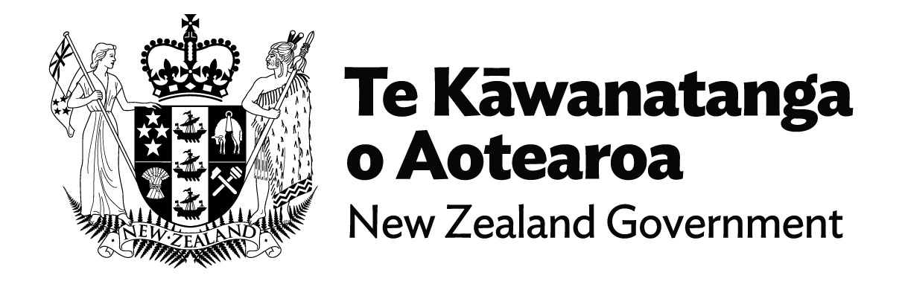

A New Zealand Income Insurance Scheme: Our proposals
Every year, more than 100,000 New Zealanders are made redundant, laid off, or have to stop working because of a health condition or disability.
The Government, Business New Zealand and the New Zealand Council of Trade Unions are proposing a new way of better protecting workers and the economy: a New Zealand Income Insurance Scheme.
Our proposed scheme – which we would like your feedback on – will see workers receive 80 percent of their usual salary for up to seven months. It will cover them if they are made redundant and laid off, or when a health condition or disability means they have to significantly reduce their work hours or stop working entirely. This will give them the time and financial security to find a good job or take part in training or rehabilitation.
The scheme will require people to look for work or take part in training and rehabilitation. It will be funded by levies on wages and salaries, with both workers and employers paying an estimated 1.39 percent each. ACC will manage the scheme.
Business New Zealand, the New Zealand Council of Trade Unions and the Government have developed this proposal to protect workers, improve productivity and prepare New Zealand for the changing world of work.
We look forward to hearing your views on everything we’ve proposed.

Our proposals at a glance
- Broad coverage for different working arrangements.
- Coverage for job losses due to redundancy, layoffs and health conditions and disabilities.
- A four-week notice period and four-week payment, at 80% of salary, from employers.
- A further six months of financial support from the scheme, at 80% of wages or a salary.
- Option to extend support for up to 12 months for training and rehabilitation.
- A case management service to support people’s return to work.
- Administered by ACC.
- Funded by levies on wages and salaries, with both workers and employers paying an estimated 1.39% each.
- Workers eligible after six months of levy contributions in the previous 18 months.

Most workers will be covered by income insurance
Our proposed scheme aims to cover as many workers as possible, to reflect the different ways people work, ensure more people can benefit and to keep costs low.
People working in New Zealand will pay insurance levies to support them if they lose their job.
To be eligible, people will need to have worked or been on statutory parental leave for at least six months in the past 18 months. New Zealand citizens and residents will be eligible for insurance payments.
We’ve developed different eligibility criteria for people who stop working because of a health condition or disability, and those who are made redundant or laid off.
The scheme’s features include:
- Coverage for employees made redundant or laid off
- Coverage for loss of work due to a health condition or disability
- Coverage for contractors and the self-employed who lose work

Financial support is provided for most job losses
Our scheme is designed to provide enough of a financial cushion that workers have the time and financial security to find a good new job, rehabilitate, or retrain for a different career.
Our scheme will see workers receive 80 percent of their usual salary – capped at salaries of $130,911 a year – for up to seven months, if they lose their job. Workers aren’t covered if they’re dismissed for poor performance or misconduct, or they quit their job.
These payments aren’t affected if someone has assets (such as property they own), or if they receive money from other sources (such as government support), or if others in their house (like their partner) continue earning.
The scheme’s features include:
- Employers will give notice and four weeks’ pay if they lay off workers or make them redundant.
- Workers made redundant or laid off for economic reasons will receive up to six months of financial support from the scheme. To qualify, the job must end.
- Workers with health conditions or disabilities will receive the same amount of insurance cover. To be eligible, someone must stop working entirely or experience a reduction in their capacity to work by at least 50 percent. The health condition or disability must be expected to last for at least four weeks. Any health issues shorter than this should be addressed with sick leave and other leave options.

Claimants will be offered support to get back to work
Our scheme aims to help people find good new jobs that match their skills and aspirations. It also aims to help people use the time to learn new skills or rehabilitate from a health condition or disability.
The scheme’s features include:
- Claimants are expected to look for work or participate in training or rehabilitation.
- Support will be available for people to find work and connect them with training or rehabilitation programmes.
- Most other forms of government support are not affected.
- People can work part-time while receiving payments.
- If claimants don’t meet their obligations, payments may be stopped as a last resort.

The scheme will be managed by ACC, which will also collect the levy
Publicly provided income insurance is a new concept for New Zealand, but we do have a similar system for accidents: ACC. We propose that the New Zealand Income Insurance Scheme is funded and managed in a similar way.
The scheme’s features include:
- Building on ACC’s experience by having it run the New Zealand Income Insurance Scheme too.
- Ensuring the scheme honours the Treaty partnership. The way the scheme is governed, delivered and evaluated should recognise a partnership approach, ensuring Māori have real authority to develop and implement policies that address Māori needs and respect te ao Māori.
- Funding the scheme through levies on wages and salaries, with both workers and employers paying an estimated 1.39 percent each.

Personas
Siaosi is in his late 50s, and has worked a long career as a public defence lawyer.
It is a busy, stressful job, and Siaosi struggles to balance his work, family and personal commitments.
Eventually, this stress catches up with him: he survives a heart attack but his doctor warns he must make changes. Siaosi’s employer leaves his job open, while he takes time off work to improve his health, supported by insurance payments. Three months later, Siaosi returns to part-time work, with less-stressful responsibilities mentoring younger lawyers. He moves up to full-time work in this new, less-stressful role a month later.
Manaia has worked for 30 years as a primary school teacher. She loved the job, but chronic back pain due to osteoarthritis means she can no longer bend down to help her young students with their studies.
Manaia’s doctor advises her to stop working, so she takes a break, supported by insurance payments. She works with her case manager on options, and signs up for a 17-week course in business administration. She returns to her primary school, this time in an administrator role in the school’s office. It’s a win-win – Manaia continues to play an important role in the children’s education and the school can use her insights and experience in new ways.

Our questions for you
Should New Zealand introduce an income insurance scheme for job losses due to redundancy, layoffs or health conditions and disabilities? Please state, yes, or, no, and feel free to expand on why or why not.
Many types of working arrangements exist, including permanent, fixed-term and casual employees, as well as contractors and self-employed people.
What do you think about our proposals to cover a broad range of working arrangements?
What do you think our requirements for workers to be eligible for payments (for example, having paid levies, being a New Zealand citizen or resident, and different coverage for health and disability-related job losses)?
What do you think about our proposals for up to six months of support from the scheme, at 80 percent of someone’s normal salary? Higher levels or longer durations of financial support will mean the levies paid by employers and employees will be higher.
Employers will provide a four-week payment on redundancy and layoffs, to discourage unnecessary redundancies and provide extra assurance that the scheme is only used by those who should be eligible, lowering costs to other employers. What do you think about this payment? Are there other ways to promote integrity?
If you’re a worker, and you lose your job, how do you think you would use the financial support you would get through this scheme?
Aside from financial support, can you think of any other support that would help workers return to work?
What obligations should there be on people receiving income insurance payments? What should happen if claimants don’t fulfil their obligations?
Should people be able to receive support for up to 12 months if they are in an approved training or rehabilitation programme? Extended support will mean higher levies, and may help some people return to work.
The scheme would be funded by levies on wages and salaries, with both workers and employers paying an estimated 1.39 percent each. Do you think the levies are good value for the protection and benefits the scheme would introduce for you and for New Zealand?
How affordable do you think the levy will be for you?
How can we ensure the proposed income insurance scheme honours the Treaty partnership?
We propose that ACC delivers the scheme. Do you have any suggestions that will be important to consider for ACC’s delivery alongside the existing accident compensation scheme?
Now that you have read about different aspects of our proposed New Zealand Income Insurance scheme, what do you think overall? Do you think New Zealand needs the scheme, taking into account what employers and employees will need to pay? What do you see as the strengths and weaknesses of the scheme?

Have your say
Visit www.mbie.govt.nz/incomeinsurance to have your say or find out more information.
Submissions close 26 April 2022.
If you have any questions about the consultation process or proposals, please email incomeinsurance@mbie.govt.nz.

