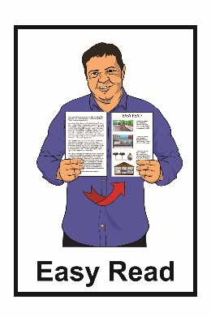

A New Zealand
Income Insurance Scheme
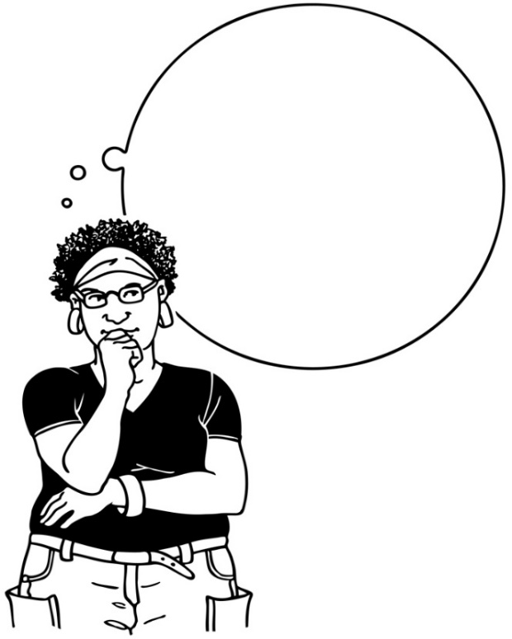

Tell us what you think of the
Income Insurance Scheme proposal

March 2022
What is this document about?

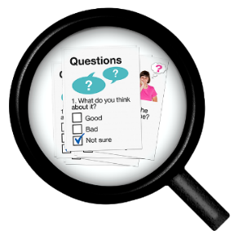
The Ministry of Business, Innovation and Employment want to ask you some questions about our proposal for a New Zealand Income Insurance Scheme.

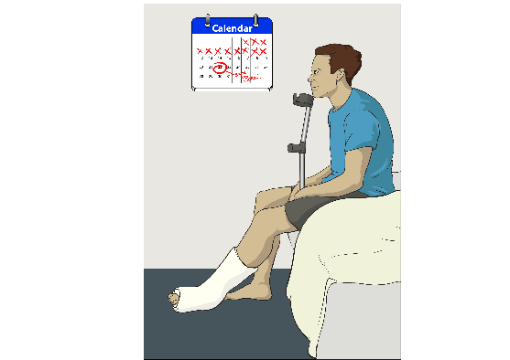
A New Zealand Income Insurance Scheme would give some financial support to people who cannot work anymore because of a health condition or disability.

Financial support is when the Government pays you money so you can pay for things like bills.

In this document we will call the New Zealand Income Insurance Scheme the Scheme.
You can read about the Scheme in Easy Read in the document:
A New Zealand Income Insurance Scheme: How the Income Insurance Scheme could work in New Zealand

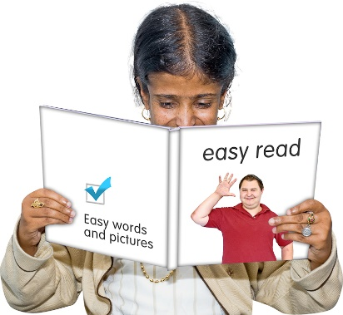
You need to read that document before answering these questions.

Your answers to our questions need to be sent to us before 26 April 2022.

If we do not get your answers before 26 April 2022 we cannot use your answers.

Answering the questions

We will ask you some questions in the next few pages.

You can ask someone to support you in completing this form.

This can be someone you trust
like a:

- family member
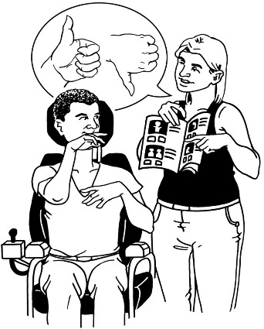
- friend

- support person.

How to answer questions

In the document we will ask you some questions that you answer as:

- Yes
or
- No.

Please tick 1 answer for these questions

You can also write why you chose that answer if you want to.
There will be other questions that ask you to write down what you think of an idea.

- Should New Zealand start an Income Insurance Scheme for people losing their jobs because of:
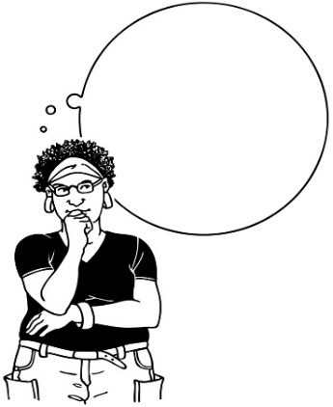
- being made redundant?
- being laid off?

Yes

No

Why do you think this?
____________________________________________________________________________________________________________________________________________________________________________________________________________________________________________________________________________________________________________

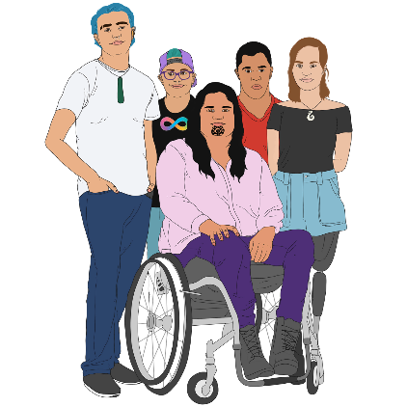
- Should New Zealand start an Income Insurance Scheme for people losing their jobs because of:
- health conditions?
- disability?

Yes

No

Why do you think this?
____________________________________________________________________________________________________________________________________________________________________________________________________________________________________________________________________________________________________________

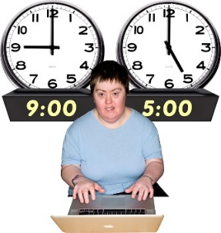
- Do you think we should cover a lot of different ways of working like:
- part time work?

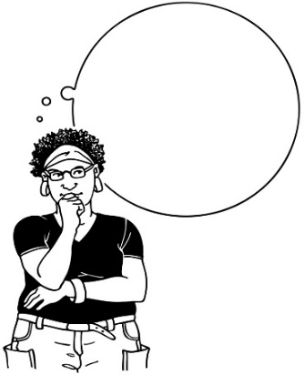
- full time work?

Yes

No

Why do you think this?
____________________________________________________________________________________________________________________________________________________________________________________________________________________________________________________________________________________________________________

- What do you think of the eligibility criteria for people to be part of the Scheme?

Eligibility criteria is a list of things that need to be true for someone to be part of the scheme

Write you answer here:
____________________________________________________________________________________________________________________________________________________________________________________________________________________________________________________________________________________________________________
______________________________________________________________________________________________________________________________________________________
- What do you think about the government paying most of what someone would normally earn for up to 6 months through the Scheme?

Write you answer here:
____________________________________________________________________________________________________________________________________________________________________________________________________________________________________________________________________________________________________________
__________________________________________________________________________________________________________________________________________________________________________________________________________________________________________________________
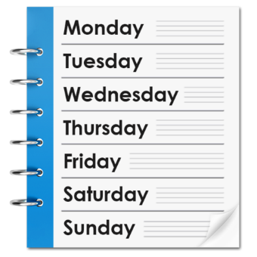
- What do you think about the payment offered for 4 weeks by employers to make sure the Scheme is only used by people who need it?
Write your answer here:
____________________________________________________________________________________________________________________________________________________________________________________________________________________________________________________________________________________________________________
__________________________________________________________________________________________________________________________________________________________________________________________________________________________________________________________
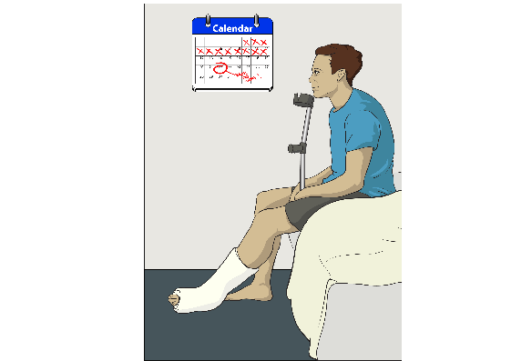
- Do you think there are other ways we can make sure the Scheme is only used by people who need it?
Write your answer here:
____________________________________________________________________________________________________________________________________________________________________________________________________________________________________________________________________________________________________________
____________________________________________________________________________________________________________________________________________________________________________________________________________________________________________________________________________________________________________

- How do you think you would use the financial support from the Scheme if you lost your job?

Write your answer here:
____________________________________________________________________________________________________________________________________________________________________________________________________________________________________________________________________________________________________________
____________________________________________________________________________________________________________________________________________________________________________________________________________________________________________________________________________________________________________
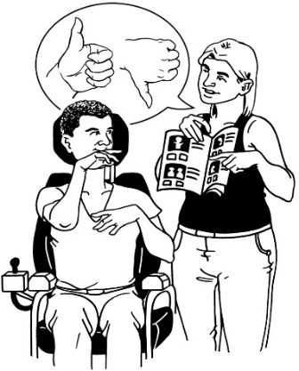
- Can you think of any support that is not financial that could support workers in returning to work?

Write your answer here:
____________________________________________________________________________________________________________________________________________________________________________________________________________________________________________________________________________________________________________
____________________________________________________________________________________________________________________________________________________________________________________________________________________________________________________________________________________________________________

- What things should people who get the Scheme payments need to do to keep getting the payments?

Write your answer here:
____________________________________________________________________________________________________________________________________________________________________________________________________________________________________________________________________________________________________________
____________________________________________________________________________________________________________________________________________________________________________________________________________________________________________________________________________________________________________

- What should happen to people getting the Scheme payments if they do not do what they are meant to?

Write your answer here:
____________________________________________________________________________________________________________________________________________________________________________________________________________________________________________________________________________________________________________
____________________________________________________________________________________________________________________________________________________________________________________________________________________________________________________________________________________________________________

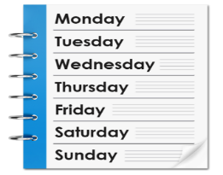
- Should people be able to get support for up to 12 months if they are:
- training for a new career?
- going through rehabilitation for their health condition or disability?

Yes

No

Why do you think that? ________________________________________________________________________________________________________________________________________________________________________________________________________
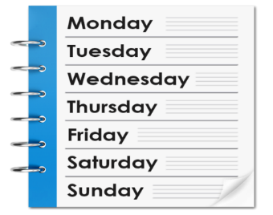
- Do you think the levies are worth paying the money to be able to have an Income Insurance Scheme?
Yes

No

Why do you think that? ____________________________________________________________________________________________________________________________________________________________________________________________________________________________________________________________________________________________________________
____________________________________________________________________________________________________
- Do you think you can afford the extra money the levies will cost?

Yes

No

Why do you think that?
____________________________________________________________________________________________________________________________________________________________________________________________________________________________________________________________________________________________________________
____________________________________________________________________________________________________
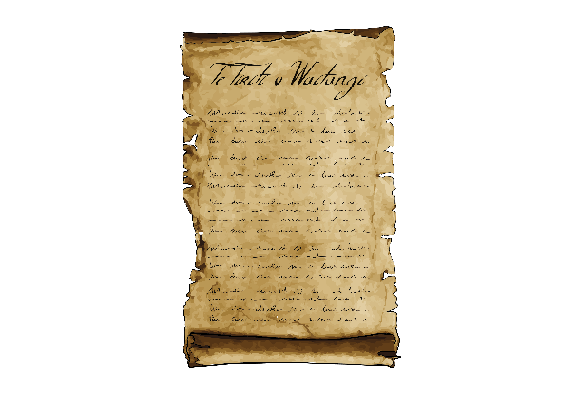
- How can we make sure the scheme follows te Tiriti o Waitangi / Treaty of Waitangi partnership?

Write your answer here:
____________________________________________________________________________________________________________________________________________________________________________________________________________________________________________________________________________________________________________
____________________________________________________________________________________________________________________________________________________________________________________________________________________________________________________________________________________________________________
- Do you have any ideas that will be important for ACC to think about for running the Scheme?
Write your answer here:
____________________________________________________________________________________________________________________________________________________________________________________________________________________________________________________________________________________________________________
______________________________________________________________________________________________________________________________________________________________________________________________________________________________________________________________________________________________________________________________________________________________
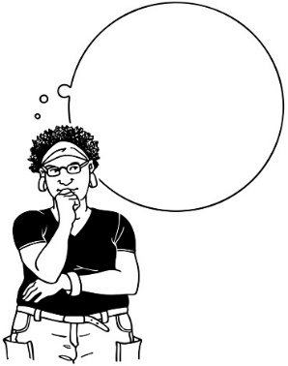
- What do you think of the whole Scheme?

Write your answer here:
____________________________________________________________________________________________________________________________________________________________________________________________________________________________________________________________________________________________________________
______________________________________________________________________________________________________________________________________________________________________________________________________________________________________________________________________________________________________________________________________________________________
- Do you think New Zealand needs the Scheme?

Yes

No

Write your answer here:
____________________________________________________________________________________________________________________________________________________________________________________________________________________________________________________________________________________________________________
________________________________________________________________________________________________________________________________________________________________________________________________________
- What do you like about the Scheme?

Write your answer here:
____________________________________________________________________________________________________________________________________________________________________________________________________________________________________________________________________________________________________________
____________________________________________________________________________________________________________________________________________________________________________________________________________________________________________________________________________________________________________
____________________________________________________________________________________________________
- What do you not like about the Scheme?

Write your answer here:
____________________________________________________________________________________________________________________________________________________________________________________________________________________________________________________________________________________________________________
____________________________________________________________________________________________________________________________________________________________________________________________________________________________________________________________________________________________________________
____________________________________________________________________________________________________
Where to send your answers

You can send us your answers by email to:
incomeinsurance@mbie.govt.nz

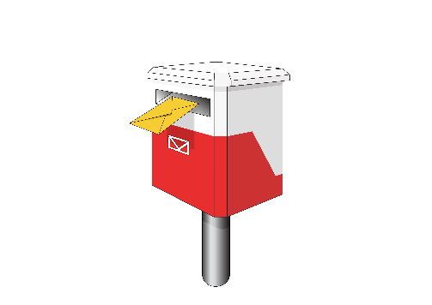
You can send us your answers by post to:
Social Unemployment Insurance Tripartite Working Group

Ministry of Business, Innovation and Employment

PO Box 1473

Wellington 6145
If you have any questions then you can send us an email at:

incomeinsurance@mbie.govt.nz

This information has been written by the Ministry of Business, Innovation & Employment
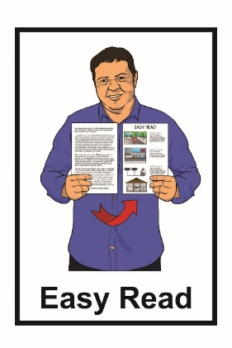
It has been translated into Easy Read with advice from the Make It Easy service of People First New Zealand Inc. Ngā Tāngata Tuatahi.

The ideas in this document are not the ideas of People First New Zealand Inc. Ngā Tāngata Tuatahi.
Make It Easy uses images from:

- Changepeople.org
- Photosymbols.com
- Sam Corliss
- Huriana Kopeke-Te Aho

All images used in this Easy Read document are subject to copyright rules and cannot be used without permission.

