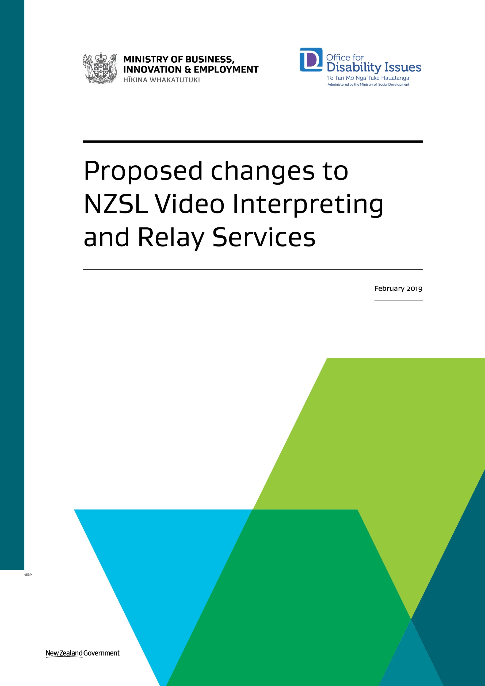

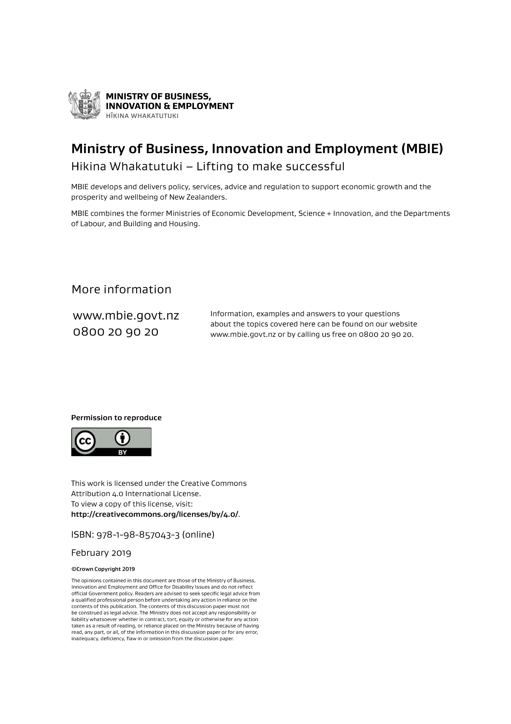

Introduction

## We want your feedback on changes we’re proposing to the video interpreting and relay services

These services are part of the Telecommunications Relay Service, which helps Deaf, deafblind, hearing-impaired and speech-impaired New Zealanders to communicate with hearing people over the phone. (All the different services and how they work are described at the end of this document: see page 17.)

We believe that these proposed changes will help us move to **more modern** services that perform well for users and their whānau and that are ready for future changes in technology.

We want to know what you and your whānau think about the proposed changes. This includes any concerns you have about the proposals.

In this document we explain the changes we propose to make and why we think they are a good idea. We ask you some questions that we would like your feedback on.

## How you can have your say

You can either send us a **video message** of you signing your feedback in New Zealand Sign Language (NZSL), or you can **email or post** us your feedback.

We also invite you to come to one of 5 **workshops** we will be hosting. These workshops will give you a chance to tell us what you think in more detail about what people need from modern video interpreting and relay services.

For details on exactly how to have your say and workshops, go to page 15.

## Background to this new phase of consultation

This is a second phase of consultation with users about the NZSL video interpreting and relay services.

It’s part of the work we’re doing to achieve one of the goals of the New Zealand Disability Strategy – that **in the future, information and communications will be easy for disabled people to access, using formats and languages that are right for them** (Outcome 5 – Accessibility).

In 2018, we consulted with users about the current relay services. Users told us they wanted video interpreting and relay services that took advantage of new technologies and that gave better access to video interpreting for New Zealand Sign Language.

We’ve now come up with a set of proposed changes that we think will mean more modern, more accessible services. This document explains those proposals and asks for your feedback about them.

## What happens after we get your feedback

After we have got people’s feedback, including from the workshops we will hold, we will look closely at it to help us decide what changes should be made to the current services.

We will publish a summary of people’s feedback on our websites ([www.mbie.govt.nz](http://www.mbie.govt.nz)/relayconsultation).

Your feedback will also help us ask for proposals from organisations that provide video interpreting and relay services. These potential suppliers will need to show us that they will be able to deliver the new, improved services.

Overview of the proposed changes

The video interpreting and relay services continue to be very important for their users. This is partly because in many situations phone calls continue to be the best or only way to contact someone. Video interpreting also makes it easier for users to communicate using New Zealand Sign Language (NZSL).

We think these services can be improved. We are proposing to move to **better, more modern** video interpreting and relay services.

## Which services exactly is MBIE proposing to change?

The proposed changes are to the following services:

* **Video Interpreting Service (VIS):** This Skype-based service allows you to sign with an NZSL interpreter who then relays your message verbally to a hearing person using a standard phone. This service is available Monday to Friday 8am to 8pm. It can also be used for remote interpreting where the hearing person is in the same room as you and the interpreter is in a different place.
* **Text-based relay services:** These services allow you to text or type a message and read the response; or speak your message and receive a text response; or text or type your message and listen to the response. The different services include mobile text relay, internet relay, CapTel, and teletypewriter/TTY services (teletypewriter to voice, voice carry-over, and hearing carry-over).
* **Speech-to-speech** **service:** If you’re speech-impaired this allows you to have a relay assistant interpret what you are saying and relay your message to a hearing person over the phone.

## What are the proposed changes?

There are six changes we are proposing:

1. **Get you to register as a user**
2. **Make the Video Interpreting Service more available**
3. **Move to digital text-based relay services**
4. **Phase out CapTel equipment**
5. **Stop using teletypewriter (TTY) equipment**
6. **Stop speech-to-speech services.**

We explain these in more detail in the next few sections of this document.

## Why the changes?

Relay services have changed a lot since they were introduced in New Zealand in 2004. Some of the services we have today are better and more consistent than in the past. There are also more options to use New Zealand Sign Language since the Video Interpreting Service was introduced in 2016.

However, changes to the services over the years have resulted in quite a large range of different services. These services go by different names and use different technologies, and some services are better than others.

The changes we are proposing would make the services easier for you and your whānau to use in various ways:

* The services would be available across everyday devices, including smartphones, tablets and computers
* The changes would mean better access to video interpreting for New Zealand Sign Language
* It would be easier for you to make and receive calls
* You would not need to buy or borrow special equipment
* The changes would make it easy for you to give your feedback about the services, and for you to be told if something goes wrong with the service.

The new services would focus on doing things better and keeping up with new technology. They would also include strong, clear rules to protect your privacy.

The improved services would also focus on providing education and support for a range of users. This would include individual users and their whānau, but also organisations, like government agencies, businesses, schools and healthcare organisations.

## Emergency calls: Make sure you register for 111 TXT

For emergency calls, it will still be important for you to register for 111 TXT. This service allows you to communicate directly with emergency services. It’s available 24 hours a day.

To find out more, and to register, go to [www.police.govt.nz/111-txt](http://www.police.govt.nz/111-txt)

In some cases, emergency services may also be able to access Emergency Caller Location Information to help them respond to your emergency. You can find out more about this at:

[www.mbie.govt.nz/science-and-technology/it-communications-and-broadband/our-role-in-the-ict-sector/emergency-call-services/emergency-caller-location-information/](http://www.mbie.govt.nz/science-and-technology/it-communications-and-broadband/our-role-in-the-ict-sector/emergency-call-services/emergency-caller-location-information/)

**Change 1:** Get you to register as a user

## What would be different?

Users would need to register to use the video interpreting and relay services.

We would make this as easy as possible. You would register by creating a log-in like you do for other services, with your own user-name and password.

You would **not** need to provide evidence to prove you have a disability when you register.

Your privacy would be strictly protected when you register and use the services.

## Why this change?

Getting users to register would help improve the services for you. It could make it easier for you to:

* receive incoming calls
* use and top up an account for international calls
* get important notifications – like when a service might be down, or during a civil defence emergency
* provide feedback about the services.

Getting users to register will also tell us more about who is using the services and how they are using them. That will then help us know whether the services are meeting users’ needs.

At the moment we only have information about how many calls are made and how many call minutes there are over a month. We do not know how many people are using the services and why they are using the services.

## Have your say

### Q. What do you think about requiring users to register to use the services? Do you have any concerns about this?

**Change 2:** Make the Video Interpreting Service more available

## What would be different?

The Video Interpreting Service would be available seven days a week.

We would find out from potential suppliers of video interpreting whether it would be practical to increase the hours of the service – for example making the service more available at night. This might depend on whether enough interpreters are available.

We also want to look at allowing interpreters to work for the service from different locations. For example, an interpreter could work from a home office instead of a call centre. There would be strong controls to make sure your privacy is protected and you still get a high-quality service.

We would look at making other improvements, making sure the video system is easy both for users to access and for organisations like government agencies to access.

## Why this change?

The Video Interpreting Service is the most popular service for users of New Zealand Sign Language. It can be used to communicate over the phone, or to provide access to an interpreter who is in a different place.

The service is currently only available Monday to Friday, 8 am to 8 pm. Outside these times, users can choose to use other relay services such as mobile text relay.

Making the service more available would mean that the service can help when in-person interpreters are unavailable – for example in emergency situations like when you are at a hospital or police station.

The most significant barrier to making the service more available is the limited number of qualified interpreters. We would like to explore ways to draw on the skills of interpreters from all around the country.

## Have your say

### Q. What do you think about our proposals for making the video interpreting service more available? Do you have any concerns about them?

**Change 3:** Move to digital text-based relay services

## What would be different?

All text-based relay services would be available across everyday devices – like mobile phones, tablets and computers.

This could be through a single app that you download. The different services would need to be presented and branded in a common way, to help make people aware of the different services and that they can all be used from everyday devices.

These services would allow users to:

* text or type their message and then read the reply
* speak their message and then receive a text reply
* text or type their message and then listen to the reply.

We would look at making other improvements – for example, allowing free calls to both landlines and mobile phones.

We would also find out about making the different services compatible with assistive technologies that people may use for their disability.

## Why this change?

If we provide relay services through everyday devices, this means users don’t need to buy or borrow special equipment to use them.

It would also make it easier to make improvements to the services as technology develops or in response to the feedback we get from users.

This change would be similar to changes made in other countries like the United Kingdom and Australia. These countries provide relay services through an app that users download to their everyday devices.

At the moment there are a number of different relay services that users may not know about because they have different names. Some of these services also use special equipment (CapTel and Teletypewriter or TTY services).

## Have your say

### Q. What do you think about moving to digital text-based relay services? Do you have any concerns about this?

**Change 4:** Phase out CapTel equipment

## What would be different?

New relay users would need to use one of the new digital relay services from 30 June 2020. There would be no new loans of CapTel equipment after this date.

Existing CapTel users would still be able to use CapTel equipment for a certain time after 30 June 2020, to allow them to change over to one of the new digital relay services. We want your feedback on the length of that change-over period to make sure users can get the right support.

## Why this change?

This change would fit with another of the suggested changes – making digital relay services available on everyday devices (see suggested change 3: Move to digital text-based relay services). This would mean shifting away from using special equipment.

The CapTel service currently requires you to pay $325 to borrow special equipment. You also need both a broadband connection and a landline phone. The organisation that provides this service also must have the right licences to be able supply the service.

If we phase out CapTel, new users would be able to access the new digital services sooner while allowing existing users to change to the new digital services over time. It would also increase funds available for re-investment in the new digital services to keep these services current with changing technology.

We estimate around 500 CapTel handsets are in use.

## Have your say

### Q. What do you think about stopping the use of CapTel equipment? Do you have any concerns about this?

### Q. What do you think would be a reasonable length of time to allow existing CapTel users to change over to new digital relay services?

**Change 5:** Stop using teletypewriter (TTY) equipment

## What would be different?

Relay services using teletypewriter equipment – or “TTY” – would not be available after 30 December 2020, allowing 6 months to change over to one of the new digital relay services. These services include:

* TTY to voice
* hearing carry over
* voice carry over.

## Why this change?

TTY equipment is now being used less and less. Users have already moved to other services such as mobile text relay and internet relay. We estimate that there are now less than 50 TTY devices.

The feedback we got last year suggested that the community is ready to turn off the TTY services as the equipment is now out of date and of poorer quality. It also suggested there should be a notice period, so that any people still using the service could change over to another service.

## Have your say

### Q. What do you think about stopping TTY services? Do you have any concerns about this, including the timing for doing this?

**Change 6:** Stop speech-to-speech services

## What would be different?

Speech-to-speech services, including video-assisted speech-to-speech, would not be available after 30 December 2020, allowing 6 months to change over to one of the new digital relay services.

We would look to make sure new digital relay services can help more speech-impaired people – for example we will explore how the services work with assistive technologies that speech-impaired people are familiar with.

## Why this change?

The speech-to-speech service is the least-used service (about 3 hours of call time a month on average). No-one has used the video-assisted speech-to-speech service in over a year.

The speech-impaired community is varied, with a number of very different communication needs. The speech-to-speech service does not appear to be meeting these diverse needs well.

A number of people have told us they have tried speech-to-speech services but stopped because they find it too hard. Speech-impaired people can also experience other barriers to using these services, like not feeling confident speaking with someone they do not know.

We also understand that users feel reluctant to tell other people that this is a good service that they should use.

## Have your say

### Q. What do you think about stopping the speech-to-speech services? Do you have any concerns about this?

Addressing other barriers to access

## Other barriers to using video interpreting and relay services

In 2018, users have told us about some of the barriers they face using the video interpreting and relay services. These include:

* Users not having access to affordable and adequate broadband, mobile data and digital devices to use video. NZSL users rely on video to communicate regularly with friends and family, to access information in NZSL, and to use the Video Interpreting Service.
* Organisations that may not have the right processes in place to help Deaf, deafblind, hearing-impaired or speech-impaired customers to access information and services. This can mean some of them do not support the use of the video interpreting and relay services, or do not provide other ways for a customer to communicate with them.

The proposed changes won’t address these issues which go beyond video interpreting and relay services. However, there is a lot happening across government to better understand and address issues relating to accessibility, disability support, and digital inclusion. For example:

* The Government has started a major project to explore how we can achieve full accessibility for everyone.
* The Ministry of Social Development is working with more organisations to implement the Accessibility Charter.
* The Ministry of Health is testing a new approach to disability support in the MidCentral District Health Board region, ‘Mana Whaikaha’, to provide disabled people and whānau with more flexible support options.
* The Office for Disability Issues and the Disabled People’s Organisations Coalition have been working with the disability community to develop the next four-year action plan to deliver the priorities of the New Zealand Disability Strategy.
* The Department of Internal Affairs is leading a cross-government programme to develop a Digital Inclusion Blueprint.

You can find out what’s happening at the Office for Disability Issues website: [www.odi.govt.nz](http://www.odi.govt.nz).

Recap of the questions

1. What do you think about requiring users to register to use the services? Do you have any concerns about this?
2. What do you think about our proposals for making the video interpreting service more available? Do you have any concerns about them?
3. What do you think about moving to digital text-based relay services? Do you have any concerns about this?
4. What do you think about stopping the use of CapTel equipment? Do you have any concerns about this?
5. What do you think would be a reasonable length of time to allow existing CapTel users to change over to new digital relay services?
6. What do you think about stopping TTY services? Do you have any concerns about this, including the timing for doing this?
7. What do you think about stopping the speech-to-speech services? Do you have any concerns about this?

How to have your say

In this document we suggest some changes to the New Zealand Sign Language Video Interpreting and Relay Services. We want to find out what you think about these suggested changes.

You can have your say in these two ways:

* **Video of your signed response** – If you use New Zealand Sign Language, you can send us a video of you signing your response. Go to the website [www.seeflow.co.nz/direct](http://www.seeflow.co.nz/direct) where you will be able to create your video message.
* **Written response** – You can write down your feedback using the template provided at [www.mbie.govt.nz/relayconsultation](http://www.mbie.govt.nz/relayconsultation)*.* You can then either **email** us your feedback, or print it out and **post** it to us:

**Email:** [relayconsultation@mbie.govt.nz](https://mako.wd.govt.nz/otcsdav/nodes/87159936/mailto%3Arelayconsultation%40mbie.govt.nz)

**Post:** Communications Policy  
Building, Resources and Markets  
Ministry of Business, Innovation & Employment  
PO Box 1473  
Wellington 6140  
New Zealand

Please tell us your name and your email address or street address when sharing your views.

**Closing date:** We will need to get your feedback by **9am on Monday, 15 April 2019**.

## Workshops

We also invite you to come to one of the workshops we will be hosting. This will give you a chance to tell us in more detail what you think about the relay services and the changes we’re proposing.

We are hosting workshops in Auckland, Hamilton, Wellington, Christchurch and Dunedin. You can find out more about the workshops at [www.mbie.govt.nz/relayconsultation](http://www.mbie.govt.nz/relayconsultation).

## We will publish some feedback

### We intend to publish some of the feedback that people send us about the suggested changes.

### Please let us know if you do **not** want us to publish your name, or to publish any particular part of your feedback.

### Because at MBIE we are part of the government, other people will be able to use the Official Information Act 1982 to ask us to show them the feedback we get. When we are responding to these requests, we will take into account whether the people who gave us feedback told us they did not want us to publish their name or their feedback.

## We will protect your private information

Any information you give us about yourself will only be used to help us make decisions about the issues covered in this document.

Please contact us if you would like a copy of, or to correct, any of your personal information. You can contact us by email: [relayconsultation@mbie.govt.nz](https://mako.wd.govt.nz/otcsdav/nodes/87159936/mailto%3Arelayconsultation%40mbie.govt.nz).

Appendix 1: Full list of services

The services listed here are all part of the Telecommunications Relay Service, which helps Deaf, deafblind, hearing-impaired and speech-impaired New Zealanders to communicate with hearing people over the phone.

These services are mainly funded from the Telecommunications Development Levy.

## Video Interpreting Service

You sign with an NZSL interpreter on Skype, the interpreter relays your message verbally to a non-NZSL user over the phone, and then signs the reply back to you. This service is available Monday to Friday, 8 am to 8 pm.

The Video Interpreting Service can also be used for remote interpreting where you and the person you want to talk to are in the same room. For example, you might want to use this service when you go see your doctor, or have a parent-teacher interview at your child’s school.

## Mobile text relay

You text your message to a relay assistant through the ‘TexMee’ application on your phone or tablet. The relay assistant then relays your message verbally to a standard phone user and texts the spoken reply back to you for you to read. This is a 24-hour service.

## Internet relay

You type your message to a relay assistant through the NZRelay website. The relay assistant then relays your message verbally to a standard phone user and types the spoken reply and sends it back to you for you to read. This is a 24-hour service.

## CapTel

You speak directly to another phone user through a special captioned telephone. A relay assistant will then listen to the other person’s response and create text captions that appear on the CapTel screen. CapTel handsets require both a broadband and landline connection and cost $325 to borrow. The service is available every day from 7 am to 10 pm.

## WebCapTel

You speak directly to another phone user through a regular phone, a relay assistant will then listen to the response and create text captions, which you can then read through the CapTel website. The service is available every day from 7 am to 10 pm.

## Teletypewriter (TTY) to voice

You type your message to a relay assistant using TTY equipment. The relay assistant then relays your message verbally to a standard phone user and then types the spoken reply and sends it back to you for you to read. This is a 24-hour service.

## Hearing Carry-Over

If you have a speech impairment you can type a message to a relay assistant using TTY equipment. The relay assistant then relays your message verbally to a standard phone user, who then speaks directly to you. This is a 24-hour service.

## Voice Carry-Over

You speak directly to another phone user using TTY equipment. A relay assistant then types the spoken reply for you to read. This is a 24-hour service.

## Speech to Speech

If you have a speech impairment you can speak with a specialist relay assistant using your own voice or a synthesizer. The relay assistant then relays your message to a standard phone user. This service is available Monday to Friday 7.30 am to 9 pm and Saturday 9 am to 5 pm.

## Video-assisted Speech to Speech

You speak with a specialist relay assistant using both Skype (to provide visual cues) and a regular phone. The relay assistant then relays your message to a standard phone user. This service is available Monday to Friday 7.30 am to 9 pm and Saturday 9 am to 5 pm.

Appendix 2: How much the different services are used

The following chart shows average monthly call minutes by service for 2018. We do not collect data about how many people are using each service. Different factors affect how much a service is used. For example, at the moment it is difficult to receive incoming calls on most services.

